5 nights in marakech

**Word race torism offre for you interisting programme to visite marakech with special price**

# 5 nights of luxe

# Hotel Hotel Atlas Medina & Spa 5 ESTRELLAS

# 1000$

# Top 5 most beautiful gardens in Marrakech to visit absolutely

## Jardin Majorelle

## Cyber Park

## Les Jardins de la Koutoubia

## Le Jardin Secret

## Parc El Harti

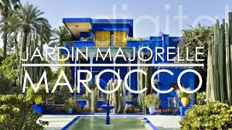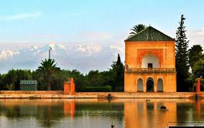

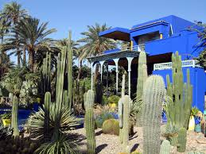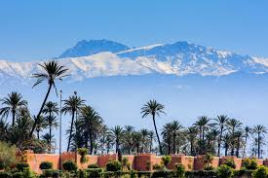

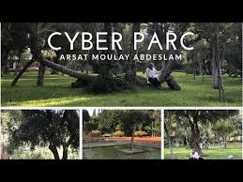

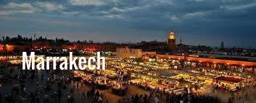

* **Excursion with the camels in palmier**
* **Mountagne atlas**
* **Lamnara**
* **Center cite jamaa lafna**
* **Kasr badia**