Word race **Tourism compagny 5 night in casablanca**

Proramme for **5 nights incasablanca luxe category** **Hotel sefitel** resevation of **50 nights and more**

|  |  |  |
| --- | --- | --- |
|  | **Sefitel hotel** | **Contractual prices valid from 01/01/2018 to 31/12/2018** |
| **(*)** **Corporate Rates** | Classic Room Sgl or Dbl | 250 euros |
| Sgl or Dbl Superior Room | 270 euros |
| Deluxe Room Sgl or Dbl | 300 euros |
| Junior Suite Sgl or Dbl | 370euros |
| Prestige Suite Sgl or Dbl | 450euros |
| Opera Suite Sgl or Dbl | Pricing on request |
| Imperial Suite Sgl or Dbl | Pricing on request |
| Penthouse Sgl ou Dbl | Pricing on request |
| Breakfast / person | 25 euros |
| Tax / person / per day | 5 euros |
|  |  |  |
|  |  |  |

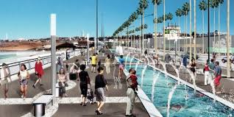 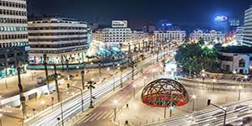

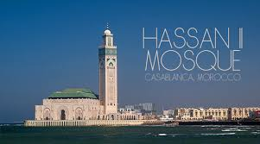 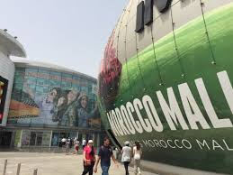  
 Excursion : centr city casablanca – ain diab cost – hassan 2 mosque- morocco mall

Transport 200 euro for group less than 15 persons per days

400 euros for the big bus per day it can reach 50 places