Word race

**Cairo,Luxor and Hurghada 8 Days**

Spend the best time of your Egypt vacation Package seeing the Capital of Egypt “Cairo ”with its highlighted magnificent scene such as The Great Pyramid of Giza, Old Cairo such as The Egyptian Museum. Then Head to“ Luxor ”which used to be the Capital of Egypt & get to see the most famous temples “Valley of the Kings” and more interesting places. Then head to a very charming city “Hurghada ”to relax on the Red Sea beaches.

Itinerary

Day 01 :

(Arrival) Welcome to Egypt, Our Representative will be waiting for you at the Arrival hall holding a sign with your Name , to pick you up to your Hotel. Then our representative will give you an overview about your Egypt vacation package.

Day 02 :

(Giza + Saqqara + Memphis) • After having your Breakfast at the Hotel, Egyptologist Guide will pick you up from your Hotel. start your great day tour to the Pyramids of Cheops, Whish consider one of the

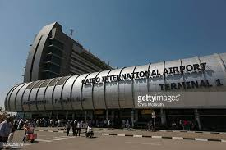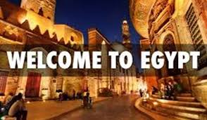

seven wonders of the world, Pyramid of king Chepren and Pyramid of king Mecrenus and Then you will visit the Great Sphinx and the Valley Temple. • Then you move to visit the Step Pyramid of king Djoser that consider the first Pyramid and the first limestone structure in Egypt. • Finish your trip by visiting the small Museum of King Ramesses II at Memphis to see the huge sleeping statue and the nicest standing statues for the King and the Alabaster Sphinx of Memphis. Finish your great day by driving you back to the Hotel.

Day 03 :

(Cairo City tour + Night train to Luxor) Start your excursion Tour with our Representative who will pick you up from Your Hotel to visit the most important sites which including:- • Egyptian Museum • Citadel of Salah Eldein (Mohamed Ali Mosque) • Coptic Cairo (Hanging Church + Coptic Museum + Crypt of Abu Serja Church) • Khan El Khalily Market. ** Night train VIP first class sitting train

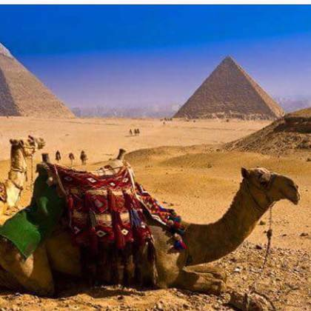

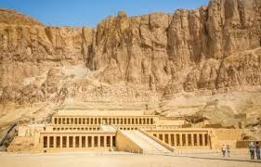

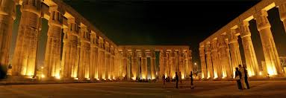 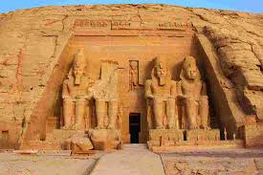  
Day 04 :

(Luxor) Egyptologist Tour guide will pick you up from your Luxor train station by air-conditioned private van to Luxor west bank you will visit valley of the kings, Hatshepsut temple and Memnon statues .End of your tour and return back to your Hotel &overnight in Luxor Hotel.

Day 05 :

(Luxor +Bus to Hurgada ) Check out form your hotel and Egyptologist Tour guide will pick you up from your Luxor Hotel by air-conditioned private van to Luxor East bank of Nile river, start unforgettable day tour to visit Karnak , then proceed to Luxor Temple of king Amunhotep III • Bus to Hurghada and spend the 1st Night at 4 stars Hotel.

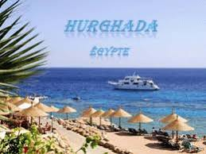

Day 06 :

(Hurghada): Enjoy your day with Scuba Diving and snorkeling to see the Coral reefs. * Stay the Second Night at the Hotel.

Day 07 :

(Bus to Cairo): After having your breakfast at the hotel and make check out, you will take afternoon bus back to Cairo and spend your Night at the Hotel in Cairo.

Day 08 :

(transfer to Cairo airport): Finish your Egypt vacation package by transferring you from the hotel in Cairo to the airport.

Included

• All transfers to/from airport& hotel by a private air-conditioned van.

• 3 Nights' accommodation in 5 star hotel in Cairo.

• English-speaking tour guide during your tours.

• Entrance fees to all sites.

• All transportation from/to Cairo/Luxor/ Hurghada.

• Two nights at 4 stars Deluxe Hotel at Hurghada.

• One Night at 4 stars deluxe hotel in Luxor.

• All service charges and taxes.

Excluded

• Visa to Egypt. • Any other optional tours if required.

• Tipping