Planter Box Report

Introduction
My Mum has said that she would like a planter box for her tomatoes to grow in. She has a few locations outside where she would like to grow tomatoes so I will have to make it suitable for outdoor use. I would prefer using decking timber to construct it as it will be nice to blend in with the outdoor furniture theme that’s already at her house. She will also need to make the planter box move to different areas around the yard so I will make it as mobile as possible.

In this report I will investigate the following;
- materials that are best suitable for the planter box and it’s intended uses.
- tools and equipment that can be used to make the planter box.
- techniques and processes that will be used in the making of the planter box.
- testing and trialling the many different methods and materials I want to use and
- feedback from my client (Mom).

Suitable Materials Treated and Selected
My Mum wants me to investigate suitable materials for constructing the planter box. There are two suitable businesses selling timber in Putaruru, Bunnings and Gold Pine. Three types of timber are being sold in town; Macrocarpa, Pine and Douglas Fir. My Mum needs more information regarding this.
This table compares the timbers I tested.

Materials | Finishing Properties | Availability | Timbers Treated | Workability | Cost
NZ Pine | Very Nice Smooth Finish when sanded | Very Available. | Finished Pine Can Be Stained or oiled, it looks good either way | It’s Very Workable | $5 Per Metre
Macrocarpa | Has A Nice quality Brownish Finish. | Very Available | Can Be Oiled With natural oil | Very Workable | $6.50 Per Metre
Douglas Fir | Has Nice Finish But Can Be Difficult To Paint | Reasonably Available | Can Be Stained  Light Stains looks best | Requires Care When Cutting | $7 Per Metre
This is NZ Pine

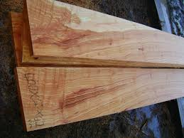
This Is Macrocarpa

This is Douglas Fir
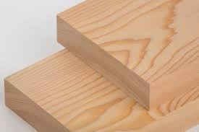

My Mum liked the finish of Douglas Fit but decided on NZ Pine Because of availability and cost

Tools and Equipment
To make my planter box I will create a plan which I will discuss with my Mum and use these tools and equipment;
➤ a drop saw to accurately cut the decking timber and other timber I use into the appropriate lengths.
➤ a cordless drill will be used to drill pilot holes and holes to attach the wheels as well as drilling drainage holes into the plywood.
➤ I can use a festool sander to create a smooth and good looking finish on all the timber I use.
➤ an impact driver will be used to get the screws into the planter box.
➤ I will be using a measuring tape to measure lengths of timber to cut on the drop saw.
➤ a pencil will be used to mark which areas to cut the timber.
➤ I can use a square to make sure everything is square and straight so that I have a nice looking finish.
➤ I will be using the jigsaw to cut the plywood for the base to size.
➤ I’ll use a handsaw to cut any tricky corners on the timber e.g. 45 degree angles.
➤ a brush will be used to apply the stain.

Techniques and processes

Joining Processes

The planter box will be made in the workshop so it will be possible to make use of any suitable joining processes. My Mum decided to use decking timber which limits the use of ways to join materials, I explored screw butt and half lap joints, I decided to go with screw joints which was tested for strength and suitability. This can be easily used to join parts using a drill or impact driver. I measured out the width of the place where it would be placed and decided on the following dimensions: 640mm wide, 1080mm long, and 760mm tall.

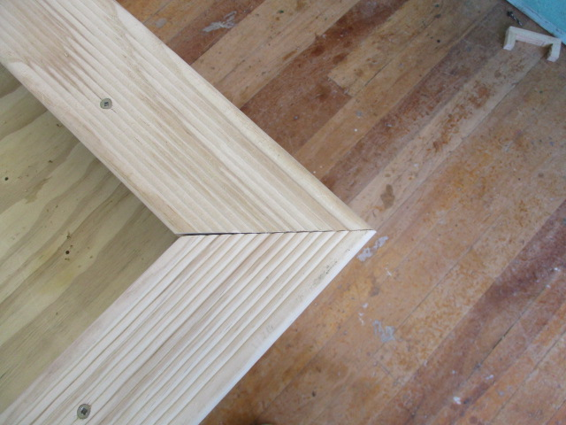
These are the 45 degree joins I made
on the top of the table
I used a 45 degree angle
Because it looked nicer than a
Normal join and it was structurally
Stronger as it held the legs together nicely

Testing and trialling
I originally had my table standing at over a metre tall, although this made sense in some ways I soon discovered it was far too wobbly and unstable to be used at this height so I decided to cut it down a bit. It took me a little while to get all the legs the same height to prevent it from wobbling. After all this I still decided to put the blocks of wood in the legs to reinforce it a little bit more. Now that it has been shortened it feels a lot sturdier and looks nicer as well.
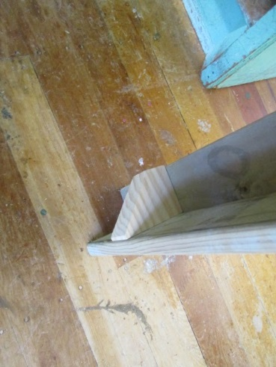
These are the blocks of wood I fitted in the legs
of my planter box to reinforce it to make it a
little bit stronger

My client insisted I use a treated plywood bottom with
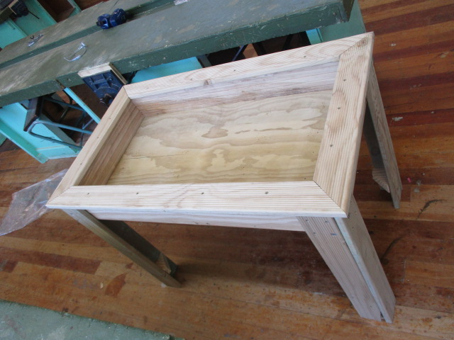
holes in it to allow water to drain
My client was happy with the depth of the box

Summary

My client (Mum) presented me with useful feedback during the construction of the planter box. She liked the fact that it’s stable and very strong but she wouldn’t mind it being a little bit taller. She likes the overall design but thinks I could have added a tray underneath it to allow for storage of tools etc. Overall she is happy with the project and will definitely get a lot of use out of it.
Now that this project is complete I can look at it and decide what I think went well and what didn’t go so well. I think the height of the planter box ended up being an excellent height for its intended purposes. The wheels I put on one side of the project were a great addition as it means my client is able to move it with ease whenever she wants, the wheels are also great on any surface which means the client can move the planter box wherever she needs to allowing her to make the most of the sun as it moves. The black plastic I used inside it was a good idea as it keeps everything clean and should give the planter box a much longer lifespan. If I did this project again I think I would use shorter legs from the beginning I also think I should make the legs out of a different type of timber as the decking timber isn’t as sturdy as I would like it to be, perhaps I would use a solid bit of timber to make the legs as this would be stronger and possibly allow me to make the planter box a little bit taller.

Joel McCann

Resources

www.craigpine.co.nz/about-nz-pine.php

www.nzwood.co.nz/forestry-2/macrocarpa/

