Пояснительная записка

Данные контрольные срезы разработаны учителем английского языка МБОУ СОШ №29 г.Владимира Князевой Н.В и предназначены для 6 класса. Объектами контроля являются элементы языка (лексика, грамматика) и речевая деятельность (чтение, аудирование, письмо). Каждая работа оценивается отдельно, имеет свои критерии оценивания и ключи.
Контрольная работа по чтению состоит из трех разделов.
Часть первая. (Базовый уровень). Понимание общего содержания текстов. Тип первого задания - установление соответствия; каждый заголовок соответствует только одному тексту, при этом один заголовок лишний; второе задание - закончить предложения, используя информацию текста.
Часть вторая. (Повышенный уровень). Умение находить запрашиваемую информацию. Тип задания – установление соответствия между утверждениями и содержанием текста, а также необходимо расположить тексты в таком порядке, чтобы получился рассказ.
Часть третья. (Высокий уровень). Полное понимание текста. Тип задания- note- making.

Критерии: максимальное кол- во баллов 32б
- базовый уровень- ( 1 текст) "удов" 12б-19б
- повышенный (1+2тексты) – "хор" 20- 25б
- высокий уровень (1-3 тексты) – "отл" 26-32б

Ключи: часть 1
1задание 1- b 2 задание 1) ...to enjoy nature
2- c 2)...to have lunch in the forest
3- d 3)...to listen to the music and dance there
4- a 4)...dogs
5)...take them for a walk in the park
6)...horse riding, football, swimming
7)...its own football team/

часть 2 1 задание 3,1,2.
2 задание 1-F, 2-T,3-F,4-T,5-T,6-F,7-T,8-T,9-F.

часть 3

 | School 1- Alice | School 2- Magnus
Location | at home in the middle of Australia | in Portland, the USA
Number of students | students from all over Australia | 1,500 students
Start and finish time | at half past eight- half past eleven | half past eight- 3p.m
Favourite subjects | Geography, History | sports,science,computers
Opinion | it's fun to have lessons at home | likes school, doesn't mind tests

Аудирование.
Проверяются умения понимать речь на слух с целью извлечения конкретной информации и полного понимания прослушанного текста.
Базовый уровень. Прослушать информацию и определить какие из приведенных утверждений соответствуют содержанию услышанного текста(True),какие не соответствуют (False).(T/F statements).
Повышенный уровень. Полное понимание прослушанного текста. Тип задания - выбрать правильный ответ из трех предложенных. (multiple choice).
Критерии: за каждый ответ 1 балл. Максимальное кол-во баллов 17б

9-11 "удовл"
12-14 "хор"
15-17б "отл"
менее 9б "неуд"
Для выполнения на "уд" достаточно сделать первое задание, на "отл" выполнить тест полностью.

Ключи: 1) F-1,2,6,7,8 2) 1-b,2-b,3-c,4-c,5-a,6-c,7-b.
T-3,4,5,9,10

Лексико- грамматический тест
Дается в контексте текста по аудированию "Эзор".
Лексика. Подобрать синоним к выделенному слову. Найти антоним к выделенному слову, из предложенных вариантов.
Повышенный уровень (творческий уровень). Выполнить лексический кроссворд.
Грамматика.1 уровень – восстановление предлога в предложении.
2 уровень- выбор правильной формы глагола.

Критерии оценки: за каждый ответ 1балл. Максимальное кол-во баллов 41б.
"уд"- 24-29б
"хор"- 30-35б
"отл"- 36-41б

Ключи: лексика- синонимы 1-c,2-b,3-a,4-b,5-d,6-c.
антонимы 1-a,2-b,3-c,4-d,5-c,6-b,7-c
кроссворд: Across:1-servant,3-animal,5-country,7-help,9-bad,10-rich.
Down: 1-story,2-traveler,4-fable,6-famous,8-friend.
грамматика:1уровень 1-d, 2-d, 3-c, 4-b, 5-a, 6-c, 7-b, 8-b, 9-c, 10-c.
2уровень 1-c, 2-d, 3-d, 4-c, 5-c, 6-a, 7-d, 8-a.

Письмо
Заполнить формуляр письма и написать правильно адрес на конверте.
1 задание -4б
2 задание- 4б
на "уд"- 4б (без ошибок написать адрес,выполнив др.задание).
на "хор"- 5-6б( выполнить 1и 2 задание с незнач.ошибками в написании слов).
на "отл"- 7-8б( без ошибок, информативно, полно).

Чтение

Часть 1

Прочитай, что некоторые британцы говорят о своих увлечениях.
a) Подбери к текстам заголовки. Один заголовок лишний.

1) We are very fond of having picnics. On Sundays our family goes to some nice place in the country. We like to sit in the open air and enjoy nature. It's a pleasure to have lunch in a forest or near the water. We can also play ball or swim if the weather is fine.

2) My best friend and I often go to the discos. We listen to music and dance there. It's fun! Rock is our favourite type of music. And we enjoy listening to jazz.

3) We have two dogs. Their names are Terry and Rex. We love them so much! Every day we take them for a walk in the park. They are so polite and nice when they meet other dogs there. I think they say "Hello!" to them in their dog language.

4) All my friends love sport. Our favourite sports are horse riding, football and swimming. Every school and college has its own football team. We often have sport competitions at our school. It's great when your team wins!

a We are fond of sports.
b British weekend
c How can we spend free time
d Pet lovers
e Most British are nice and polite.

b). Закончи предложения, используя информацию текста.

1). On Sundays the British like____________________________________________________________.
2). They think it's pleasant to______________________________________________________________.
3). Some boys often go to the disco to_______________________________________________________.
4). Many British families keep_____________________________________________________________.
5). They enjoy looking after them and every day they___________________________________________.
6). The most favoutite sports among the British are____________________________________________.
7). Most British schools have______________________________________________________________.

Часть 2

Прочитай три отрывка о рабочем дне девочки.
а) Расположи отрывки в таком порядке, чтобы получился рассказ.

1). At one o'clock Ann usually has lunch. After lunch she helps mother about the house. Ann doesn't like to wash the dishes but she enjoys shopping. Sometimes she doesn't remember what her mother told her to buy but she never forgets to buy some milk for her cat.

2). Ann can play the piano very well. Her friends often come to see her in the evening. They enjoy listening to music and sometimes Ann plays or sings for them. They always praise (хвалят) her singing. Sometimes they go out for a walk if the weather is fine and enjoy fresh air and a good company.

3). Ann often goes to bed late and she hates getting up early. Her mornings are very busy. She can't always find her things. She looks for her schoolbag everywhere and at last finds it under the sofa. Sometimes she doesn't have time to eat her breakfast and she is often late for school. I wonder why she never gets bad marks!

b) Отметь буквой Т (true) информацию, соответствующую тексту, и буквой F ( False) – не соответствующую тексту.

1.She is never late for school.
2.She always gets good marks.
3.She goes to bed early.
4.She enjoys shopping.
5.Sometimes she goes for а walk in the evening.
6.She doesn't sing well.
7.She can't find her things in the morning.
8.She always buys milk for her cat.
9.She likes to wash the dishes.

Часть 3

Прочитайте два текста о разных школах и заполните таблицу.

 | School 1 — Alice | School 2 — Magnus
Location
Number of students
Start and finish time
Favourite subjects
Opinion

I am Alice. I am in my sitting room at home, talking to my teacher on the radio. Yes, I am at school!
I live in the middle of Australia, a long way from any towns or cities, so I belong to the School of the Air. Students from all over Australia belong to such school. Every day, I start at half past eight. I have two hours of radio lessons and sometimes I watch lessons on TV. After that, I have three hours of homework, then I have free time.
I don't mind going to school in the sitting room — it's fun! I like using the radio. I like Geography because I'm interested in learning about foreign countries and I like talking to my Geography teacher about her visits to Europe, Asia and America. I also like History lessons. Unfortunately, we don't have sport lessons.
I am Magnus. I go to Green Street School in Portland, the USA. We get to school by bus.
Our school is quite big. There are about 1,500 students. I don't mind going to school. The lessons aren't very difficult for me. Our lessons start at half past eight. We usually have five or six 45-minute lessons. I am interested in science and computer studies. I usually get good grades in these subjects and I don't mind having tests in English and Literature.
I like my school. I am good at sport. I like playing ball games, especially baseball, football and basketball. We don't have uniform in our school and we don't study foreign languages. Some schools in Portland teach Spanish and German. I would like to study German.
I usually come home after 3 p.m. and go to the local stadium to play baseball with my friends.

Аудирование.

1).Прослушайте текст об Эзопе и выполните задания. Базовый уровень.
Aesop
to make up
fable
a servant
to reach
draw people's attention

Aesop lived in Greece more than two thousand years ago. He was the servant of a rich man. He made up little stories about man and animals and told them to his friends. Each story had a moral.
Everybody liked hearing the stories he told. A little story with a moral is called a fable. Mothers and fathers told Aesop's stories to their children. Travelers heard the fables in Greece and told them in other countries.
From the 15th century Aesop's fables were translated into French, English and German. In Russia, they were translated during the time of Peter the Great.
Aesop became famous all over the world and his fables are still told today they draw people's attention to what is bad and help people become better.

Определите, какие из приведенных утверждений соответствуют содержанию (T- True),какие не соответствуют (F- False).
1.Aesop lived in France.
2.He was a rich man.
3.He lived more than two thousand years ago.
4.His stories had a moral.
5.Mothers and fathers told Aesop's stories to their children.
6.Aesop told his own stories in other countries.
7.Aesop's fables were translated in 20th century.
8.In Russia they were not translated.
9.His fables are still told today.
10.They help people to become better.

2)Прослушайте письмо американского мальчика Майка и выполните задание, выбрав правильный вариант ответа. Повышенный уровень.

Hello! My name's Mike. I'm 13 and I'm a student. I live in Chicago, Illinois. Illinois is one of the states in the USA. My hobby is sport. It's great! I play baseball. It makes me strong. I enjoy listening to rock music. My favourite rock group is "Zeppelin". And I also like circus. It's fun to look at clowns and clever animals! I'm good at history and maths. I read a lot about great people. I'd like to be a journalist and travel around the world. I want to see people and life. What about you?

Выбери правильный вариант:

1. Mike is...
a. fourteen
b. thirteen
c. twelve
2. Mike lives ...
a. in the country
b. in a big city
с. in a small town
3. Mike likes to do sport...
a. in the gym
b. in the swimming pool
c. at the stadium
4. Mike enjoys...
a. quiet music
b. folk music
c. quick and loud music
5. Mike likes to read ...
a. biographies
b. fairy-tales
c. poems
6. Mike can...
a. draw well
b. count and do sums well
c. recite poems well
7. Mike would like to work ...
a. on a farm
b. for a newspaper or a magazine
c. in a hospital

Лексико – грамматический тест.

лексика.

1)Find the synonyms to the given words you came across in the story "Aesop''

1. lived
a) moved
b) died

2. little
a) large
b) small

3. hearing
a) listening
b) swimming

4. to be called
a) to be shouted
b) to be named

5. famous
a) unknown
b) talented

6. laugh
a) cry
b) weep

c) stayed
d) made

c) less
d) lose

c) digging
d) giving

c) to be given
d) to be taken

c) strange
d) well-known

c) smile
d) shout

2)Find the antonyms to the given words used in the story "Aesop"

1. lived

a) moved
b) stayed

2. rich
a) prosperous
b) poor

3. friend
a) comrade
b) fellow

4. like
a) to be fond of
b) love

5. famous
a) well-known
b) outstanding

6. laugh
a) smile
b) cry

7. bad
a) worse
b) worst

c) told
d) inhabited

c) naive
d) lame

c) enemy
d) mate

c) think
d) hate

c) unknown
d) typical

c) become
d) take

c) good
d) fine

грамматика.

1)Insert the missing prepositions:

1. Aesop lived____Greece more than two thousand years ago.
a) at c) by
b) on d) in

2. He was the servant___a rich man.
a) about c) at
b) over d) of

3. He made____little stories____man and animals and told them____his friends. Each story had a moral.
a) up/on/about с) up/about/to
b) on/to over d) on/to/up

4. A little story____a moral is called a fable.
a) about c) on
b) with d) to

5. Mothers and fathers told Aesop's stories______ their children.
a) to c) about
b) - d) with

6. Travelers heard the fables______ Greece and told them______ other countries.
a) in / at c) in / in
b) at/ at d) at / in

7. ... the 15th century Aesop's fables were translated_______ French, English and German.
a) since / to c) until / into
b) from / into d) after / to

8. ... Russia, they were translated during the time______ Peter the Great.
a) into / at c) into / by
b) in / of d) in / about

9. Aesop became famous all______ the world are still told today.
a) about c) over
b) round d) through

10. They draw people's attention _______what is bad and help people_______ become better.
a) on / at c) to / —
b) at / on d) at/ —

2)Choose the correct tense form:

1. Aesop____in Greece more than two thousand years ago.
a) had lived c) lived
b) has lived d) were lived

2. He____the servant ot a rich man.
a) are c) has been
b) is d) was

3. He____little stories about man and animals and____them to his friends.
a) had made up / had told c) did / told
b) has made up / has told d) made up / told

4. Each story____a moral.
a) has c) had
b) gave d) gives

5. A little story with a moral___called a fable.
a) was c) is
b) has been d) had been

6. Travelers____the fables in Greece and____them in other countries.
a) heard / told c) hear / tell
b) have heard / have told d) heard / tell

7. From the 15th century Aesop's fables____into French, English and German.
a) translated c) had been translated
b) has been translated d) were translated

8. Aesop____famous all over the world and his fables____ still____today.
a) became / are told c) has become / are told
b) becomes / tell d) had become / told

Do puzzle:
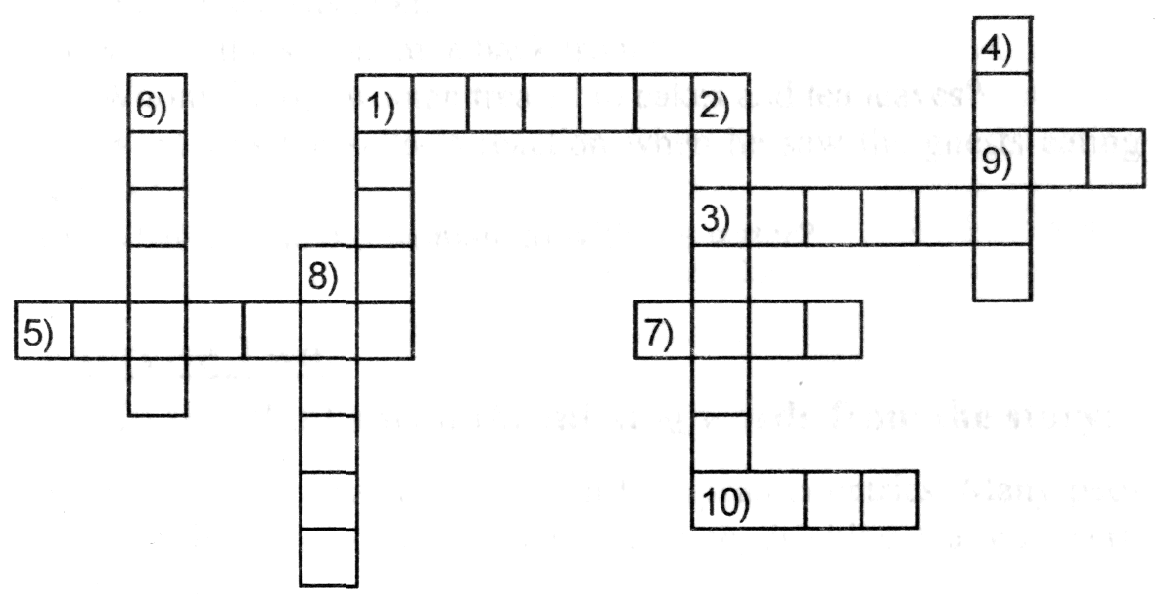
Across:
1) Who was Aesop?
3) Who lives in the forests?
5) The place where nations live?
7) The synonym of the word "SOS"?
9) The antonym of the word "well"?
10) The antonym of the word "poor"?

Down:
1) What thing of Aesop had a moral?
2) A man who always travels.
4) A little story with a moral.
6) The antonym of the word "unknown".
8) The synonym of the word "comrade".

Письмо

1) Как вы должны оформить конверт (не забудьте указать на конверте свой обратный адрес), если пишете письмо Mrs Smith ,которая живет в Великобритании в городе Manchester, на улице Old Street, в доме №346, почтовый код EC4 9NG

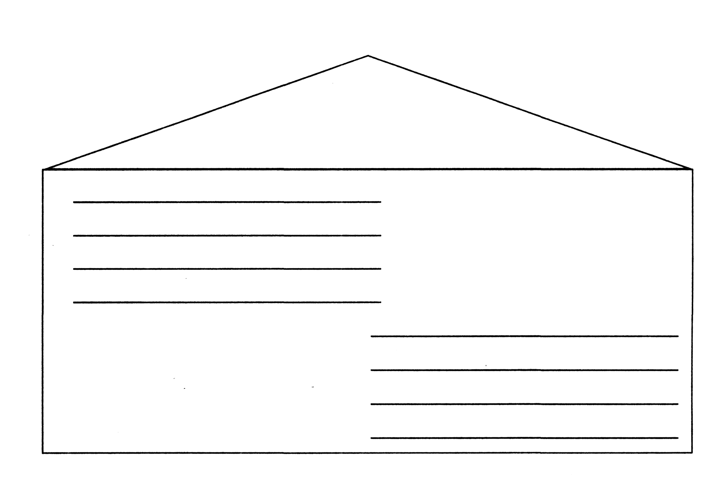

2)Circle and lable 0) the country, 1) the number of the house, 2) the city, 3) the street, 4)the postcode. There is an example for you(0).
Great Briatain- 0) The country

3) Вы собираетесь провести летние каникулы в англоговорящей семье в Великобритании.Вот письмо , которое вы должны написать им. Заполните его.

You are going to spend your summer holidays with an English-speaking family. Here is a letter you might write to them.

Complete it.

___________________(Date)
Dear Mr. and Mrs. Smith,
Thank you very much for offering (предложение) to meet me at the airport.
I'm arriving (прибываю) on_________________(date) at______(time).
I'm____________________________________(describe yourself).
I have got____________________________________________
I'll be wearing_________________________(describe your clothes).
Looking forward to seeing you.
Yours sincerely,
_________________(your name).

- Сигал Т. К. Английский язык: Тесты. 5-6 кл. М.: Дрофа, 2000
- Брюсова Н. Г. Контрольные и проверочные работы по английскому языку. 5-6 классы. М.: Дрофа, 2001

