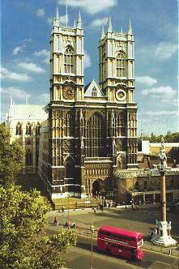
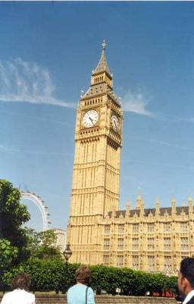
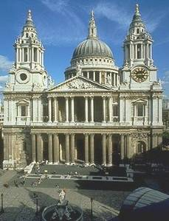
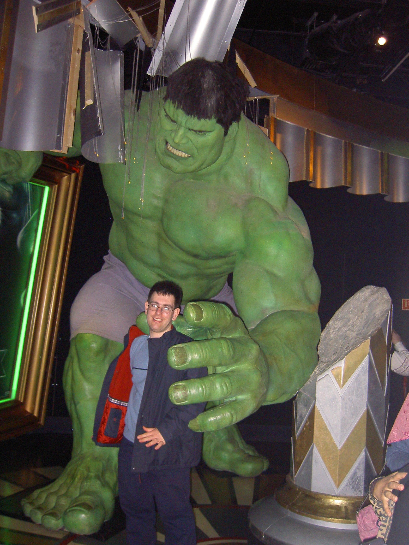
A B C D

E F G
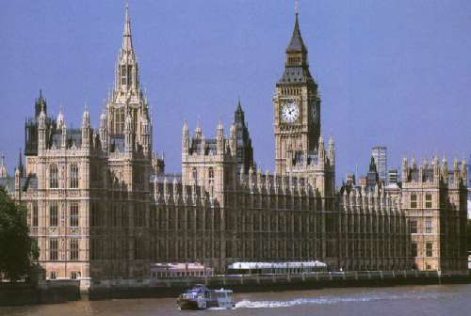
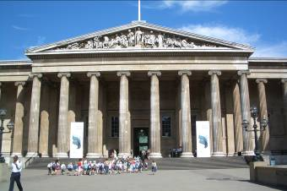
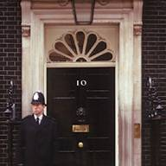

H I J
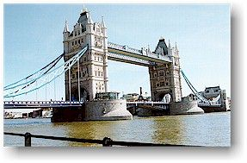
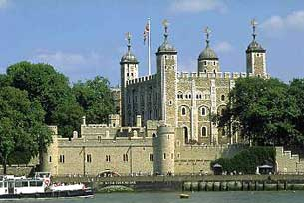
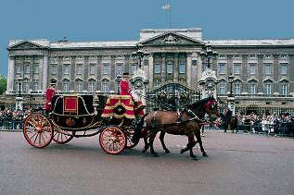

K L

- Madame Tussaud’s

- Buckingham Palace

- The Tower of London

- The London Eye

- Trafalgar Square

- The Houses of Parliament

- The British Museum

- St. Paul’s Cathedral

- Big Ben

10. Tower Bridge
11. 10, Downing Street
12. Westminster Abbey

Do You Know Great Britain?

- What is the official name of Britain?
- Where is the UK situated?
- What parts does the UK consist of?
- What is the capital of Britain?
- What river is the British capital situated on?
- What is the capital of Scotland?
- What is the capital of Wales?
- What is the capital of Northern Ireland?
- What is the symbol of England?
- What is the symbol of Scotland?
- What is the symbol of Wales?
- What is the symbol of Northern Ireland?
- What is the national costume of Scotland?
- What is the national instrument of Scots?
- When do British people celebrate Christmas?
- What is the traditional Christmas meal in Britain?
- What is the western coast of the British Isles washed by?
- What is the eastern coast of the British Isles washed by?
- What channel lies between Britain and the continent of Europe?
- What are the largest islands of the British Isles?
- What is the highest mountain peak in Wales?
- What is the highest mountain peak in Britain?
- What is the most famous forest in England?
- What is Loch Ness famous for?
- What is the London home of the Queen?
- Where does the Prime Minister of Great Britain live?
- What is the official name of the parliament building?
- What was the Tower of London in the past?
- What is the Tower of London now?
- What birds live in the Tower of London?
- What is there in the centre of Trafalgar Square?
- What is Big Ben?
- What is the Madame Tussaud’s Museum famous for?
- Who wrote the book “Gulliver’s Travels”?
- Who wrote “Treasure Island”?
- Who is known as the author of “Robinson Crusoe”?
- Who defeated the French at the battle of Trafalgar?
- Who was the architect of St. Paul’s Cathedral?
- What is the head of state of Great Britain?
- What Houses is the British parliament divided into?
- How many members are there in the House of Lords?
- How many members are there in the House of Commons?
- Which House of the British parliament is elected by people?
- What are the most famous Universities of the UK?
- What sports were invented in Britain?

Answers

- The United Kingdom of Great Britain and Northern Ireland.
- On the British Isles.
- English, Scotland, Wales, Northern Ireland
- London
- on the Thames
- Edinbourgh
- Cardiff
- Belfast
- the red rose
- the thistle
- the daffodil
- the shamrock
- the kilt
- the bagpipe
- on the 25th of December
- roast turkey and pudding
- by the Atlantic Ocean the Irish Sea
- by the North Sea
- the English Channel
- Great Britain and Ireland
- Snowdon
- Ben Nevis
- Sherwood Forest
- for the legend about the monster
- Buckingham Palace
- at 10, Downing Street
- Westminster Palace, the Houses of Parliament
- it was a fortress, a palace, a prison
- it is a museum
- ravens
- Nelson’s Column
- the bell of the largest clock in the Houses of Par.
- for its wax figures of famous people
- Jonathan Swift
- Robert Louis Stevenson
- Daniel Defoe
- Admiral Nelson
- Christopher Wren
- the Queen
- The House of Commons and the House of Lords
- more than 1,000 members
- 650 members
- the House of Commons
- Cambridge and Oxford
- Basketball, Football, tennis…

