 | 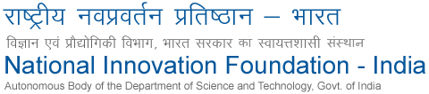 | 

Innovation: Utility stick for Parkinson’s patient
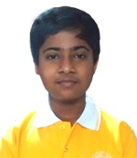 | Name : Parth Bansal  District & State : Kanpur (D), Uttar Pradesh  Award : IGNITE (given by President of India)  Function : 7 November, IGNITE 2016 Awards  Venue : President House
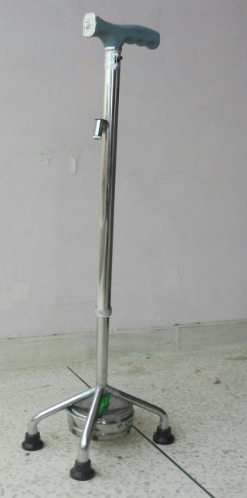 | 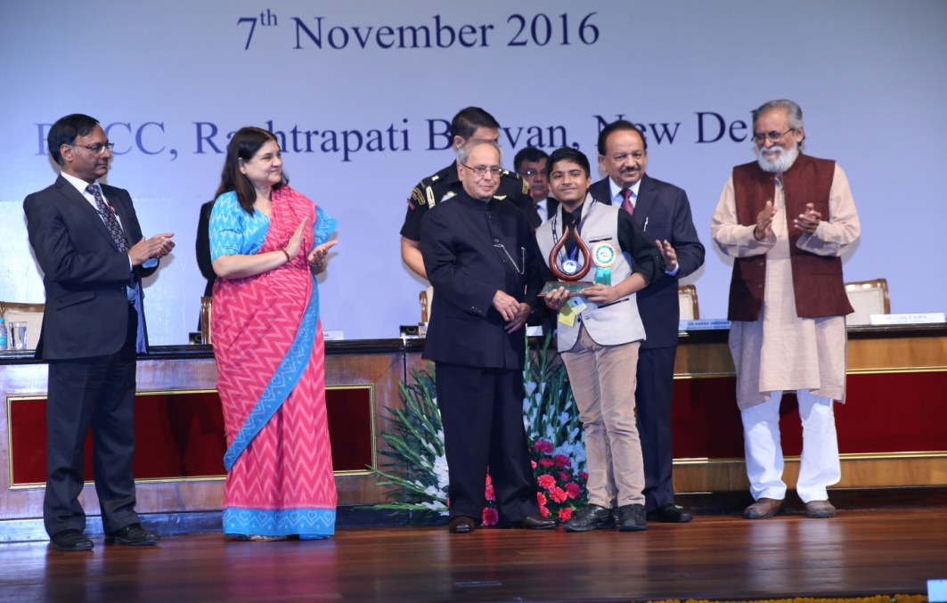

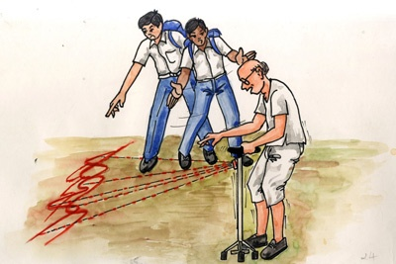 | Innovation Description:  Parth was deeply saddened when his father disclosed his grandmother’s illness (Parkinson’s disease) to him. Parkinson's patients face difficulty in taking first steps straight, but can use stairs and cross obstacles easily. Parth conceived an idea to project a laser light from a walking stick in front of patients on the ground, which will appear like an obstacle, and he believed that patients may be able to take their first steps this way. There are sticks available with simple line to be crossed.  Parth believes this technological improvement will help countless Parkinson's patients and make their lives easier. He loves watching educational programs on science and technology, and is interested in making models, robots and gaming apps.

