**Description:**  
9 in1 Multifunction Arduino Sensor Shield is a multi-function expansion board for UNO Arduino (Arduino shield), which can sense parameters of temperature, humidity, and brightness, and do other functions such as buzzing, indicating, and  IR receiving. It is suitable for Arduino beginners to learn about basic experimental modules and usage because no welding and no connection is required and the user can directly download the program and perform her/his experiment.  
This multi-function module is composed of the next module with their functions:  
A red LED module and A blue LED module for indicating two situations or states by 2 separate LED  
Full-Color LED Module or RGB module to indicate 3 states or conditions by a single integrated LED  
IR receiver module for receiving infrared signals  
Brightness sensor module for detecting/sensing environment brightness   
LM35D temperature sensor module for detecting/sensing environment temperature  
DHT11 temperature and humidity sensor module for detecting/sensing environment temperature and humidity  
Passive buzzer module for audio warning  
Rotary potentiometer module for analog controlling of a parameter  
  
**Features:**  
2-way button module  
2-way LED module  
Full-Color LED Module  
IR receiver module  
Brightness sensor module  
LM35D temperature sensor module  
Passive buzzer module  
Rotary potentiometer module  
DHT11 temperature and humidity sensor module  
One I2C interface (A4 SDA, A5 SCL)  
One TTL serial port  
Two channel digital ports (D7, D8)  
One channel analog port (A3)  
Reset button

**Package Include:**  
1 x Arduino Shield

[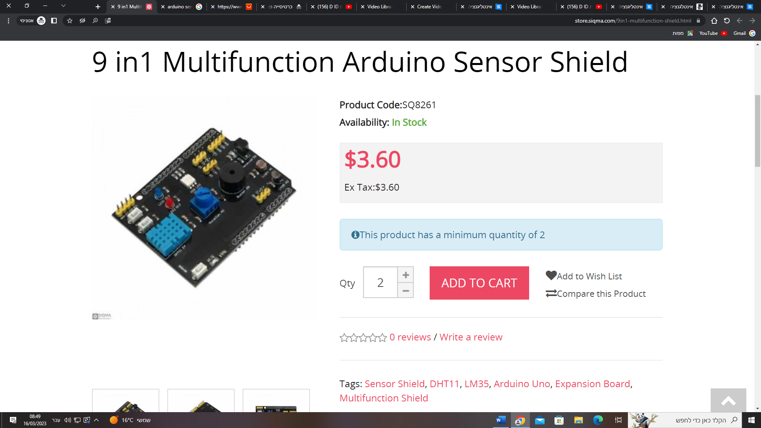](https://store.siqma.com/9in1-multifunction-shield.html)