Basic Grooming for dogs

* Bath

Includes wash with choice of shampoo, blow dry, and brushing.

-small dog (<25 lbs) $10

-medium dog (26-40 lbs) $20

-large dog (>40 lbs) $30

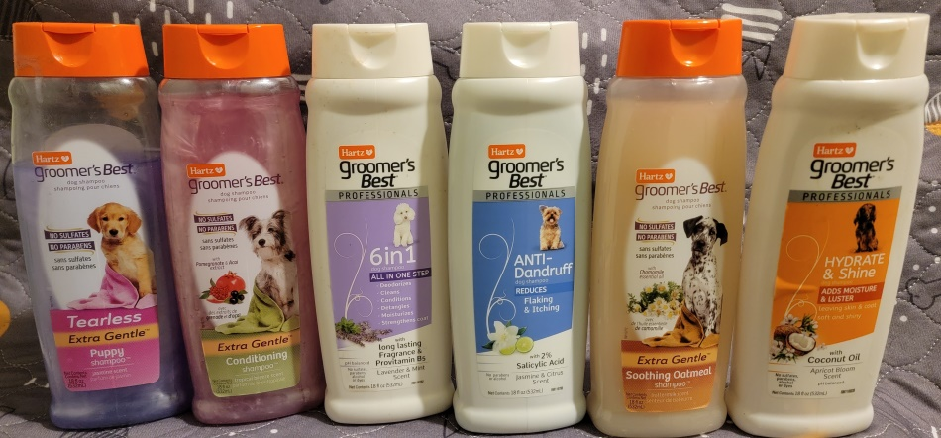Extra Gentle Tearless Puppy Shampoo Jasmine Scent

Extra Gentle Conditioning Shampoo Tropical Breeze Scent

6 in 1 Lavender & Mint Scent

Anti-dandruff Jasmine & Citrus Scent 2% Salicylic Acid

Extra Gentle Soothing Oatmeal Buttermilk Scent

Hydrate & Shine with Coconut Oil Apricot Bloom Scent

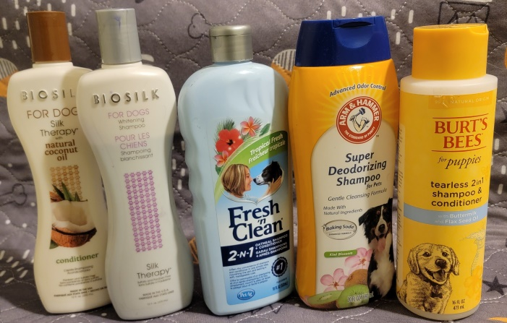Bio Silk Natural Coconut Oil Conditioner

Bio Silk Whitening Shampoo

Fresh n Clean 2-1 Oatmeal Shampoo/Conditioner Tropical Fresh

Arm & Hammer Super Deodorizing Shampoo Kiwi Blosom

Burt’s Bees Puppy 2-1 Shampoo/Conditioner with Buttermilk & Flax Seed Oil

* Nail Trimming $5