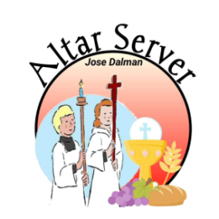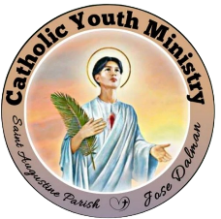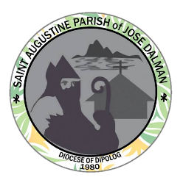**KNIGHTS OF THE ALTAR**

**Catholic Youth Ministry**

Saint Augustine Parish Jose Dalman

**Profiling CY: 2023-2024**

Group Number:

Date Installed:

Batch: 3

**PERSONAL INFORMATION:**

Full Name: Myrvin N. Malmis

Date of Birth: November 23, 2008

Age: 15

Address: Madalag Jose Dalman Z.N

Contact Number: 09361290837

Facebook Account Name: Myrvin Malmis

**IN CASE OF EMERGENCY:**

Parent/Guardian Name: Myrna Malmis

Contact Number: 09361290837

Relationship: Mother

___________________________

Signature over Printed Name