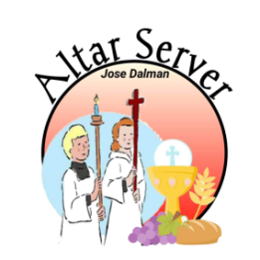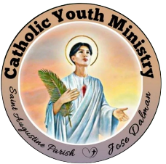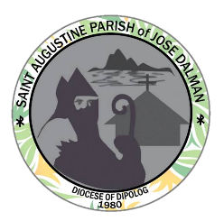**KNIGHTS OF THE ALTAR**

**Catholic Youth Ministry**

Saint Augustine Parish Jose Dalman

**Profiling CY: 2023-2024**

Group Number:

Date Installed:

Batch: 1

**PERSONAL INFORMATION:**

Full Name: Stephen Carl V. Moncada

Date of Birth: November 24, 2006

Age: 17

Address: Ponot Jose Dalman Z.N

Contact Number: 09565542174

Facebook Account Name: Sutiban Karn

**IN CASE OF EMERGENCY:**

Parent/Guardian Name: Angelie Moncada

Contact Number:09955888507

Relationship: Mother

___________________________

Signature over Printed Name