****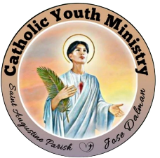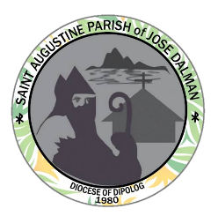**KNIGHTS OF THE ALTAR**

**Catholic Youth Ministry**

Saint Augustine Parish Jose Dalman

**Profiling CY: 2023-2024**

Group Number:

Date Installed:

Batch: 1

**PERSONAL INFORMATION:**

Full Name: Ferland Tagapan

Date of Birth: April 1, 2001

Age: 21

Address: Litalip Jose Dalman Z.N

Contact Number: 09811460288

Facebook Account Name: Ferland Tagapan

**IN CASE OF EMERGENCY:**

Parent/Guardian Name: Roland Tagapan

Contact Number: 0935042841

Relationship: Father

___________________________

Signature over Printed Name