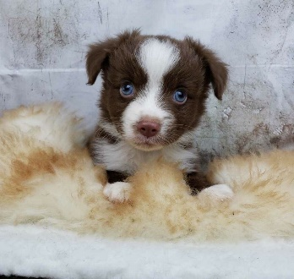
Norris Lake TN Tiny Mini Aussies Puppy Contract
PURCHASE CONTRACT:
This agreement is made between Norris Lake TN Tiny Mini Aussies & the buyer listed below for the purchase of an Australian Shepherd.
Name_____________________________ Phone__________________

Address____________________________________City____________________________State___________

Zip_______________Email____________________________________________________________________

ASDR Registration number or Litter number________________________________________

Date of birth_____________________________Sex___________

Color and markings_________________________________________________________

Sire name_________________________________________________________________________

Sire ASDR reg #____________________________________________________________________

Dam name________________________________________________________________________
Dam ASDR reg #___________________________________________________________________

Purchase Price $______________________Deposit $________________________ Balance $___________________

Deposit of $200 is required to hold your puppy and is non-refundable. Balance must be paid in full by money order or cash at pick up. This puppy is the product of two genetically health tested ASDR registered purebred mini Australian Shepherd parents.

All Pet/Non Breeding: Are required to be spayed /neutered at the age of 6 months and will be sold with limited registration, which
will be marked as such on registration papers.
All Show/Breeding: Will be sold with full registration. Seller does not guarantee performance.

All puppies and dogs are on a strict health program, including scheduled vaccinations, preventative shots, de-worming, parasite control and high quality, high protein dog food. The puppy purchased is guaranteed healthy at the time it is picked up. Buyer agrees to take puppy to the vet within 48 hrs of receipt or this contract becomes invalid. If the pup is found by a licensed Veterinarian, not to be in good health (internal, external parasites and kennel cough excluded) buyer must notify seller within 24 hrs with a report from licensed Vet. Failure to return written report within 24 hrs of exam invalidates this agreement. Seller is not responsible for any fees incurred. Seller guarantees said dog or pup to be free from hereditary diseases at the time of purchase. Buyer agrees to provide fresh water and high quality food daily and to continue a strict health program of continued vaccinations and deworming and parasite control. If at anytime for any reason, the buyer can not keep said dog or puppy. Buyer agrees to contact seller and offer animal back to seller, before it is offered to any other person for any reason.

Seller(s) Signature___________________________________________________Date______________

Buyer(s) Signature__________________________________________________Date_______________

Norris Lake TN Tiny Mini Aussies : Nan Diederich 865-405-0338 : Nanette_diederich@hotmail.com

