The Given Tree

They’d grown
From a seedling
To a towering tree

But not alone

The sky blessed them with water
Water, the liquid of life
Enough to grow
But not to drown

The sun provided the light
Light, the creator of day
The warmth they feel
One that fights off the cold

Mother released her knowledge
Knowledge, the fruit of time spent
Shared all she knew
So that they could bloom with purpose

Their ancestors granted them soil
Soil, the ground from which we build
Gave them a community
Connected through roots and branches

They are grateful for the effort
The time spent
The life lived
To help them become what they are

They want to become Mother
Sky
Sun
Or Ancestor
For someone

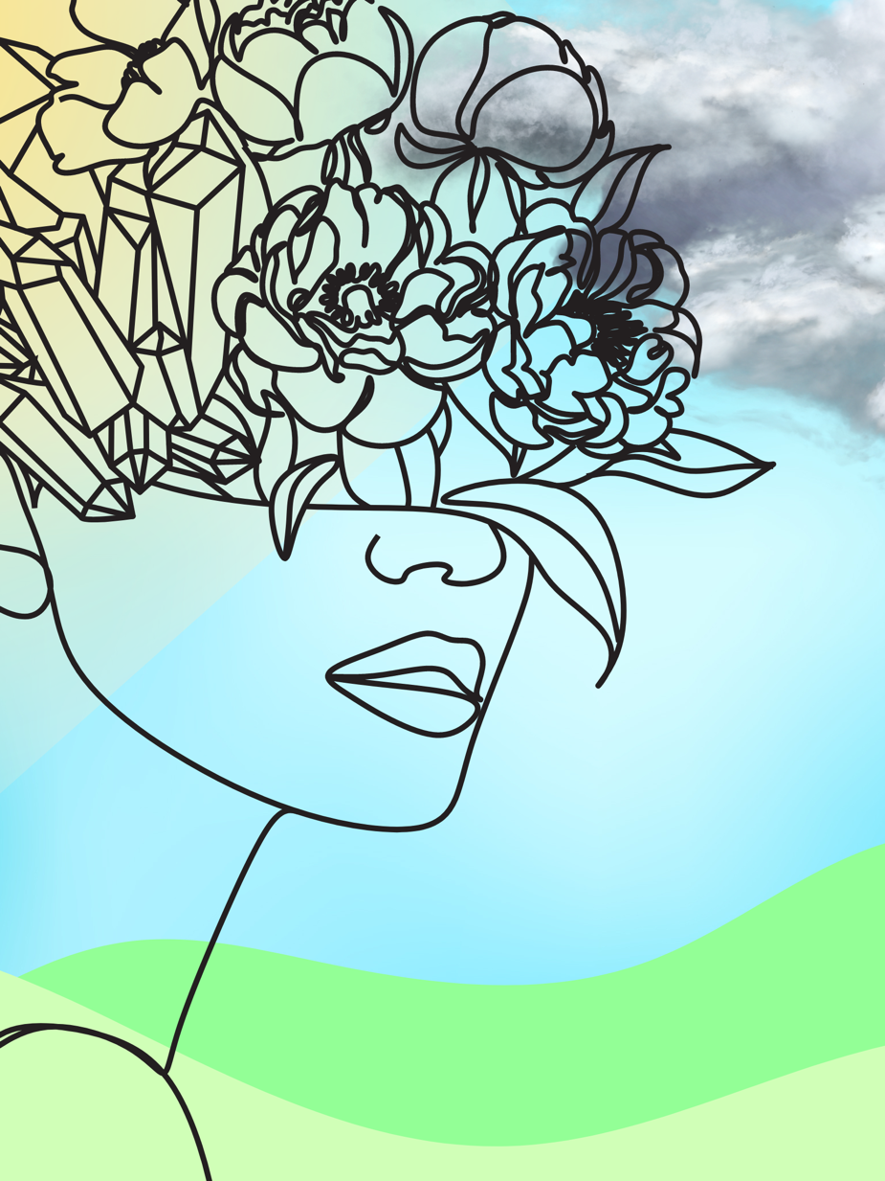

This is a quick Canva cover for the poem. I only noticed just as I was about to send this in that “book cover” was wanted. This is my speedy creation

