Raining Tacos
Parry Gripp

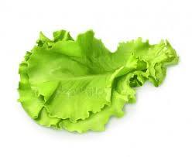
It's raining tacos
From out of the sky
Tacos
No need to ask why
Just open your mouth and close your eyes
It's raining tacos
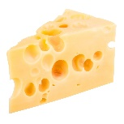
It's raining tacos
Out in the street
Tacos
All you can eat
Lettuce and shells
Cheese and meat
It's raining tacos
Yum yum yum yum yumity yum
It's like a dream!
Yum yum yum yum yumity yum
Bring your sour cream
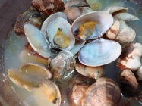
Shell
Meat
Lettuce
Cheese
Shell
Meat
Lettuce
Cheese
Shell
Meat
Cheese cheese cheese cheese cheese
It's raining tacos, ooh…

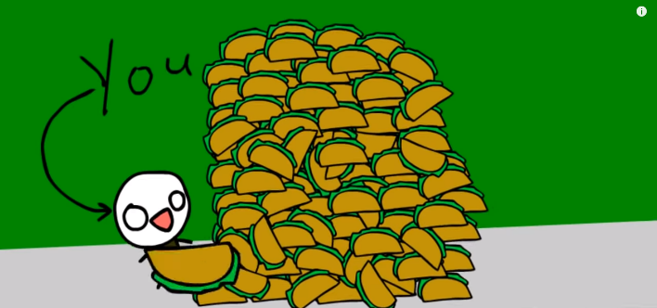

What’s the date today?

What’s the weather like?

Imagine that It is raining something special:

