**🡪Tell us about the life of the artist. Did he do anything else that was significant?**

Leonardo Da Vinci was a painter, engineer and anatomist of the Italian Renaissance of the XV and XVI century. He was born in Anchiano on April 15, 1452 and died on May 2, 1519 in Amboise (France).

He was the son of Piero Fruosino di Antonio, nobleman and ambassador of the Republic of Florence and of a young peasant woman named Caterina di Meo Lippi.

The reading, writing and arithmetic skills were learned in Florence. He was very observant and immediately began to stand out in the painting. In 1469, he began working as an apprentice with Andrea del Verrocchio, who was an artist, goldsmith, blacksmith, sculptor, and painter. In his workshop, Leonardo learned from drawing and painting techniques to the basis of chemistry, through engraving and sculpture techniques. In this apprentice stage he only collaborated with Vassari in the work called the Baptism of Christ (1472-1465) and painted the angels.

At the Antonio Pallaiuolo workshop, at the same time, it was where he learned anatomy. After six years as an apprentice, he set up his own workshop in Florence and in 1476 he painted his first painting called the Virgin of the Carnation. In 1478 he was already an independent painter. In 1482 Leonardo da Vinci began working for the Duke of Milan and remained there for 17 years as an engineer.

In 1490, he opened a school and taught all his knowledge and shared his research. It was there that I draw the famous Vitruvian Man, where Leonardo explains the ideal proportions of the human body.

In 1494, the Dominican convent of Santa Maria dalle Grazie commissioned da Vinci to paint a fresco in one of its rooms, known as the Last Supper (1494-1498), one of the most famous.

A year later, French troops conquered Milan and Leonardo fled the city with his friend, the Franciscan mathematician and friar Luca Pacioli.

**After a brief period in Mantua, Leonardo moved to Venice. There he worked as a military engineer and created defensive systems to protect the city from attacks by the Turks. Many of his inventions were not built.**

**During these years, da Vinci was already known in Italy as a genius. His skills and his polymathic were famous in the country of the boot. Many commissions came to him, although many were left only in sketches, such as The Battle of Anghiari.**

**Leonardo da Vinci's most famous work is the Gioconda and is believed to be the portrait of Lisa Gherardini, wife of Francesco del Giocondo. The enigmatic smile and the gaze of the model have made this painting one of the most commented and studied in history. This work is in the Louvre Museum in Paris.**

**Around 1506, went to Milan and the Virgin of the Rocks ended. In 1513 he went to live in Rome and it was there that he worked with Pope Leo X.**

**Due to the few commissions he had, he went to live in France in 1516 and focused on his investigations. And she finally died on** May 2, 1519 in Amboise (France).

**Da Vinci was a very restless person and his curiosity about the how and why of things around him came. This prompted this genius to carry out a multidisciplinary task that covered practically all branches of knowledge.**

**🡪Show us other examples of his art**

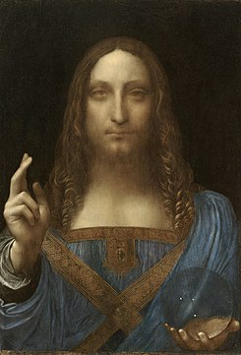**These are some example of painting and sculptures form Leonardo da Vinci:**

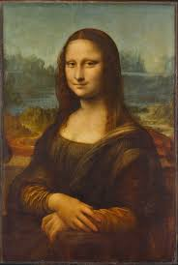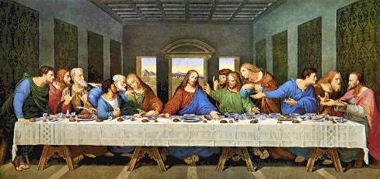

The last Supper

Salvador Mundi

Gioconda

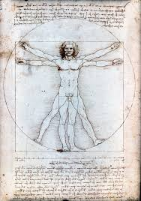

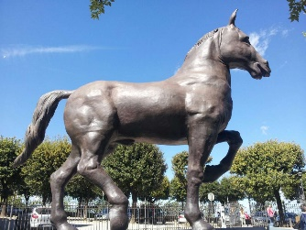

Vitruvian man

Leonardo's horse

**The most famous paintings of Leonardo da Vinci are the Gioconda and the last Supper. But all of the paintings have a hidden message.**

**-The Last Supper is a painting that represents the last supper that Jesus made with his apostles before dying. You can see some precious stones drawn on the brooch that Christ has on his neck. To leave their message there, 7 apostles each carry a stone in different parts of their clothing. It is believed that he wanted to refer to the Apocalypse of Saint John.**

**-As we can see in the painting called Salvador Mundi, it is seen that he is holding a transparent glass orb. At this time, it was very difficult to draw it, only those who knew a lot of technique get it. Everything looks perfectly behind the orb.**

**-The Vitruvian Man is a drawing that teaches the ideal proportions of the human body and the reason why the drawing is famous is because it is accompanied by anatomical notes from around 1490 in one of his diaries.**

**- The Leonardo’s Horse was commissioned by the Duke of Milan and was the artist's last work. It had to be the largest statue of a horse in the world, but the artist died before finishing it. First he designed the horse and later with clay he made the sculpture of about 7 meters but with the war that arrived in Milan it was destroyed. Charles C. Dent, 500 years later, with the sketches that Leonardo da Vinci had designed, ordered that they build the horse with steel.**

**🡪Where can the painting be seen and what other significant art works can be seen there?**

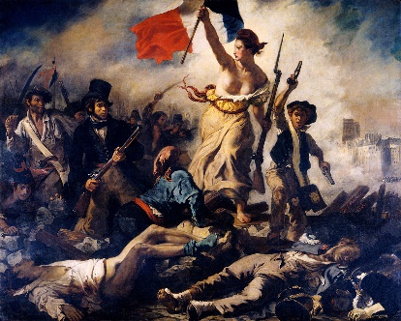**The Gioconda also called as the Mona Lisa, is in a museum called the Louvre Museum which is located in France. In this museum we can also find other works of art such as:**

**· Liberty leading the people: This painting is made by a French painter and lithographer named Eugene Delacroix. It is a picture of romanticism painted with oil in 1830. It represents the French revolution that happened from July 27 to 29 of that same year (1830).**

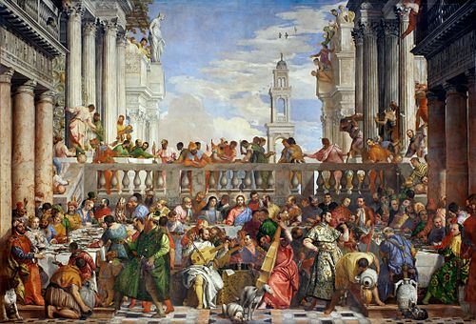**·The Wedding Feast at Cana: This painting was painted by Veronese, who was born on the 1523 in Verona, Italy and died on April 19, 1588 in Venice. This painting is made in oil on canvas and was painted in 1563. It is a colossal work.**

**There are many more interesting works that you can see.**

**Napoleon's coronation:**

**This painting is made with oil on canvas. It is a work commissioned by the painter Jacques-Louis David, who is famous for his historical frescoes. Napoleon commissioned him with a gigantic painting that shows him during his coronation and that of the Empress Josephine. This painting well represents the lavishness of that ceremony, in which the position of each character was studied for reasons not only aesthetic, but also political.**

**-The raft of the jellyfish:**

**This painting is painted in oil and is made by Théodore Géricault in the 19th century. It represents the survivors of the shipwreck of the French frigate "Medusa", who when they saw the silhouette of another ship in the distance, tried to attract attention to rescue them.**

**🡪What is the story of the painting and the meaning of some of the images?**

The Mona Lisa, also known as La Gioconda, is the wife of Francesco del Giocondo. This painting is painted in oil on wood and is the property of the Government of France. This famous painting is exhibited in the museum called Louvre in Paris, France.

We can see that she is a woman dressed in the Florentine fashion of her time and who is sitting in a mountainous landscape. It follows one of Leonardo da Vinci's techniques that is soft modeling and very shady. The reason this painting is so famous is for its seductive and distant gaze. Her smile is a visual representation of the idea of happiness suggested by the word "Gioconda" in Italian.

The reason why Leonardo da Vinci put this background is to give more protagonist and importance to the model.

**🡪Are there any interesting theories related to the painting?**

**The identity of ‘La Gioconda’ remains a mystery to almost most people. People believe that the woman being portrayed is Lisa Gherardini, the wife of an Italian merchant called Francesco Bartolomeo de Giocondo. This woman was known by the nickname of Mona Lisa. This is a thesis accepted by art critics. But there are many more theories about the picture.**

**There is people who think that the model could be from the mother of Da Vinci, or a friend of Juliano II de Médecis, who was a nobleman from the Renaissance period. Others think that the model could have been a lover of the Leonardo da Vinci or even a self-portrait of the author imagining as if he was a woman.**

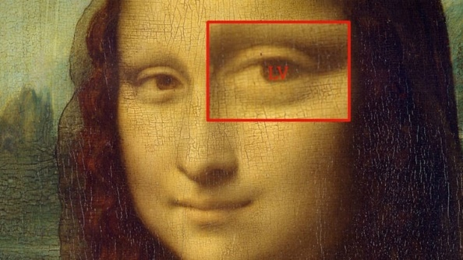**The smile and the look of this woman have also been commented. If we look focused at the painting, we can see that the woman is serious and only through the smile does her mood change. This smile is called "the unattainable smile"**

**The Mona Lisa, also hides some mysteries. In the right eye, with an HD magnifying glass, we can see that there are two letters, which are "LV" (it is believed to be his signature) and that in the other eye, also with a magnifying glass, we can see a 72, the letters CE and L2.**

**There is people who think that the person who was acting as a model was ill because their skin color was very yellowish. Another reason they thought she was sick is that she had fat bumps on parts of her body and this indicated to them that she was sick.**

**Other people believe that to entertain the model and to make her smile they used musicians. The smile seems to be forced since it cannot smile. So there is that mystery with his smile.**

**🡪Has the painting ever been used in TV commercials, movies, music, on T-Shirts etc.?**

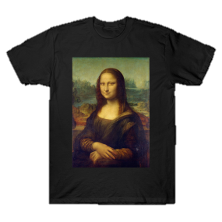**This painting is very famous so it is logical that it has appeared in movies, on television, on some t-shirts... There are many Mona Lisa t-shirts, but not all of them are similar to the painting. Mona Lisa, in some t-shirts it comes out with a dog filter, with glasses, with a mobile phone... But, on television channels the picture actually comes out, without modifications. One of the channels where the Mona Lisa painting appeared one day is in RTVE. Apart from this channel, in other channels showed the painting at live and direct.**

**Mona Lisa's name appears in several songs. There are also videos where Mona Lisa is singing the song, but they are not entirely real, that is, they are edited and modified.**

**From my point of view, I think they choose the Mona Lisa for t-shirts, songs and television channels because it gives them more advertisement** **and since this painting is very famous, it causes more visualizations and people buy the t-shirts.**

**🡪 What do YOU think of the painting and WHY?**

**From my point of view, this painter had a very good idea and it is also a very important painting. What I found very curious is how Leonardo da Vinci painted this work of art since it seems that Mona Lisa follows you with her gaze. It also impresses me the way it is painted. Before being painted, Leonardo draw it by hand made but anyway this painting is painted great, with a mountainous background that is blurred and it seems that the fields behind it are far away. So basically it was a very good idea and without knowing exactly what person he painted, since there are many theories, just looking at the image we can see that it is a work of art with a lot of time dedicated and that is very expressive.**

**As we know humanism is the interest in the study of humans, including the anatomy and physiology of the bodies, that is, the parts of the body and how they work together. So in these times what they did in the paintings was that they looked real and were very detailed. In da Vinci's case, some of his paintings follow this method of humanism. Not only did he do it in this painting of the Mona Lisa, but also with the painting called "the Last Supper" and others ...**

**🡪 What were the other main innovations of the Renaissance? Explain why they were important**

**During the Renaissance they also invented:**

* **The printing facilitated the copies of the books and allowed them to reach many people. The first book that was copied by the printer was the Bible.** **Thanks to the invention of the printing, they were able to spread the knowledge and culture of peoples to different parts of the world.**
* **The Compass is a Chinese invention that helped European cultures find the new continent.** **Thanks to the compass, the navigators were able to improve the navigation and from it, they were able to reach new lands that allowed them to establish commercial agreements and also contributed to the expansion of the great civilizations and empires.**
* **Galileo's Telescope: Galileo Galilei perfected the Copernicus telescope and made it 30 times more powerful. With this telescope, Galileo discovered many planets including Saturn.** **This telescope, made possible for one of the most important astronomers to see invisible stars with the naked eye since the telescope allowed to see distant objects.**
* **Gunpowder: The powder was also created by the Chinese and was exported to Europe, creating the firearm.**
* **Weapons: Firearms were used as a new resource of war.**

**🡪Other contributions da Vinci made:**

**As we know, da Vinci was an inventor, technologist, philosopher, botanist, scientist, anatomist, urban planner, sculptor, painter, and engineer. These are some contributions from Da Vinci.**

**-The self-propelled vehicle:**

**It was considered the first car that was recorded. He made this invention with wood and worked with a mechanism that caused the interaction of springs with sprockets. In 2004, a group of scientists decided to recreate his invention and it was very successful because it worked in the same way as da Vinci's invention.**

**-The air screw:**

**Da Vinci also made the first sketch of the mechanism that allowed helicopters to operate. He based his theory on the idea of what a screw does if there is an object "screwing" inside a solid body. Logic led him to think that it should rise automatically. Da Vinci called this invention "aerial screw".**

**-The diving suit:**

**Da Vinci liked the sea very much and was one of his well-known obsessions. An idea came to him that was the possibility of exploring it in such a way that he wanted to invent some inventions to facilitate the task. Da Vinci designed a diving suit that was made from leather and connected to an air sleeve that was made from a cane. From there it was connected to a bell that floated on the surface. He considered every detail and designed a bag that they could pee in during the scan.**

**-The anatomy:**

**Da Vinci dedicated part of his life in the study of human anatomy, although at that time he was punished with the death penalty. But even so, he investigated the respiratory system, the bones, the male and female reproductive system ...**

**-The gears:**

**Archimedes had previously invented the cogwheel. However, da Vinci was the one who created the gears in all their forms. He wrote down the schematics and drawings of many gears that are still used today. The basic gear consists of a pair of wheels and one of them provides cylindrical bars. The other is formed in turn by two wheels also linked by cylindrical bars.**

**There are so many more inventions that da Vinci made.**

**🡪Webs:**

* <https://www.saberespractico.com/biografias-resumidas/leonardo-da-vinci/>
* <https://canalhistoria.es/perfiles/leonardo-da-vinci/>
* <https://www.leonardodavinci.net/paintings.jsp>
* <https://www.culturagenial.com/es/cuadro-la-libertad-guiando-al-pueblo/>
* <https://es.wikipedia.org/wiki/Las_bodas_de_Can%C3%A1_(Veronese)>
* <https://www.elviajedesofi.com/que-ver-en-el-louvre-en-dos-horas-20-obras-que-no-te-puedes-perder/>
* <https://www.lavanguardia.com/vida/junior-report/20190429/461871697737/mona-lisa-gioconda-da-vinci-misterio.html>
* <https://felipeforerohistoria.wordpress.com/renacimiento/inventos-del-renacimiento/>
* <https://madridpress.com/art/252338/la-importancia-de-la-imprenta-en-nuestra-sociedad>
* <https://www.importancia.org/brujula.php>
* <https://www.eluniversal.com.mx/articulo/cultura/artes-visuales/2017/02/15/el-enigmatico-mensaje-en-la-ultima-cena-de-da-vinci>
* <https://historia.nationalgeographic.com.es/a/ultima-obra-maestra-leonardo-da-vinci_14253>
* <https://academiaplay.es/aportaciones-leonardo-da-vinci-humanidad/>