**What was the Renaissance?**

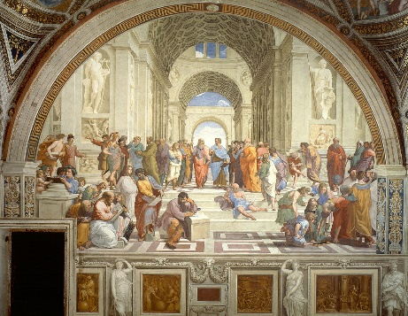The Renaissance begins in 1400 and ends in approximately 1600. This name was given by a historian named Jacob Burckhardt. During this period, they wanted to learn from the civilizations of Rome and Greece and that is why it had an effect on the arts, education, architecture and the way of understanding the solar system.

The Renaissance began in Italy, which was divided into states. Each of these states governs its own affairs and often conflicts with each other. So, each of the states has its individual characteristics, for example, Rome is governed by the papacy (the Pope), Venice, Florence ...

**What were the key ideas of the Renaissance?**

The key ideas of the Renaissance were humanism and classicism.

HUMANISM:

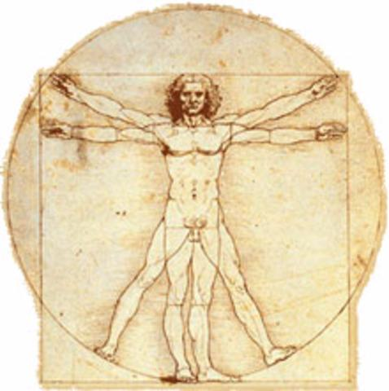Humanism is the interest in the study of humans, including the anatomy and physiology of the bodies, that is, the parts of the body and how they work together. It also involved a greater degree of individualism and the study of the potential of humans in different fields. In the arts, he showed more realistic images of people, for example, the greater use of portraits.

It was developed in the rediscovery of the books of the Greeks and Romans. There was a very important poet in this process named Francesco Petrarch.

CLASSICISM:

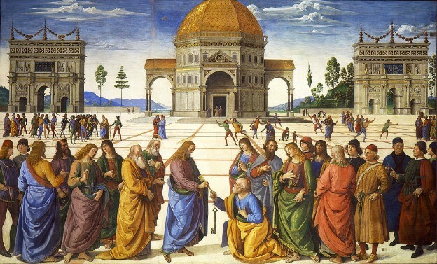Classicism is referred to the works that the Greeks and Romans did. Many Greek and Roman architectural styles were restored during the Renaissance, some examples are arches, columns, and pediments. An interest could also be seen in some of the political dimensions of the ancient world and in the Greek systems of government that promoted democratic measures.

**Project:**

I have chosen Mona Lisa because it is a very famous peace of art. I am interested to know more about it, why Leonardo da Vinci had the idea, who is Mona Lisa, how it is painted…