<https://salamtabish.blogspot.com/>



***Tåbìsh Sålám***

Cereal cyst nematode causes “Molya disease” in wheat and barley. Second stage juvenile (J2) is the infective stage which enters inside the plant and start feeding on permanent feeding site known as “Syncytium” which acts as a metabolic sink. With

further development, J2 starts to swell and becomes lemon shaped creamish-white adult

female. Upon maturity this white female will turn to brown female called as “Cyst” (dead female) containing about 400 eggs inside the body which acts as a protective cover against drastic environment. Upon sensing the moisture and host plant, the second stage juvenile break down the cyst and comes out from the birth pore and invade the wheat crop in next season.

## Introduction

Cereal cyst nematode (*Heterodera avenae*) is a microscopic obligate parasite which feeds on roots, belonging to sedentary endoparasitic group of nematodes. It was first discovered from Rajasthan in 1958 by Vasudeva. This discovery proved as a landmark event in the history of Nematology in India. It is most prevalent in light sandy soil in North Indian conditions *i.e.* Rajasthan, Haryana, Delhi, Himachal Pardesh, Jammu & Kashmir, Madhya Pardesh, Punjab and Uttar Pardesh. Wheat and Barley are the main hosts in India.

This nematode causes “Molya disease” in wheat and barley. Second stage juvenile (J2) is the infective stage which enters inside the plant and start feeding on permanent feeding site known as “Syncytium” which acts as a metabolic sink. With further development, J2 starts to swell and become lemon shaped creamish-white adult female. Upon maturity this white female will turn to brown female called as “Cyst” (dead female) containing about 400 eggs inside the body which acts as a protective cover against drastic environment. Upon sensing the moisture and host plant, the second stage juvenile break down the cyst and comes out from the birth pore and invade the wheat crop in next season. This nematode is active during rabi season and complete one generation during the entire season.

## Symptoms

Unlike other pathogen, nematode symptoms are not diagnostic because there are some common symptoms which may resembles to water or nutrient deficiency and any other physiological disorder. In case of nematode, two types of symptoms are produced and generally above ground symptoms are not identifiable and can be easily misunderstood with any other pathogen.

1. **Above ground symptoms:** Nematode Infested plant may show yellowing (Fig. 1) and stunted growth in patches due to cluster distribution of the nematode. Tillering is greatly reduced.

1. **Below ground symptoms:** Roots become typically bushy with slight swelling marking at the site of nematode infection. But during the Jan./Feb., the white glistening like female (Fig. 2)

## 

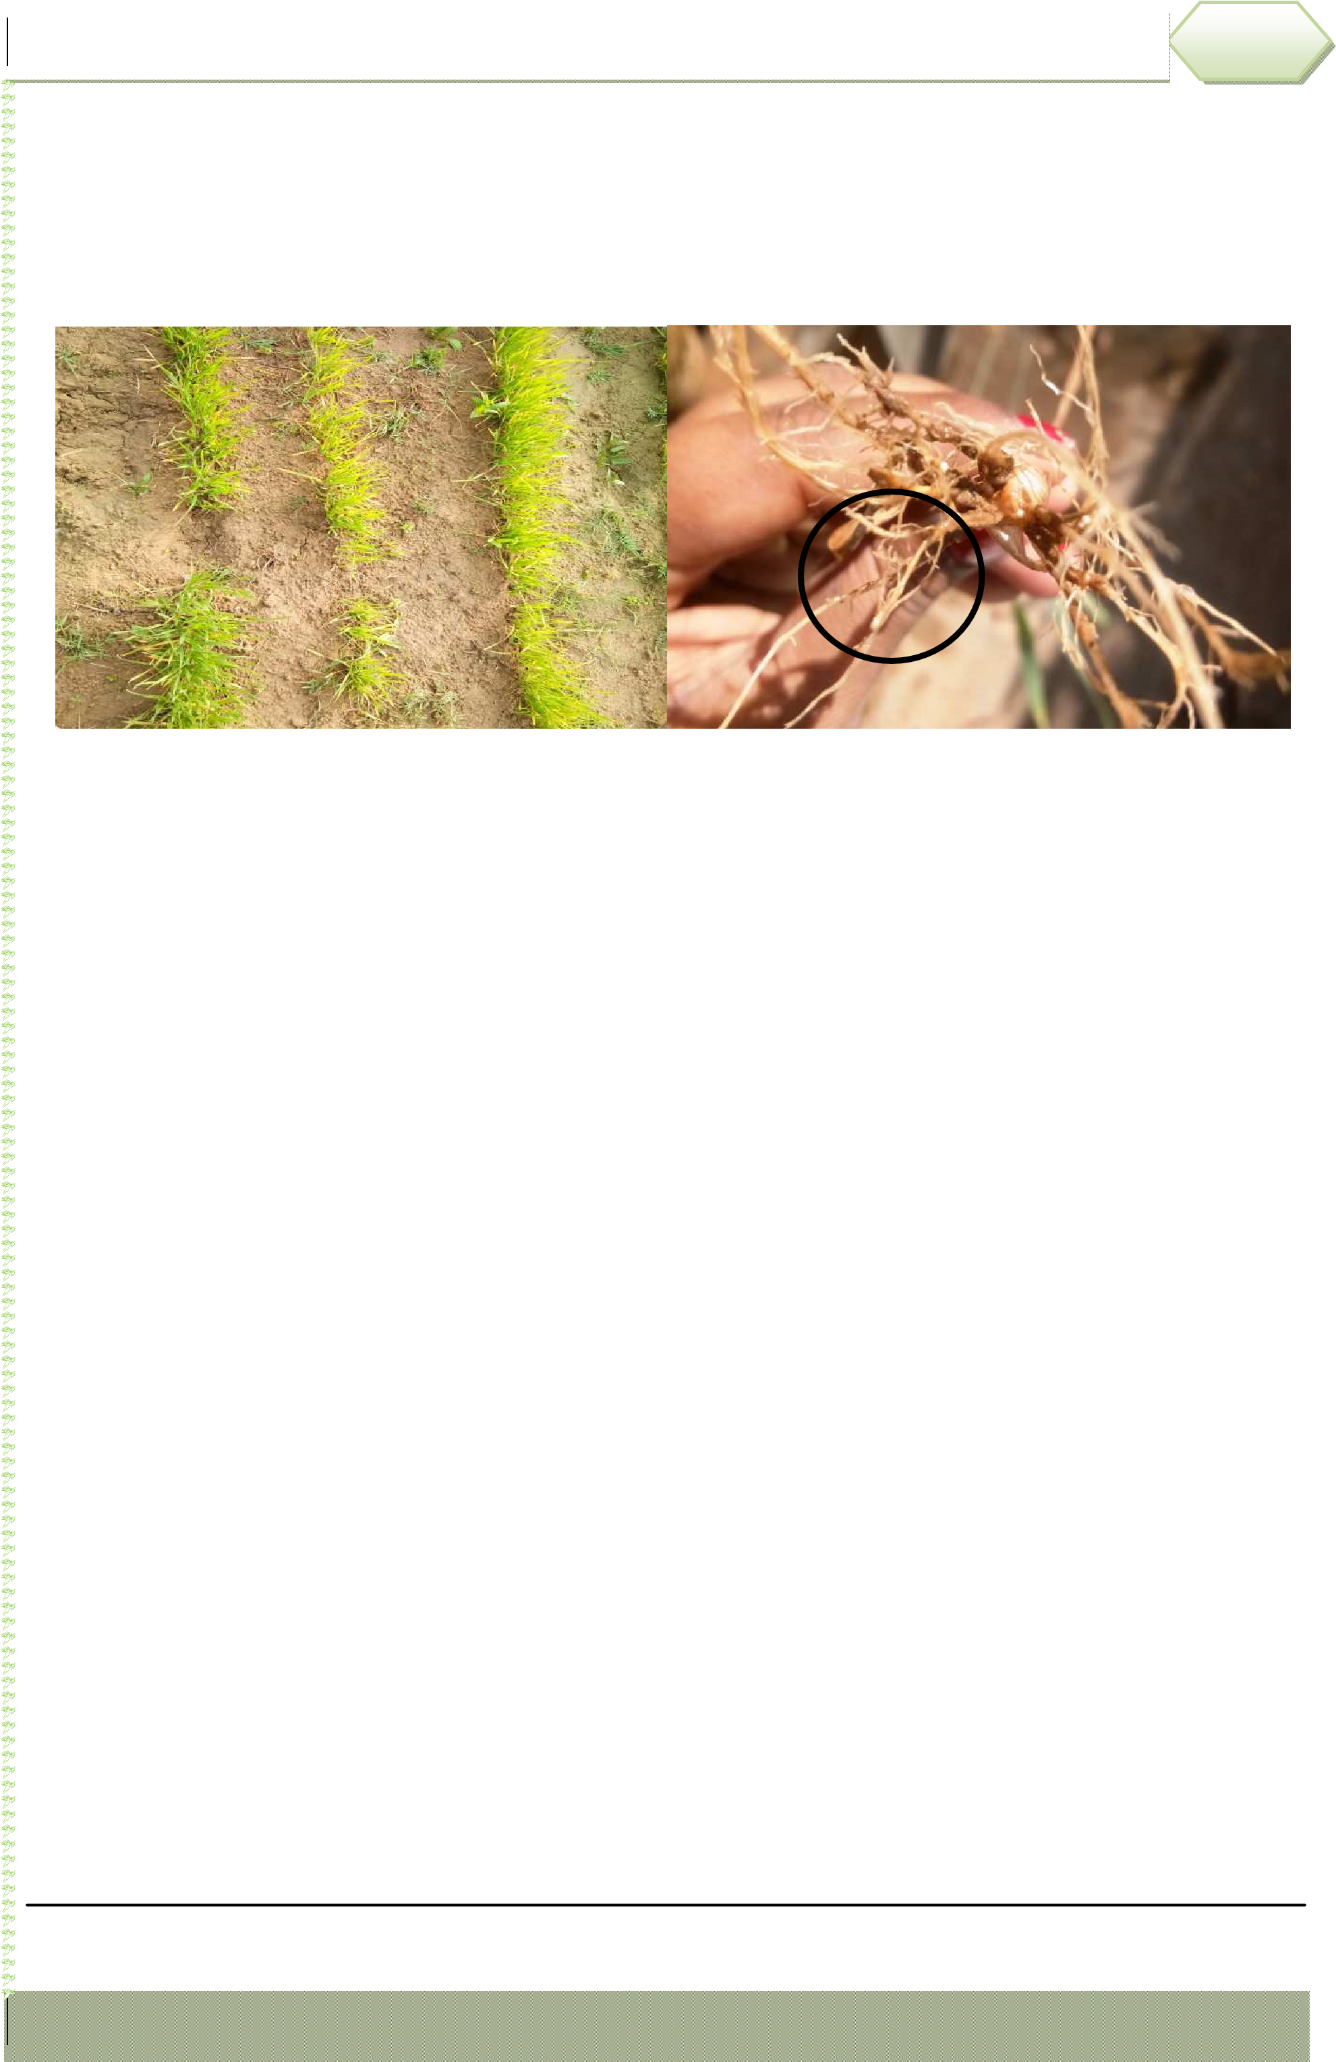can be seen on roots that is the confirmatory/diagnostic sign of this nematode. Upon maturity, the brown cyst and detach from the roots and remain as such in soil till next crop is grown, acting as the source of inoculum for next years as J2 hatch out upon sensing the host crop, specific temperature and moisture conditions.

**Fig 1**: Nematode infested yellowing symptoms in field **Fig 2**: Nematode symptoms on roots showing white female

### Management

There are no alternative methods to manage the nematode in standing crops. It is suggested to take care of various agronomic practices to manage the nematode population to avoid further yield losses.

### 1. Deep Summer Ploughing

During the onset of summer, the infested field is ploughed at 10-15 days interval during MayJune. This method is very effective to kill the nematodes due to desiccation in hot weather when is combined with soil solarization using polythene sheets.

### 2. Crop Rotation

The most easiest way to manage the nematodes include the crop rotation practices since cereal cyst nematode is very host specific so susceptible crops should be grown once in few years and rotating them with non-host crops like mustard, fenugreek, coriander, cumin and gram.

### 3. Adjusting the Time of Planting

The crops may be planted up to 15th November when soil temperature is low and at that time the nematodes are not active. The early planted wheat crop can escapes nematode damage since the crop is sufficiently healthy to tolerate the nematode attack.

### 4. Use of Resistant Varieties

Raj MR-1 is the resistant variety of wheat against this nematode which can be grown in Molya infested fields. BH 75 and BH 393 of barley can be grown in case of that area where wheat cultivation is not possible due to heavy damage.

### 5. Seed Treatment

The wheat seed can be treated with Azotika (*Azotobacter chroococcum*) HT-54 @ 50 ml per 10 kg seeds.

### 6. Integrated Nematode Management

Since under Indian conditions, field is fallow during May/June, 2-3 deep summer ploughings can be done easily in combination with growing a non-host crop or resistant variety for one season.

## 

Contact: <https://salamtabish.blogspot.com/>

[sumitabish@gmail.com](mailto:sumitabish@gmail.com)

<https://5eb11d81da2f9.site123.me/>