Língua estrangeira moderna – Inglês 6 ano A

Tuesday, 30, June, 2020

HELLO MY STUDENTES I AM TEACHER, ROBISON

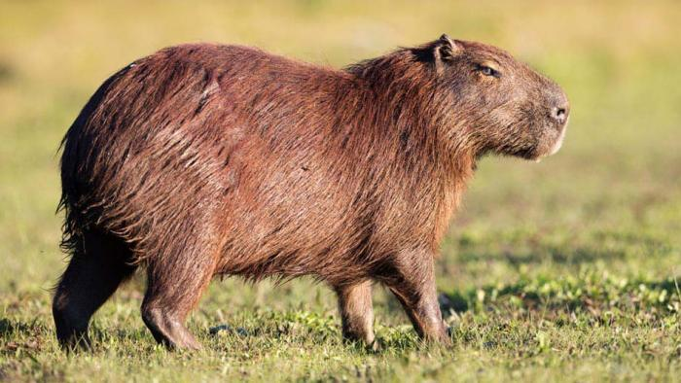**ACTIVITY EXAMPLE**:

**COMMOM NAME:** CAPIVARA

**SCIENTIFIC NAME:** HYDROCHOERUS

**CLASS:** HERBÍVORO

**DIET:** CAPIM, ERVAS

**SIZE:** 50-60 CM

**WEIGHT:** 35-66 KG

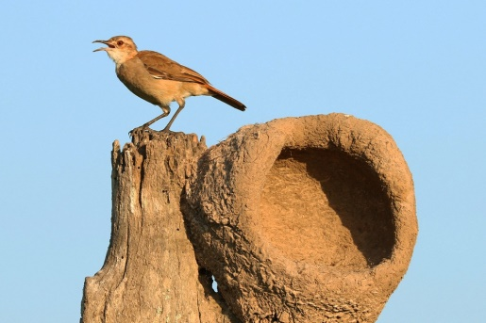

**COMMOM NAME:**

**SCIENTIFIC NAME:**

**CLASS:**

**DIET:**

**SIZE:**

**WEIGHT:**

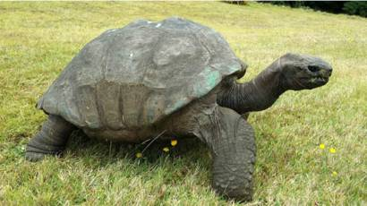 **COMMOM NAME:**

**SCIENTIFIC NAME:**

**CLASS:**

**DIET:**

**SIZE:**

**WEIGHT:**