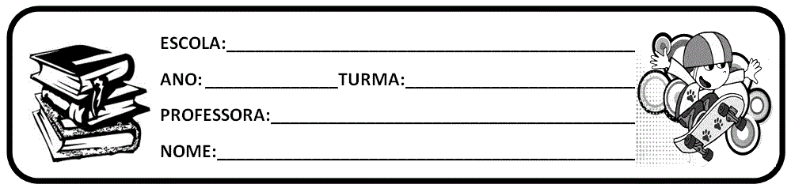

ACTIVITY 2

a) Look at the slides below and complete the sentences with information about:

|  |  |
| --- | --- |
| What scientists do.    Scientists try to learn how the world works; Scientists make observations and look for interesting patterns;  Scientists use experiments to try to answer questions and solve problems;  Scientists learn things through research. | Scientists |
| There are many types of scientists who study everything from:  Medicine/doctor; Rocks;  Weather;  Planets and stars; Animals;  Plants;  And much more! | There are scientists who study |

|  |  |
| --- | --- |
| Have you ever wondered...    How many animals there are in different places? Why animals live in different places?  How animals work and live together? | Scientists ask questions like |
| Ecologists are scientists who try to answer these questions! | Ecologists are |
| What is ecology?  Ecology is the study of the relationship between organisms and their environment. | Ecology is |

|  |  |
| --- | --- |
| Ecologists work all over the world in many types of habitats.  Who are ecologists?   * Ecologists are curious about the world around them and work hard to learn new things. * Do you ever ask questions about living things? Well, you are an ecologist! * Ecologists are real people, just like you and me! | Ecologists are |
| Instituto Oceanográfico, São Paulo, Brasil.   * Many scientists are interested in studying the ocean. * There are many labs in São Paulo, where scientists work hard. * Scientists diving and snorkeling to learn about the plants and animals that live on the coral reef. | In São Paulo’s Instituto Oceanográfico you can find |
| Working as a scientist: Observations.   * To ask good questions and learn about coral reefs, ecologists observe animals in the wild; * When scientists make observations, they watch plants and animals to see how they interact. | Scientists |

|  |  |
| --- | --- |
| Working in a Lab:   * After making observations, scientists can bring animals back to the lab to study them; * They can make more observations and study animals more closely in a controlled environment. | After observing, scientists |
| Working in a Lab: Experiments.     * Scientists design experiments to answer their questions about different plants and animals; * They test these ideas to see if they can explain the patterns they observed. | Scientists design experiments to |

|  |  |
| --- | --- |
| Working in the water.   * Scientists use scientific tools; * They can use special cameras under water; * They can dig with hand-made tools to see what is in the sand; * Scientists measure animals and distances. | Scientists use tools like |
| Scientists may wear special clothes. | Scientists wear |
|  | Can scientists have fun? |

Images from: **pixabay.com**

* OBSERVAÇÕES: PODEM COPIAR OU IMPRIMIR E DEIXAR NO CADERNO DE SALA, NÃO SE ESQUEÇAM DE FAZER O CABEÇALHO.
* ESSAS ATIVIDADES SÃO BASEADAS NA AULA ONLINE DO CMSP.
* GOOD STUDIES!
* BYE! BYE!