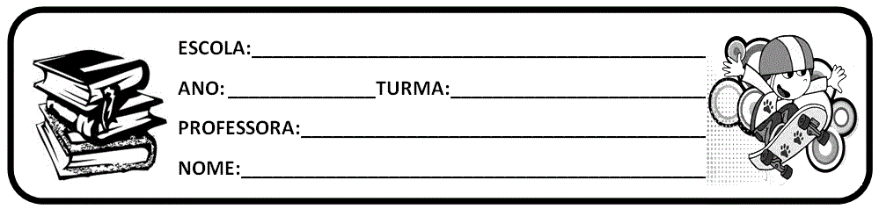

## ACTIVITY 1

a) Look at the following mind map with sources of water. Relate them to the images on the previous activity and complete it.



**River**

**Water**

## ACTIVITY 2

a) Complete the definitions of different types of water and sources with the words in the box.

**river - lake - oceans - aquifers - ground water - salt water - fresh water - river**

1. A is a watercourse, usually fresh water, that flows by gravity toward an ocean, a lake, a sea, or another .
2. are large amounts of salt water that covers almost three quarters of the Earth’s surface, is divided by continents and large archipelagos.
3. A is a natural depression on Earth’s surface that permanently contains a variable amount of water.
4. In geology is considered all that water that occupies all the empty spaces of a geological formation, the so-called . Ground water is formed by surplus rainwater.
5. around the world has a salinity close to 3,5%, which means that for every liter of seawater there are 35 grams of dissolved salts, most of which are sodium chloride. Seawater has no uniform salinity around the globe.
6. Water is an abundant renewable natural resource that occupies approximately 70% of our planet’s surface. However, 97% of this water is salty and therefore unfit for consumption. Less than 3% of the planet’s , of which 2.5% is trapped in glaciers. Of the remaining 0.5% of water in the world, most are trapped in ground water aquifers, making human access difficult.

# ORIENTAÇÕES: PODEM COPIAR OU IMPRIMIR. DEIXEM NO CADERNO DE SALA DE VOCÊS, NÃO SE ESQUEÇAM DE FAZER O CABEÇALHO. ESSAS ATIVIDADES SÃO BASEADAS NA AULA DP CMSP DO DIA DE HOJE 19/05/2020. SE PRECISAR VOLTAR LÁ NA AULA PRA REALIZAR ESSAS ATIVIDADES AQUI ESTÁ O LINK.

# <https://www.youtube.com/watch?v=RIooSxJduuI>

# GOOD STUDIES CLASS!

# BYE,BYE!