### C:\Users\Cliente\Desktop\Nova pasta\CABEÇALHO DE ATIVIDADES.GIF

### ACTIVITY 1

1. Listen to your teacher’s reading of the text below. Complete the gaps with the words from the box.

**name big family sisters brother**

**Jack:** Hey, Beth.

Do you have a big or small ?

**Beth:** I have a big family.

**Jack:** How many brothers and do you have?

**Beth:** I have one brother and two sisters.

And you, how many brothers and sisters do you have?

**Jack:** I don’t have sisters. I have one , one dog and two cats.

I have a family too.

**Beth:** Oh, I have pets too!

I have a bird. Her is Tina.

### ACTIVITY 2

1. Observe the way someone represents his/her family:

Tina

Cat

Cecília

Jéssica

Sister

Roberto

Father

Marta

Mother

Arnaldo

Fátima

Gregório

Rosa

Me

Grandmother

Grandfather

Grandmother

Grandfather

1. Is this way of showing our family different from the one in the previous exercise? Why?
2. What kind of information do you find in this family tree?
3. How many brothers/sisters does Cecília have?
4. Which pets does Cecília have?

### ACTIVITY 3

1. Read the following text.



Image from: **https://pixabay.com/pt/**

I am **Pedro**.

I want to introduce my family to you.

**Carlos** is my **father**. **Catarina** is my **mother**.

**Carlos** and **Catarina** are my parents.

**Sara** is my **sister** and **Bruno** is my **little brother**. My family is very happy.

1. In your notebook, write a text about your family. You can follow Pedro´s example.
2. Now, introduce your family to your friends using your notes.

### ACTIVITY 4

a) Match the name of each animal to its picture.

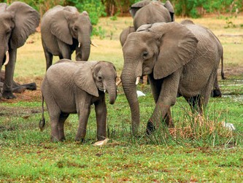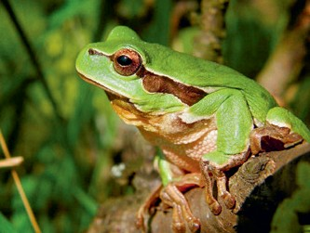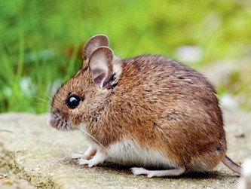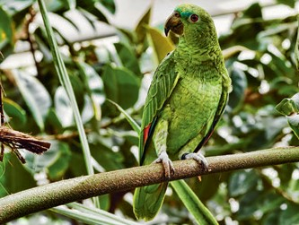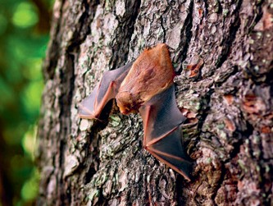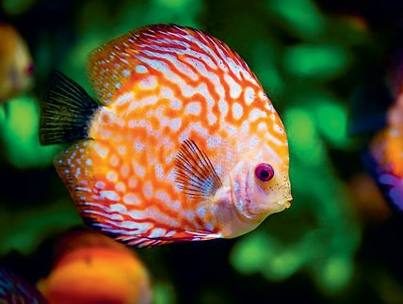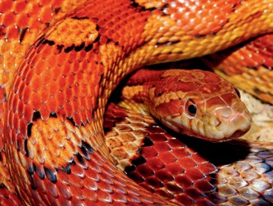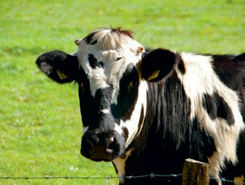

BAT COW

ELEPHANT

BEAR

SNAKE

FISH

LION

PARROT

MOUSE FROG

Images from: **https://pixabay.com/pt/**

### ACTIVITY 5

1. In pairs, write simple sentences, by following the model: (Write 10 examples).

Example:

Parrots fly. Fish swim.

1. Student A writes the first 5 sentences.
2. Student B writes the second 5 sentences.
3. Then cut the words and add them to a bag.
4. Finally, sort and recreate the sentences with the correct matche

ORIENTAÇÃO: PODEM COPIAR NO CADERNO OU IMPRIMIR FICA A CRITÉRIO DE VOCÊS. O IMPORTANTE É REALIZAR AS ATIVIDADES.

ESSAS ATIVIDADES SÃO COMPLEMENTAÇÕES DAS AULAS DO CMSP. É PRECISO USAR O DICIONÁRIO, INTERNET OU OUTRO MEIO PARA CONFERIR AS PALAVRAS EM INGLÊS PARA RESPONDER AS ATIVIDADES.

NÃO DEIXE DE FAZER O CABEÇALHO. OK!