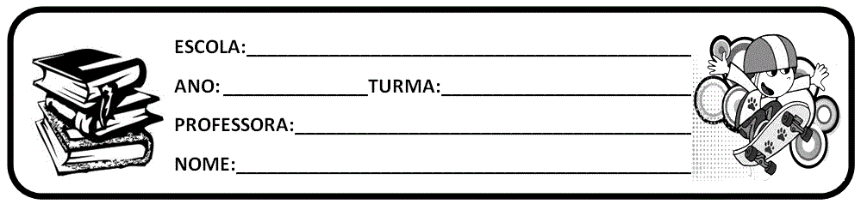

1. ATIVIDADE SOBRE O LIVRO APRESENTADO NA AULA DO CMSP DO DIA 05/05/2020.
2. BASEANDO NO RESUMO FEITO NA AULA A RESPEITO DO LIVRO, ESCREVA NAS LINHAS ABAIXO O QUE VOCÊ ENTENDEU DA HISTÓRIA.

­­­­­­­­­­­­­________________________________________________________________________________________________________________________________________________________________________________________________________________________________________________________________________________________________________________________________________________________________________________________________________________________________________________________________________________________________________________________________________________________________________________________________________________________________________________________________

1. RELEMBRANDO O QUE ESTUDAMOS EM SALA DE AULA RESPONDA:
2. QUAL NOME DO LIVRO DA HISTÓRIA ACIMA MENCIONADO¿
3. QUAIS PERSONAGENS CITADOS ¿
4. ONDE ACONTECEU A HISTÓRIA¿
5. ­ ENTENDEU.RERSUMO FEITO PELA PROFESSORA NA AULA A RESPEITO DO LIVRO, ESCREVA NAS LINHAS ABAIXO O QUE VOCTEVE PERSONAGEM PRINCIPAL¿ QUAL¿
6. QUEM É O AUTOR DO LIVRO¿
7. QUAL FOCO NARRATIVO APRESENTADO NA HISTÓRIA¿ EXPLIQUE.
8. QUAL DISCURSO DA HISTÓRIA¿ EXPLIQUE.
9. AGORA CHEGOU SUA VEZ DE SER O ESCRITOR DESSA NARRATIVA, QUAL FINAL DARIA PARA ESSA HISTÓRIA. ESCREVA NAS LINHAS ABAIXO.

___________________________________________________________________________________________________________________________________________________________________________________________________________________________________________________________________________________________________________________________________________________________________________________________________________________________________________________________________________________________________________________________________________________________________________________________________________________________________________________________________________________________________________________________________________________________________________________________________________________________________________________________________________________________________________________________________________________________________________________________________________________________________________________________________________________________________________________________________________________________________________________________________________________________________________________________________________________________________________________________________________________________________________________________________________________________________________________________________________________________________________________________________________________________________________________________________________________________________________________________________________________________________________________________________________________________________________________________________________________________________________________________________________________________________________________________________________________________________________________________________________________________________________________________________________________________________________________________________________________________________________________________________________________________________________________________________________________________________________________________________________________________________________________________________________________________________________________________________________________________________________________________________________________________________________________