Complejo Educativo Distrito Italia

Tercera guía de Trabajo de Inglés de 4th Grade Profe. Manuel Méndez

(Suspensión de Clases)

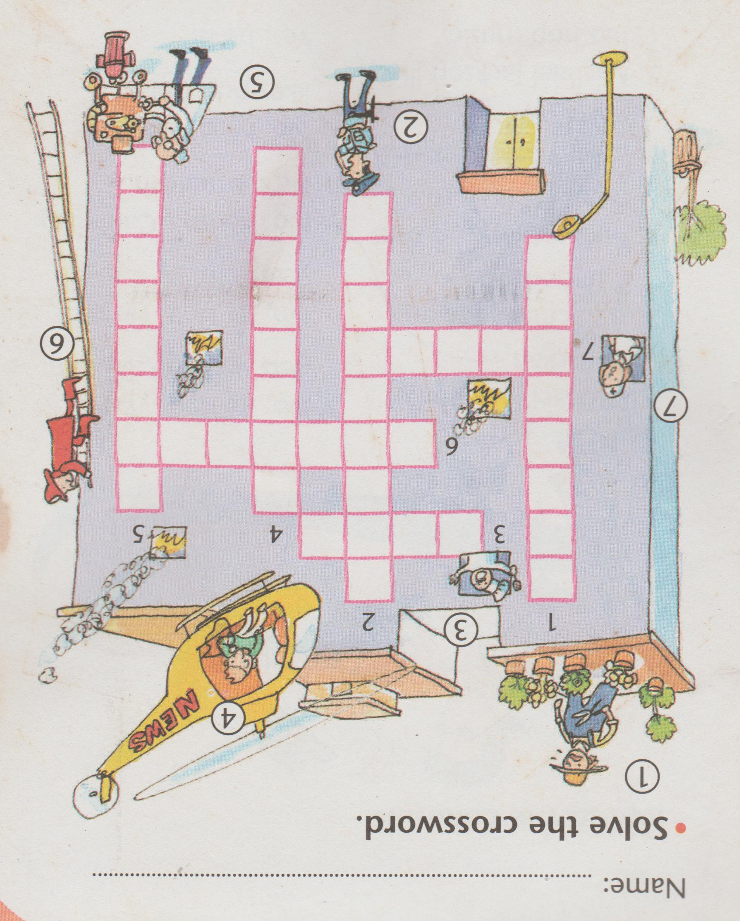Page 1. There are seven professions that you have to write to complete the crossword.

Page 2.Read the statements and match them to their answers.

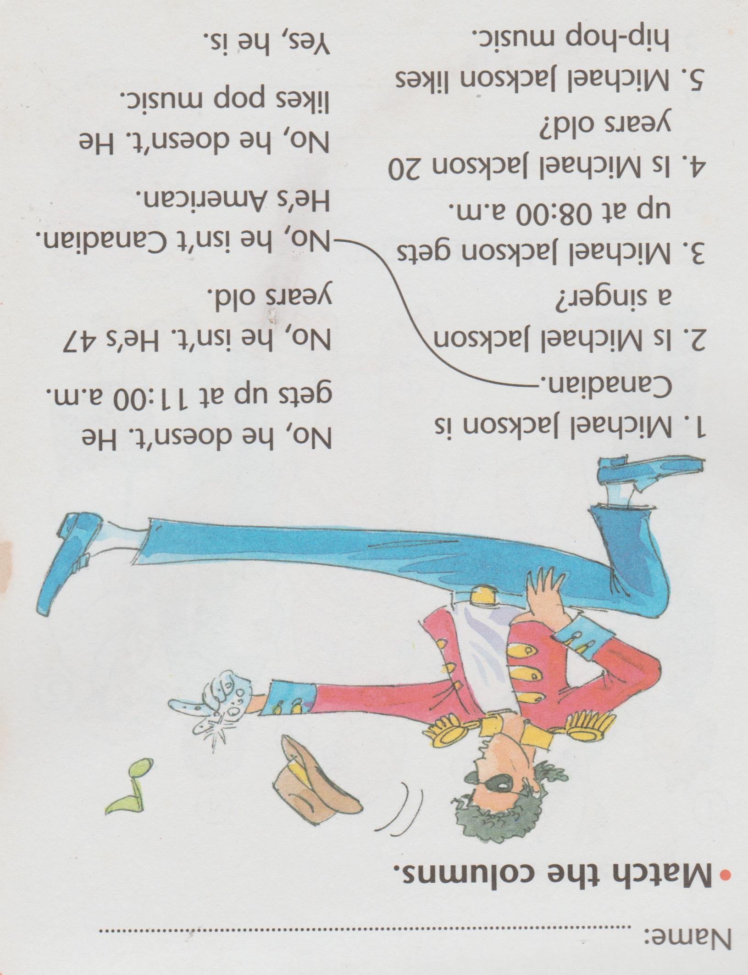

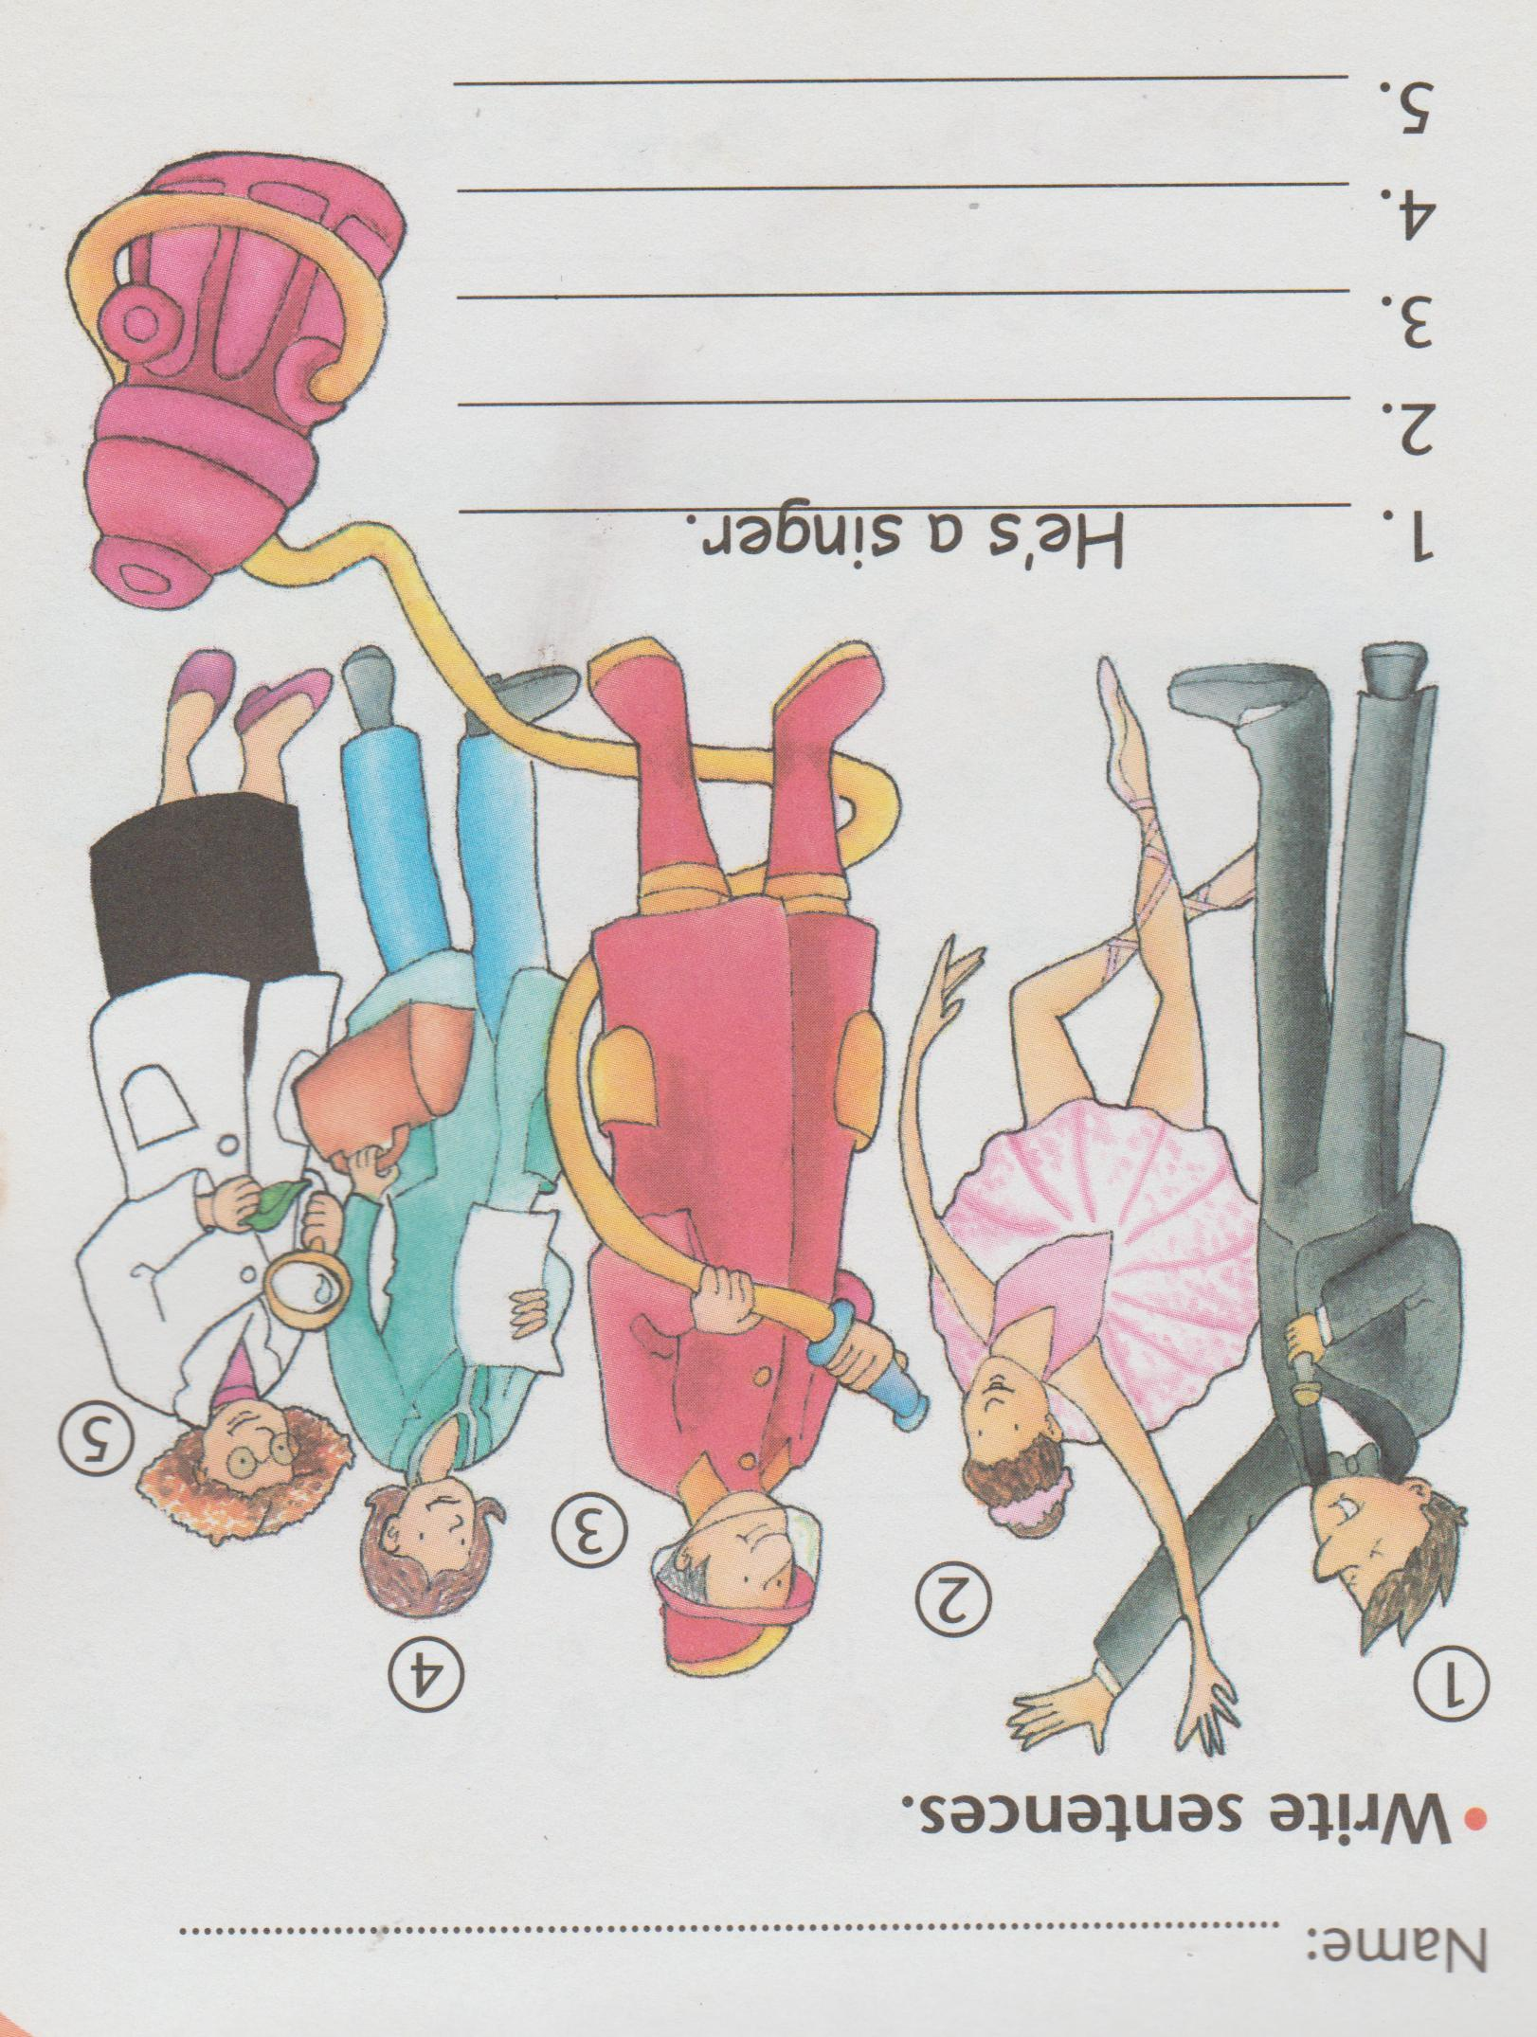Page 3. Write the professions, use personal pronouns and verbs to complete the sentences.

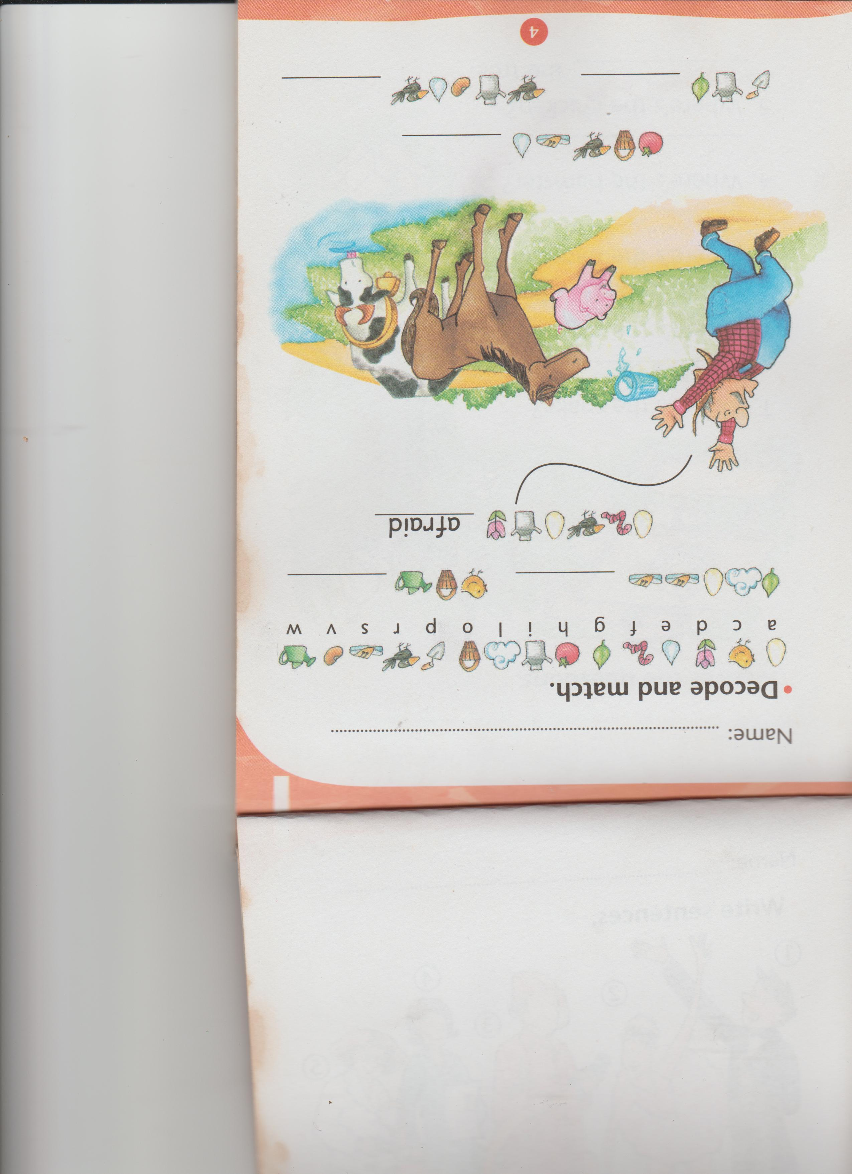Page 4.Write the words on the blank spaces deciphering the code.