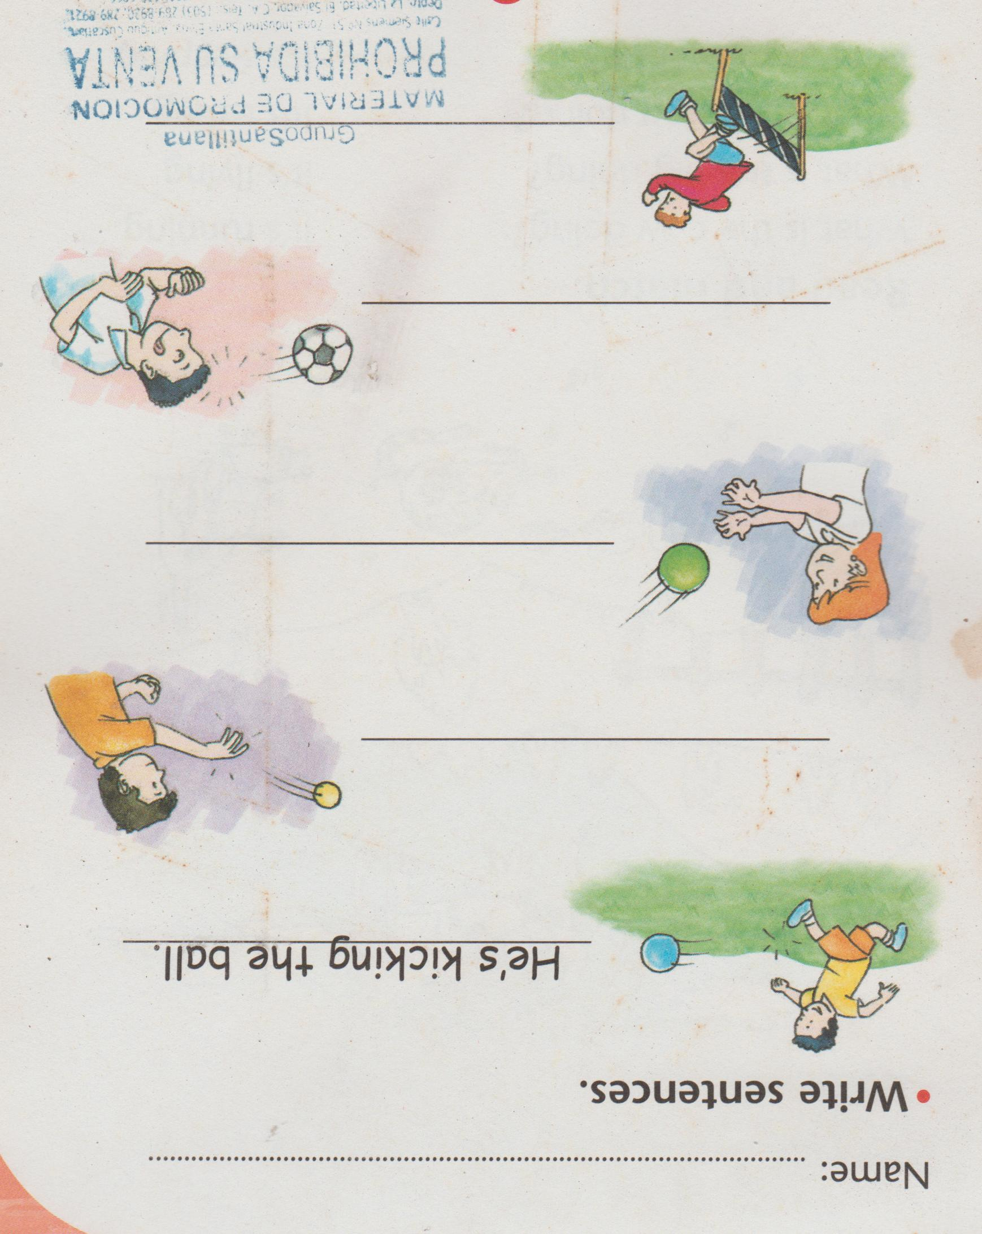Complejo Educativo Distrito Italia

Cuarta guía de Trabajo de Inglés de 3rd Grade Profe. Manuel Méndez

(Suspensión de Clases)

Page 1. Look at the actions and write the sentences. Use pronouns, verbs and the actions.

Page 2. Look what the animals are doing, read the questions and join them with their actions, then color the picture 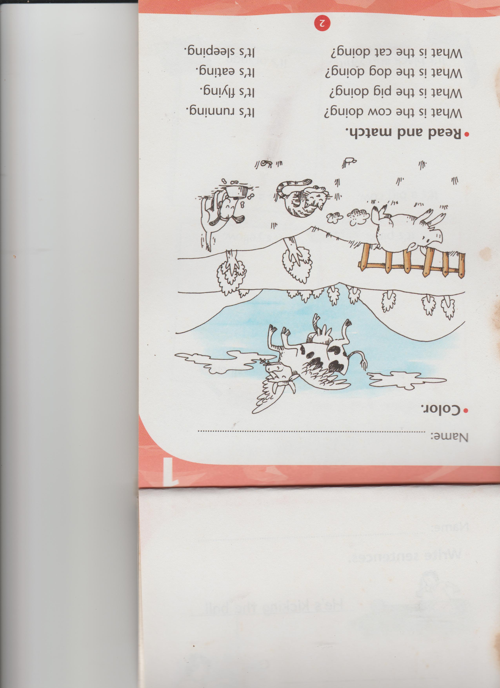

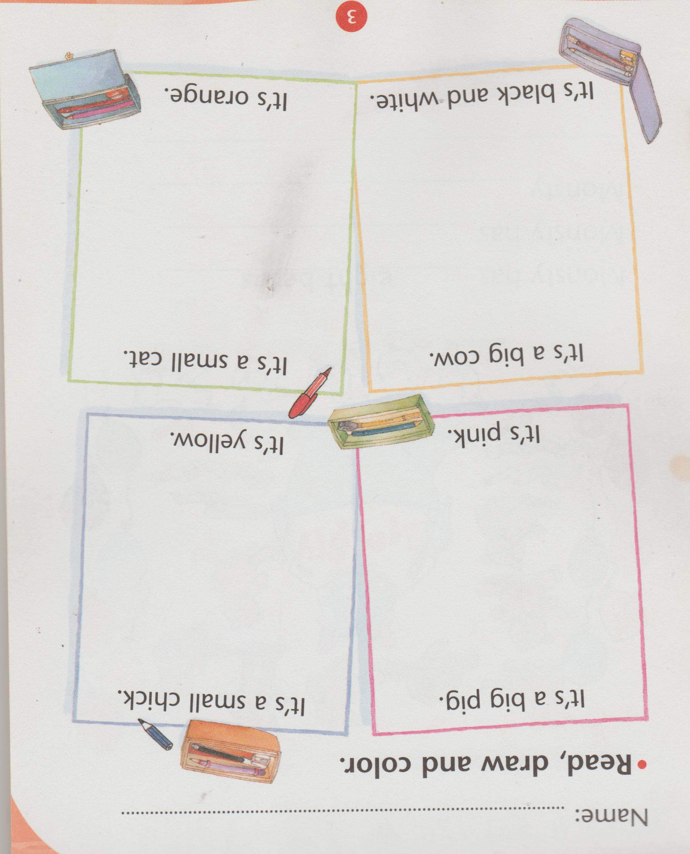Page 3. Read the sentences inside the frames and draw what it says.

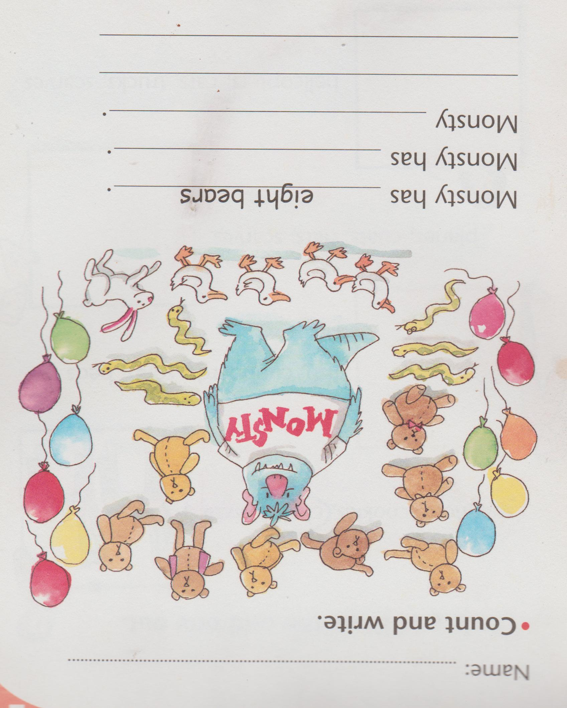Page 4. Look, count and write on the blank spaces the number of toys Monsty has.