Complejo Educativo Distrito Italia

Cuarta guía de Trabajo de Inglés de 2nd Grade Profe. Manuel Méndez

(Suspensión de Clases)

Page 1. Complete the greeting, the name of the colors and color the figures.

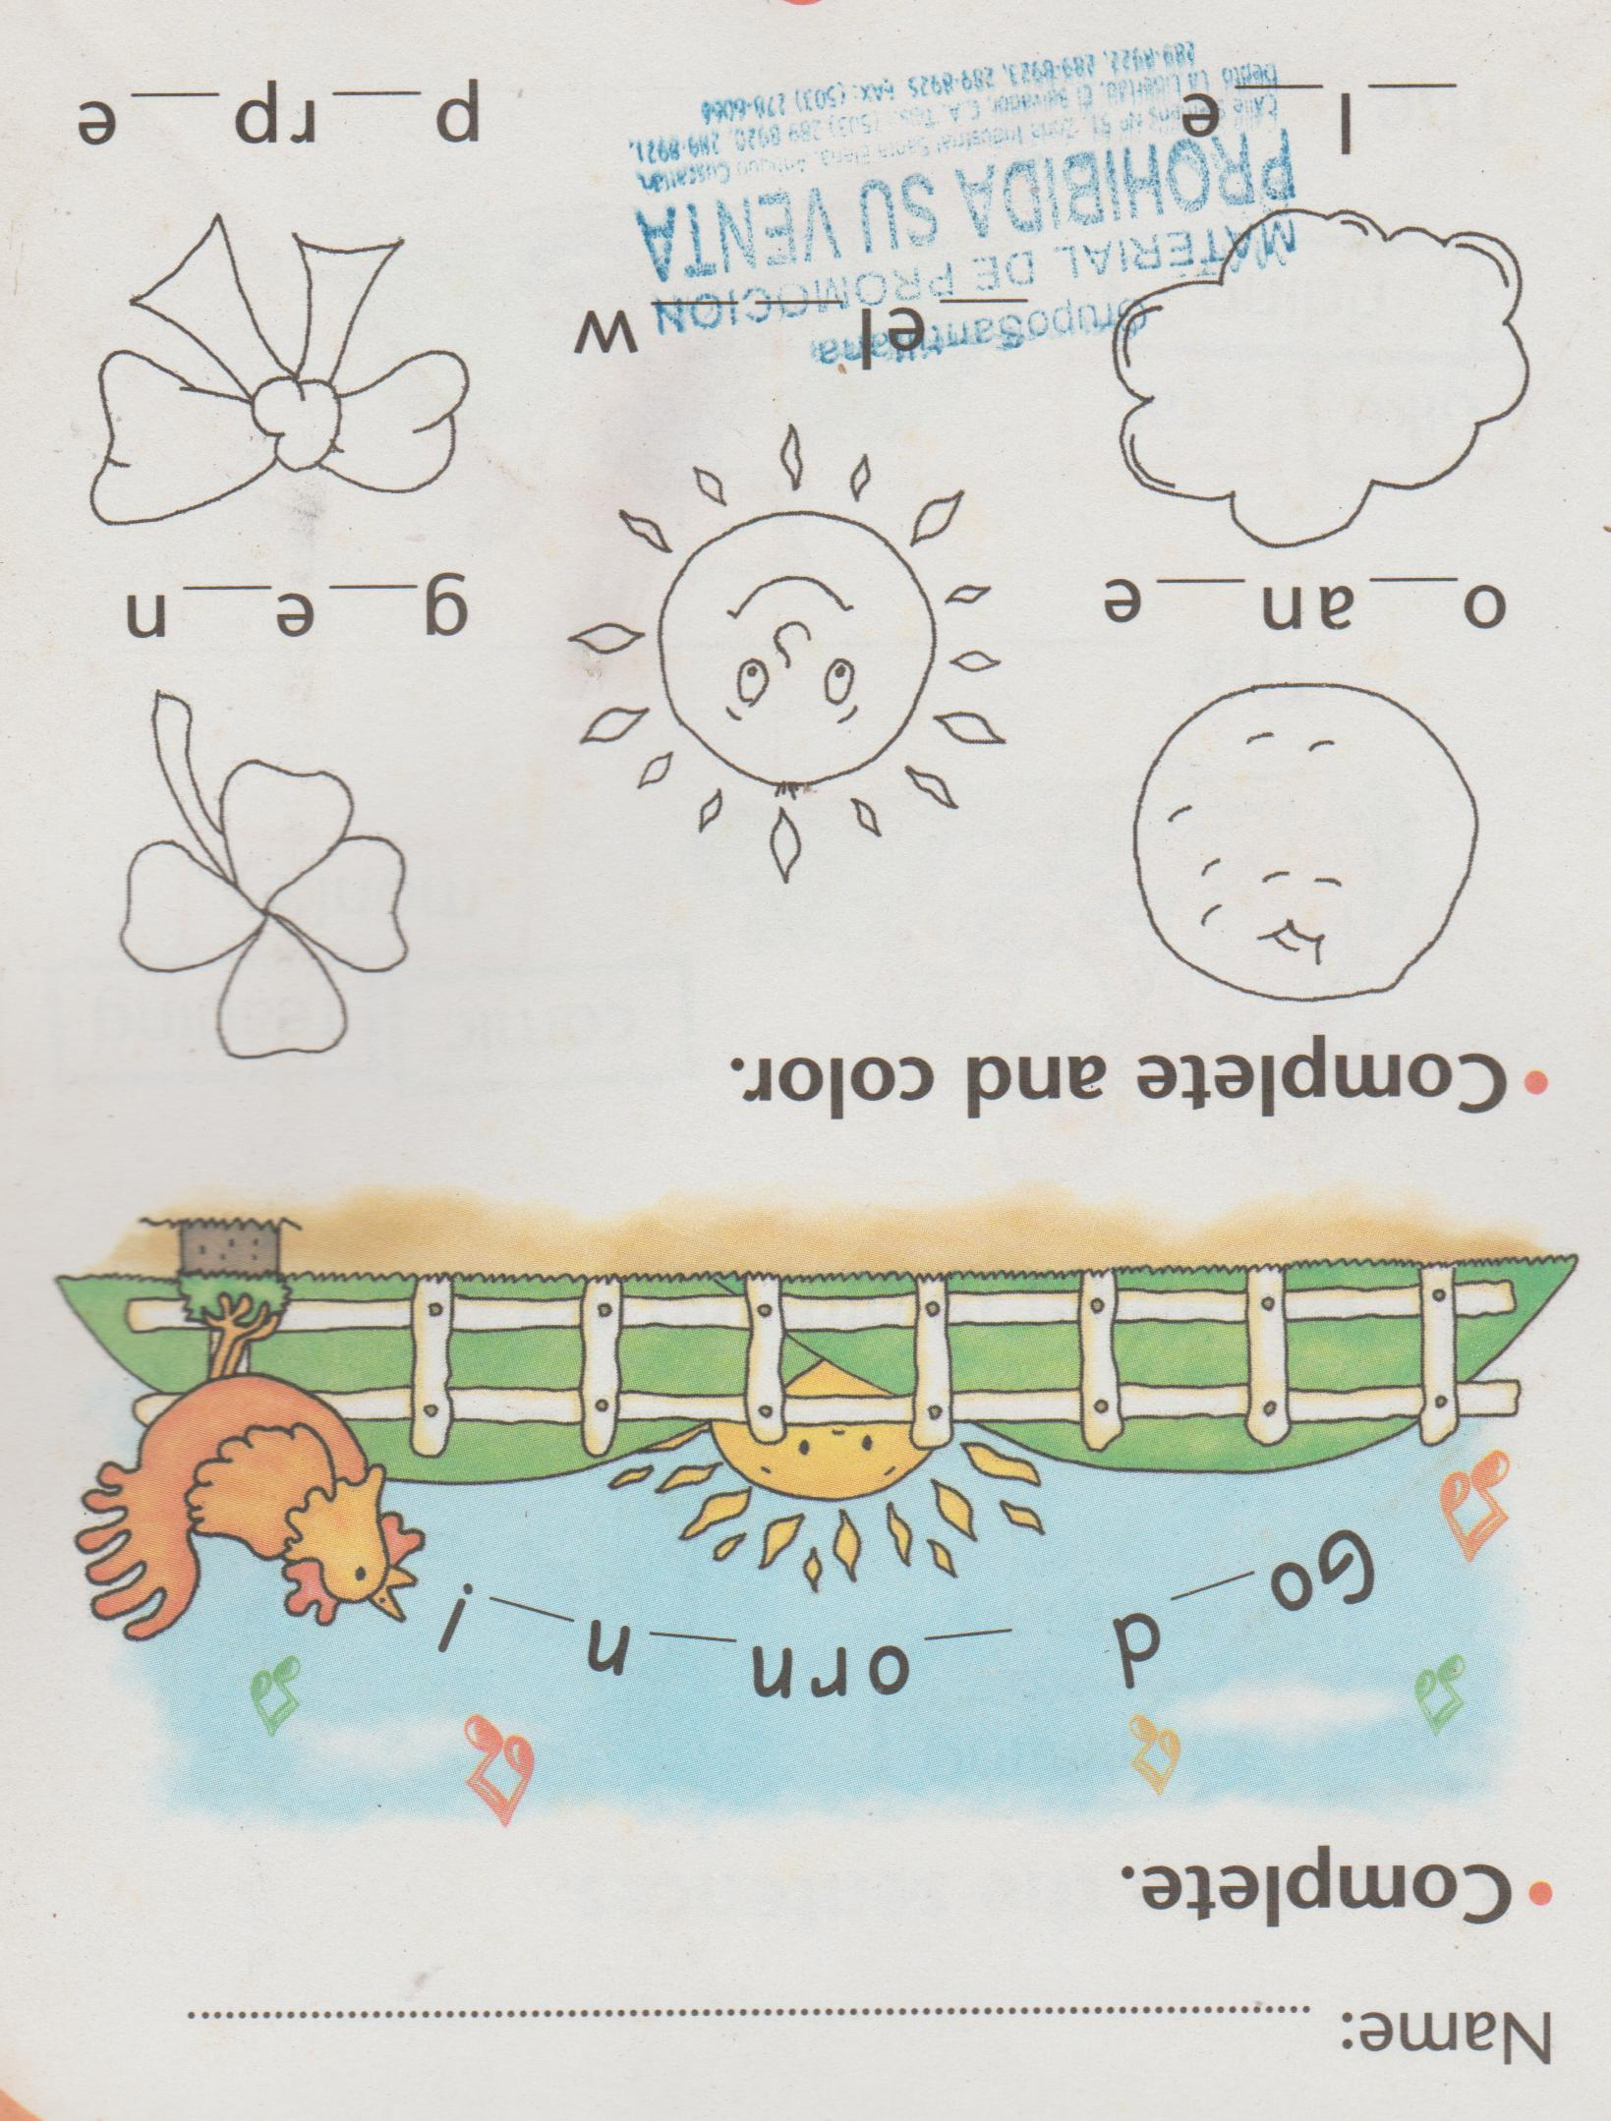

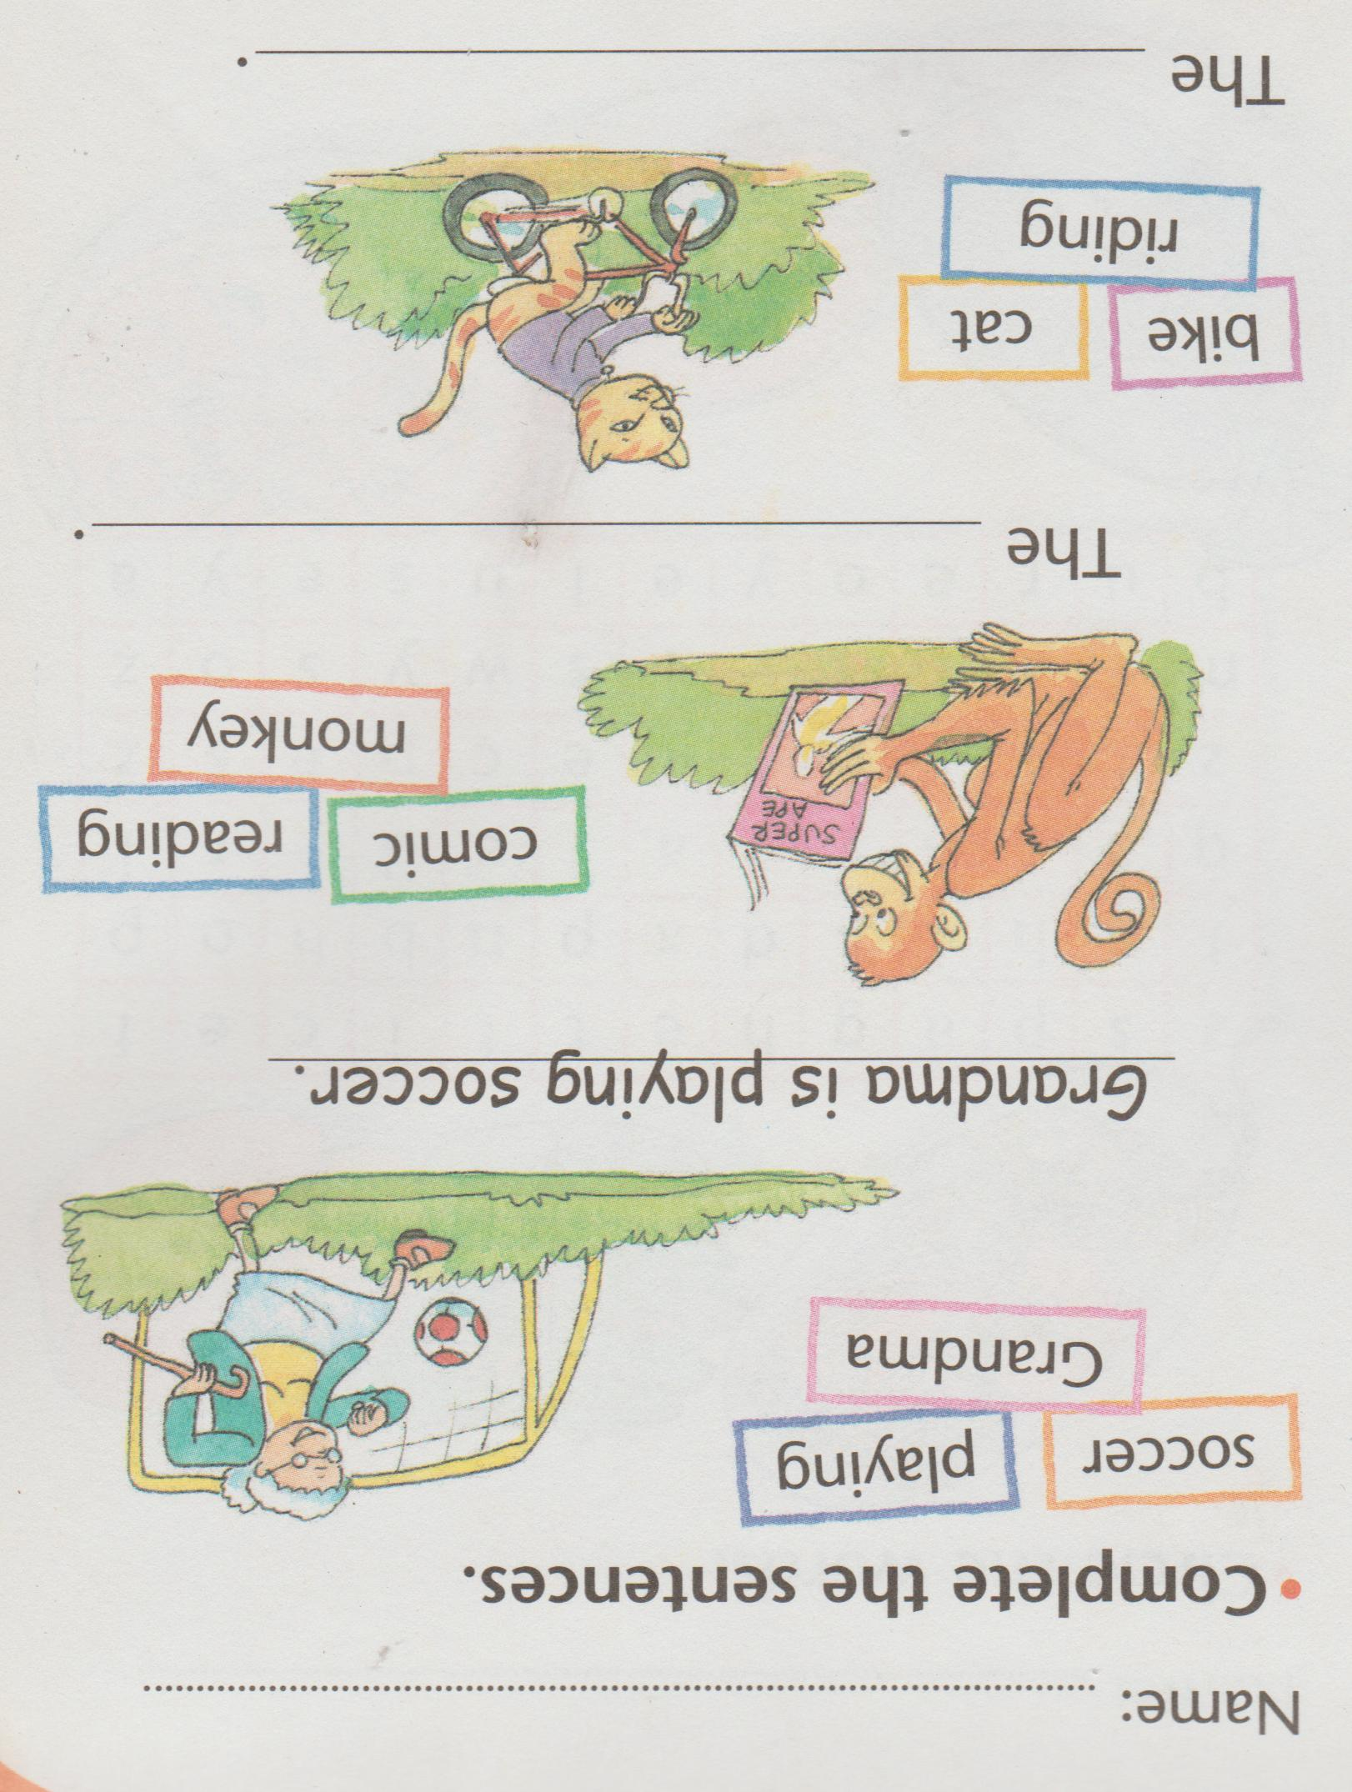Page 2. Use the words and the verb “to be” to complete the sentences. Follow the example.

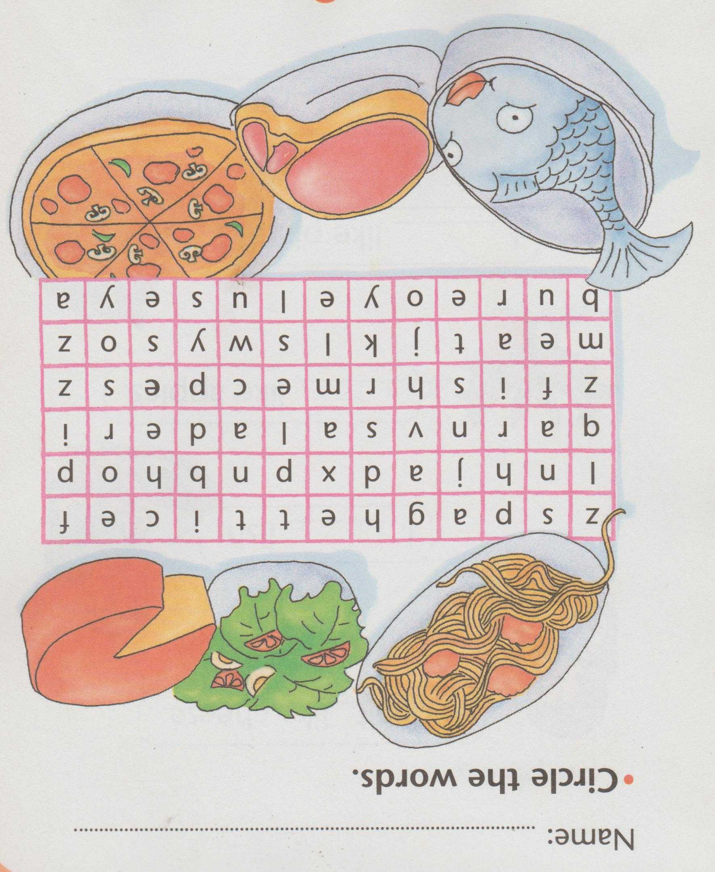Page 3. Find the names of the food and circle.

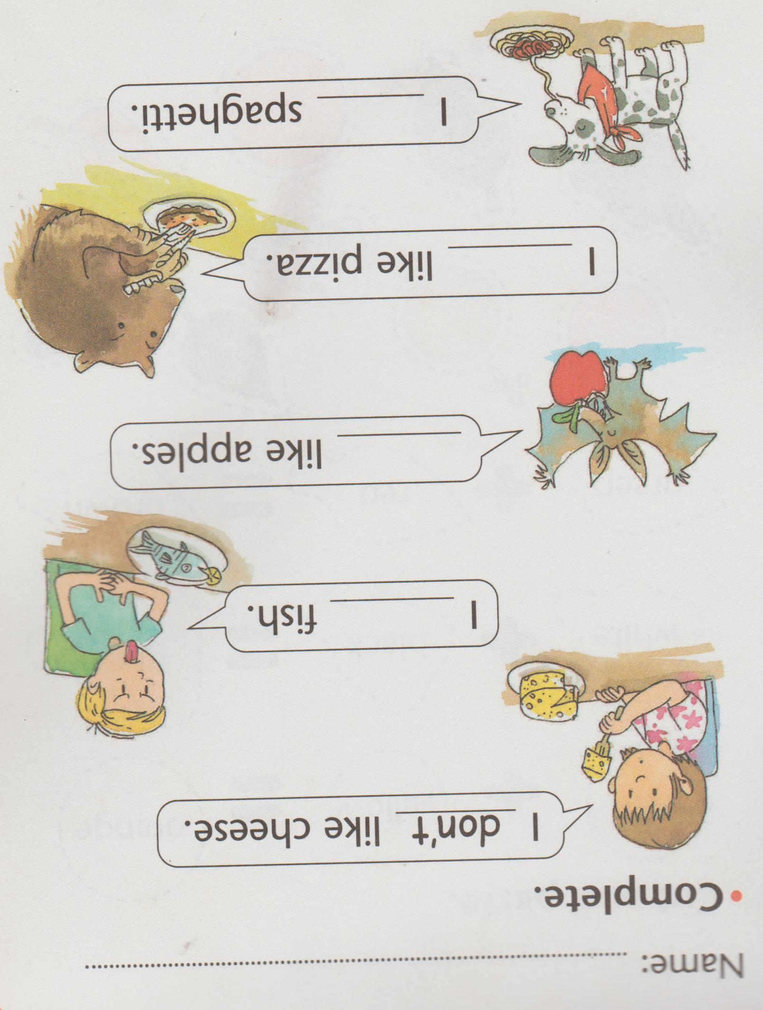Page 4. Look at the expressions and write “like” or “don´t like” as you see to complete the sentences.