Distrito Italia Complex

Class Suspension. Acivity 3. Teacher Manuel. Grade: 2nd. Section: A – B - C - D

Indication: 1- Copy three times the names of the members of the family.

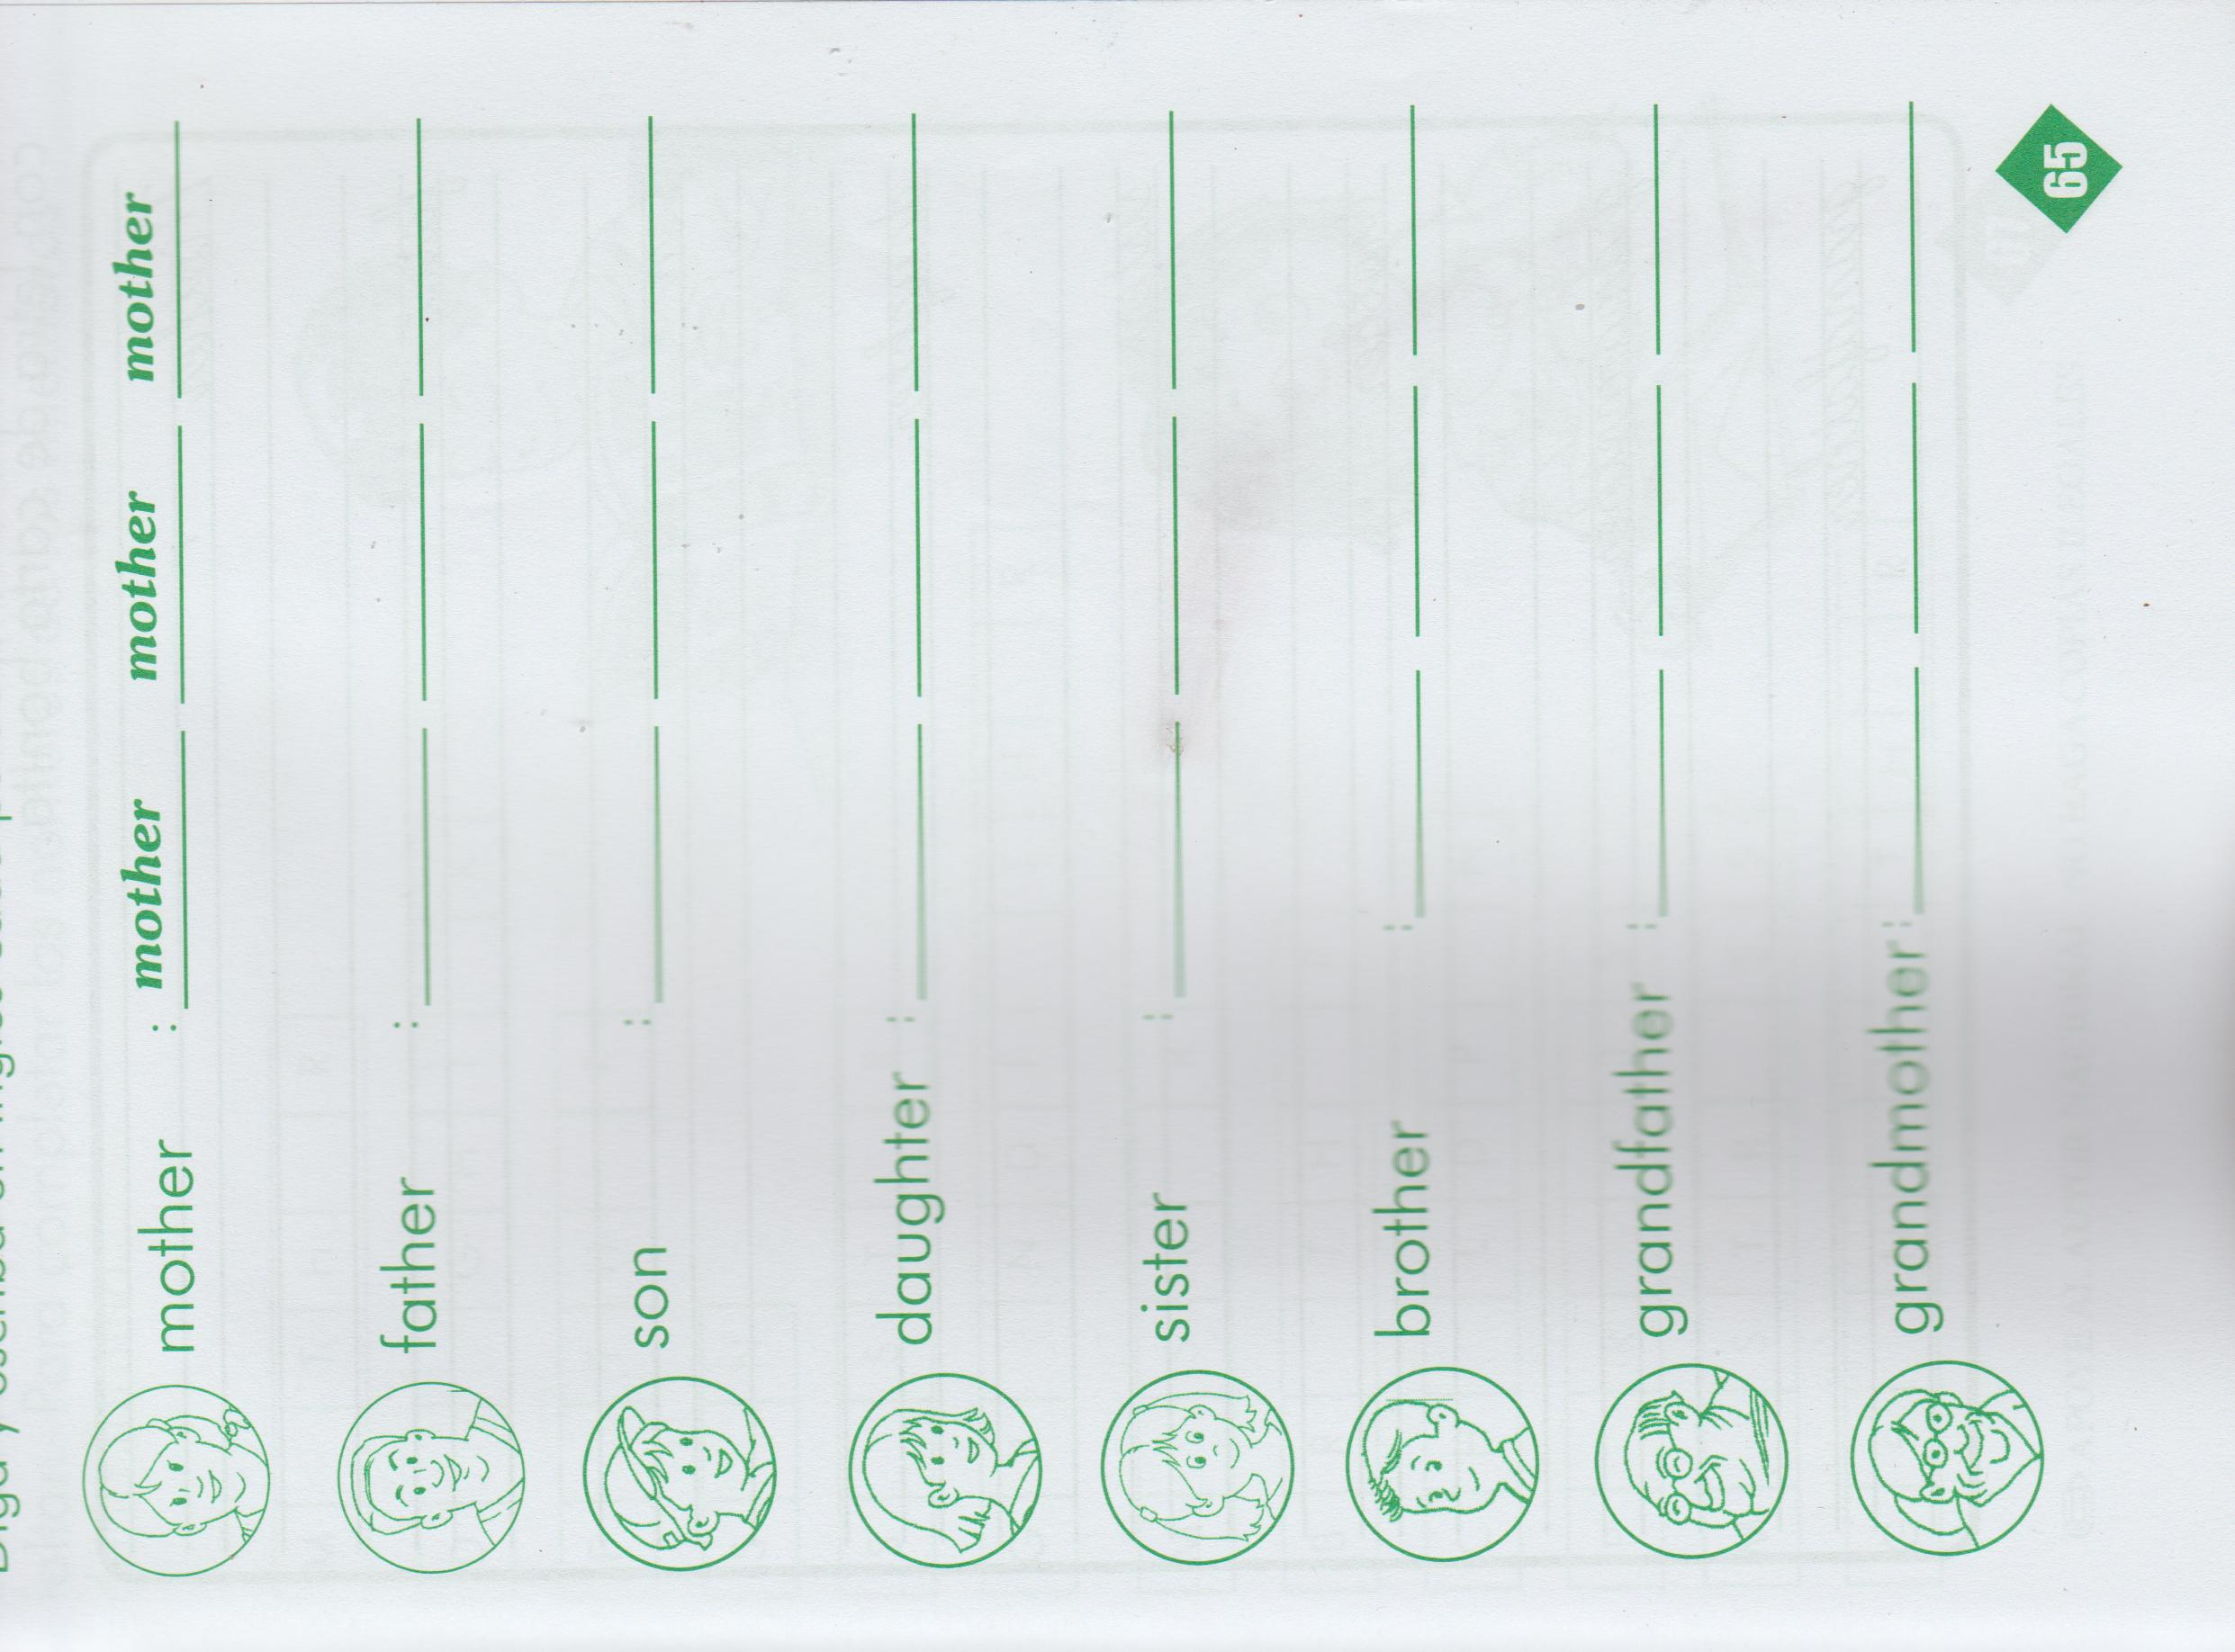 2-Add one more line and write the meaning of each word in Spanish.

3-Copy the lesson on your notebook

.

