Distrito Italia Complex

Class Suspension. Acivity 3. Teacher Manuel. Grade: 1st. Section: A – B - C .

Indication: 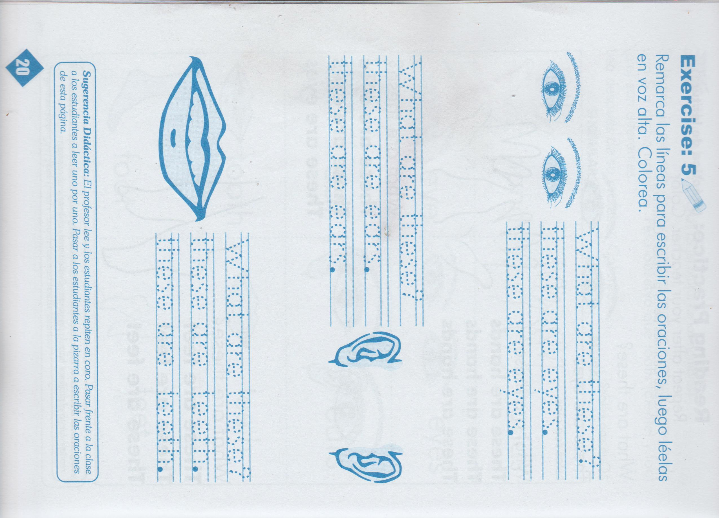1-Join the dots and complete the sentences

2-Color the parts of the body 3-Copy this lesson on your notebook.

.

