Distrito Italia Complex

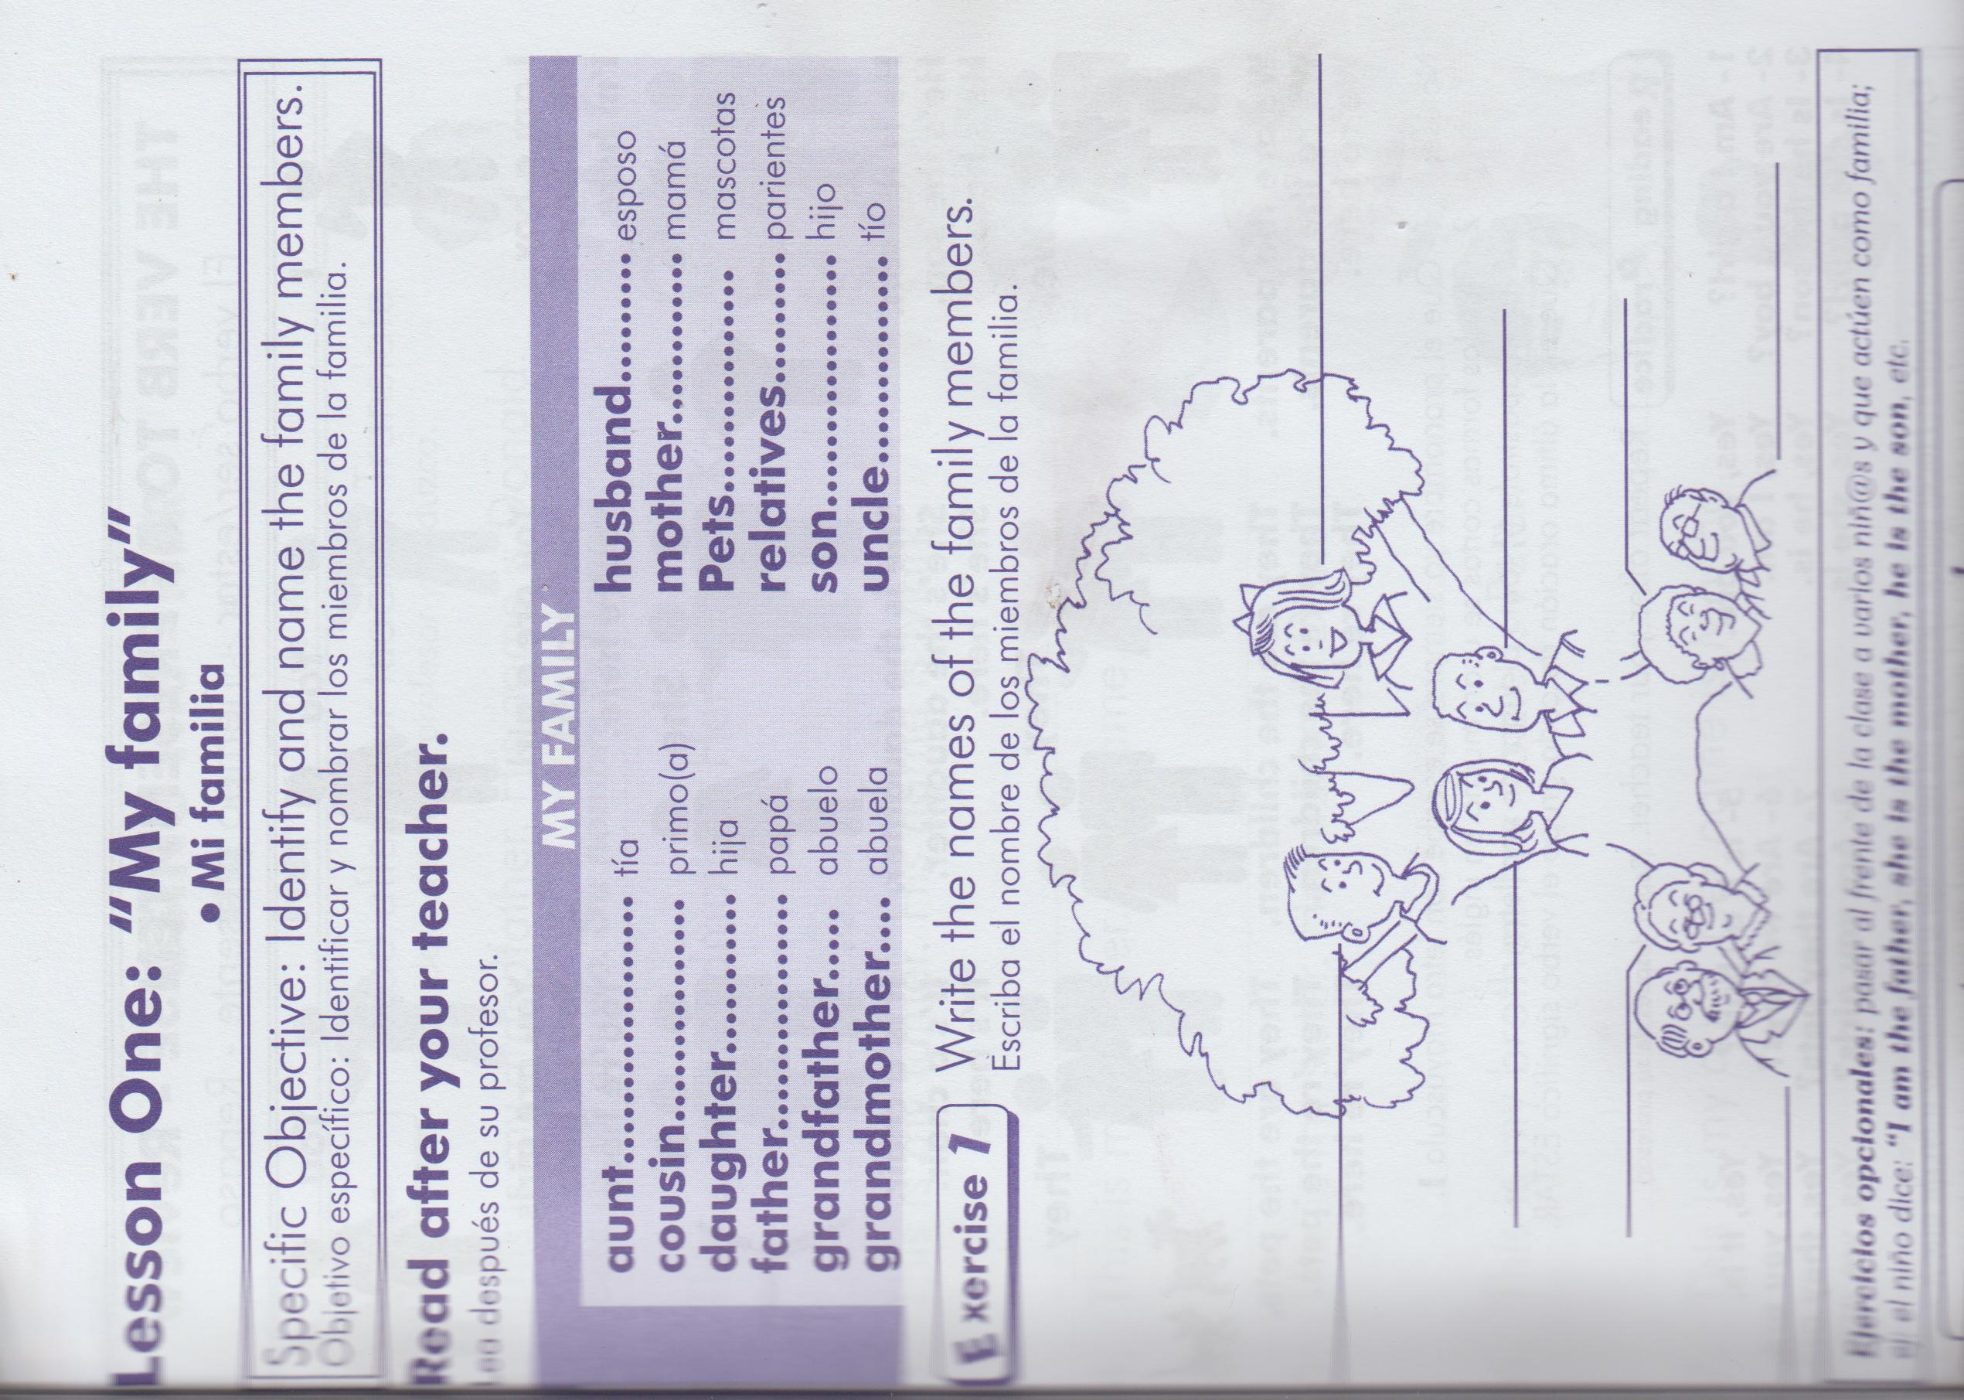Class Suspension. Acivity 3. Teacher Manuel. Grade: 3rd. Section: A – B - C .

Indication: 1- Write the names… according to the relationship.

2- Translate the sentences to Spanish

3- Copy the lesson on your notebook and color the pictures.

.

