Prefeitura Municipal de Ponte Nova
SECRETARIA DE EDUCAÇÃO
Estado de Minas Gerais

Atividade de Língua Portuguesa– 4°ano

Tema: Brincadeira

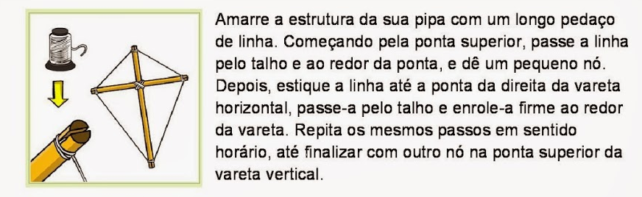

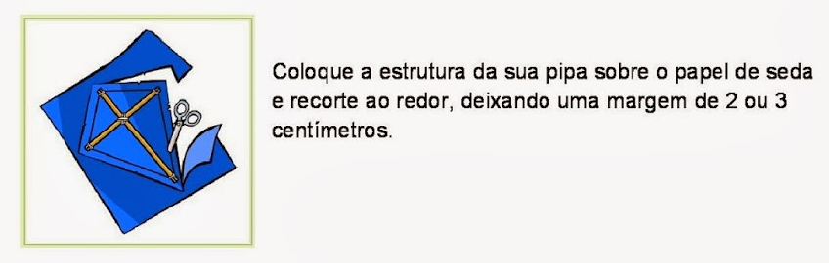

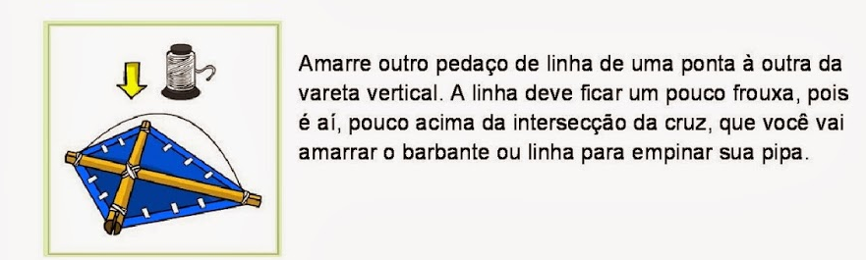

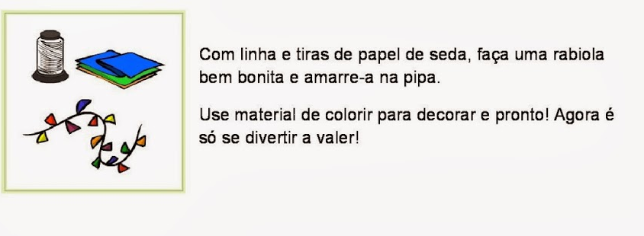

- Que gênero textual é esse?

______________________________________________________________

- Para que serve um texto instrucional?
______________________________________________________________________________________________________________________________________________________________________________________________________

- Você gosta de soltar pipa?
____________________________________________________________________________________________________________________________________

- Quais os cuidados que devemos ter ao soltar pipa?
___________________________________________________________________________________________________________________________________________________________________________________________________

CAÇA- PALAVRAS
- Encontre o nome de oito brinquedos.
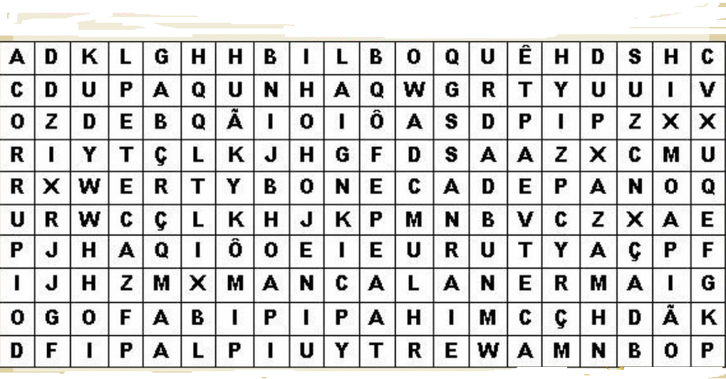

- Faça uma Produção de texto de acordo com a imagem abaixo:







