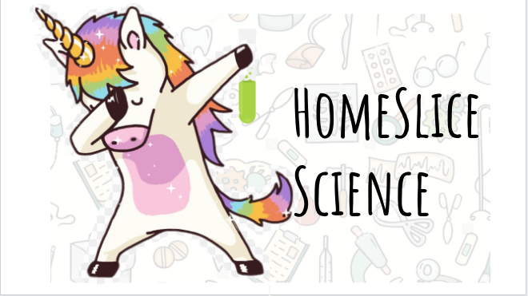
Experiment Sheet

Rainbow Skittles

Materials:
- Flat plate (white if possible)
- Skittles
- Water

Method:

- Place the Skittles on the plate - make an interesting pattern and try to put different colours next to each other
- Gently pour the water into the plate as far away from the Skittles as possible (round plate: pour into the middle).
- Wait and watch what happens - takes about 5-10 minutes.

Why do the colours spread?
Skittles are covered in food colouring and sugar. When you pour water over the skittles the coloured coating dissolves spreading through the water.
The colour and sugar dissolve into the water and then diffuse through the water, making it the colour of the skittle.
Taking it further / Extension Ideas:

Can you time how long the colours take to reach the centre of the plate using cold and warm water? Which do you think will be faster?
Skittles race! What about using a square or rectangular plate: put the Skittles on one side and pour in the water. Which colour gets to the opposite side first?
Try using other sweets, can you find any that work as well as skittles?
Think about this:
Why do you think the colours don’t mix?
Can you spot the ‘S’ from the skittles? What happens to it?
How could you speed up the reaction?

