**Carbonyl Complexes**

**General Information**

**Carbonyl Complexes** are compounds that contain carbon monoxide as a coordinated ligand. Carbon monoxide is a common ligand in transition metal chemistry, in part due to the synergistic nature of its bonding to transition metals. We can describe the bonding of CO to a metal as consisting of two components. The first component is a two electron donation of the lone pair on carbon (coordination exclusively through the oxygen is extremely rare) into a vacant metal d-orbital. This electron donation makes the metal more electron rich, and in order to compensate for this increased electron density, a **filled** metal d-orbital may interact with the **empty** pi* orbital on the carbonyl ligand to relieve itself of the added electron density. This second component is called **pi-backbonding** or pi-backdonation. This is shown diagramatically as well as through a simple MO picture below. The MO has been color coded so you can identify each component of the bonding interaction:

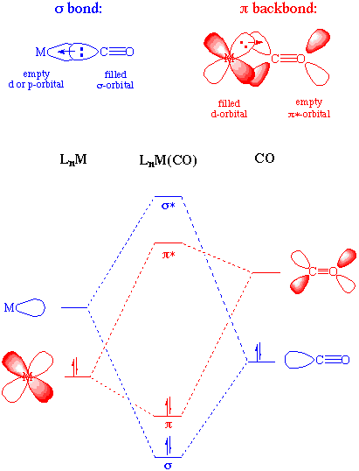

The two components of this bonding are synergistic. The more sigma donation by the carbonyl (or other sigma-donors on the metal center), the stronger the pi-backbonding interaction. Notice that although this involves the occupation of a pi* orbital on the CO, it is still a bonding interaction as far as the metal center is concerned. There is a fundamental similarity between the nature of carbonyl-metal bonding and that of [alkenes](http://www.ilpi.com/organomet/alkene.html), acetylenes, [phosphines](http://www.ilpi.com/organomet/phosphine.html), and [dihydrogen](http://www.ilpi.com/organomet/dihydrogen.html).

This occupation of the pi* on CO does lead to a decreased bond order in the carbon monoxide molecule itself. As we might expect, as the pi-backdonation becomes stronger, the CO bond order should decrease from that of the free ligand. Two consequences that we might expect if the CO bond order was reduced would be a lengthening of the C-O bond and a decrease in the carbonyl stretching frequency in the IR. Both of these hold true.

**Bonding modes of CO**

CO typically bonds in an end-on fashion through carbon as shown above. However, bridging carbonyls are not uncommon and often undergo exchange with terminal carbonyls. A variant of a bridging carbonyl is the "semi-bridging" carbonyl in which the M-CO-M bond is asymmetric rather than symmetric. Some less common bonding modes are shown below; notice that the metrical data provided in each case are consistent with a decrease in the CO bond order:

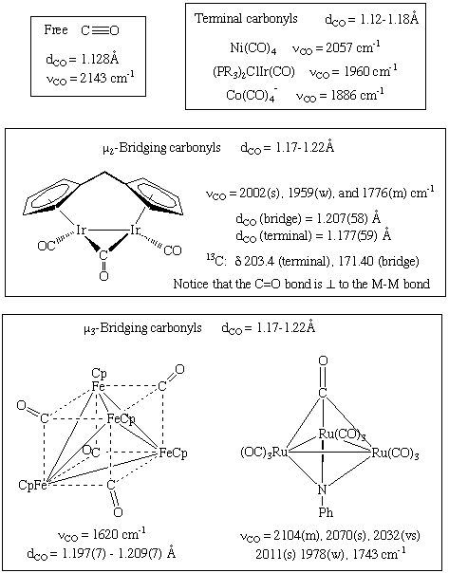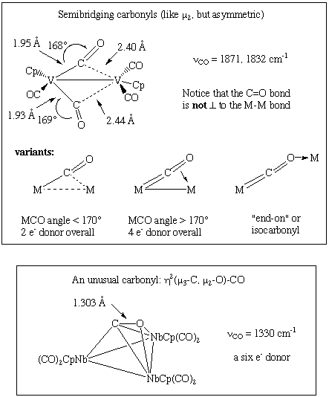

**Spectroscopic Features of Carbonyl Complexes**

In the IR, typical stretching frequencies are:

* + Uncoordinated or "free" CO: 2143 cm-1
  + Terminal M-CO: 2125 to 1850 cm-1
  + Doubly bridging (mu-2): 1850 to 1750 cm-1
  + Triply bridging (mu-3): 1675 to 1600 cm-1
  + Semibridging: somewhere between terminal and mu-2.

Two convenient trends are observed in the IR spectra of carbonyl complexes that are both consistent with the concept of pi-backbonding discussed above:

* + With each charge added to the metal center, the CO stretching frequency decreases by approximately 100 cm-1.
  + The better the sigma-donating capability (or worse the pi-acceptor ability) of the other ligands on the metal, the lower the CO stretching frequency.

For simple carbonyl complexes, counting the number of IR and Raman CO stretching frequencies will often permit one to make a structural assignment. The number of CO stretches expected for possible geometries/isomers can be predicted using group theory and the calculated results compared to the experimental data.

In the 13C NMR spectrum, coordinated carbonyl ligands typically appear in the range of 180 to 250 ppm. Isotopically enriched carbonyl complexes are often prepared to simplify mechanistic investigations or to facilitate the collection of the spectrum. In addition, the coupling of a 13C-enriched complex to other spin active nuclei such as 103Rh or 31P, can aid in structural assignments.

**Syntheses of metal carbonyls**

Metal carbonyls can be made in a variety of ways. Here are just a few examples:

For Ni and Fe, the [homoleptic](http://www.ilpi.com/organomet/homoleptic.html) or binary metal carbonyls can be made by the direct interaction with the metal (Equation 1).

In other cases, a reduction of a metal precursor in the presence of CO (or using CO as the reductant) is used (Equations 2-3).

Carbon monoxide also reacts with various metal complexes, most typically filling a vacant coordination site (Equation 4) or performing a [ligand substitution reactions](http://www.ilpi.com/organomet/substitution.html) (Equation 5).

Occasionally, CO ligands are derived from the reaction of a coordinated ligand through a [deinsertion](http://www.ilpi.com/organomet/insertion.html" \l "introduction) reaction (Equation 6).

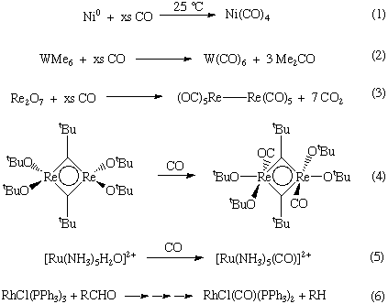

**IR stretching frequency α Bond strength and bond order**

**(a) Charge on Metal :**

Greater the -ve charge on the metal (i.e. more electron density on metal) stronger will be the back bonding , hence lower will be the C-O stretching frequency.

Since the increased extent of back bonding increases the M-C double-bond character and therefore, the stretching frequency of M-C bond increases.

A formal positive charge on a metal carbonyl causes the great ability of metal to attract electrons and lower will be the tendency of metal to back donate electron density to π* on CO. therefore the C-O bond order and stretching frequency increases.

For isoelectronic species C-O stretching frequency increase in the order:

**[Ti(CO)6]2− < [V(CO)6]− < [Cr(CO)6] < [Mn(CO)6]+ < [Fe(CO)6]2+**

**(b) Number of CO Ligand:**

As the number af CO ligands attached to a metal increases, the formal negative charge on metal increases.

Therefore, the extent of back donation increases and hence stretching frequency decreases as shown in table;



**(c) Presence of Other Ligand on Metal:**

**sigma- donor:**

Presence of sigma bonded ligand (i.e.electron donating ) on a metal like NH , Pyridine. Increase electron density on the metal , so π-back bonding increases and C-O frequency decreases.

**pi- acceptor Ligands:**

Presence of pi-bonded ligand (i.e. electron withdrawing) on a metal likes PF3, CS, NO.

The pi-acceptor ligands decrease the electron density on metal. So, π-back bonding decrease and hence C-O frequency increase.

The effect of other ligands present on CO frequency:



**Metal Nitrosyls :**

When an electron is removed from π* of NO the bond order increases from 2.5 to 3. Because NO is nitrosyl ion, the compound containing both NO and CO are called carbonyl nitrosyls. The NO can act as 1- or 3-electron donor on the neutral ligand or covalent model.

When NO acts as 3e- donor, the M-NO unit is linear [Fig (a)]. In majority of nitrosyl complexes the MNO unit is linear, consistent with sp -hybridization on nitrogen.

When NO acts as a one electron donor, the M-NO unit is bent.



The bent geometry is due to the presence of a lone pair of O electrons on nitrogen.



Useful information about the linear and bent bonding modes of NO is summarized in below figure 