NOMENCLATURE OF COORDINATION COMPOUNDS AND IONS

NAMING COMPLEX IONS

Transition metal ions and some main block elements form coordination compounds which typically consist of a coordinate complex and counter ions. Coordination complexes are composed of ligands surrounding a central metal atom or ion.
The coordinate complex itself consists of a transition metal atom or ion and the surrounding ligands. The coordinate complex is always enclosed in square brackets, [ ]. The coordinate complex can be an ion, cation or anion, or a neutral complex. Counter ions are needed to produce a neutral coordinate compound if the complex is an ion.
Ligands possess one or more donor atoms, atoms that donate the lone pair of electrons. Donor atoms may possess more than one lone pair of electrons, but only one pair is involved in the bond. An electron pair donor is referred to as a Lewis Base.
The central metal atom or ion accepts the lone pair of electrons involved in the bond. An electron pair receptor is referred to as a Lewis Acid.
Bonds that are formed between the ligands and the central metal atom or ion are distinctive in that the bonds of the molecule are formed with both of the electrons involved in the bond being donated by just one of the atoms involved in the bond; this is known as a coordinate covalent bond, thus giving these compounds their name.

Example: [Fe(OH₂)₆]Cl₂
Hexaaquairon (II), [Fe(OH₂)₆]⁺, is a complex ion consisting of the transition metal ion Fe⁺² and six attached neutral water, OH₂, ligands. The oxygen atom of each water molecule has two lone pairs of electrons one of which the neutral ligand donates to the coordinate covalent bond. The oxygen atom is referred to as the donor atom. The donor atom is listed first in the chemical formula of the ligand in contrast with the normal pattern for the ordering of atoms in a chemical formula: cation then anion. Also, note that when bringing together the complex ion with the counter ion, the complex ion is always enclosed in brackets [ ] while names of common ligands are enclosed in parenthesis ( ). The counter ion in for this example is the chloride anion, Cl⁻.
Transition metal complexes, such as tetraamminedichlorocopper (II), [Cu(NH₃)₄Cl₂] are neutral and do not require counter ions.

Complex Ion Nomenclature:
The chemical formula and the chemical name for Complex cations have different rules.
The complex cation chemical formula follows traditional rules for naming ionic compounds with the cation listed first. For example [Cu(OH₂)₆]²⁺, the cationic copper II ion is listed first and the neutral water ligand is listed second. Complex cation chemical names are assembled by alphabetically listing the number and name of the ligands attached to the central metal atom or ion followed by the name of the central atom and its oxidation number indicated by a Roman numeral in parenthesis, for example, hexaaquacopper (II).
The chemical names and formulas for Complex anions follow the same rules as complex cations with one additional step. The name of the central atom is changed by adding an –ate ending and then the oxidation number in parentheses. For example: [FeF₆]³⁻ , hexafluoroferrate (III). Note here also that the Latin name for iron is used to avoid an awkward sounding name. A list of such transition metals follows in the section on naming rules.
Ligands are ions, ionic molecules, or neutral molecules that have atoms which possess lone pairs and thus act as Lewis bases. Ligand is derived form the Latin legare meaning to bind. The lone electron pairs are donated to empty d orbitals of the transition metal atom or ion creating a coordinate covalent bond. When a ligand donates only a single pair of electrons to the metal center the ligand is referred to as monodentate. Dentate comes from the Latin dens meaning tooth. Monodentate then figuratively means single toothed. Ligands that donate two, three, four, five, or six lone pairs of electrons are collectively referred to as polydentate, and bidentate, tridentate, tetradentate, pentadentate, and sexadentate respectively. Polydentate ligands typically form five- and six-membered rings and are referred to as chelating agents and the complex is referred to as chelate. Chelate comes from the Greek chela meaning claw.
The number of coordinate covalent bonds formed typically ranges from two to eight depending on the charge, size, and electron configuration of the transition metal atom or ion. The coordination number may also be as low as 1 and as high as 12. The number of ligands attached to the central metal atom or ion, the number of coordinate covalent bonds, is the coordination number, (CN); with two, four and six the most common coordination numbers. The coordination sphere is the number of coordinate covalent bonds plus the number of central metal atoms or ions, often the coordination sphere is one more than the coordination number.

Simplified IUPAC Rules for Naming Coordination Compounds:

- Cations are always named before the anions.
- Ligands are named before the metal atom or ion.
- Ligand names are modified with an -o added to the root name of an anion. For neutral ligands the name of the molecule is used, with the exception of OH₂, NH₃, CO and NO. Names of common neutral ligands are listed in Table 1, and common anionic ligands are listed in Table 2.

Table 1 – Neutral Molecules

aqua | OH₂
ammine | NH₃
benzene | C₆H₆
carbonyl | CO
nitrosyl | NO
methylamine | CH₃NH₂
dimethylamine | (CH₃)₂NH
trimethylamine | N(CH₃)₃
ethylenediamine or en | H₂NCH₂CH₂NH₂ | bidentate
diethylenetriamine or dien | NH(CH₂CH₂NH₂)₂ | tridentate
triethylenetetraamine or trien | N(CH₂CH₂NH₂)₃ | tetradentate
ethylenediaminetetraacetato (EDTA) | (COOH)₂N(CH₂)N(COOH)₂ | hexadentate
1,10-phenanthroline or phen | C₁₂H₈N₂ | bidentate
pyrdidine or py | C₅H₅N
2,2′-bipyridine or bipy | (C₅H₄N)₂ | bidentate
2,2′,6′,2′′terpyridine or terpy | (C₅H₄N)₃ | tridentate
bis(diphenylphosphine) ethylene or dppe | (C₆H₅)₂P(CH₂)₂ P(C₆H₅)₂ | bidentate
bis(dimethylphosphino) ethylene or dmpe | (CH₃)₂P(CH₂)₂ P(CH₃)₂ | bidentate

Table 2 – Anions

fluoro | F⁻ |  | nitrito | ONO⁻
chloro | Cl⁻ |  | nitrato | NO₃⁻
bromo | Br⁻ |  | oxalate (ox) | C₂O₄²⁻ | bidentate
iodo | I⁻ |  | oxo | O²⁻
carbonato | CO₃²⁻ |  | sulfato | SO₄²⁻
cyano | CN⁻ |  | thiocyanato | SCN⁻
hydrido | H⁻ |  | azido | N₃⁻
hydroxo | OH⁻ |  | thiosulfato | S₂O₃²⁻
nitro | NO₂⁻ |  | acetylacetonate (acac) | CH(COCH₃)₂⁻ | bidentate

- The prefixes mono-, di-, tri-, tetra-, penta-, and hexa- are used to denote the number of simple ligands.
- The prefixes bis-, tris-, tetrakis-, etc., are used for more complicated ligands or ones that already contain di-, tri-, etc.
- The oxidation state of the central metal ion is designated by a Roman numeral in parentheses.
- When more than one type of ligand is present, they are named alphabetically. Prefixes do not affect the order.
- If the complex ion has a negative charge, the suffix –ate is added to the name of the metal.
- Sometimes the Latin name is used to identify the metal.

Latin Names for Some Metal Ions Found in Anionic Complex Ions
copper | cuprate
gold | aurate
iron | ferrate
lead | plumbate
silver | argentate
tin | stannate
- In the case of complex-ion isomerism the names cis, trans, fac, or mer may precede the formula of the complex-ion name to indicate the spatial arrangement of the ligands. Cis means the ligands occupy adjacent coordination positions, and trans means opposite positions just as they do for organic compounds. The complexity of octahedral complexes allows for two additional geometric isomers that are peculiar to coordination complexes. Fac means facial, or that the three like ligands occupy the vertices of one face of the octahedron. Mer means meridional, or that the three like ligands occupy the vertices of a triangle one side of which includes the central metal atom or ion.

Examples of rules:

[CrCl₂(OH₂)₄]⁺ tetraaquadichlorochromium (III) ion
[CrCl₄(OH₂)₂]⁻ diaquatetrachlorochromate (III) ion
[Cr(OH₂)(NH₃)₅]³⁺ pentaammineaquachromium (III) ion
[Ga(OH)Cl₃]⁻ trichlorohydroxogallate (III) ion
cis-[PtBrCl(NO₂)₂]²⁻ cis-bromochlorodinitroplatinate (II) ion
trans-[Co(OH)Clen₂]⁺ chlorobis(ethylenediamine)-trans-hydroxo cobalt (III) ion
[Mn(CO)₃(C₆H₆)]⁺ benzenetricarbonvlmanganese (I) ion
[Ni(CO)₄] tetracarbonylnickel (0)
NH₄[AuCl₄] ammonium tetrachloroaurate (I)

Common Structures
Because ligands can coordinate in various ways and in different arrangements profound differences are seen in the chemical properties of compounds with identical composition. The ordering and connectivity yield unique physical and chemical properties for each isomer. The structure, or molecular geometry, also yields dramatic differences in the chemical properties of coordination complexes. Tetrahedral compounds behave differently than square planar compounds containing exactly the same metal atom and the same ligands with the same ordering and connectivity. Typical geometries for the most common coordination numbers are listed in Table 3.

Table 3
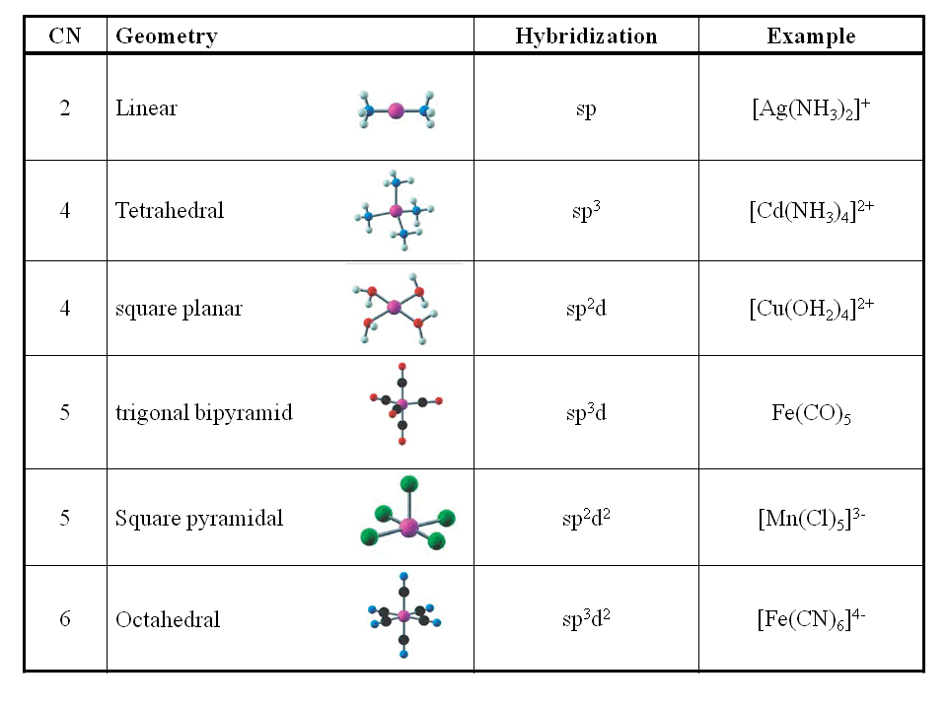
The complex ion, [CoCl₄]²⁻, has a coordination number equal to 4. The structure of [CoCl₄]²⁻ might be:

tetrahedral - ligands attached at the corners of a tetrahedron
square planar - ligands attached at the corners of a square

Tetrahedral geometries predominate. However, for transition metal ions with nd⁸ electron configuration such as Ni²⁺, Pd²⁺, Pt²⁺, Rh²⁺, Ir⁺, Au³⁺, and for the 3d⁹ electron configuration Cu²⁺ the square planar configuration dominates. This is due to the requirement of involving only one of the d-orbitals, dx²-y², which has four lobes pointing to all four ligands. The [CoCl₄]²⁻ complex ion is experimentally known to have a tetrahedral structure.
. 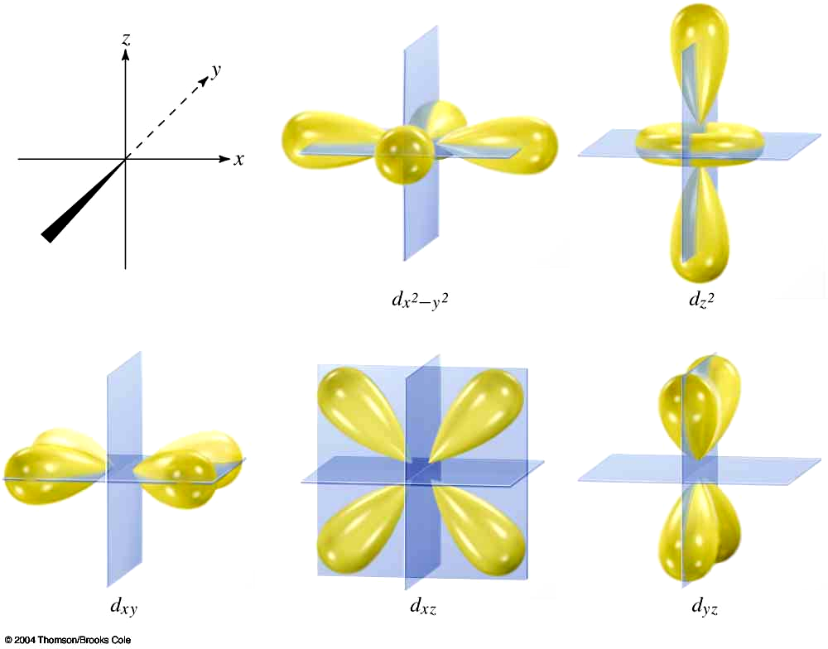
A Comparison of Tetrahedral and Square Planar Structures
Example | sketch | model
[CoCl₄]²⁻  tetrahedral  CN = 4 | 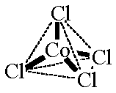 | 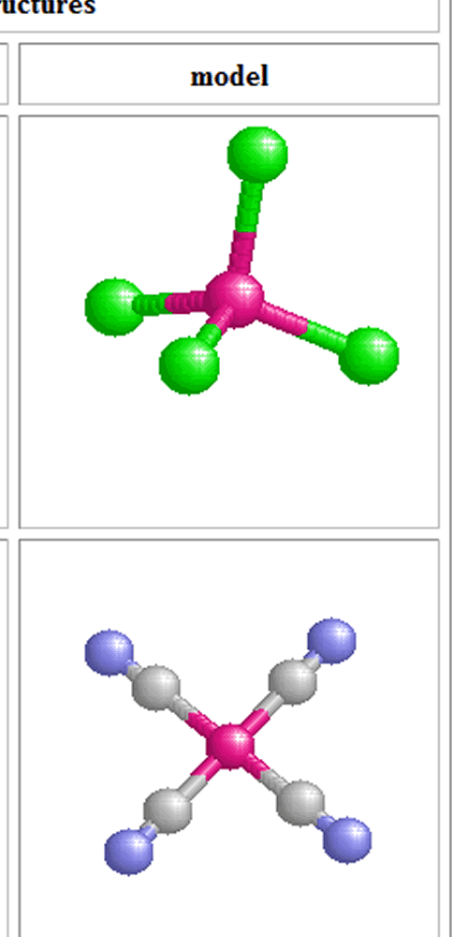
[Ni(CN)₄]²⁻  square planar  CN = 4 | 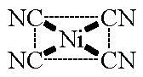
Linear and octahedral are the most common structures for coordination numbers 2 and 6, respectively.
A Comparison of Linear and Octahedral Structures
Example | sketch | model
[Ag(NH₃)₂]⁺  linear  CN = 2 | 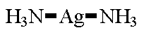 | 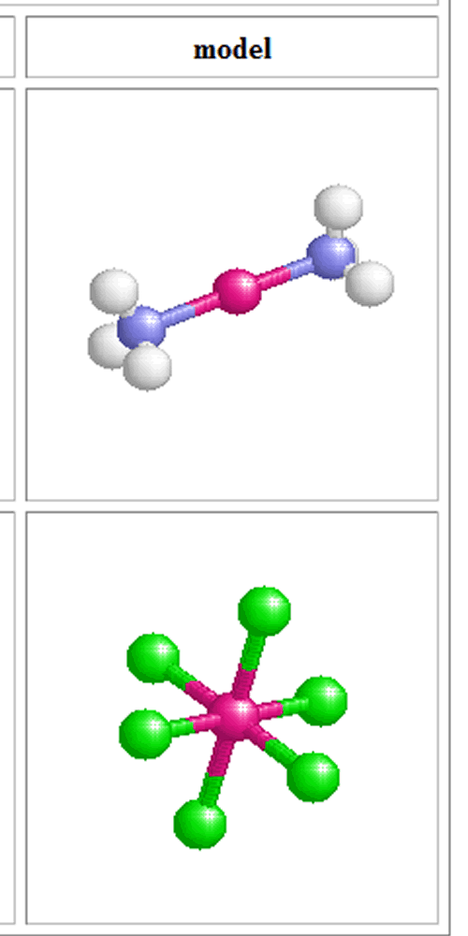
[PtCl₆]²⁻  octahedral  CN = 6 | 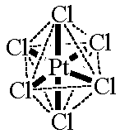
Structures With Monodentate Ligands
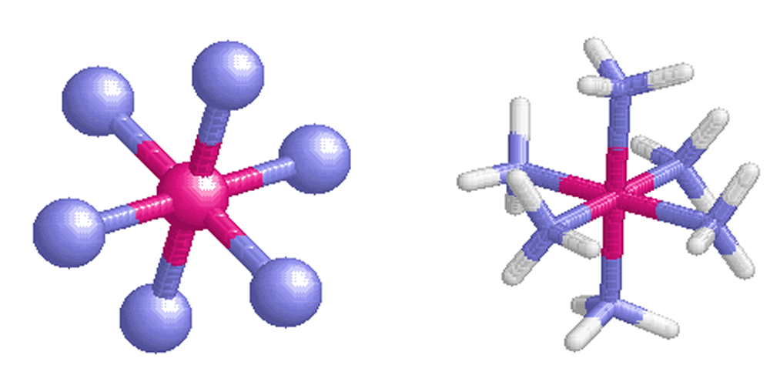 . | = Ni  = N  = H
[Ni(NH₃)₆]²⁺
[Ni(NH₃)₆]²⁺

Monodentate ligands can be either ions (usually anions) or neutral molecules.

In many three-dimensional representations spheres are used for simplicity and clarity. Stick structures are similarly used when it is desired to show all atoms and preserve the three-dimensional structure of the ligand. For the coordination complex, [Ni(NH₃)₆]²⁺, each ammonia ligand is represented as a sphere, an abbreviated structure, in the figure below left, the sphere represents the nitrogen donor atom of the ligand and in the stick representation for the same complex shown in the figure below right the nitrogen donor atoms are shown with attached hydrogens, a complete structure.

Common Applications of Monodentate Ligands
The cation tetraamminecopper (II), [Cu(NH₃)₄]²⁺ is common in waterbed conditioners, responsible for preventing the growth of fungi and bacteria. The cation is dark-blue in color and has a square planar geometry. The dicarbonyldiiodoruthenium (II) cation, [RhI₂(CO)₂]⁻, is used as a catalyst in the "Monsanto Process" for making acetic acid, the component in vinegar which gives it its acidity and subsequent tang.
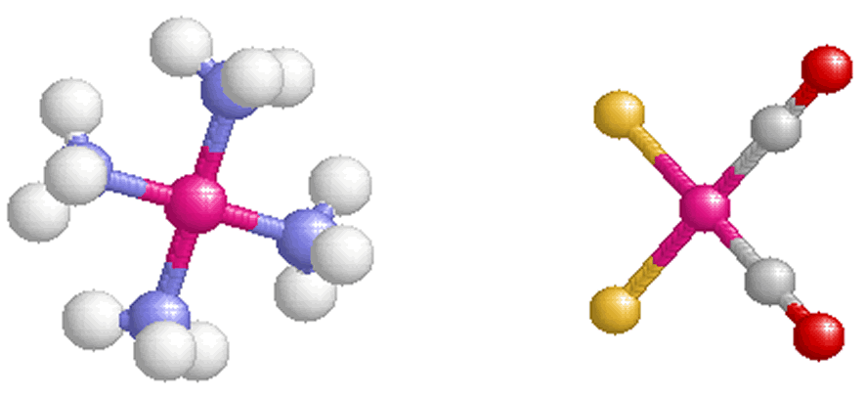  [Cu(NH₃)₄]²⁺ [RhI₂(CO)₂]⁻ | = Cu/Rh  = N  = H  = O  = C  = I
Structures With Bidentate Ligands

Bidentate ligands have two donor atoms donate two pairs ("bi") of electrons to a metal atom. The neutral ligand ethylenediammine, abbreviated as en, contains two N atoms that each donate a pair of electrons to a metal atom. A stick figure representation for ethylenediamine is shown below left. As the two amine groups are joined by an ethylene group a five membered ring is formed after the two nitrogen atoms have coordinately bonded to the central metal atom as shown in the figure below right. This five-membered ring is a very stable structure just as five-membered rings are for organic compounds. Ethylenediamine is therefore a chelating ligand.
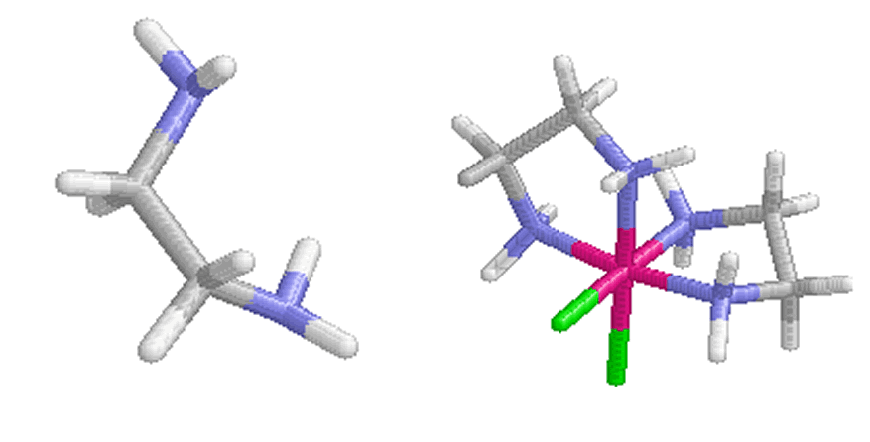  ethylenediammine (en) cis-[Ni(en)₂Cl₂] |  | = Ni  = C  = N  = H  = Cl
The oxalate anion contains four O atoms, two carbonyls and two deprotonated alcohol groups, each capable of making a coordinate bond. Resonance structures suggest that the negative charge is delocalized between two sp² hybridized oxygens bridged by a sp² hybridized carbon. The formation of the two coordinate bonds localizes the electrons by electrostatic attraction to the metal ion changing the hybridization of the bonded oxygens to sp³. In the complex [Ni(ox)₂]²⁻, below right, two oxalate ions are bonded to a Ni²⁺ ion. The CN of 4 for the 3d⁸ electronic configuration Ni²⁺ is square planar.
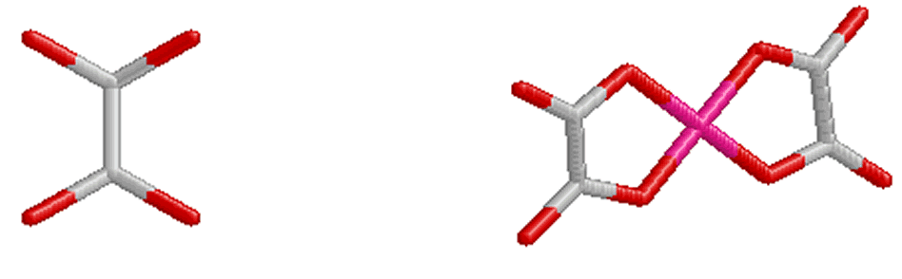 |  | = Ni  = C  = O
oxalate ion (ox) [Ni(ox)₂]^{2- .}
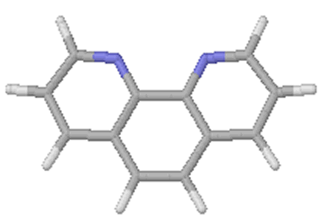 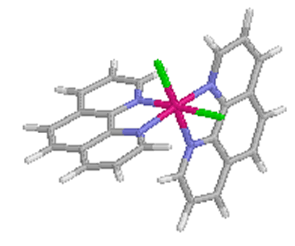 . |  | = Rh  = C  = H  = N  = Cl
phenanthroline (phen) cis-[Rh(phen)₂Cl₂]⁺

Phenanthroline, an aromatic hydrocarbon, is a neutral molecule containing two donor N atoms.
For the cationic complex, cis-[Rh(phen)₂Cl₂]⁺, two phenanthroline molecules are bonded to the central Rh ion one of the phenanthroline molecules bonds through one equatorial bond and one axial bond while the second bonds through two equatorial bonds. If both phen groups had been bound equatorially, the chloro groups would have been trans to each other.
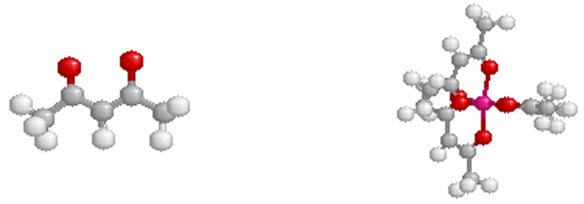 |  | = Cr  = C  = H  = O
acetylacetonate ion (acac) [Cr(acac)₃]³⁺
Acetylacetonate ion makes two coordinate bonds one with each of the two oxygen donor atoms.
Three acetylacetonate ions are bonded to the Cr atom, forming three 5-membered rings. The CN of 6 for the tris(acetylacetonate)chromium (III) cationic complex results in an octahedral geometry.
Other Bidentate Ligands
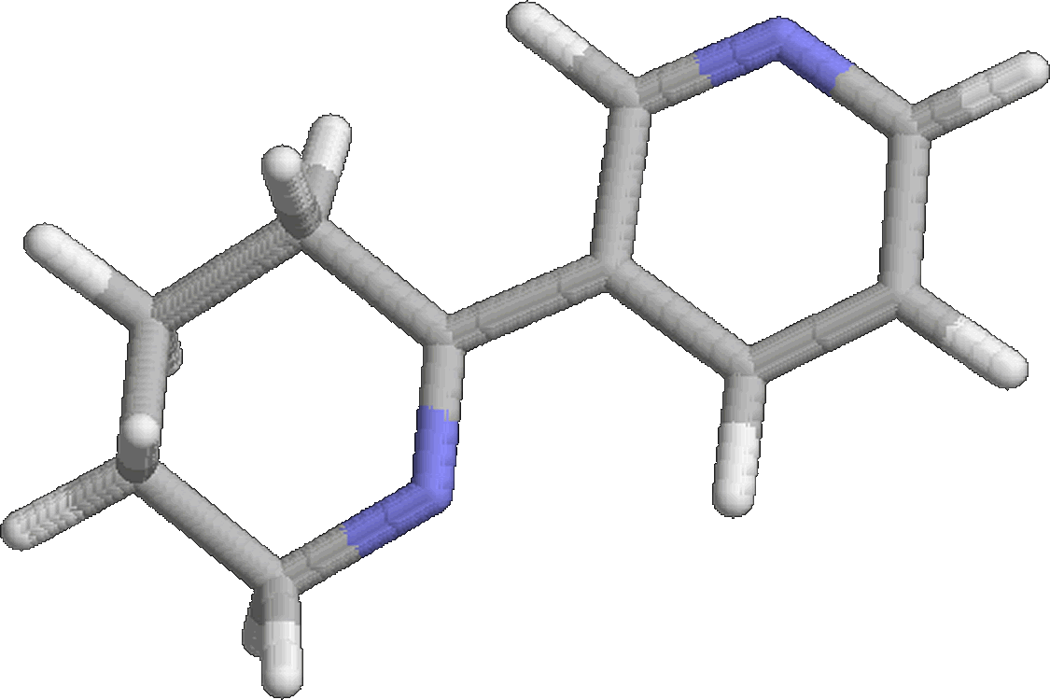  2,2′-bipyridine or bipy  Two nitrogen donor atoms | 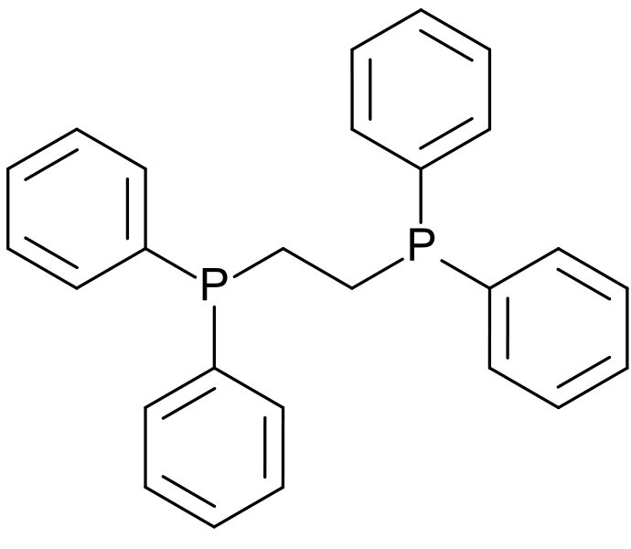  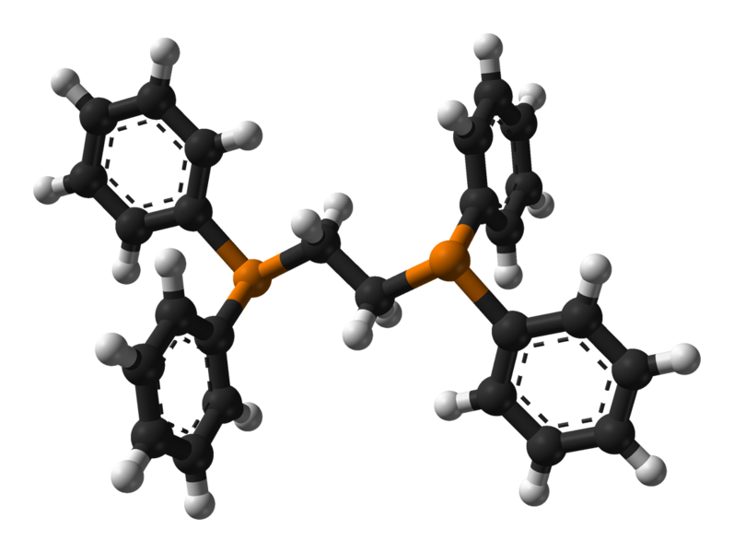  Ethylene-1,2-bis(diphenylphosphine) or dppe  Two phosphorus donor atoms
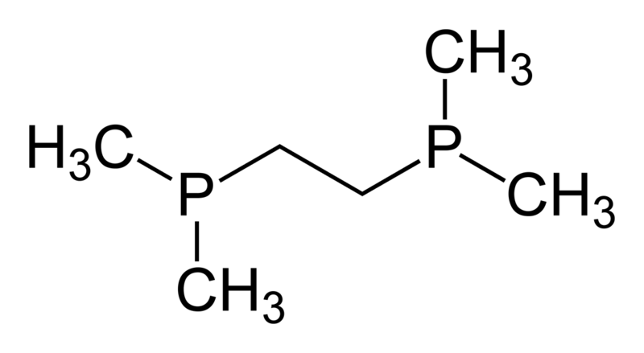
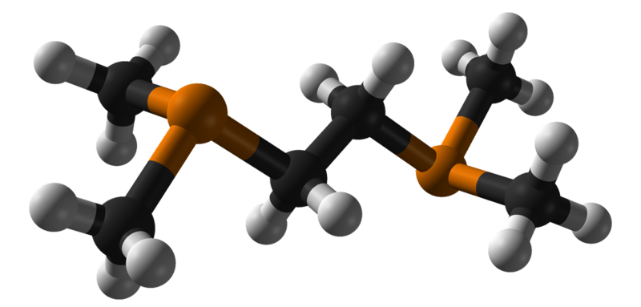
bis(dimethylphosphino) ethylene or dmpe
Two phosphorus donor atoms
Common Applications of Bidenate Ligands

ZUD cleanser contains oxalic acid and is used to remove rust deposits by creating chelation complexes with the iron (III) ion from the Fe₂O₃. Rust reacts with oxalic acid to produce a colorless, water-soluble complex ion (i.e., [Fe(C₂O₄)₃]³⁻) which contains the three of the bidentate oxalate ion ligands. The exposed carbonyls of the complex ion make the complex water-soluble and the resulting complex can be washed away with water.
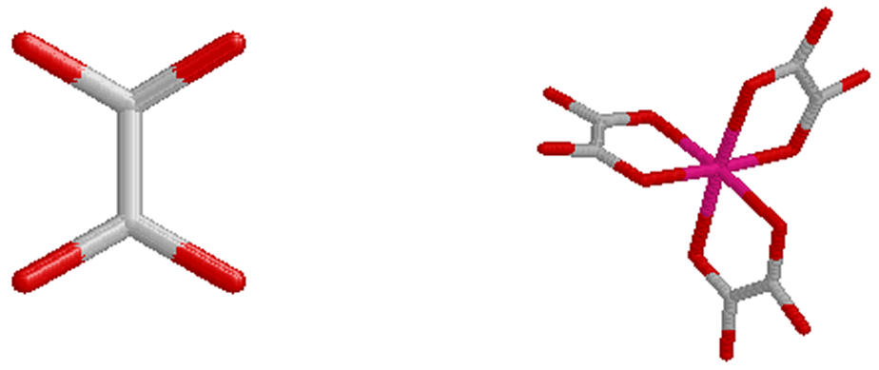 | = Fe  = O  = C

Structures With Tridentate and Tetradentate Ligands

Some Tridentate Ligands
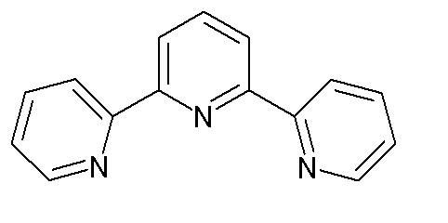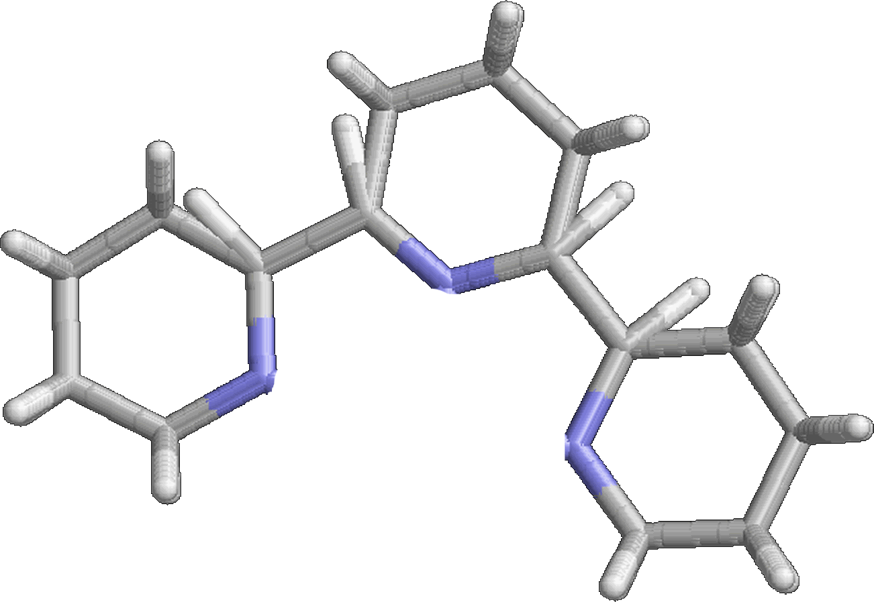  2,2';6',2"-terpyridine or terpy | 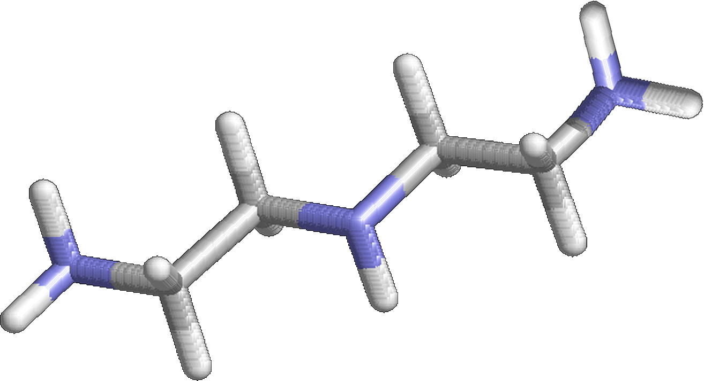  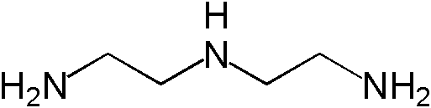  diethylenetriamine or dien
A Tetradentate Ligand
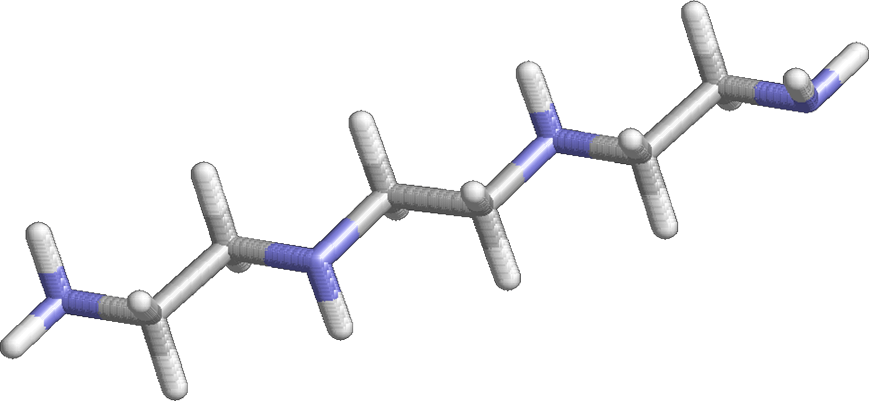
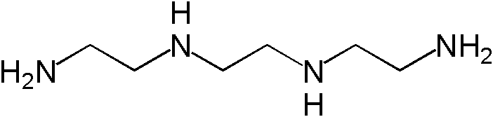
triethylenetetramine, or trien

EDTA – A sexidentate ligand
Some ligands can bond to a metal atom using more than two pairs of electrons. An example is ethylenediamminetetraacetate ion (EDTA⁴⁻), the Lewis structure of which is shown below. EDTA⁴⁻ forms very stable complexes with most of the transition metals.
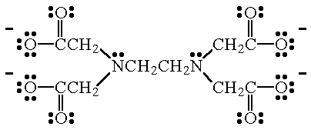
EDTA⁴⁻
This sexidentate ligand forms very stable complexes (usually octahedral structures) with multivalent transition metal ions. The donor atoms in EDTA⁴⁻ are the two N atoms, and the four, negatively charged O atoms.

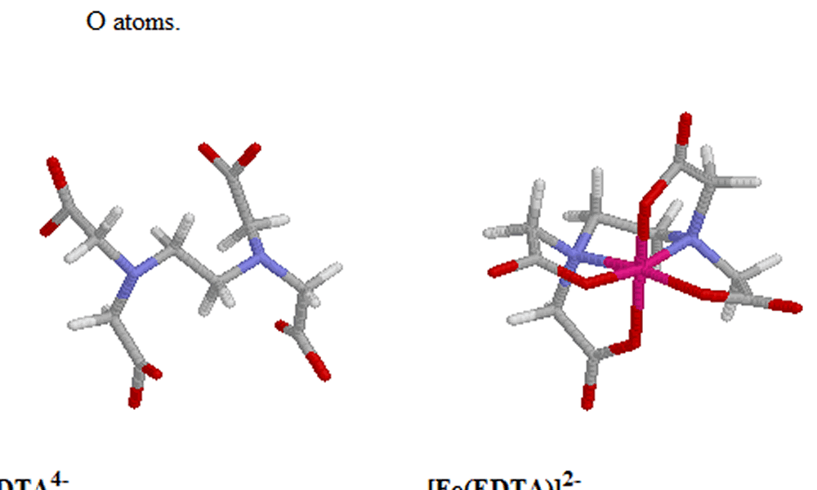 | = Fe  = C  = O  = H  = N
EDTA⁴⁻ [Fe(EDTA)]²⁻

When the tetravalent EDTA ion bonds to a divalent or greater metal atom, the two N atoms and four of the oxygen atoms are used. Just as with the oxalate ion the electron density of the delocalized electron cloud of the deprotonated carboxylic groups is localized fixing the hybridization of one the oxygens to sp³. In this complex, a single EDTA⁴⁻ ion forms 6 bonds to the Fe³⁺ cation. The CN of 6 is an octahedral structure.

Applications:

EDTA⁴⁻ is used to "trap" trace amounts of transition metals that could potentially catalyze the decomposition of the product.

The sodium salt of EDTA⁴⁻ (i.e., Na₄EDTA) can be found in many commercial products including:
- soap
- beer
- mayonnaise
Other Structures
The most common coordination numbers are 2, 4 and 6. However, several examples of coordination compounds which have coordination numbers of 3, 5 and 7 are well known.

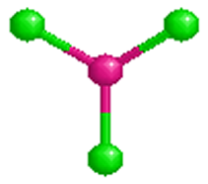 |  |  | = Hg  = Cl
[HgCl₃]⁻
The trichloromercurate (II) complex ion is an example of CN 3 coordination complex and has a trigonal planar structure.
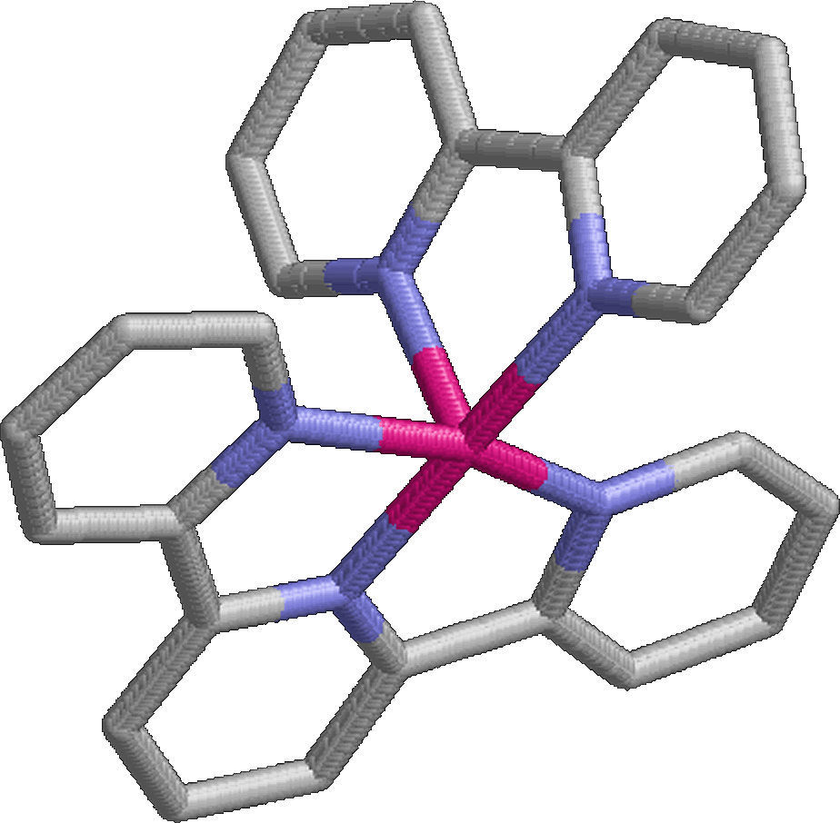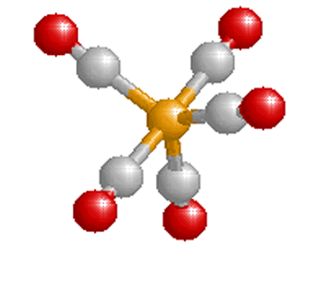 |  |  | = Fe  = V  = C  = O  = Cl
[Ru(terpy)(bipy)]²⁺  (bipy)(terpy)ruthenium (II), CN 5, has a square pyramidal structure. Three N atoms from the terpy molecule and one N atom from the bipy are bonded to the Ru atom at the corners of the equitorial square and the other N atom of the bipy molecule is bonded to the metal above the plane of the square. | [Fe(CO)₅]³⁺  For this coordinate complex, the CN 5 results in a trigonal bipyramidal structure. Three carbon monoxide molecules are bonded to the Fe atom at the corners of an equilateral triangle and the other two CO molecules are bonded to the metal above and below the plane of the triangle.
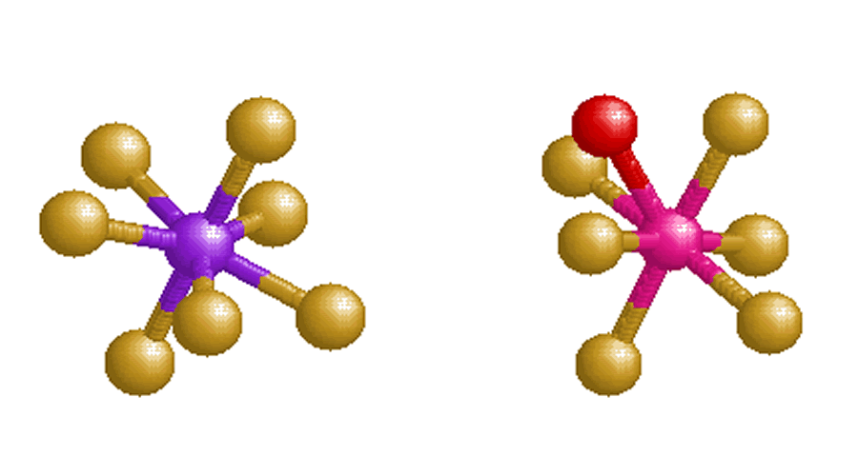 |  |  |  | = I/Nb  = F  = O
IF₇  Iodine heptafluoride contains only main-group elements. CN 7 results is pentagonal bipyramidal structure. Note that five F ions are bonded to the I atom at the corners of a pentagon while the other two fluoride ions are bonded axially above and below the plane of the pentagon. |  | [NbOF₆]³⁻  The CN 7 for hexaflurooxoniobate (III) results in a capped octahedron - triangular face structure. AS shown six F ions are bonded to the Nb atom in an octahedral arrangement. The O atom is bonded to the Nb atom at one of the triangular faces of the octahedron, thus capping the octahedron.
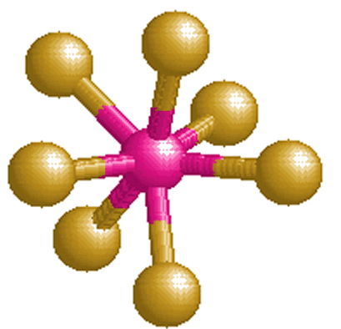 |  |  |  | = Nb  = F
[NbF₇]²⁻
In this compound, the coordination number of 7 results in a capped trigonal prism structure.
Stereoisomers
Isomers:
- are two or more molecules or ions that contain the same number and kinds of atoms (identical molecular formulas), but the atoms are arranged differently (i.e., the structures are non-superimposable),
- have different physical and/or chemical properties,
- do not exist for all coordination compounds,
- and are generally categorized as

- Structural isomers: isomers that have the same molecular formula, but one or more bonds is/are different (i.e., the connectivity between atoms is different). There are two types of structural isomers:
  - coordination sphere isomers (occuring only for coordination complexes with associated counter ions or waters of hydration)
    - hydration
    - ionization
    - coordination
  - linkage isomers (occurring only for monodentate ligands possessing more than one donor atom)

- Stereoisomers: contain the same number and kinds of atoms, and the same number and kinds of bonds (i.e., the connectivity between atoms is the same), but the atoms are arranged differently in space. There are two types of stereoisomers:
  - geometric isomers, and
  - optical isomers.

Geometric isomers and optical isomers occur not only for organic compounds as previously discusse but also with many coordination compounds.

In order to be isomers, the two compounds must have the same molecular formula and have nonsuperimposable structures.

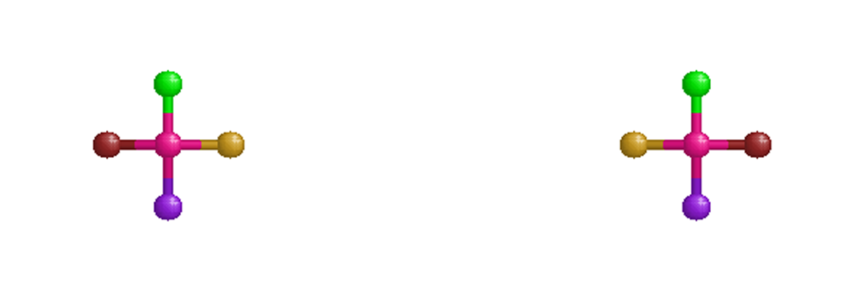
The two square planar structures above have the same molecular formula (one each of green, yellow, purple, brown and pink), and appear to be arranged differently in space. Through some combination of rotating, twisting and/or turning one of the structures we find an orientation in which all of the atoms match up with the other structure. This means that the two structures are superimposable (placing the translated structure on top of the other). These two structures are not superimposable and are not isomers.

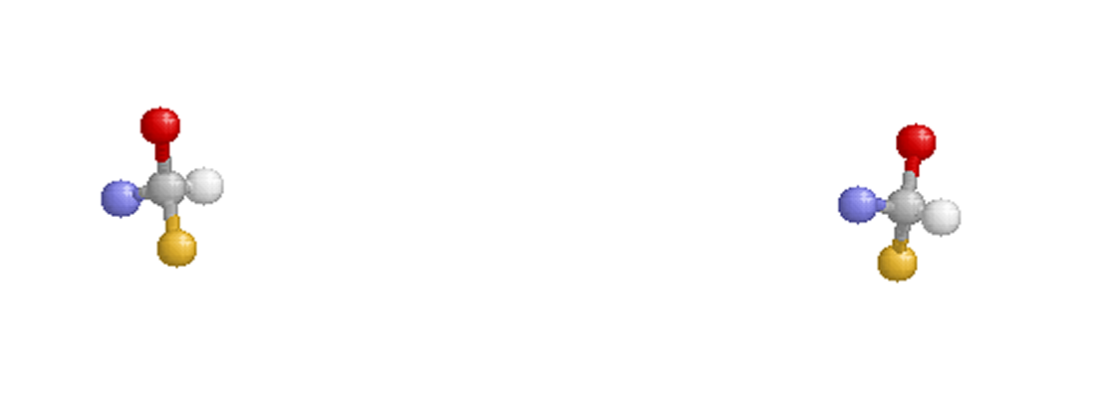
The two tetrahedral structures above also possess identical molecular formulas (one each of yellow, red, blue, white and gray), and appear to be arranged differently in space. No combination of translations (rotations, flips, or twists) results in an orientation in which all of the atoms match up with the other structure. Therefore the two structures are non-superimposable. These two structures are isomers.

Coordination Sphere Isomers
Coordination isomers are two or more coordination compounds in which the composition within the coordination sphere (i.e., the metal atom plus the ligands that are bonded to it) is different (i.e., the connectivity between atoms is different).
Not all coordination compounds have coordination isomers.
Coordination sphere isomers have different physical and chemical properties.

Hydration Coordination Sphere Isomer
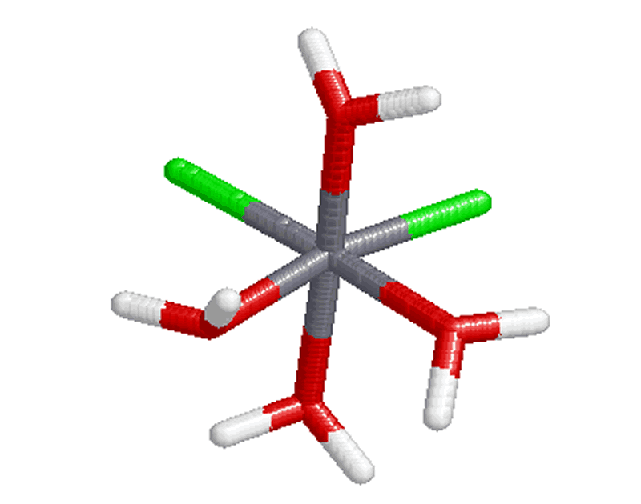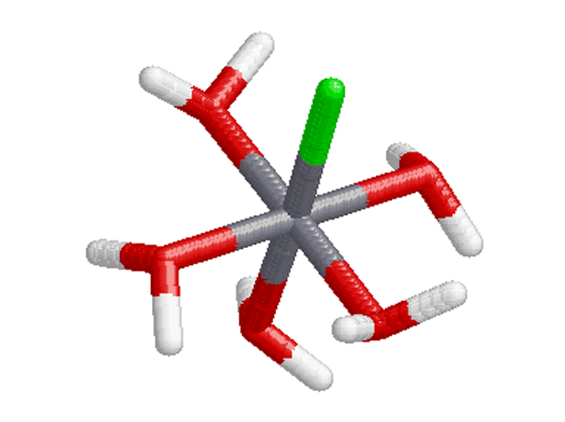 |  |  |  | = Cr  = O  = H  = Cl
cis-[Cr(OH₂)₄Cl₂]∙H₂O  Aqua groups within the coordination sphere are bonded to the Cr atom by the oxygen atoms. The water of hydration with the complex cis-[Cr(OH₂)₄Cl₂]∙H₂O is not shown in the structure above. | [Cr(OH₂)₅Cl]Cl  For this structure only one chlorine atom remains inside the coordination sphere and bonded to the Cr atom. The water of hydration has moved inside the coordination sphere and replaced the chloro group. The displaced chloro group is now a counter ion not shown in the above structure.
Ionization Coordination Sphere Isomer
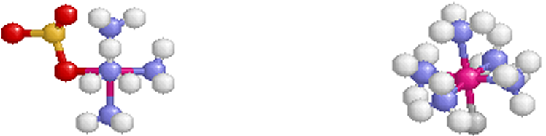 |  |  |  | = Cr  = N  = O  = S  = H  = Br
[Cr(NH₃)₅(OSO₃)]Br  The sulfate group inside the coordination sphere is bonded to the Cr atom by an O atom. The bromide counter ion needed to maintain charge neutrality for the compound with the complex ion [Cr(NH₃)₅(OSO₃)]⁺ is not shown in the above structure. |  |  | [Cr(NH₃)₅Br]SO₄  The bromine ion is bonded to the Cr atom at the bottom of the octahedral structure and has inside the coordination sphere displacing the sulfato group. The resulting sulfate counter ion is not shown in the above structure.
Coordination Coordination Sphere Isomer
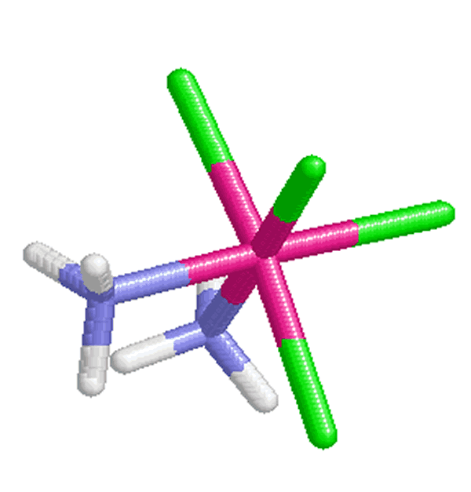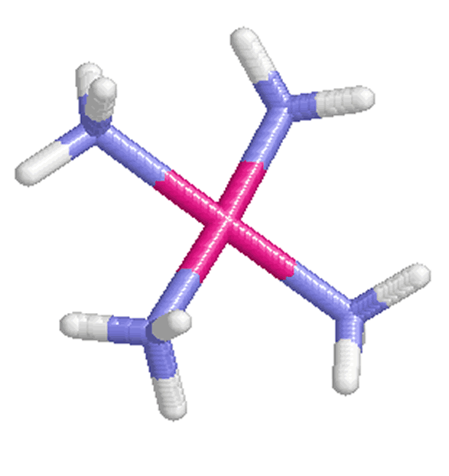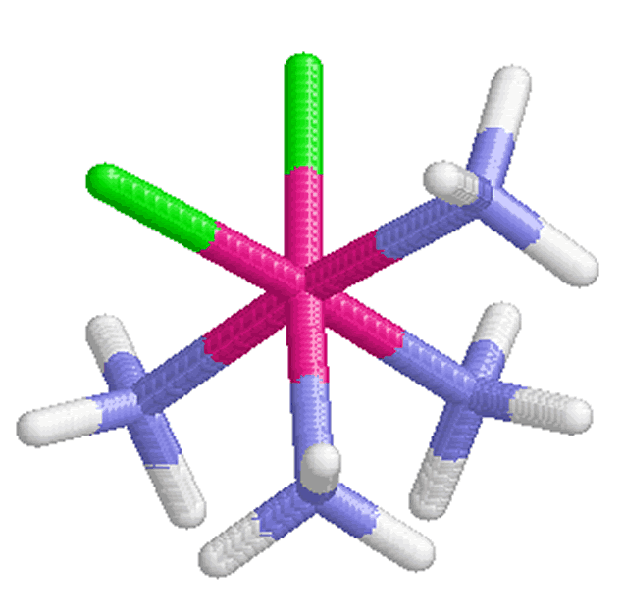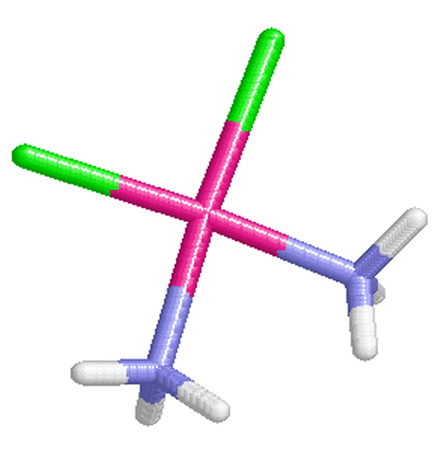 |  |  |  | = Cr  = O  = H  = Cl
cis-[Pt(NH₃)₂Cl₄][Pt(NH₃)₄]  The ammine groups are bonded to the Pt ion by N atoms inside both coordination spheres. Note that only the cationic coordination sphere contains chloro group ligands. |  | cis-[Pt(NH₃)₄Cl₂] cis- [Pt(NH₃)₂Cl₂]  For this structure two chloro ligands originally bonded to the Pt atom within the cationic coordination sphere have exchanged with two of the ammine groups in the anionic coordination sphere.
Linkage Isomers

Linkage isomers are coordination compounds in which the donor atom of at least one of monodentate ligands capable of bonding through two or more donor atoms is different. These ligands are referred to as ambidentate ligands

Some of these type ligands are listed below.

The standard form of the name is assigned to the linkage involving the less electronegative donor atom of the ligand. The variant form of the name is assigned to the linkage involving the more electronegative atom of the ligand. Linkage isomers have different physical and chemical properties.

Common Ambidentate Ligands That Can Form Linkage Isomers
ligand | Lewis structure | name | donor atom
CN⁻ | 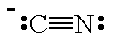 | cyano | C
CN⁻ |  | isocyano | N
SCN⁻ | 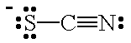 | thiocyanato | S
SCN⁻ |  | isothiocyanato | N
NO₂⁻ | 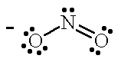 | nitro | N
NO₂⁻ |  | nitrito | O

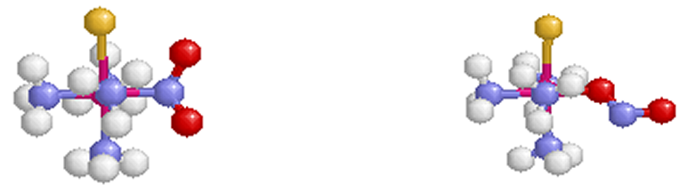 |  | = Co  = N  = H  = O  = Cl
[Co(NH₃)₄Cl(NO₂)]⁺  For the tetraamminechloronitrocobalt (II) ion, the less electronegative nitrogen of the nitrous oxide ligand is bonded to the Co atom. The nitrous oxide ligand is written as "NO₂" in the molecular formula with the N atom nearest to the Co symbol to indicate that the N is the donor atom and the name nitro is used when naming the coordination complex. | [Co(NH₃)₄Cl(ONO)]⁺  When the more electronegative O atom of the ambidentate nitrous oxide ligand is bonded to the Co atom the name is changed to nitrito. The nitrous oxide ligand is written as "ONO" in the molecular formula with the O atom nearest to the Co symbol to indicate that the O atom is the donor atom.

Geometric Isomers
Geometric isomers are two or more coordination compounds which contain the same molecular formula, and bonds, but have different spatial ordering of the atoms. The square planar molecule, Pt(NH₃)₂Cl₂, the two ammonia ligands (or the two chloride ligands) can be adjacent to one another or opposite one another. To change between the two isomers bonds must be broken and new bonds formed.
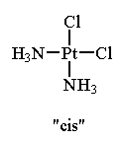 | 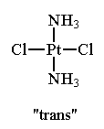
These two structures contain the same molecular struture and bonds but are non-superimposable. The isomer in which like ligands are adjacent to one another is called the cis isomer. The isomer in which like ligands are opposite one another is called the trans isomer.
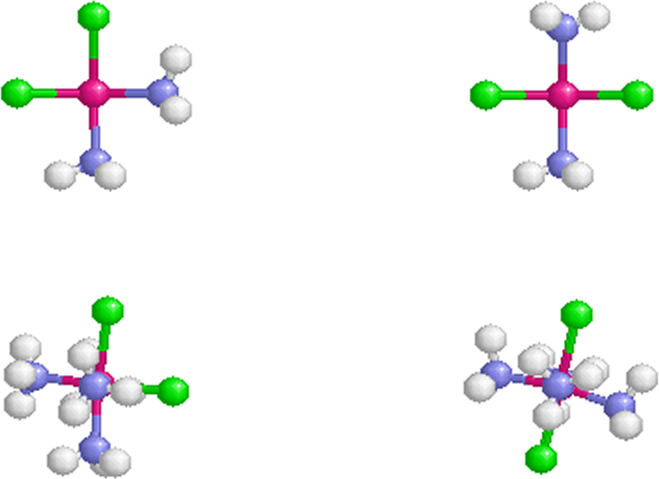 |  | = Pt  = N  = H  = Cl
cis-Pt(NH₃)₂Cl₂  The two ammine ligands are adjacent to one another and the two chloro ligands are adjacent to one another. This compound is used medicinally to treat certain types of cancer. (tradename: "cisplatin"). | trans-Pt(NH₃)₂Cl₂  The two ammine ligands are opposite one another and the two chloro ligands are opposite one another. The like ligands are on opposite sides of the central metal ion. This compound does not exhibit any anti-tumor activity.
For the common structures which contain two or more different ligands, geometric isomers are possible only with square planar and octahedral structures. Geometric isomers do not exist for linear and tetrahedral structures.
= Co
= N
= H
= Cl
cis-[Co(NH₃)₄Cl₂]⁺  In the cis isomer the two chloro ligands are adjacent to one another in this octahedral complex ion. To move form one like ligand to the other it is not necessary to cross the plane containing the central metal ion. | trans-[Co(NH₃)₄Cl₂]⁺  In the trans isomer the two chloro ligands are opposite one another in this complex ion. To move from one like ligand to the other the plane containing the metal ion must be crossed.
Optical Isomers

Optical isomers are two compounds which contain the same number and kinds of atoms, and bonds (i.e., the connectivity between atoms is the same), and different spatial arrangements of the atoms, with non-superimposable mirror images. Each non-superimposable mirror image structure is called an enantiomer. Molecules or ions that exist as optical isomers are called chiral. Separate equimolar solutions of the two isomers rotate plane polarized light by equal angles but in opposite directions. The phenomenon of rotation of polarized light is called optical activity.

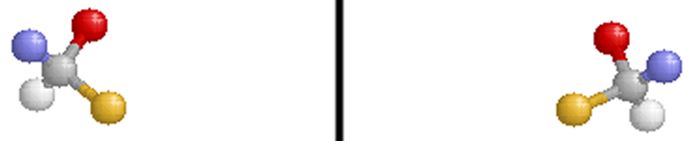 | = C  = H  = F  = Cl  = Br
Two Enantiomers of CHBrClF
Note that the molecule on the right is the reflection of the molecule on the left (through the mirror plane indicated by the black vertical line). These two structures are non-superimposable and are, therefore, different compounds.
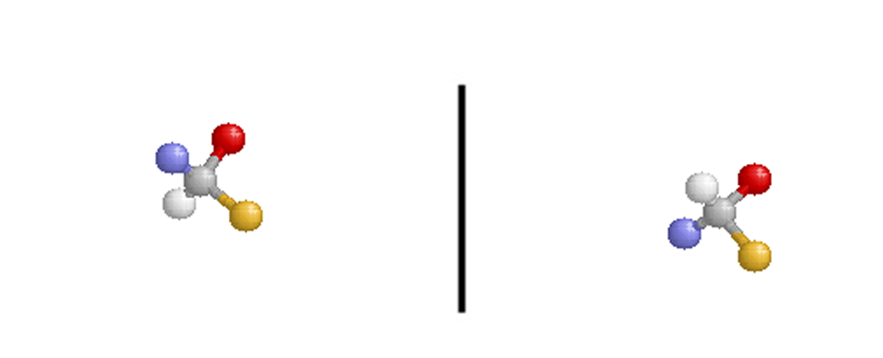

Pure samples of enantiomers have identical physical properties (e.g., boiling point, density, freezing point). Chiral molecules and ions have different chemical properties only when they are in chiral environments.

Optical isomers get their name because the plane of plane-polarized light that is passed through a sample of a pure enantiomer is rotated. The plane is rotated in the opposite direction but with the same magnitude when plane-polarized light is passed through a pure sample containing the other enantiomer of a pair.
- Octahedral complexes can exhibit another type of geometric isomerism
- mer-fac isomerism.
  - mer isomerism involves all three similar ligand lying in the same plane, or meridinal like a globe.
  - fac facial involves a grouping of three similar ligands that are arranged on a triangular face of the octrahedron
fac and mer-Co(NH₃)₃Cl₃
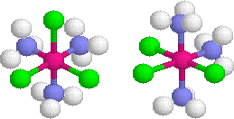
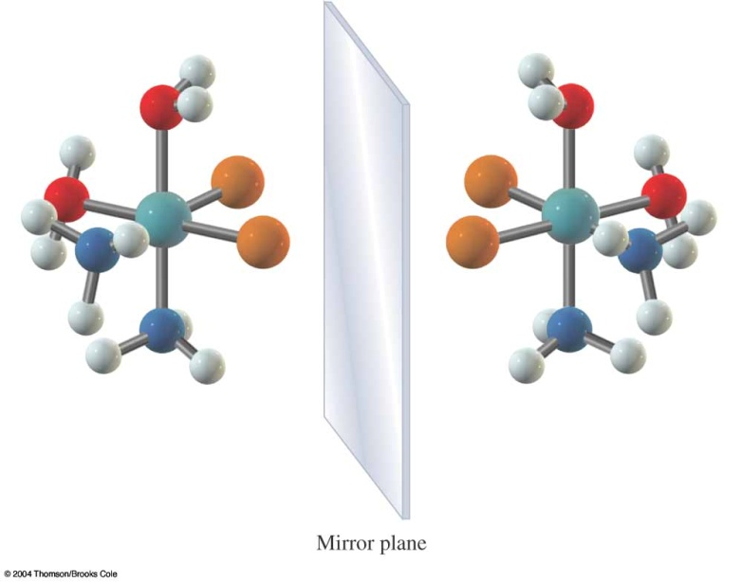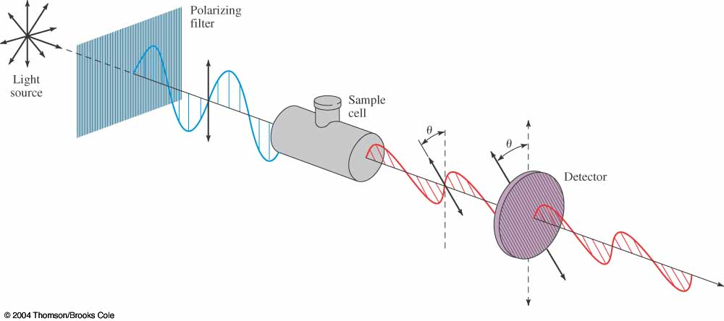

Aqueous Metal Ions
As water can function as a Lewis base and transition metal ions can function as Lewis acids, most salts containing transition metals form coordination complexes when they are dissolved in water.
All salts which contain a first-row transition metal (i.e., Sc, Ti, V, Cr, Mn, Fe, Co, Ni, Cu, Zn) form octahedral complex ions when they are dissolved in water.
In aqueous solution, transition metal cations are usually symbolized as M^{n+}(aq), where M is the atomic symbol of the metal ion and n is the charge on the ion. For example, Fe³⁺ in aqueous solution is written as Fe³⁺(aq). The (aq) symbol indicates that the metal ion is aquated.
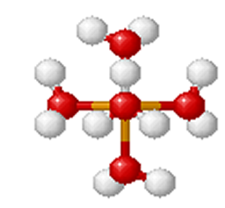 | = Fe  = O  = H
[Fe(OH₂)₆]³⁺

Above is the octahedral complex produced when Fe(NO₃)₃ is dissolved in water. The nitrate counter ions are not shown. When the pH is above 3.5 the hydrolysis reaction will proceed with the splitting of water and ferric hydroxide is formed with the solution becoming more acidic. The FeO(OH) will precipitate out of solution. Hexaaquairon (III) and the subsequent ferric hydroxide are end products in the redox chemistry of pyrite, a major problem known as acid mine drainage. The precipitate referred to as “yellow-boy” is also commonly seen in iron petroleum pipelines.

Complex Formation In Aqueous Solution
When SCN⁻ is added to an aqueous solution containing Fe(NO₃)₃, [Fe(OH₂)₆]³⁺ ions react with SCN⁻ (not free Fe³⁺ ions).

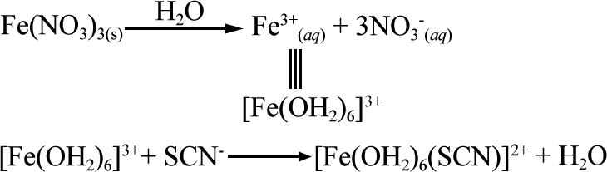
The SCN⁻ ion replaces a water molecule in the coordination sphere to produce the complex ion, [Fe(OH₂)₅(SCN)]²⁺. These two ions are hydration isomers, a subclass of coordination sphere isomers.
Biological Compounds
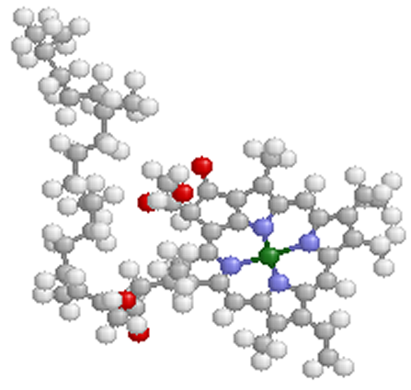 | =Mg  =C  =O  =H  =N | 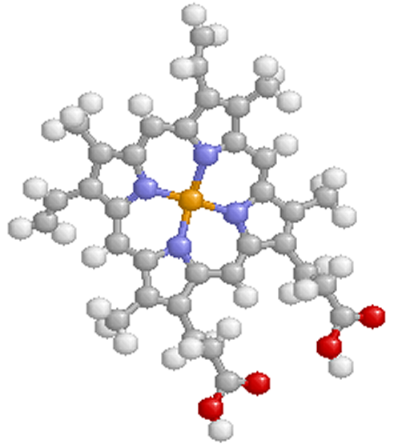 | =Fe  =C  =O  =H  =N
chlorophyll a  Plants appear green because chlorophyll a absorbs red and purple light; the reflected light consequently appears green. The geometry around the Mg ion is square planar. |  | Heme  Heme is the iron-containing complex in hemoglobin. In hemoglobin, the red heme complex is bonded to a large protein molecule (globin) by coordination of the protein to a position above the plane of the heme molecule. The geometry around the Fe ion is square planar.

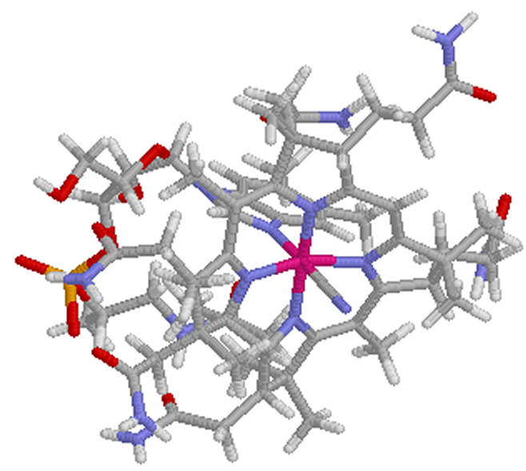 | = Co  = C  = O  = H  = N  = P
vitamin B₁₂
Vitamin B₁₂ is one of the essential vitamins required for living organisms. Note the octahedral structure around the Co atom.
A great deal of help in compiling this and many of the Chime images came from http://www.chem.purdue.edu/gchelp/cchem/ Additional Chime images from http://www.rcsb.org/pdb/
Exercise 1: Determine the oxidation number for each of the transition metal atoms or ions

- [V(OH₂)₆](NO₃)₃
- (NH₄)₂[CoCl₄]
- [Co(py)₄]Br₂
- K4[Mn(CN)6]
- [Co(P(CH₃)₃)₄]₂(SO₄)₃
- Ni(NH₃)₄Cl₂

Exercise 2: Put the following compounds together to give the formula of the compound.
Remember to use [ ] to identify the complex ion in ionic complexes.
Where you need a counterion to produce a neutral compound, use either K⁺ or SO₄⁻².
Remember to list the cation first, followed by anion for ionic compounds.

Metal/charge Ligands Formula
- V⁺³ Four H₂O and two SCN [V(OH₂)₄(SCN)₂]SO₄
- Co⁺² Four Br
- Ru⁺³ Three oxalates
- Os⁺³ Three dppe
- Ni⁺² Two Br⁻, two NH₃, and two CN
- Fe⁺³ Six CN⁻

Exercise 3: Name the following.

- K₄[Ni(CN)₄]
- (NH₄)₃[Fe(SCN)₆]
- Na₂[Ni(CN)₄]
- [Fe(ox)₃]³⁻
- [Co(NH₃)₅Cl]Br₂
- [Cr(OH₂)₄Cl₂]Cl
- [Pt(NH₃)₂]Cl₂
- Na₂[MoOCl₄]
- [Cr(OH₂)₆](NO₃)₃
- [Fe(NH₃)₆]SO₄
- (NH₄)₂[CoCl₄]
- Cr(NH₃)₄Cl₂
- [Co(P(CH₃)₃)₄]₂(SO₄)₃
- [Ni(OH₂)₆]Cl₂

Exercise 4: Write formulas for the following.

- potassium hexacyanoferrate(III)
- sodium hexafluoroaluminate
- Pentaaquabromomanganese(III) sulfate
- hexaamminechromium(III) nitrate
- sodium tetrahydroxochromate(III)
- hexaammineruthenium(III) tetrachloronickelate(II)
- tetraamminecopper(II) pentacyanohydroxoferrate(III)
- potassium diaquatetrabromovanadate(III)

Exercise 5: Provide the name or chemical formula for the following complex compounds or ions.

- [Al (OH₂)₆] Br₃
- [Cr (NH₃)₆] Cl₃
- potassium hexafluoroferrate (III)
- tetrahydroxozincate (II) ion
- [Co (OH₂)₄Cl₂] Cl
- [Cu (NH₃)₄]⁺²
- potassium hexachlorostannate (IV)
- tetraamminedichloroplatinum (IV) hexachloroplatinate (IV)

Exercise 6: Draw the structure for each of the following complex compounds or ions.

- trans-dichlorobis(ethylenediamine)cobalt (III) chlorate
- [Co (NH₃)₆] Cl₃
- cis-diammine-trans-dibromo-cis-dichloroplatinum (VI) bromate
- tetraaquacadmium (II) nitrate
- mer-[Fe (NC)₃(ONO)₃]⁻⁴
- sodium tetraisocyanocuprate (I)
- Ag₄fac-[Fe (NC)₃(ONO)₃]
- Both optical isomers for cis-aqua-cis-carbonyl-cis-cyanonickel (II)
Exercise 7: Which of these compounds is chiral?

(a) Co(NH₃)₃(CN)₃
(b) Cr(NH₃)₂(OH₂)₂(CN)²⁺
(c) cis-Pd(NH₃)₂(Cl)₂
(d) trans-Fe(en)₂(Cl)₂⁺
(e) cis-Mn(en)₂(Cl)₂

Exercise 8: What is the total number of stereoisomers possible for Co(NH₃)₂(Br)₂(en)⁺?

(a) 3
(b) 4
(c) 5
(d) 6
(e) 7

Solutions
Exercise 1: Determine the oxidation number for each of the transition metal atoms or ions
- [V(OH₂)₆](NO₃)₃
x + 6(0) + 3(-1) = 0 x = +3

- (NH₄)₂[CoCl₄]
2(+1) + x + 4(-1) = 0 x = +2

- [Co(py)₄]Br₂
x + 4(0) + 2(-1) = 0 x = +2

- K₄[Mn(CN)₆]
4(+1) + x + 6(-1) = 0 x = +2

- [Co(P(CH₃)₃)₄]₂(SO₄)₃
2(x + 4(0)) +3(-2) = 0 x = +3

- Ni(NH₃)₄Cl₂
x + 4(0) + 2(-1) = 0 x = +2

Exercise 2: Put the following compounds together to give the formula of the compound.
Remember to use [ ] to identify the complex ion in ionic complexes.
Where you need a counterion to produce a neutral compound, use either K⁺ or SO₄⁻².
Remember to list the cation first, followed by anion for ionic compounds.
Metal/charge Ligands Formula

- Co⁺² Four Br

determine if complex is anionic or cationic
1(Co⁺²) + 4(Br⁻) = 1(+2) + 4(-1) = -2 complex is anionic
determine necessary counter ion for neutral compound must be positive so select potassium (K⁺)
formula is K_{x}[Co(Br)₄]
solve for number of potassium needed x(K⁺)+1(Co⁺²)+4(Br⁻)=x(+1)+1(+2)+4(-1)=0 x=2
substitute for x K₂[Co(Br)₄]

- Ru⁺³ Three oxalates

1(Ru⁺³) + 3(ox⁻²) = 1(+3) + 3(-2) = -3 complex is anionic choose K⁺
K_{x}[Ru(ox)₃]
x(K⁺) + 1(Ru⁺³) + 3(ox⁻²) = x(+1) + 1(+3) + 3(-2) = 0 x=3
K₃[Ru(ox)₃]

- Os⁺³ Three dppe

1(Os⁺³) + 3(dppe) = 1(+3) + 3(0) = +3 complex is cationic choose SO₄⁻²
[Os(dppe)₃](SO₄)_{x}
1(Os⁺³) + 3(dppe) + x(SO₄⁻²) = 1(+3) + 3(0) + x(-2) = 0 x=3/2
[Os(dppe)₃](SO₄)_{3/2} * 2 = [Os(dppe)₃]₂(SO₄)₃
- Ni⁺² Two Br⁻, two NH₃, and two CN

1(Ni⁺²) + 2(NH₃) + 2(Br⁻) + 2(CN⁻) = + 1(+2) + 2(0) + 2(-1) + 2(-1) = -2 complex is anionic choose K⁺
K_{x}[Ni(NH₃)₂(Br)₂(CN)₂]
x(K⁺) + 1(Ni⁺²) + 2(NH₃) + 2(Br⁻) + 2(CN⁻) = x(+1) + 1(+2) + 2(0) + 2(-1) + 2(-1) = 0 x=2
K₂[Ni(NH₃)₂(Br)₂(CN)₂]

- Fe⁺³ Six CN⁻
1(Fe⁺³) + 6(CN⁻) = 1(+3) + 6(-1) = -3 complex is anionic choose K⁺
K_{x}[Co(Br)₄]
x(K⁺) + 1(Fe⁺³) + 6(CN⁻) = x(+1) + 1(+3) + 6(-1) = 0 x=3
K₃[Fe(CN)₆]

Exercise 3: Name the following.
- K₄[Ni(CN)₄] potassium tetracyanonickelate
- (NH₄)₃[Fe(SCN)₆] ammonium hexathiocyanatoferrate(III)
- Na₂[Ni(CN)₄] sodium tetracyanonickelate(II)
- [Fe(ox)₃]³⁻ trioxalatoferrate(III) ion
- [Co(NH₃)₅Cl]Br₂ pentaamminechlorocobalt(III) bromide
- [Cr(OH₂)₄Cl₂]Cl tetraaquadichlorochromium(III) chloride
- [Pt(NH₃)₂]Cl₂ diammineplatinum(II) chloride
- Na₂[MoOCl₄] sodium tetrachlorooxomolybdate(IV)
- [Cr(OH₂)₆](NO₃)₃ hexaaquachromium(III) nitrate
- [Fe(NH₃)₆]SO₄ hexaammineiron(II) sulfate
- (NH₄)₂[CoCl₄] ammonium tetrachlorocobaltate(II)
- Cr(NH₃)₄Cl₂ tetraamminedichlorochromium(II)
- [Co(P(CH₃)₃)₄]₂(SO₄)₃ tetrakis(trimethylphosphine)cobalt(III) sulfate
- [Ni(OH₂)₆]Cl₂ hexaaquanickel(II) chloride

Exercise 4: Write formulas for the following.
- potassium hexacyanoferrate(III) K₃[Fe(CN)₆]
- sodium hexafluoroaluminate Na₃[AlF₆]
- pentaaquabromomanganese(III) sulfate [Mn(OH₂)₅Br]SO₄
- hexaamminechromium(III) nitrate [Cr(NH₃)₆](NO₃)₃
- sodium tetrahydroxochromate(III) Na[Cr(OH)₄]
- hexaammineruthenium(III) tetrachloronickelate(II) [Ru(NH₃)₆]₂[NiCl₄]₃
- tetraamminecopper(II) pentacyanohydroxoferrate(III) [Cu(NH₃)₄]₃[Fe(CN)₅OH]₂
- potassium diaquatetrabromovanadate(III) K[V(OH₂)₂Br₄]

Exercise 5: Provide the name or chemical formula for the following complex compounds or ions.
- [Al (OH₂)₆] Br₃ hexaaquaaluminum bromide
- [Cr (NH₃)₆] Cl₃ hexaamminechromium(III) chloride
- potassium hexafluoroferrate (III) K₃[FeF₆]
- tetrahydroxozincate (II) ion [Zn(OH)₄]⁻²
- [Co (OH₂)₄Cl₂] Cl tetraaquadichlorocobalt(III) chloride
- [Cu (NH₃)₄]⁺² tetraamminecopper(II) ion
- potassium hexachlorostannate (IV) K₂[SnCl₆]
- tetraamminedichloroplatinum (IV) hexachloroplatinate (IV) [Pt(NH₃)₄Cl₂][PtCl₆]

Exercise 6: Draw the structure for each of the following complex compounds or ions.

- trans-dichlorobis(ethylenediamine)cobalt (III) chlorate
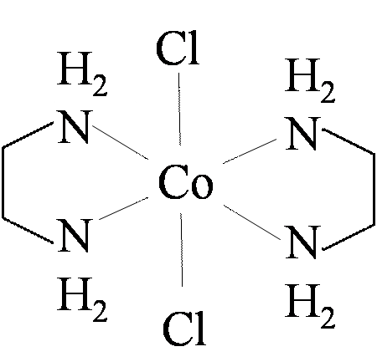

- [Co (NH₃)₆] Cl₃
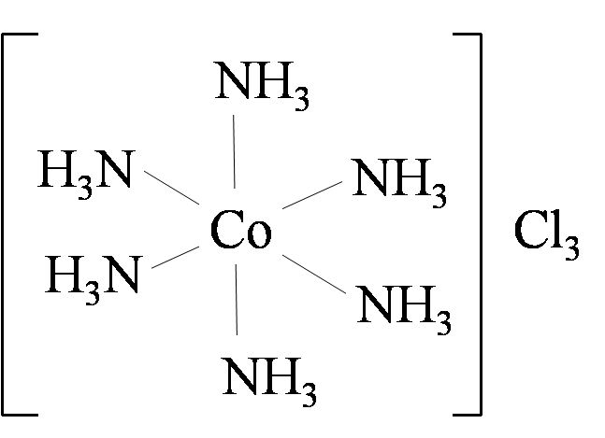

- cis-diammine-trans-dibromo-cis-dichloroplatinum (VI) bromate
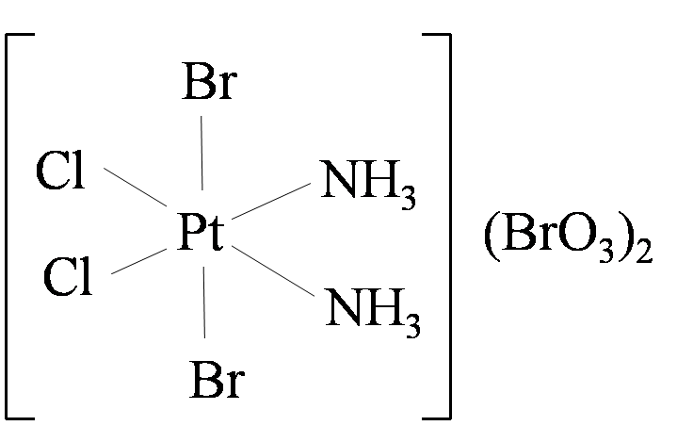

- tetraaquacadmium (II) nitrate
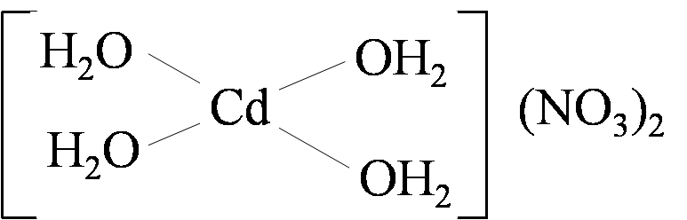

- mer-[Fe(NC)₃(ONO)₃]⁻⁴
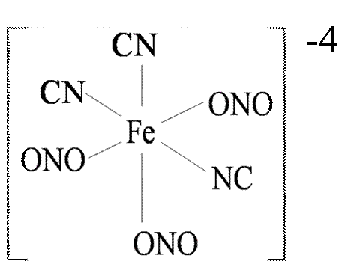

- sodium tetraisocyanocuprate (I)
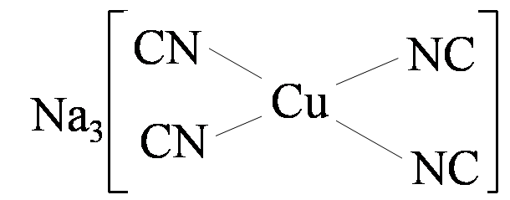

- Ag₄fac-[Fe (NC)₃(ONO)₃]
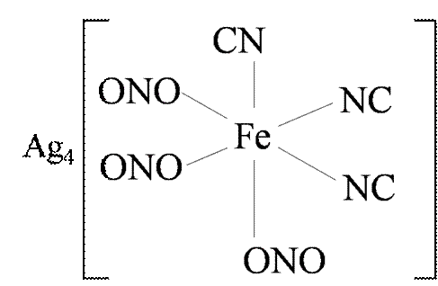

- Both optical isomers for cis-aqua-cis-carbonyl-cis-cyanonickel (II)
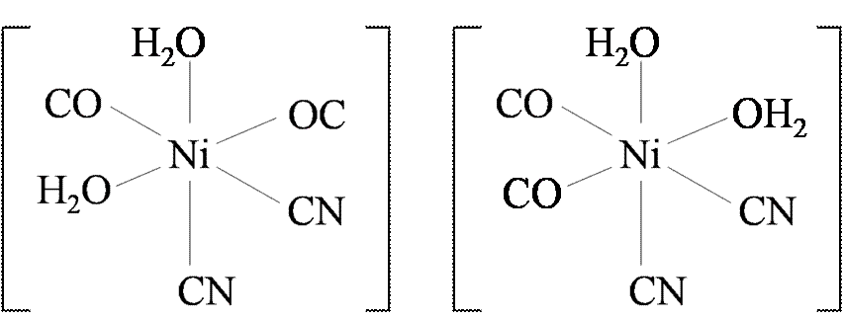

Exercise 7: Which of these compounds is chiral?

(a) Co(NH₃)₃(CN)₃
(b) Cr(NH₃)₂(OH₂)₂(CN) ₂²⁺
(c) cis-Pd(NH₃)₂(Cl)₂
(d) trans-Fe(en)₂(Cl)₂⁺
(e) cis-Mn(en)₂(Cl)₂

Exercise 8: What is the total number of stereoisomers possible for Co(NH₃)₂(Br)₂(en)⁺?

(a) 3
(b) 4
(c) 5
(d) 6
(e) 7

