**Grade 10 TRIGONOMETRY**

**Definitions:**

Define the trigonometric ratios,  and using right-angled

triangle.



1.  (1)
2.  (1)
3.  (1)

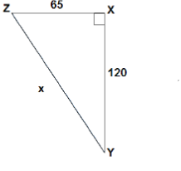

1.  (1)
2.  (1)
3.  (1)
4.  (1)
5.  (1)
6.  (1)

**Using Trig Ratios to Solve Triangles: Sides**

The trig ratios can be used to find lots of information, and one of their main purposes is to help solve triangles. To solve a triangle means to find the length of all the sides and the measure of all the angles.  
  
There are three steps:  
  
**1. Choose which trig ratio to use.**  
- Choose either sin, cos, or tan by determining which side you know and which side you are looking for.  
  
**2. Substitute**  
- Substitute your information into the trig ratio.

**3. Solve**  
- Solve the resulting equation to find the length of the side.

**Example :**  
  
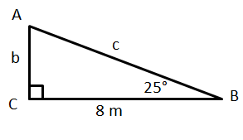http://www.softschools.com/math/calculus/images/using_trig_ratios_to_solve_triangles_sides_img3.png  
  
1. Find b.

**Step 1: Choose which trig ratio to use.**  
  
So we need to choose the trig ratio that has **opposite and adjacent.** This of course is the **tangent.**  
  
**Step 2: Substitute**

http://www.softschools.com/math/calculus/images/using_trig_ratios_to_solve_triangles_sides_img2.png

Then, we substitute in the angle and the side we know:   
  
**Step 3: Solve**  
  
Now move the 8 to the other side by multiplying both sides by 8:   
  
And use a calculator to find the answer: 3.7 m.  
  
Find c :    8.8 m.

**Practice:**  
  
Find the following. Round your answers to two decimals.  
  
1) a      2) c      3) x      4) y (8)

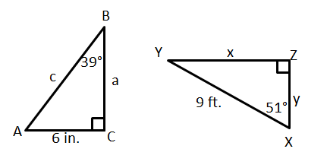

**Solving two – dimensional problems involving right-angled triangles.**

1. The length of a mast is 8, 5m, and the length of the shadow of the mast is 7, 25m. Calculate the angle of elevation of the sun at the particular moment. (4)
2. The angle of elevation of a glider according to a woman on the ground is 430. If the glider is 2 340m from the woman, calculate the altitude of the glider. (4)
3. Two towers are 12m apart. From B the angle of elevation to DE is 290 and from D the angle of elevation to BC is 480. Calculate the difference in the heights of the towers.



(7)

1. A building (DF) and a tower (CE) are 94m apart. From the roof of the building the angle of elevation to the top of the tower is 150 and the angle of depression to the bottom of the tower is 460. Calculate the height of the tower.



(7)

**Special angles and Reduction formulae:**

To simplify ratio of angles greater than 900  and smaller than 3600 CAST diagram is used to give the sign of the simplified ratio. Reduction formulae are used to reduce the angle.

**Derive values of the trigonometric ratios for the special cases (without using a calculator).**

1.  (2)
2.  (2)
3.  (4)
4.  (4)
5.  (6)

**Solving Right- angled triangle**

Determining the diagram

Two pieces of information are given to determine the quad within which the triangle lies. The third side of the triangle is found using the Theorem of Pythagoras.

Substitute to evaluate the expression given.

1. Use diagrams to determine the numerical values of ratios for angles

from 0° and 90°.

1.  ,  an acute angle (4)
2.  (2)
3.  (3)
4.  (4)
5.  (5)
6.  (4)

2. Use diagrams to determine the numerical values of ratios for angles from 0° and 360°.

1. If , , determine  (4)
2. If  and  is an acute angle, determine. (4)
3. If and, determine. (5)
4. If and, determine. (5)
5. If and, determine. (5)

