|  |  |  |  |  |  |  |
| --- | --- | --- | --- | --- | --- | --- |
| ***GR 10 REVISION: EQUATIONS*** | | | | | | |
|  |  |  | |  |  |  |
| 1. Solve for : | | | | | | |
|  | |  |  |  |  |  |
| a. | |  |  | b. |  |  |
|  | |  |  |  |  |  |
| 3.  c. | |  |  | d. |  |  |
|  | |  |  |  |  |  |
| e. | |  |  | f. |  |  |
|  | |  |  |  |  |  |
| g. | |  |  | h. |  |  |
|  | |  |  |  |  |  |
| i. | |  |  | j. |  |  |
|  | |  |  |  |  |  |
| k. | |  |  | l. |  |  |
|  | |  |  |  |  |  |
| m. | |  |  | n. |  |  |
|  | |  |  |  |  |  |
| o. | |  |  | p. |  |  |
|  | |  |  |  |  |  |
|  | |  |  |  |  |  |

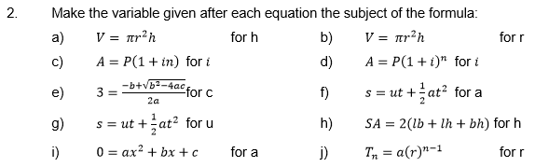

3. Solve for *x* and *y* simultaneously:

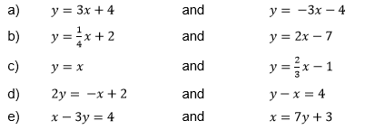

4. Solve for *x.* (Represent your answer on a number line)

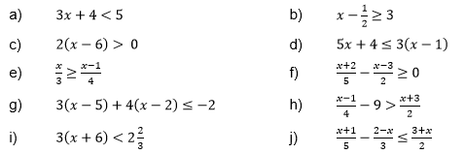

5.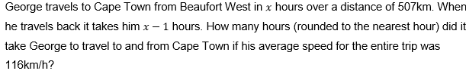

6.

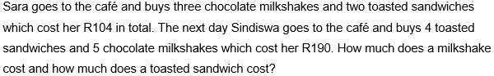

7.

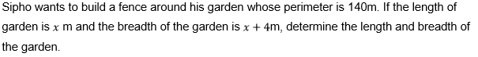

8.



***ANSWERS***

|  |  |  |  |  |  |  |  |  |  |
| --- | --- | --- | --- | --- | --- | --- | --- | --- | --- |
|  | | | | | | | | | |
| 1 | |  | |  | |  | |  |  |
| a. |  | | $$2x+2-3=6x-9$$ $8=4x$ $2=x$ | | | b. | |  | $$3x^{2}-12x=0$$ $3x\left(x-4\right)=0$ $$x=0 or x=4$$ |
|  |  | |  | | |  | |  |  |
| 3.  c. |  | | $5^{x-2}=5^{-2}$ $$x-2=-2$$ $x=0$ | | | d. | |  | $x^{\frac{1}{2}}=16=2^{4}$ $${\left(x^{\frac{1}{2}}\right)}^{2}={\left(2^{4}\right)}^{2}$$ $x=2^{8}=256$ |
|  |  | |  | | |  | |  |  |
| e. |  | | $$3^{x}\left(3-\frac{1}{3}\right)=24$$ $3^{x}\left(\frac{8}{3}\right)=24$ $3^{x}=9=3^{2}$ $x=2$ | | f. | | $$x\left(2x+1\right)-\left(x+2\right)\left(x+1\right)=x\left(x+1\right)$$ $2x^{2}+x-\left(x^{2}+3x+2\right)=x^{2}+x$ $2x^{2}+x-x^{2}-3x-2=x^{2}+x$ $-2=3x$ $-\frac{2}{3}=x$ | | |
|  |  | |  | | |  | |  |  |
| g. |  | | $$x^{2}-5x-14-10=0$$ $x^{2}-5x-24=0$ $\left(x-8\right)\left(x+3\right)=0$ $x=8 or x=-3$ | | | h. | |  | $5^{2x^{2}-x-3}=5^{0}$ $2x^{2}-x-3=0$ $$\left(2x-3\right)\left(x+1\right)=0$$ $x=\frac{3}{2} or x=-1$ |
|  |  | |  | | |  | |  |  |
| i. |  | | $x^{-\frac{3}{2}}=125=5^{3}$ $${\left(x^{-\frac{3}{2}}\right)}^{-\frac{2}{3}}={\left(5^{3}\right)}^{-\frac{2}{3}}$$ $x=5^{-2}=\frac{1}{25}$ | | | j. | |  |  |
|  |  | |  | | |  | |  |  |

|  |  |  |  |  |  |  |  |
| --- | --- | --- | --- | --- | --- | --- | --- |
| k. |  | $2^{x-1}=\frac{1}{64}=2^{-6}$ $$x-1=-6$$ $x=-5$ | | l. | | $\frac{x}{x+2}-\frac{x}{x-3}=\frac{3x-2}{\left(x+2\right)\left(x-3\right)}$ $$x\left(x-3\right)-x\left(x+2\right)=3x-2$$ $$x^{2}-3x-x^{2}-2x=3x-2$$ $2=8x$ $\frac{1}{4}=x$ | |
|  |  |  |  | |  | |  |
| m. |  | $$\frac{5x}{2\left(x+3\right)}=\frac{5}{x+3}$$ $5x=5\left(2\right)=10$ $x=2$ | n. | |  | | $2^{2x+1}=32=2^{5}$ $$2x+1=5$$ $2x=4$ $x=2$ |
|  |  |  |  | |  | |  |
| o. |  | $x\left(x^{2}-1\right)=0$ $$x\left(x-1\right)\left(x+1\right)=0$$ $$x=0 or x=1 or x=-1$$ | p. | |  | |  |

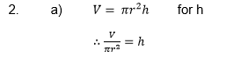 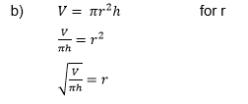

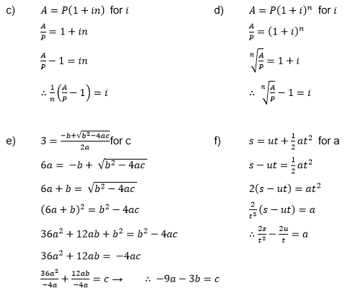

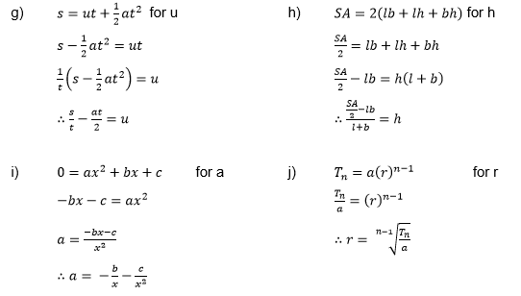

3.

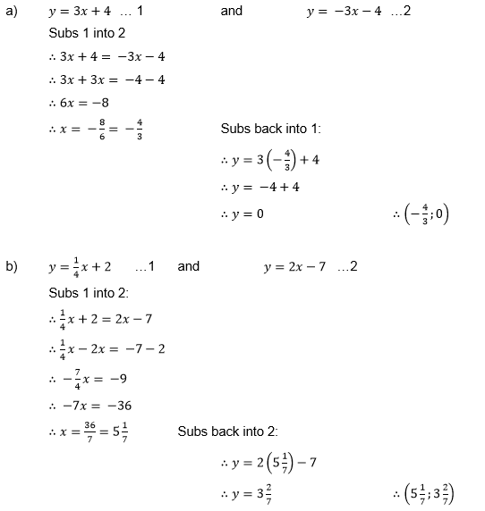

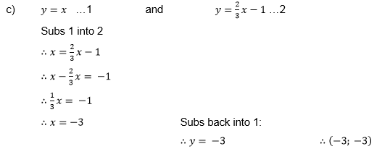

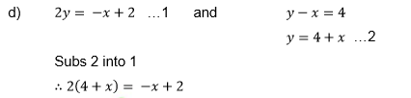

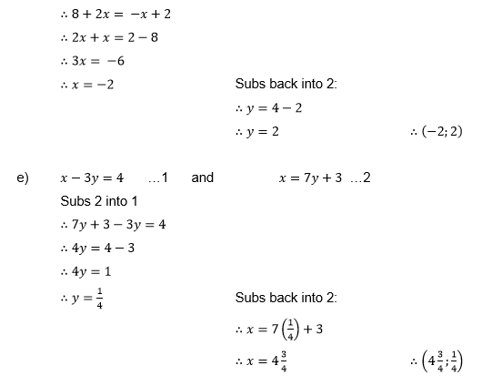

4.

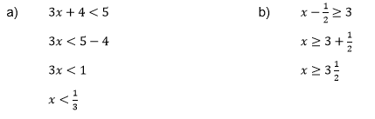

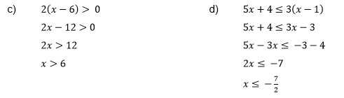

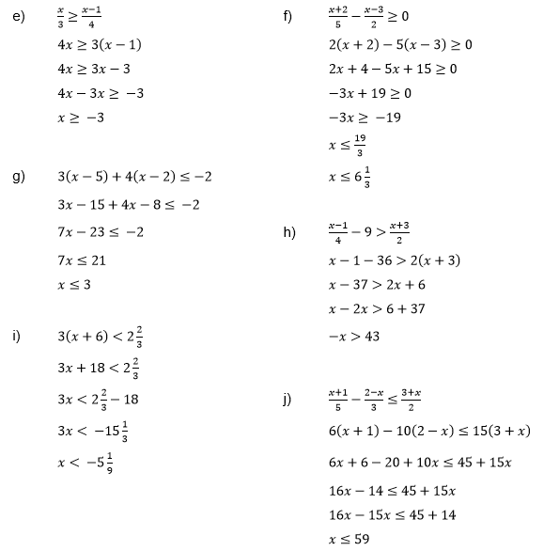

5.

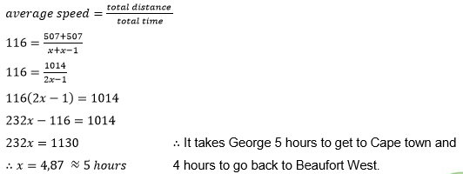

6.

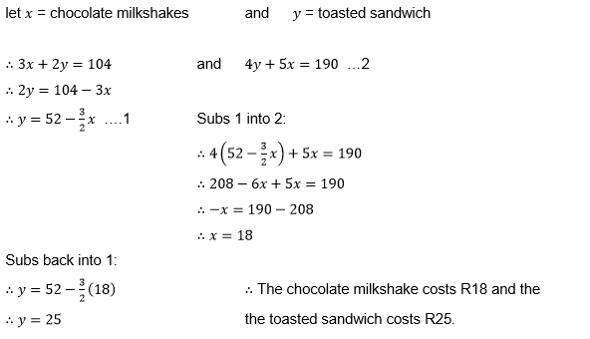

7.

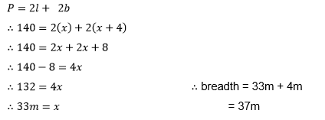

8.

