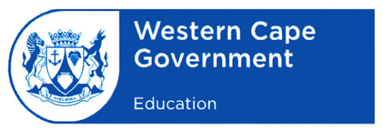Western Cape Education Department **Curriculum GET**

President Ramaphosa announced that all schools will close on Wednesday 18 March and re-open on 14 April 2020 due to the International COVID -19 pandemic.

Director, Curriculum GET, Ms. Karen Dudley together with Senior Curriculum Planners have compiled a **document per subject** to assist parents and learners to prepare for term 2. These documents contain links to the internet and in specific to the WCED E-portal, tips and hints to keep learners from Grade ECD – 9 academically connected and ready for the new term.

|  |  |  |  |
| --- | --- | --- | --- |
| **ECD** | | | |
| ECD |  |  |  |
| **FOUNDATION PHASE** | | | |
| **Subject** | **English** | **Afrikaans** | **IsiXhosa** |
| Home Language |  |  |  |
| First Additional Language |  |  |  |
| Mathematics |  |  |  |
| Life Skills |  |  |  |

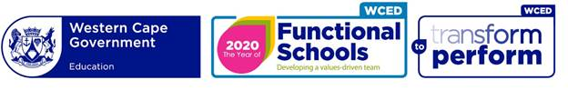

|  |  |  |
| --- | --- | --- |
| **INTERSEN** | | |
| **Subject** | **English** | **Afrikaans** |
| Languages |  |  |
| Mathematics |  |  |
| Life Orientation |  |  |
| Social Sciences |  |  |
| Natural Sciences |  |  |
| Technology |  |  |
| Economic Management Sciences |  |  |
| Creative Arts |  |  |