Earth Day Coordinate Graphing Mystery Picture Worksheet
Practice plotting ordered pairs with this fun Earth Day coordinate graphing mystery picture! All points are represented by whole numbers, there are no fractions or decimals.
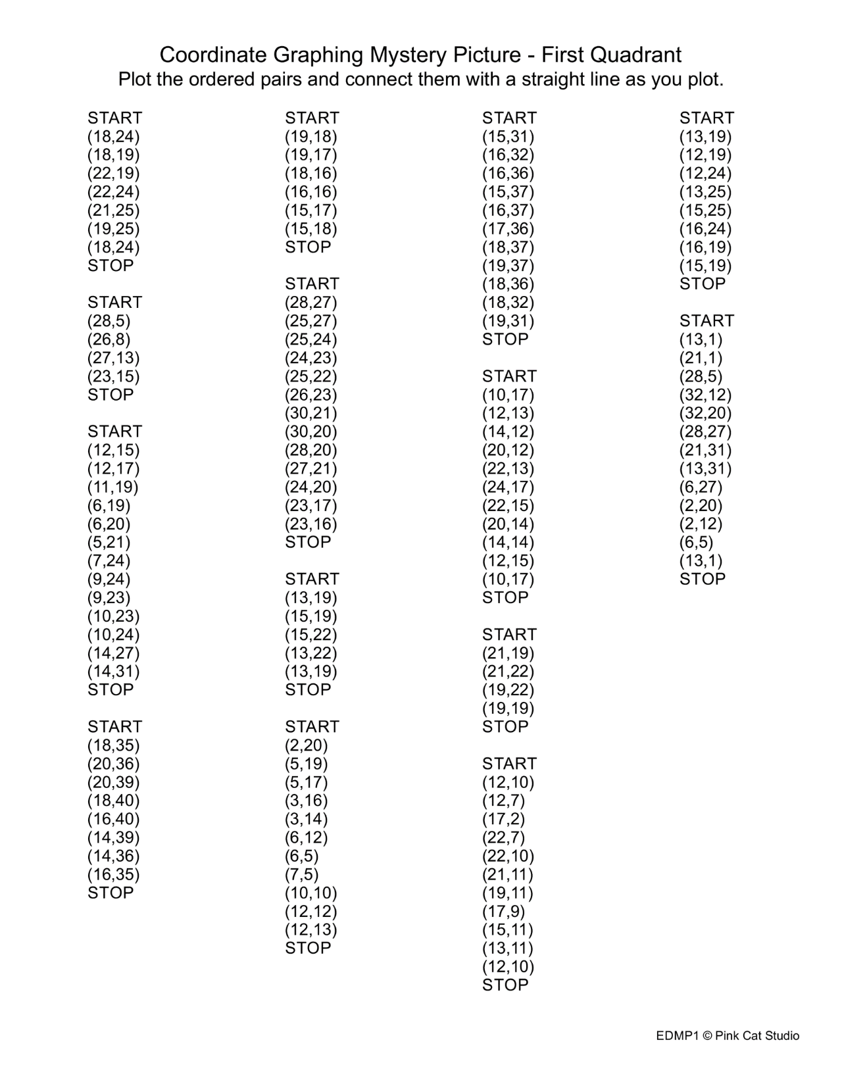
Instructions: Students plot the ordered pairs and draw connecting straight lines as they plot. When the word “STOP” is reached, the student should NOT connect the last point with the first in the group.

