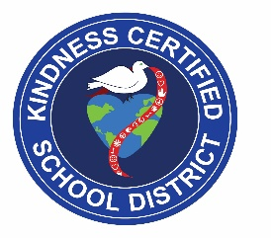
GREAT KINDNESS CHALLENGE
DOUBLE CHURCHES ELEMENTARY SCHOOL
DAILY ACTIVITIES
WEEK OF JANUARY 24-28, 2022
MONDAY  Jan. 24th | TUESDAY  Jan. 25th | WEDNESDAY  Jan. 26th | THURSDAY  Jan. 27th | FRIDAY  Jan. 28th
MORNING MEETING  KINDNESS QUOTE:  “Choose to be KIND over being right and you’ll be right every time.”  -Richard Carlson  SPREAD THE SPIRIT OF KINDNESS  Students, Faculty & Staff:  Wear t-shirts with positive words to spread the spirit of KINDNESS.  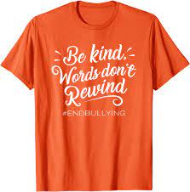 | MORNING MEETING  KINDNESS QUOTE:  “Be KIND whenever possible. It is always possible.”  -Dalai Lama  PEACE, LOVE &  KINDNESS  Students, Faculty & Staff:  Wear peace sign or tie-dye and help create PEACE, LOVE & KINDNESS around the world. | MORNING MEETING  KINDNESS QUOTE:  “Let today be a day to let KINDNESS rule all your actions.”  -Jonathan Lockwood Hui  SHINE BRIGHT WITH  KINDNESS  Students, Faculty & Staff:  Wear your favorite pair of sunglasses. | MORNING MEETING  KINDNESS QUOTE:  “A warm smile is the universal language of KINDNESS.”  -William Arthur Ward  A LITTLE SPOT OF KINDNESS  Students, Faculty & Staff:  Wear something with dots or spots and see how many acts of kindness you can spot  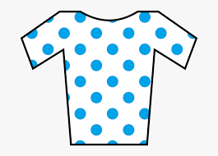 | MORNING MEETING  KINDNESS QUOTE:  “When words are both true and KIND they can change our world.”  -Buddha  TEAM  KINDNESS  Students, Faculty & Staff: Wear your favorite sports team shirt or your DCE shirt and be a part of the TEAM KINDNESS.  Team Kindness  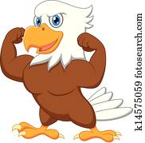  Hannan Hawk Pride
Additional ways DCES is spreading KINDNESS during the GREAT KINDNESS CHALLENGE week are below:
**Art classes – Can create art of KINDNESS by answering the question, “What does KINDNESS look like?”
**P.E. classes – Can power up by working together in activities and encouraging each other to spread KINDNESS.
**Music classes – Can listen to music that they think sounds like kindness.
**Bulletin Board (outside the Café) – Students can grab a note from the bulletin board different to write about something KIND that another person has done for them and share with Mrs. Mays
**Digital School Sign, Facebook, School & Teacher Websites, Connect Ed. – Express and promote that DCES is a community of KINDNESS.

