UNIT -1
NUCLEAR CHEMISTRY

Learning goals and key skills:
- Write balanced nuclear equations
- Know the difference between fission and fusion
- Predict nuclear stability in terms of neutron-to-proton ratio
- Calculate ages of objects or amounts of materials from data on nuclear abundances using the half-life of a radioactive material
- Convert between nuclear activity units
- Calculate mass and energy changes for nuclear reactions
- Understand the meaning of radiation dosage terms
- Understand the biological effects of different kinds of radiation

The nucleus

The nucleus is comprised of the two
nucleons: protons (p+) and neutrons (n0)

Mass number

Atomic number (optional)

Symbol
12
C
6

Atomic number: equal to the number of protons in the nucleus. All atoms of the same element have the same number of protons.
Mass number: equal to the sum of the number of protons and neutrons for an atom.

Isotopes

Atoms with identical atomic numbers but different mass numbers

12
C carbon-12
6

14
C carbon-14
- Hydrogen or
H protium
1
- H deuterium, D 1

6
3
H tritium, T
1

Isotopes
Radionuclides are nuclei that are radioactive – i.e., they will spontaneously emit radiation. Atoms containing these nuclei are called radioisotopes. Some nuclides (radionuclides) of an element are unstable, or radioactive. There are several ways radionuclides can decay into a different nuclide.

238
U
92
235
U
92

234
U
92
abundance: 99.27%

0.72%

0.0055%
half-life
4.47 billion years

700 million years

246,000 years

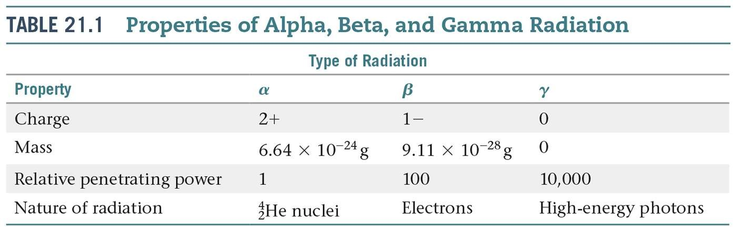

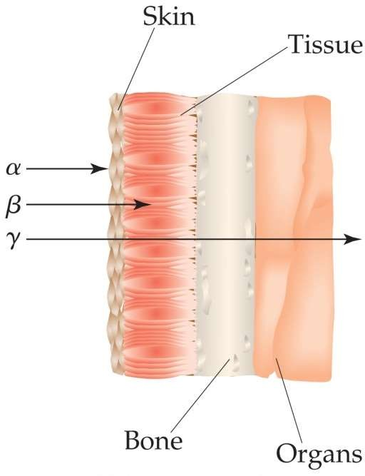
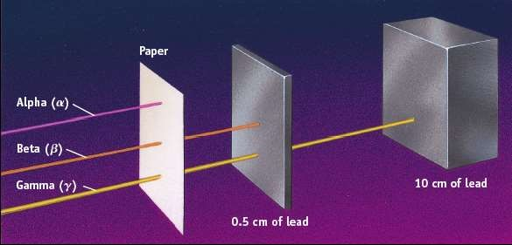

a, b and g Radiation
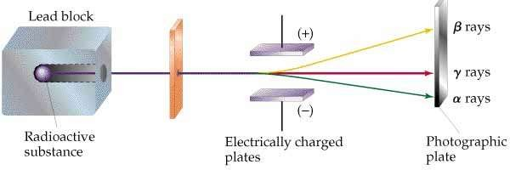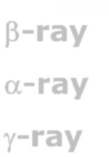

b-ray  High speed electron: charge= -1, mass= 9.1110-28 g a-ray  He core: charge= +2, mass= 7295  mass of electron g-ray  Electromagnetic Radiation: no charge, no mass

a-ray g-ray
b-ray
4

symbol
a or 4He 2 2
0 b or 0 e g or 0 g
-1 -1 0

symbol
Other common nuclear particles
neutron proton positron
 | 0 | 1 | +1 or or +1
charge | 0 | 1+ | 1+
mass | 1.675 × 10-24 g  1.00867 amu | 1.673 × 10-24 g  1.00728 amu | 9.11 × 10-28 g  0.00549 amu

1n 1 p
0 b b 0 e

+

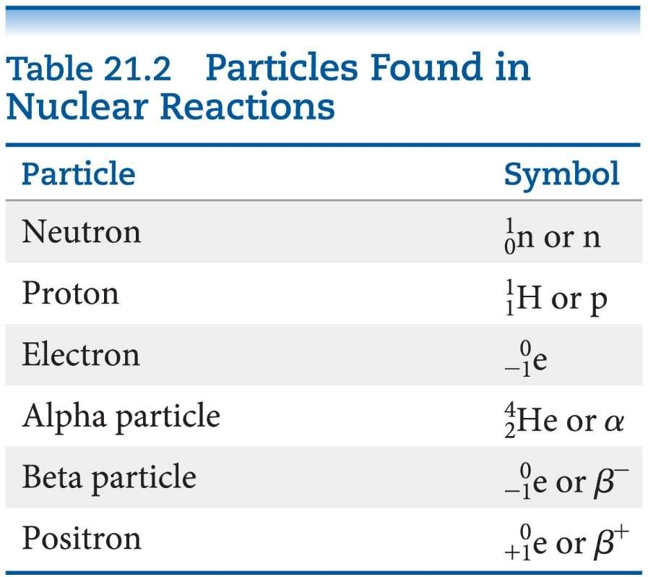

Types of Radioactive Decay

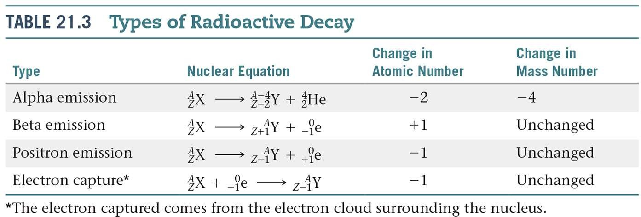

Nuclear reactions
Balance using conservation principles, baryon number conservation.

Alpha decay
Radium-226 emits an alpha particle.

226 Ra
88
4 He +
2
222 Rn
86

Beta decay
An unstable neutron in the nucleus will emit a beta particle.

1n 0
0 -1
b + 1 p
1

Carbon-14 undergoes beta decay.

14C 0

b 14 N

6 -1 + 7

Nuclear reactions
Gamma emission
An excited nuclear state emits gamma radiation. 0
g
(Generally not shown when writing nuclear equations.) 0

Uranium-238 undergoes alpha decay and then gamma emission.

Technetium-99 is metastable and undergoes gamma emission. (Half-life is 6 hours.)

Nuclear reactions
Positron emission
A neutron-poor nuclei will undergo positron emissions.

1 p 0 b + 1n
1 +1 0

Carbon-11 undergoes positron emission.

11C 0 e +
11 B

6 +1 5

Nuclear reactions
Electron capture (K-capture)

A neutron-poor nucleus can decay by positron emission or electron capture.
1 p + 0 e 1n
1 -1 0

Iron-55 decays by electron capture.

-Any atom with more than one proton will have repulsions between the protons in the nucleus.
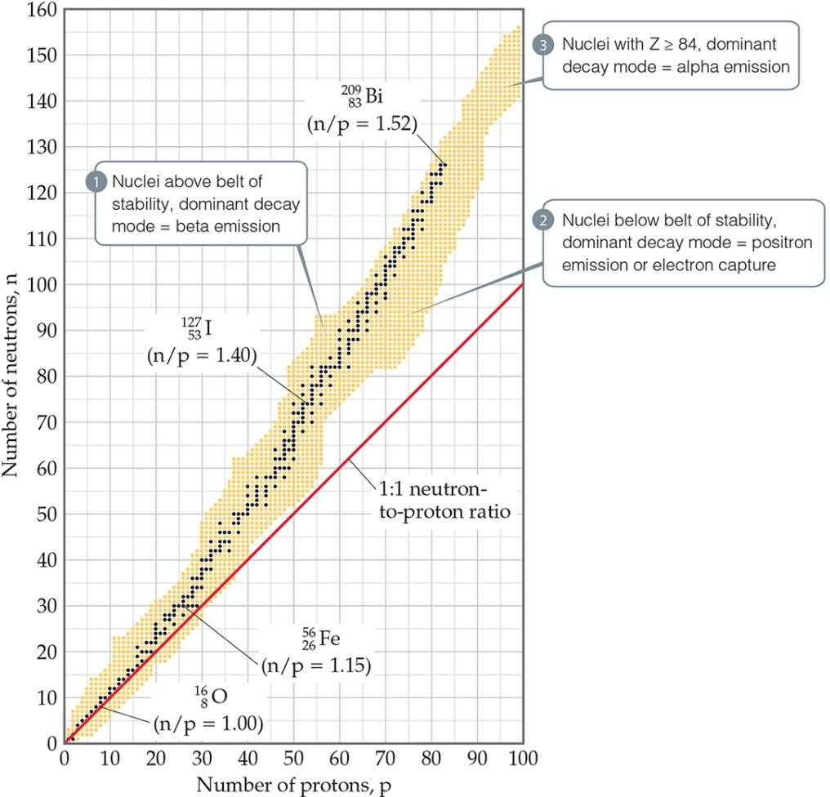
-Strong nuclear force helps keep the nucleus together, key role of ratio of neutrons to protons.

Belt of stability

Only 1H and 3He have more p+ than n0.
- Up to Z = 20 (Ca), n0/p+ ≈ 1.
- Above Z = 20, n0/p+ > 1.
- After Z = 83 (Bi), all isotopes are unstable.
For unstable nuclei:
- the heavier, the shorter the half-life.
- the further from the line, the shorter the half-life.

Predicting nuclear decay
too high N:
b emission

too high N and Z (≥84):
a emission

too high Z : electron capture

too high Z: b+ emission

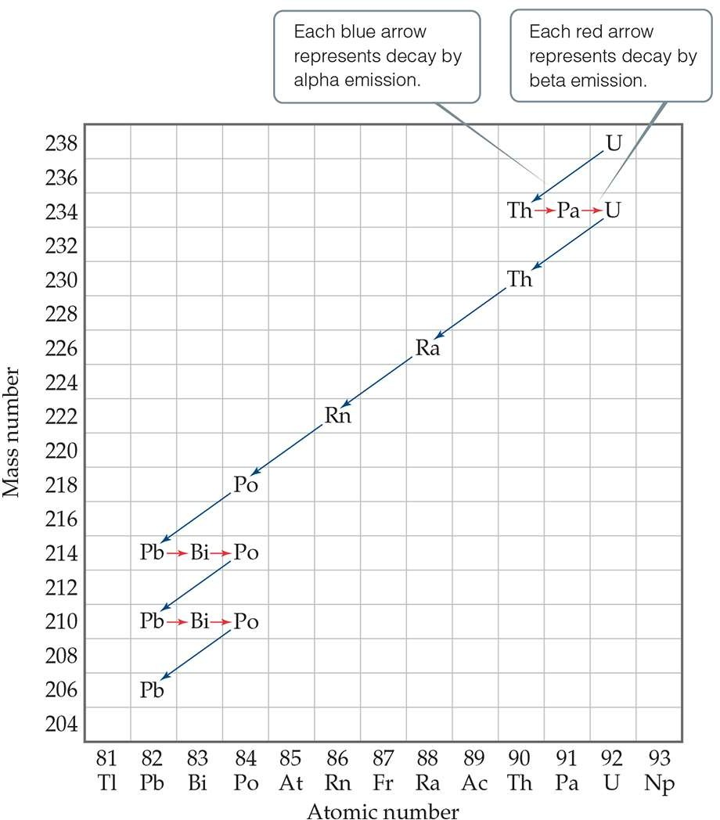
Radioactive/nuclear disintegration series
  - Large radioactive nuclei cannot stabilize by undergoing only one nuclear transformation.

  - They undergo a series of decays until they form a stable nuclide (often a nuclide of lead).

Example
The radioactive series beginning with uranium-238 (Z
= 92) terminates with lead-206 (Z = 82). How many alpha decays occur, and how many beta decays occur?

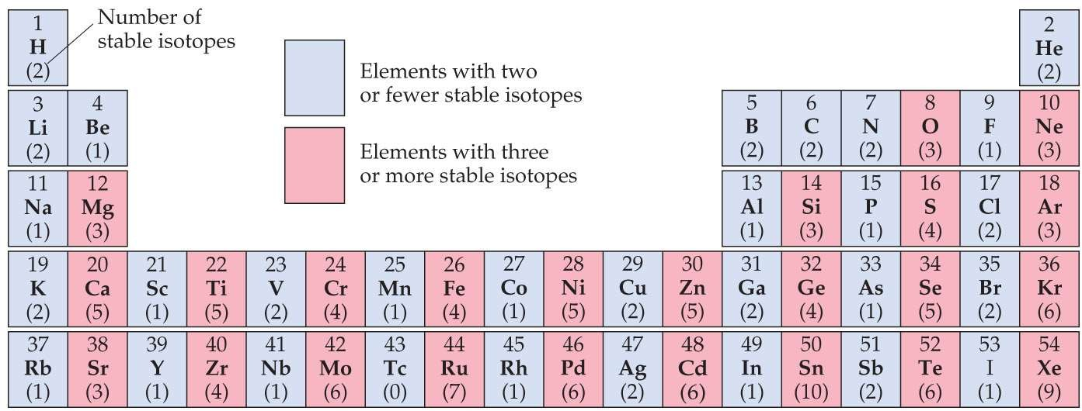

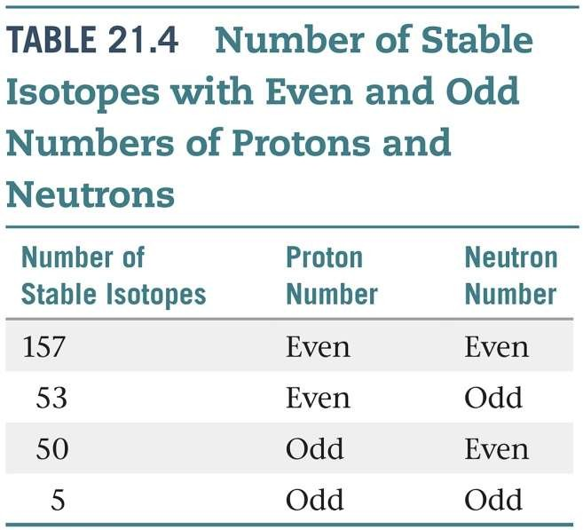
Nuclei with
- 2, 8, 20, 28, 50, 82, 126, or 184 p+
or
- 2, 8, 20, 28, 50, 82, 126, or 184 n0
are generally more stable than other nuclei.
- “Magic numbers”

Particle Accelerators
Nuclear transformations can be induced by accelerating a particle and colliding it with the nuclide.
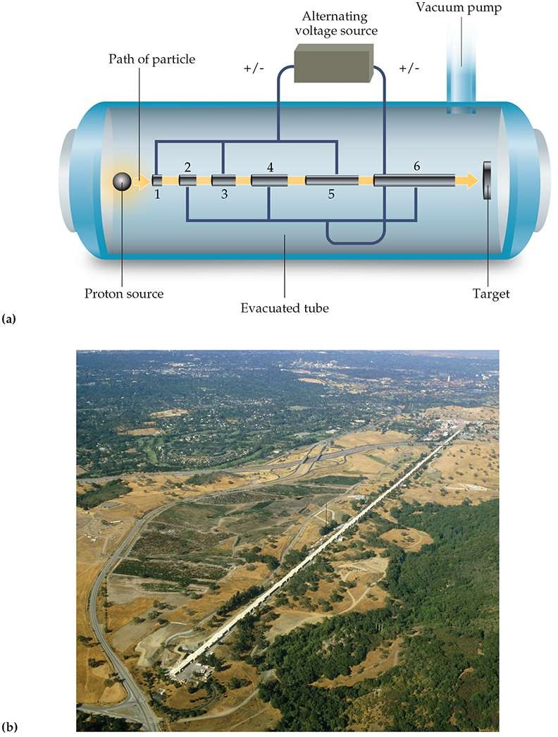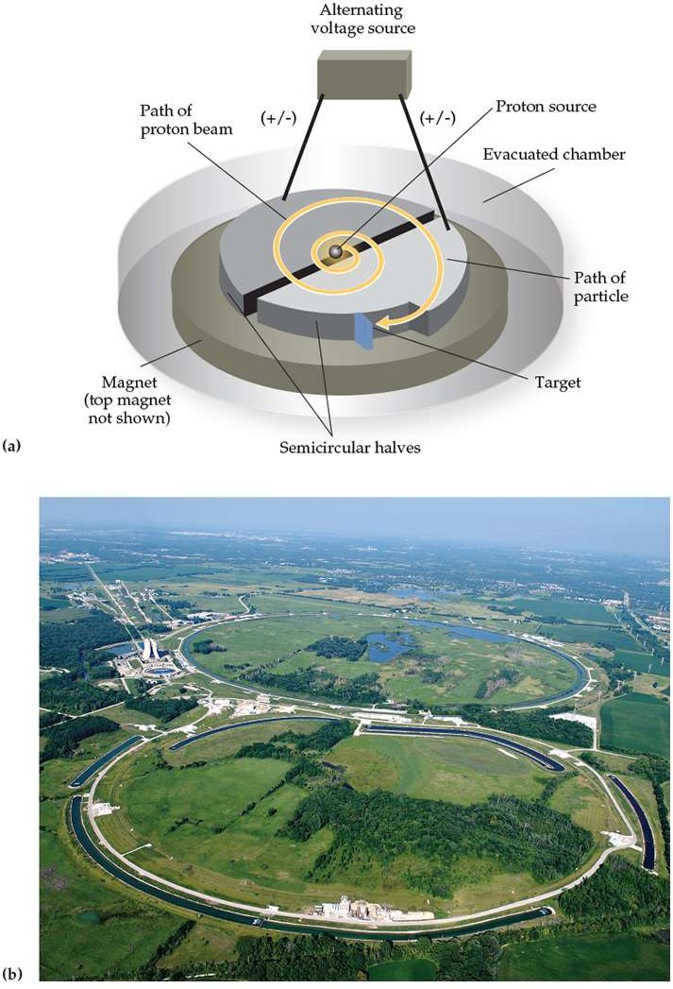

Nuclear transformations
A nucleus can be transformed when it is struck by a neutron or another nucleus. This type of reaction is called a nuclear transmutation.

14N +
4He 1H
+ 17O

7 2 1 8
target bombarding ejected product nucleus particle particle nucleus
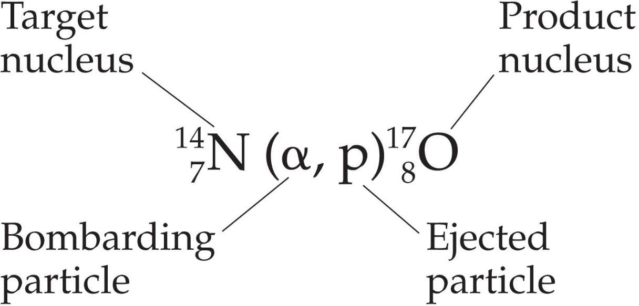

Nuclear kinetics: first-order process

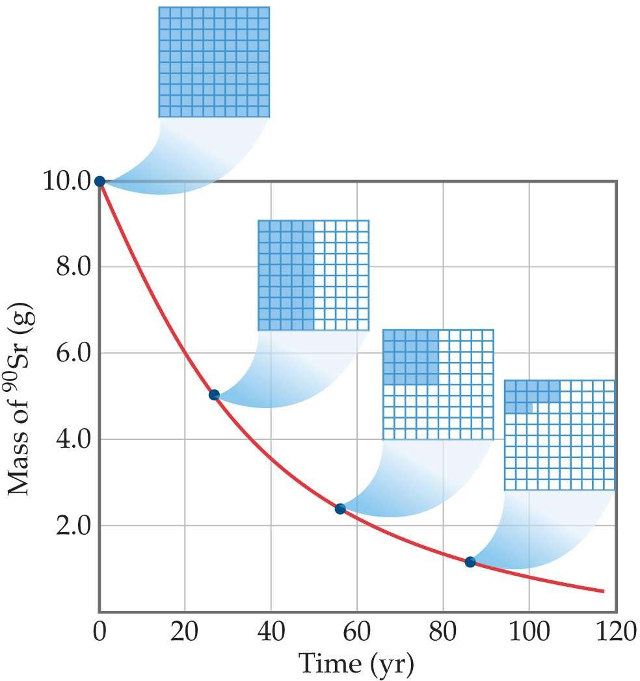ln Nt N0
k
= - kt
0.693

= t1/2

Half-life is the time required for half of a radionuclide sample to decay.
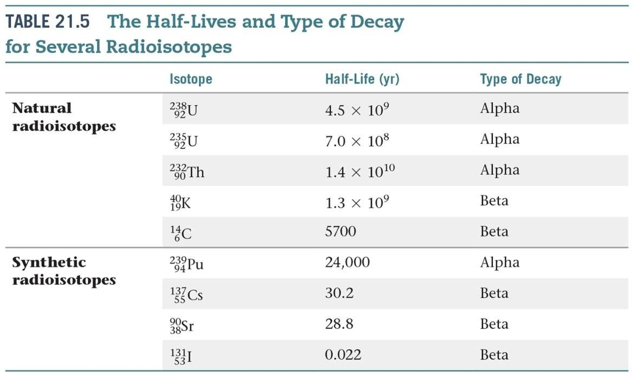

Rates of decays
activity: rate at which a sample decays, disintegrations per unit time, typically measured in dps (disintegrations per second)

becquerel (Bq): SI unit for activity.
1 Bq = 1 dps

curie (Ci): rate of decay of 1 g of radium.
1 Ci = 3.7 × 1010 dps

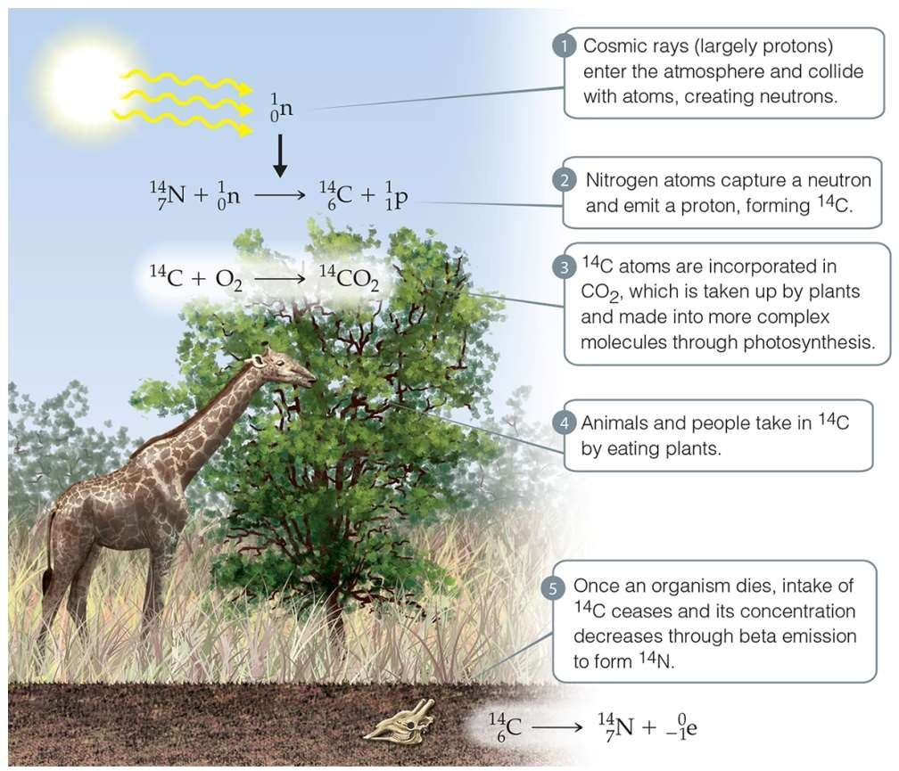Kinetics of Radioactive Decay: Radiometric Dating
A wooden object from an archeological site is subjected to radiocarbon dating.
The activity of the sample that is due to 14C is measured to be
11.6 disintegrations per second. The activity of a carbon sample of equal mass from fresh wood is
15.2 disintegrations per second. The half- life of 14C is 5715 yr. What is the age of the archeological sample?

Example
A 1.0 mg sample of uranium-238 decays at a rate of 12 alpha emissions per second = 12 dps. Find the half-life of uranium-238.

Measuring Radioactivity
Film badges (spots on the developed film) and phosphors (measure the amount of light emitted by a phosphor in a scintillation counter)
Geiger counters are used to measure the amount of activity present in a radioactive sample.
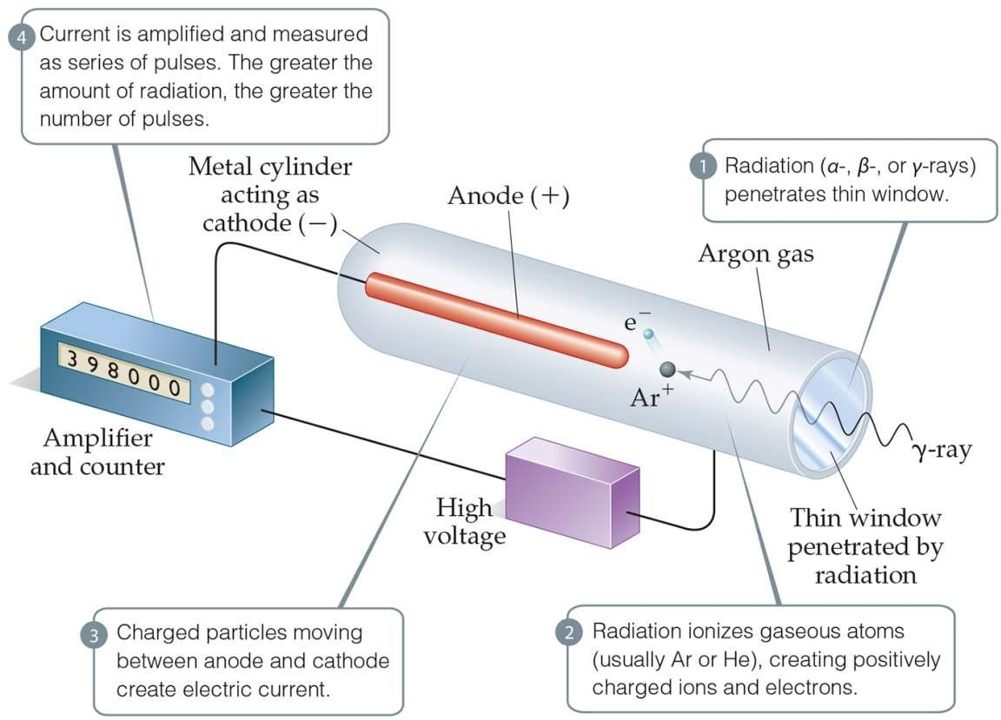
- The ionizing radiation creates ions, which conduct a current that is detected by the instrument.

Radiotracers
Radiotracers: radioisotopes used to study a chemical reaction. An element can be followed through a reaction to determine its path and better understand the mechanism of a chemical reaction.
- Radioisotopes are administered to a patient (usually intravenously) and followed. Certain elements collect more in certain tissues, so an organ or tissue type can be studied based on where the radioactivity collects.
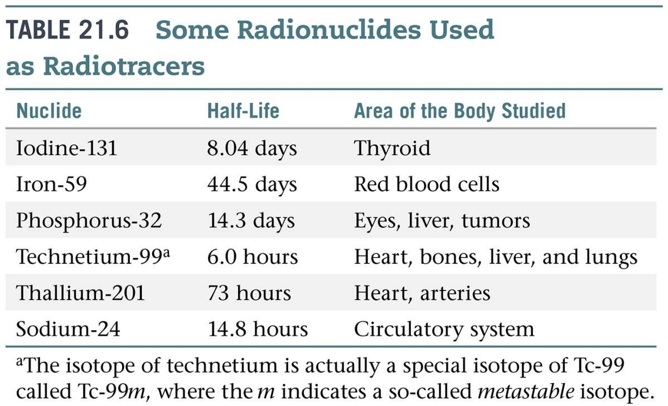

Nuclear binding energy

The mass difference between a nucleus and its constituent nucleons is called the mass defect. We can use Einstein’s equation to find the nuclear binding energy: the energy required to separate a nucleus into its individual nucleons.

E = mc2
1 eV = 1.602×10-19 J
c = 2.99792458 108 m s-1

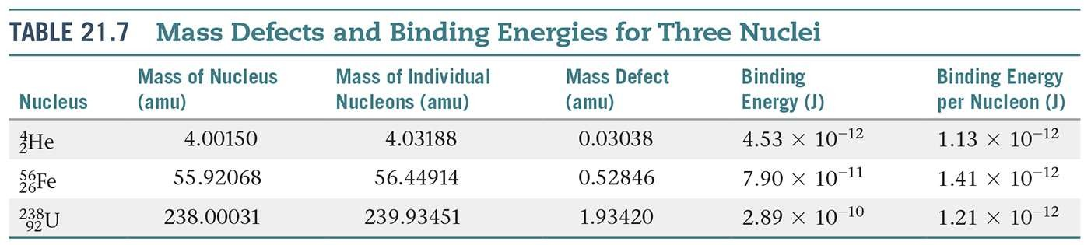

Example
Calculate the nuclear binding energy for deuterium.
1H + 1n 2H
1 0 1
1.007825 amu 1.008665 amu 2.01410 amu

The mass defect is 0.00239 amu.

Avogadro Constant = 6.0221421×1023 mol-1 mass of electron = 5.4857x10-4 amu
mass of neutron = 1.008665 amu mass of proton = 1.007276 amu

Example

Calculate the nuclear binding energy per mole for deuterium.
1H + 1n 2H
1 0 1

1.007825 amu 1.008665 amu 2.01410 amu

The mass defect is 0.00239 amu.

Example
Calculate the nuclear binding energy per nucleon for deuterium.
1H + 1n 2H
1 0 1

1.007825 amu 1.008665 amu 2.01410 amu

The mass defect is 0.00239 amu.

Nuclear binding energies
- Heavy nuclei gain stability and give off energy when they split into two smaller nuclei. This is fission.
- Lighter nuclei emit great amounts of energy by being combined in fusion.
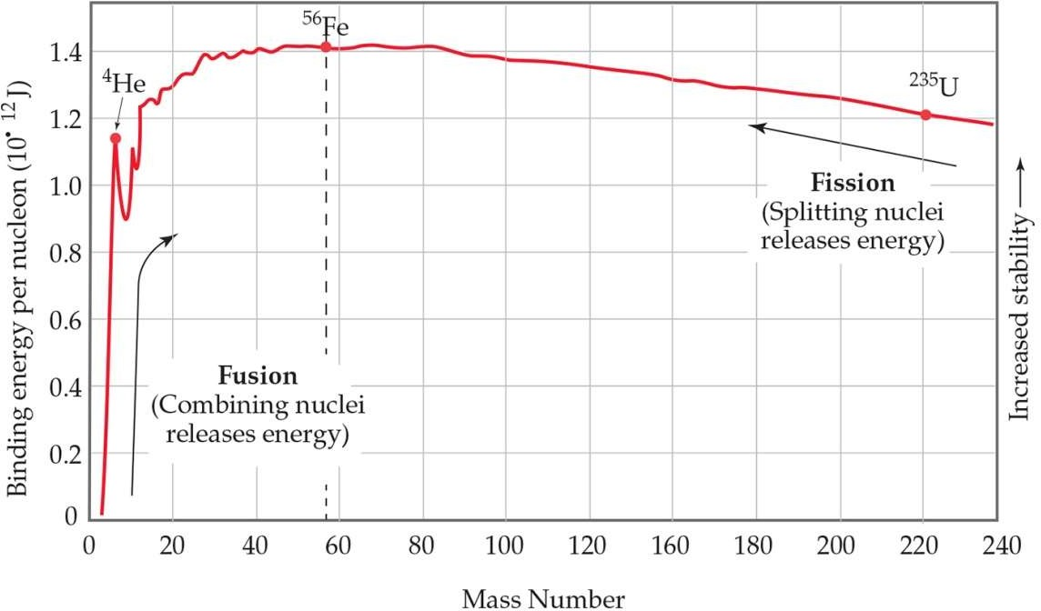

Nuclear Fission

Fermi’s proposed transuranium synthesis

238U
+ 1n
239U 239X + 0b

92 0 92 93 -1

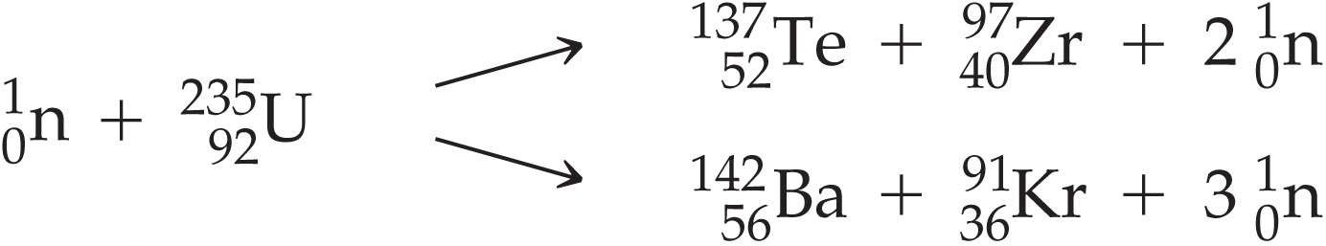
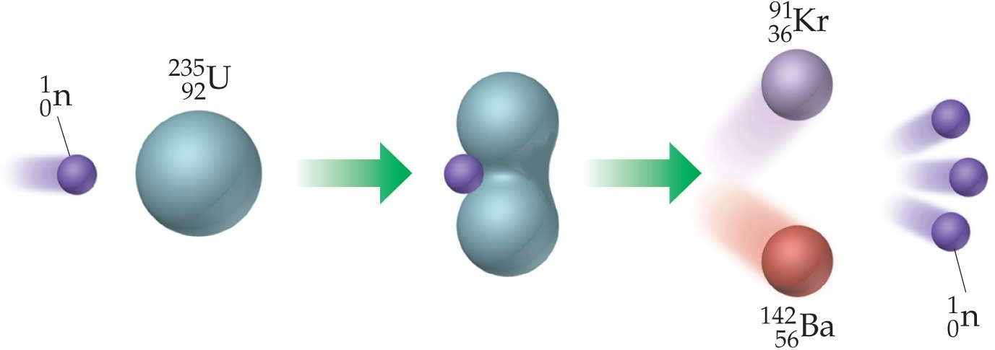
Meitner, Strassman, Hahn discovered U-235 didn’t make a new element, but ...

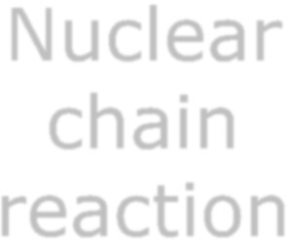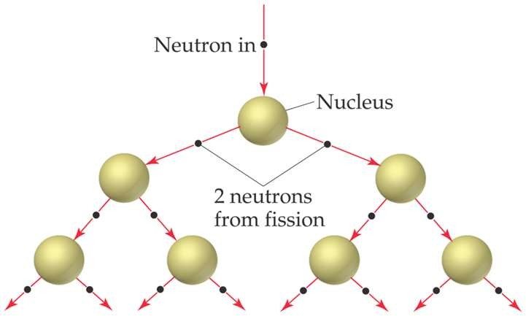
Nuclear chain reaction

Bombardment of the radioactive nuclide with a neutron starts the process.
  - More neutrons are produced from the transmutation.
  - A critical mass of radioactive nuclides is needed for a self-sustaining chain reaction.

    - The minimum mass that must be present for a chain reaction to be sustained is called the critical mass.
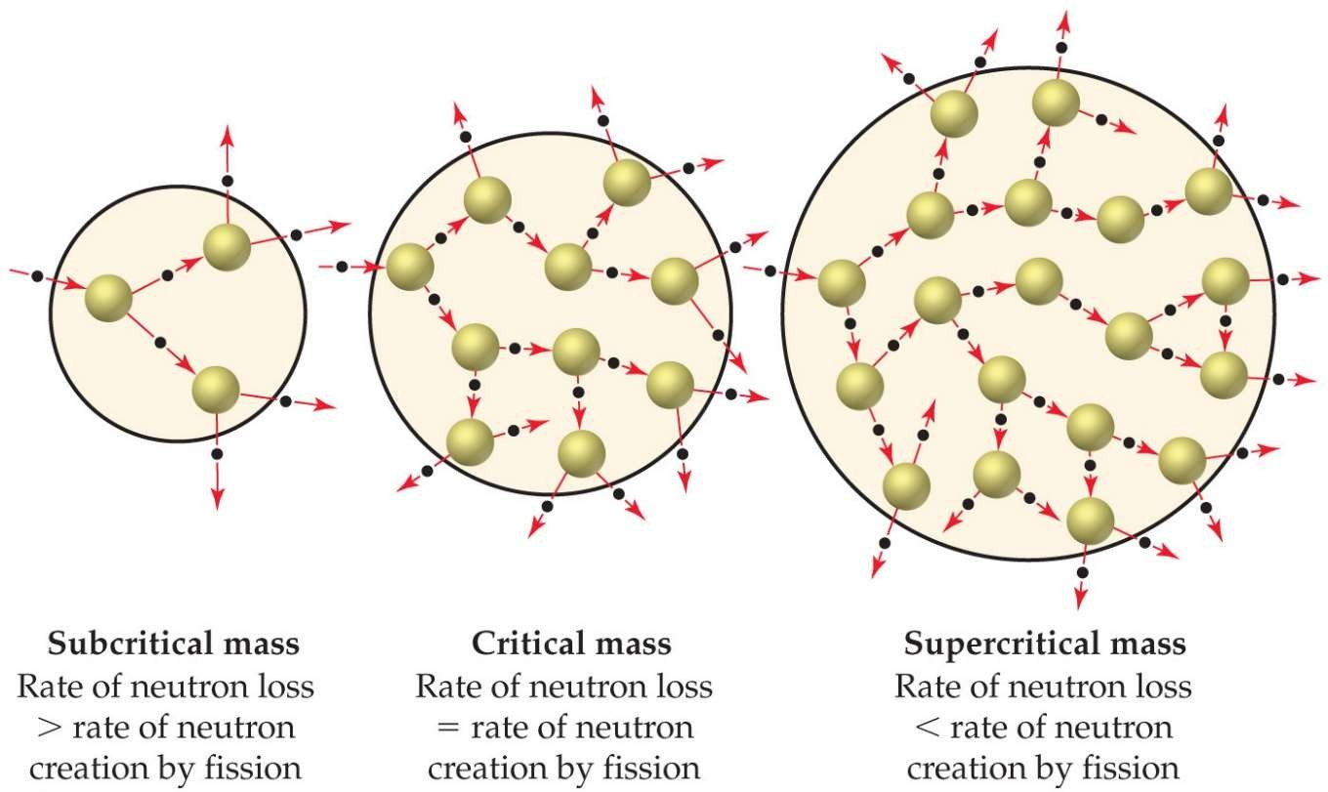
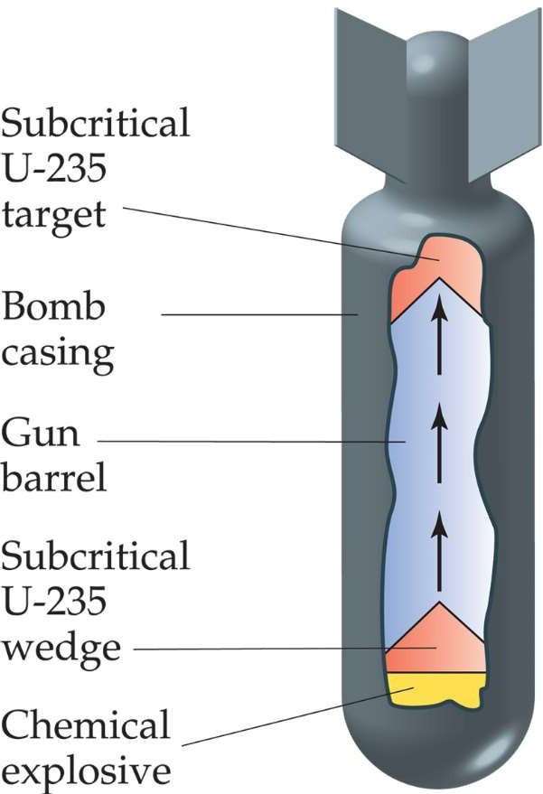
    - If more than critical mass is present (supercritical mass), an explosion will occur. Weapons were created by causing smaller amounts to be forced together to create this mass.

Nuclear reactors
In nuclear reactors, the heat generated by the reaction is used to produce steam that turns a turbine connected to a generator.
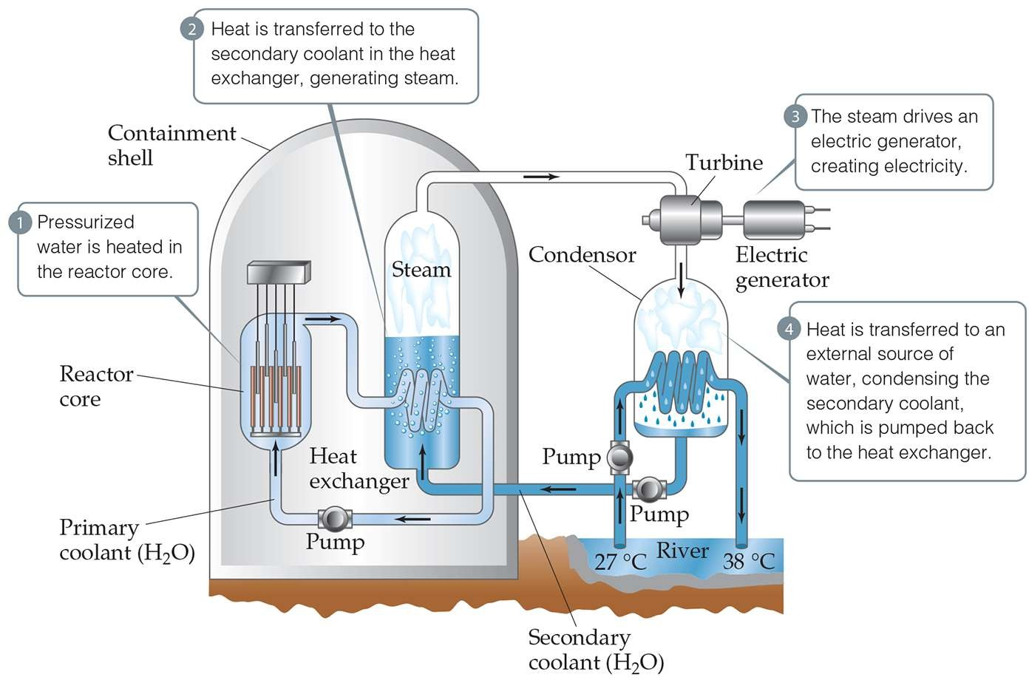

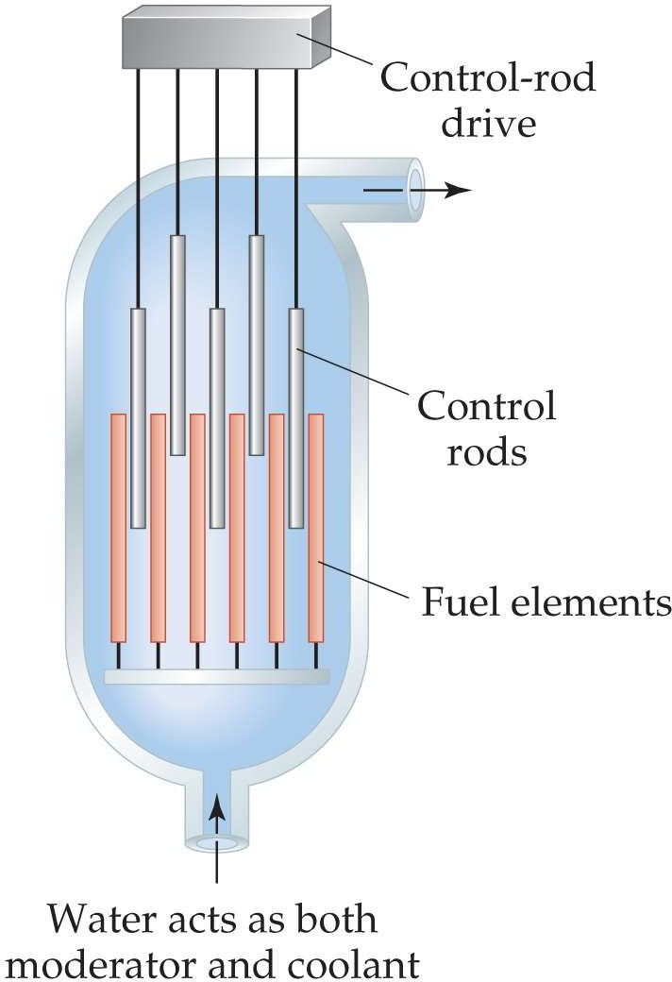Nuclear reactors

The reaction is kept in check by the use of control rods made of boron carbide, Ag, In, Cd, or Hf.

These block the paths of some neutrons, keeping the reactor core from overheating.

Nuclear waste
- Reactors must be stopped periodically to replace or reprocess the nuclear fuel.
- They are stored in pools at the reactor site.
- The original intent was that this waste would then be transported to reprocessing or storage sites, but politics….
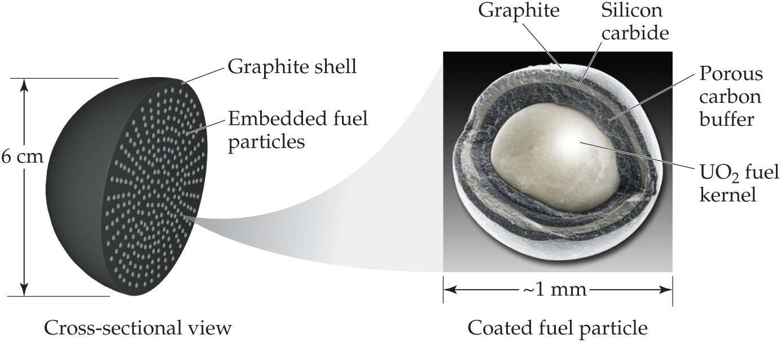

Nuclear fusion
  - Potentially superior method of generating power
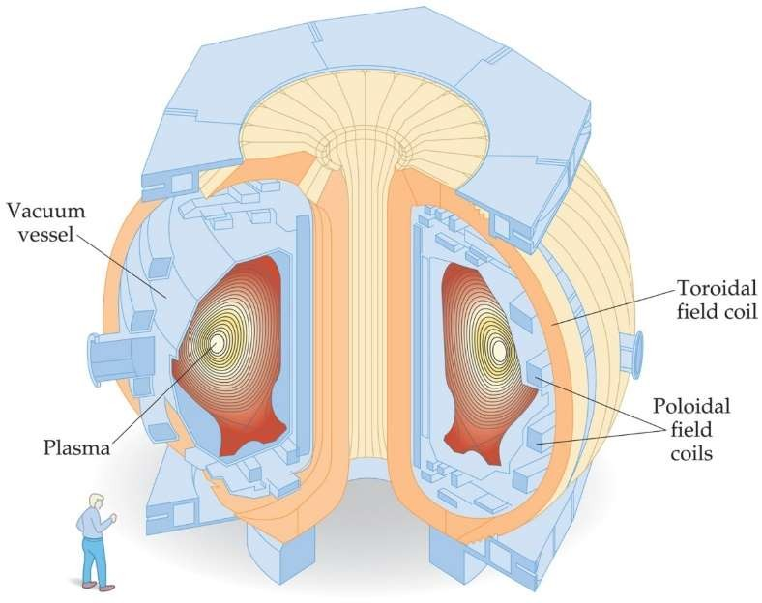
  - Need ~40,000,000 K for any fusion reaction.
A tokamak fusion test reactor has only been able to get 100,000,000 K – but not stable and has not yet produced more power than it takes to use.
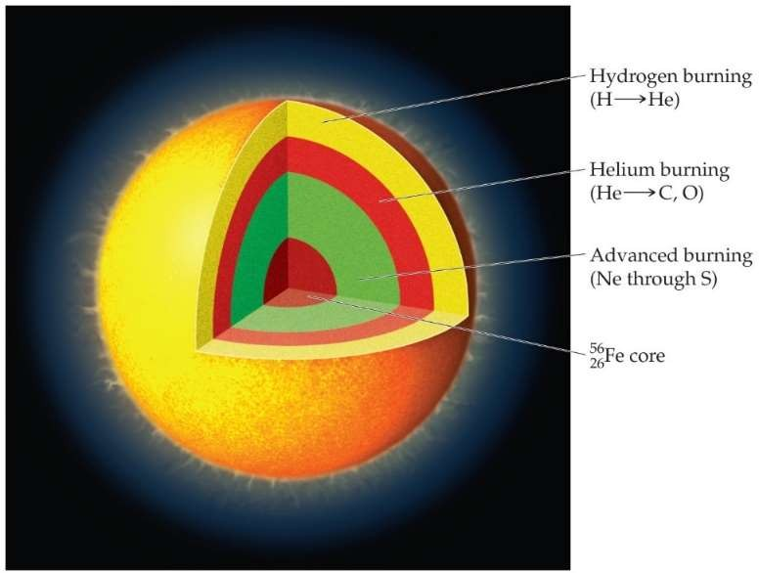
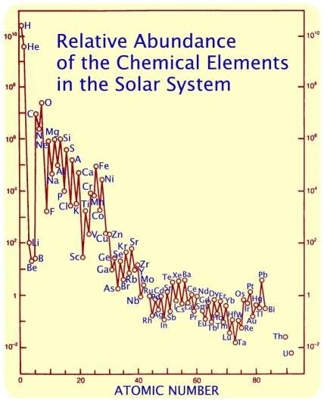
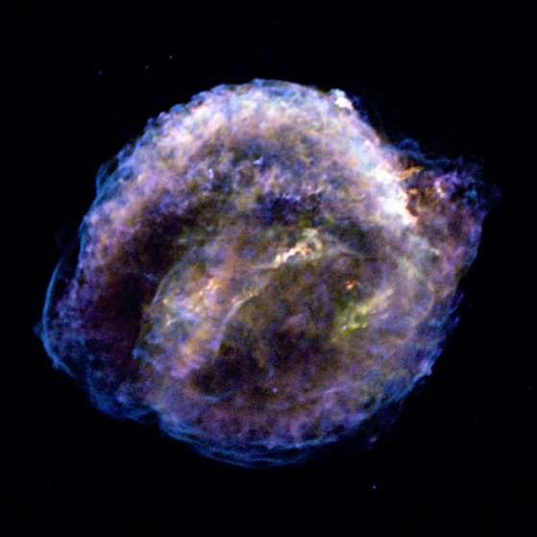

Origin of the elements

produces
yellow stars
1H fusion He red giants
4He fusion C, O, Ne, Mg red supergiants
4He + 12C Na, Si, S, Ar, Ca
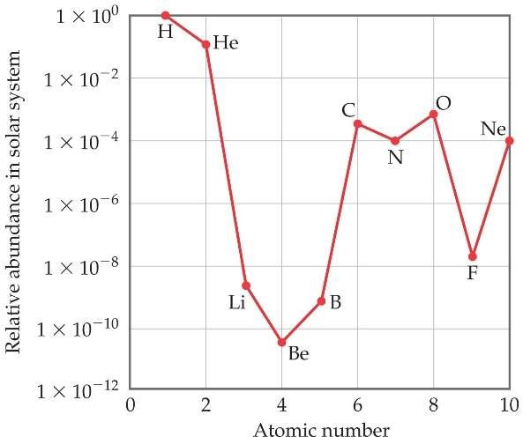
12C + 12C Fe, Ni
12C + 16O

supernovae, neutron stars
56Fe + 1n Z > 28

Radiation in the Environment
    - I
onizing radiation is more harmful to living
systems than nonionizing radiation, such as radiofrequency electromagnetic radiation.
    - Since most living tissue is ~70% water, ionizing radiation is that which causes water to ionize.
    - This creates unstable, very reactive OH radicals, which result in much cell damage.
    - The damage to cells depends on the type of radioactivity, the length of exposure, and whether the source is inside or outside the body.
    - Outside the body, gamma rays are most dangerous.
    - Inside the body, alpha radiation can cause most harm.

Constant exposure to radiation.

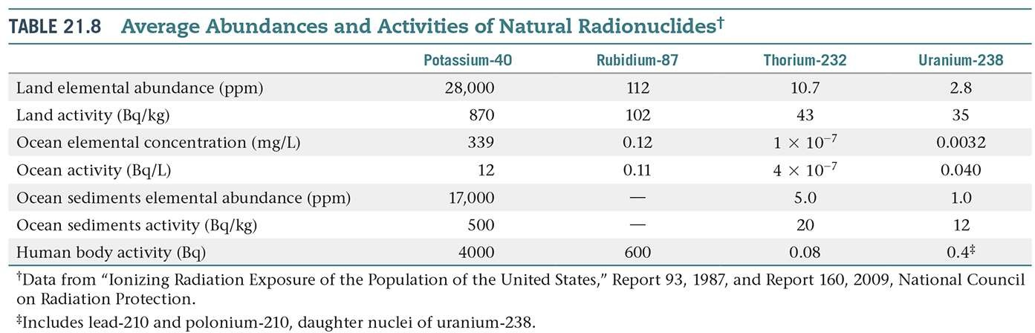

Radiation doses

gray (Gy): SI unit of absorbed dose 1 Gy = absorption of 1 J/kg tissue
rad: radiation absorbed dose

1 rad = absorption of 0.01 J/kg tissue 1 Gy = 100 rads
RBE: relative biological effectiveness
RBE (b and g) = 1 RBE (a) = 10
rem = (# rads) (RBE)
roentgen equivalent for man
sievert (Sv) SI unit for dosage

1 Sv = 100 rem, 1 mSv = 0.1 rem

Short-Term Exposure
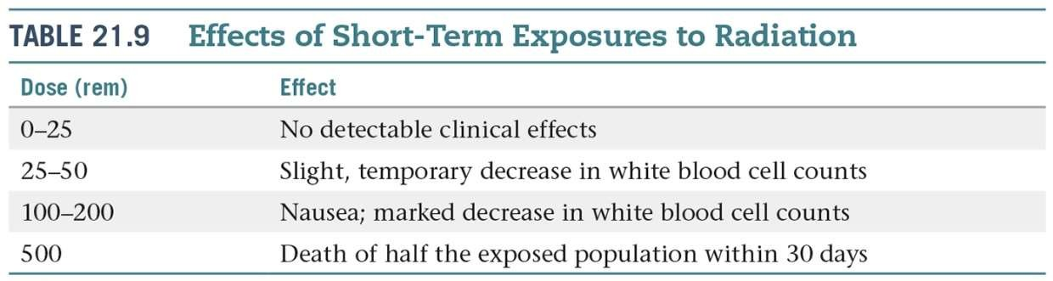

    - 600 rem is fatal to most humans.

- Average individual background radiation dose: 0.34 μSv/h or 3.0 mSv/year for Americans
- Dental radiography: 0.005 mSv
- Average dose to people living within 16 km of Three Mile Island accident:
0.08 mSv during the accident
- Mammogram: 3 mSv
- Brain CT scan: 0.8–5 mSv
- Chest CT scan: 6–18 mSv
- Gastrointestinal series X-ray investigation: 14 mSv
- Current average limit for nuclear workers: 20 mSv per year
- Dose from smoking 30 cigarettes a day: 13-60 mSv/year (.04 picocuries of polonium 210)
- Criterion for relocation after Chernobyl: 350 mSv/lifetime
- Typical dose near Chernobyl reactor 4 and its fragments, shortly after explosion: ≈ 10–300 mSv /hour
- March 16, 2011, a radiation level of 300 mSv/h was recorded between the exteriors of the secondary containment buildings of Unit 2 reactor and Unit 3 reactor of Fukushima Daiichi Nuclear Power Station.
- In Fukushima Prefecture, the level in the town of Namie (20 km), which peaked at 170 μSv/h at 2 p.m. on March 17, 2011 fell to 25.2 μSv/h as of April 10. The accumulated radiation for the March 23 to April 9 period was
13.95 mSv. Radiation levels have also fallen to 1.8 μSv/h (24.24 μSv/h at peak time) in Fukushima city.

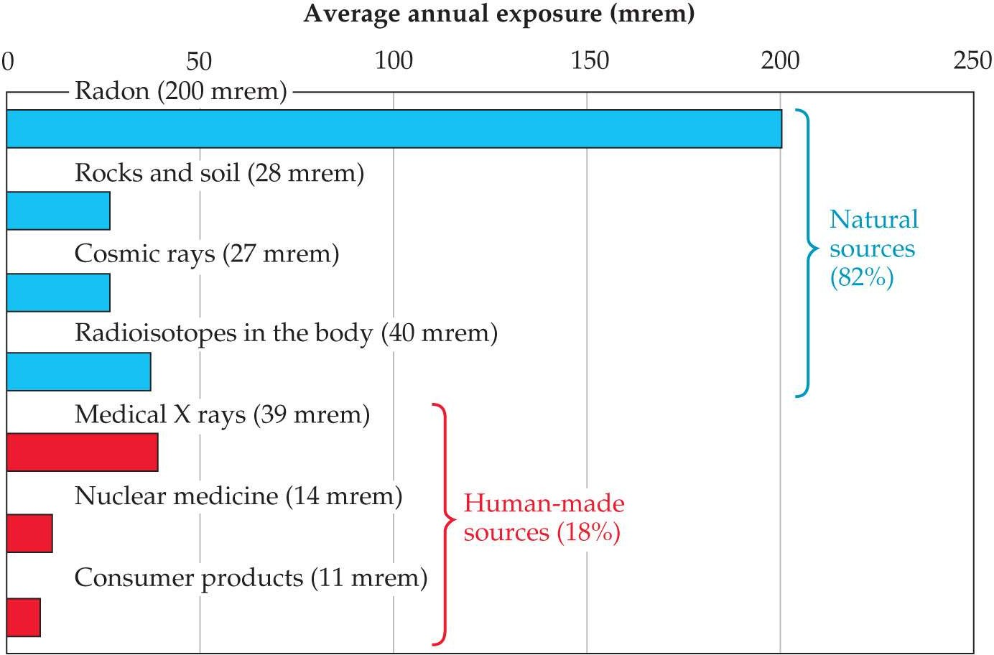

Average exposure per year is about 360 mrem.

- Radon-222 is a decay product of uranium-238, which is found in rock formations and soil.
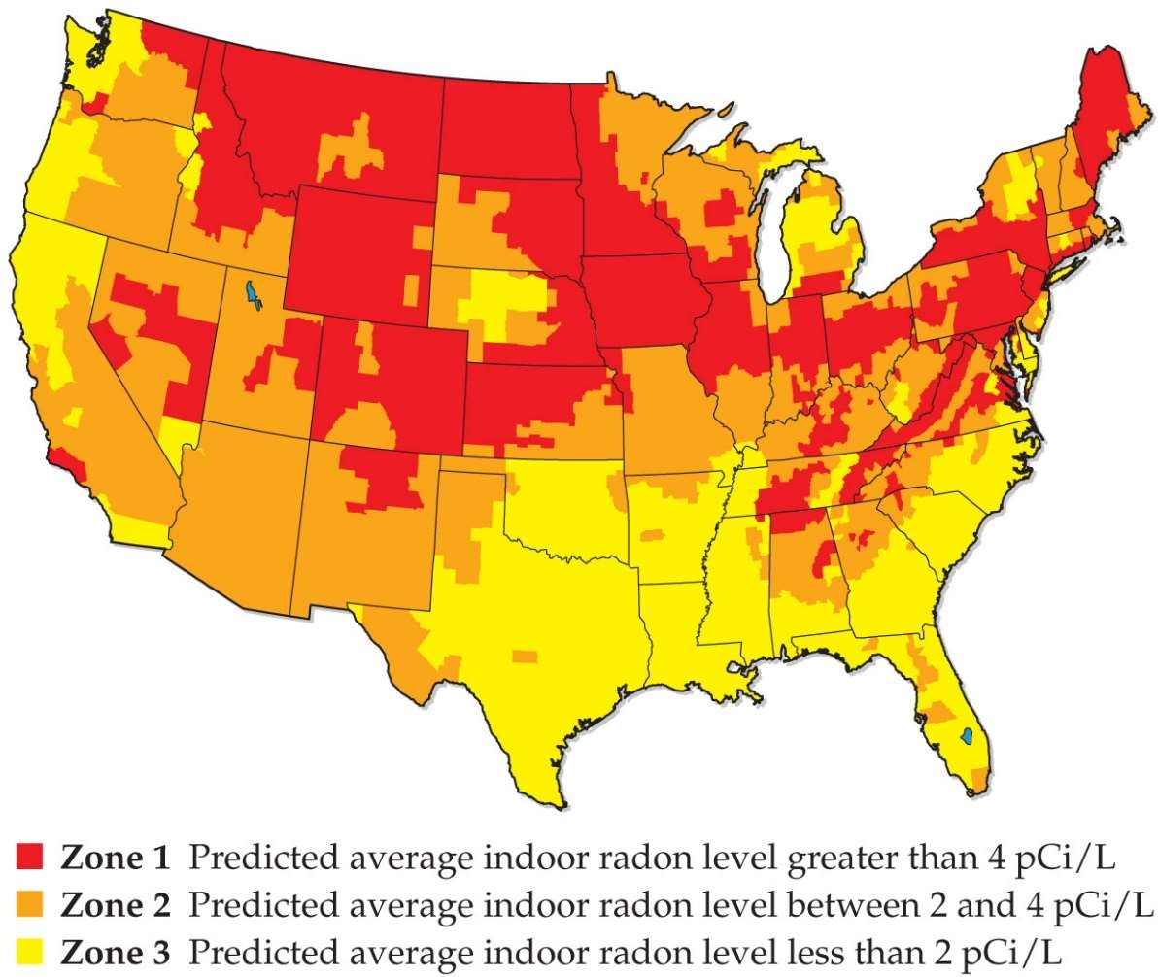
- Most of the decay products of uranium remain in the soil, but radon is a gas.
- When inhaled, it can cause significant harm, since the decay produces alpha particles, which have a high RBE.
- It is estimated to contribute to 10% of all lung cancer deaths in the United States.

BNCT
Boron Neutron Capture Therapy
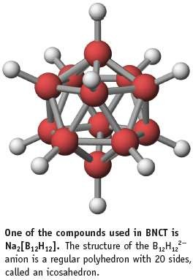
- 10B can capture slow neutrons
- Tumor cells preferentially take up boron compounds
- 10B + 1n → 11B* → 7Li + 4a 5 0 5 3 2

Food irradiation
- Food can be irradiated with g rays from 60Co or 137Cs.
- Irradiated milk has a shelf life of 3 months without refrigeration.
- USDA has approved irradiation of meats and eggs.

