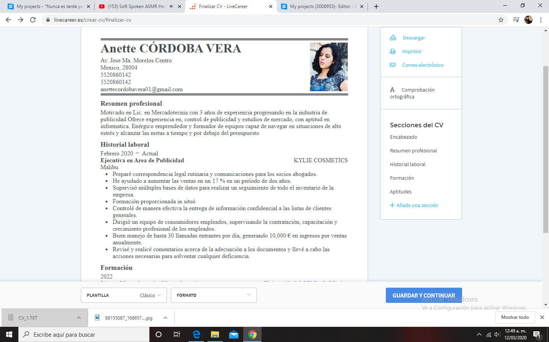

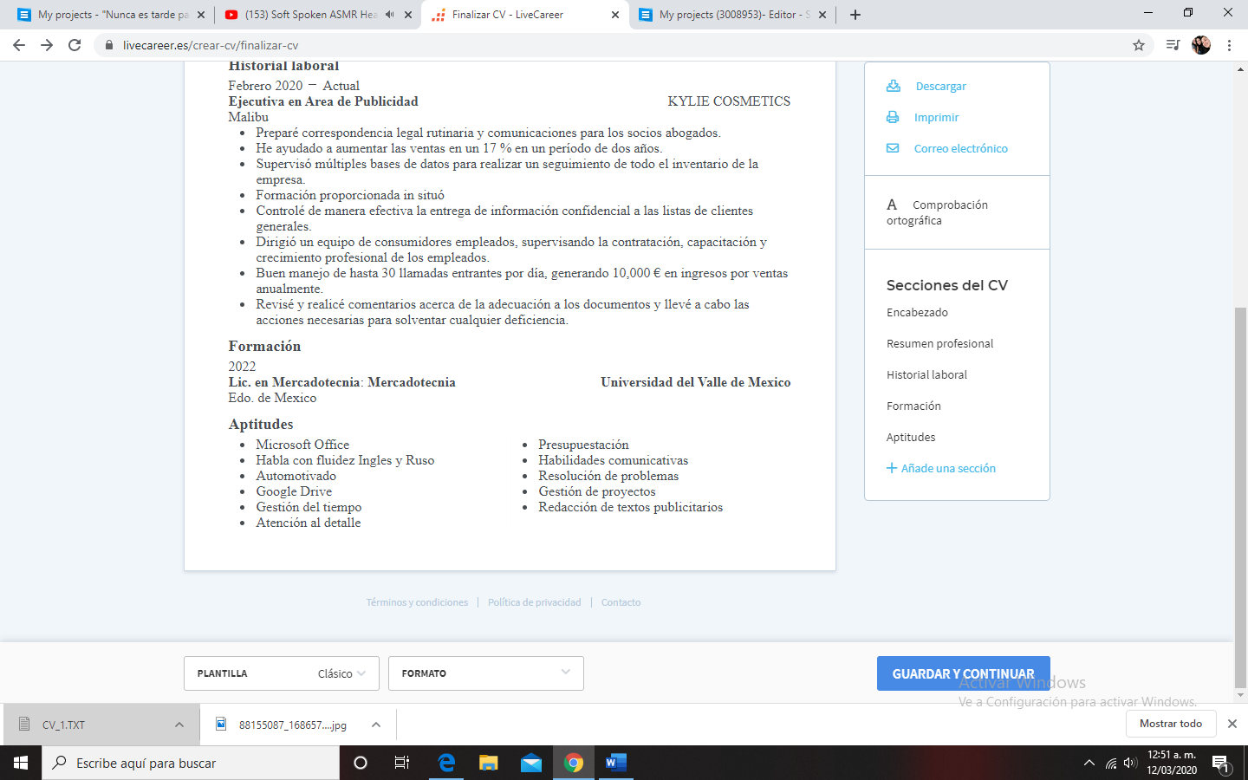

***Curriculum vitae:*** [***https://www.livecareer.es/crear-cv/finalizar-cv***](https://www.livecareer.es/crear-cv/finalizar-cv)