**FRIENDS OF THE WAGGGS WORLD CENTRES**

Minutes of the Annual General Meeting held on 23rd March 2024

At Pax Lodge at 2pm and on zoom at 7pm British Summer Time

1. **WELCOME,**

Karen Burrows (KB) welcomed everyone to the meetings and thanked everyone for joining the AGM.

1. **INTRODUCTION OF the FOWWC and the TRUSTEES / AND APOLOGIES**

Caroline Poulton (CP) reminded everyone of what the FOWWC do:

We support the Five World Centres with the money to spend on projects or items they need. Some of our members join to support all the Centres because they have been to one or more and this is a way to support with one membership.

Others join because they have not been to any World Centre and can support all of them this was, whether they get to go to one or not.

Trustees being herself Caroline Poulton and joint Chair Karen Burrows, Jane Muncey, Kim Clegg, Avril Dossetter, Christine Millburn, Jenny Egan, Marion Cotterill and Heather O’Halloran

Trustee vacancies:

Kim has been **Treasurer** for a number of years, but will be stepping down at the end of this year.

Karen’s term as **joint Chair** will be up for renewal by the next AGM and this position will be available to take on jointly with Caroline.

Avril has been a Trustee for a number of years and with her term up for renewal she has decided to step down.

Anyone wishing to know more about these roles, please do contact us – by post, email, or via the website.

Members present at the in person AGM = 11 (6 + 5 Trustees)

Members present at the zoom AGM = 15 (8 + 7 Trustees)

Apologies = 9 (over the 2 meetings)

3**) MINUTES FROM THE PREVIOUS MEETING – March 2023**

The minutes from the March 2023 AGM had been circulated prior to the meeting to both those present and these were agreed as acceptable. These were accepted by Annette Preston and seconded by Jane Muncey.

**4) MATTERS ARISING -** none to discuss

**5) CHAIRMANS REPORT**

**Chairs report 2023**

A presentation was shown at the event.

This can be found on the FOWWC website under Newsletters and Articles and attached to these minutes in hard copy.

**7) TREASURES REPORT – KIM**

We ended the year with a general fund (membership) balance of £7.95k which includes all trading activities now and this is £2.4k lower than the end of last year.

Please see the balance sheet on the next page for more details of income and expenditure.

**Donations to WAGGGS World Centres 2023**

Our Chalet, Our Cabana, Pax Lodge, Kusafiri and Sangam

Proposed distribution (each) £1,600

A total of £8,000 to be sent to the centres this year – this is lower than in past years reflecting changes to our income

All members were asked to show their hands in agreement –

in person agreed to the proposals

online event – a question was raised about the donations made and could we purchase more specific items for the Centres to use. This will be followed up with the Centres and further information sent out to the members.

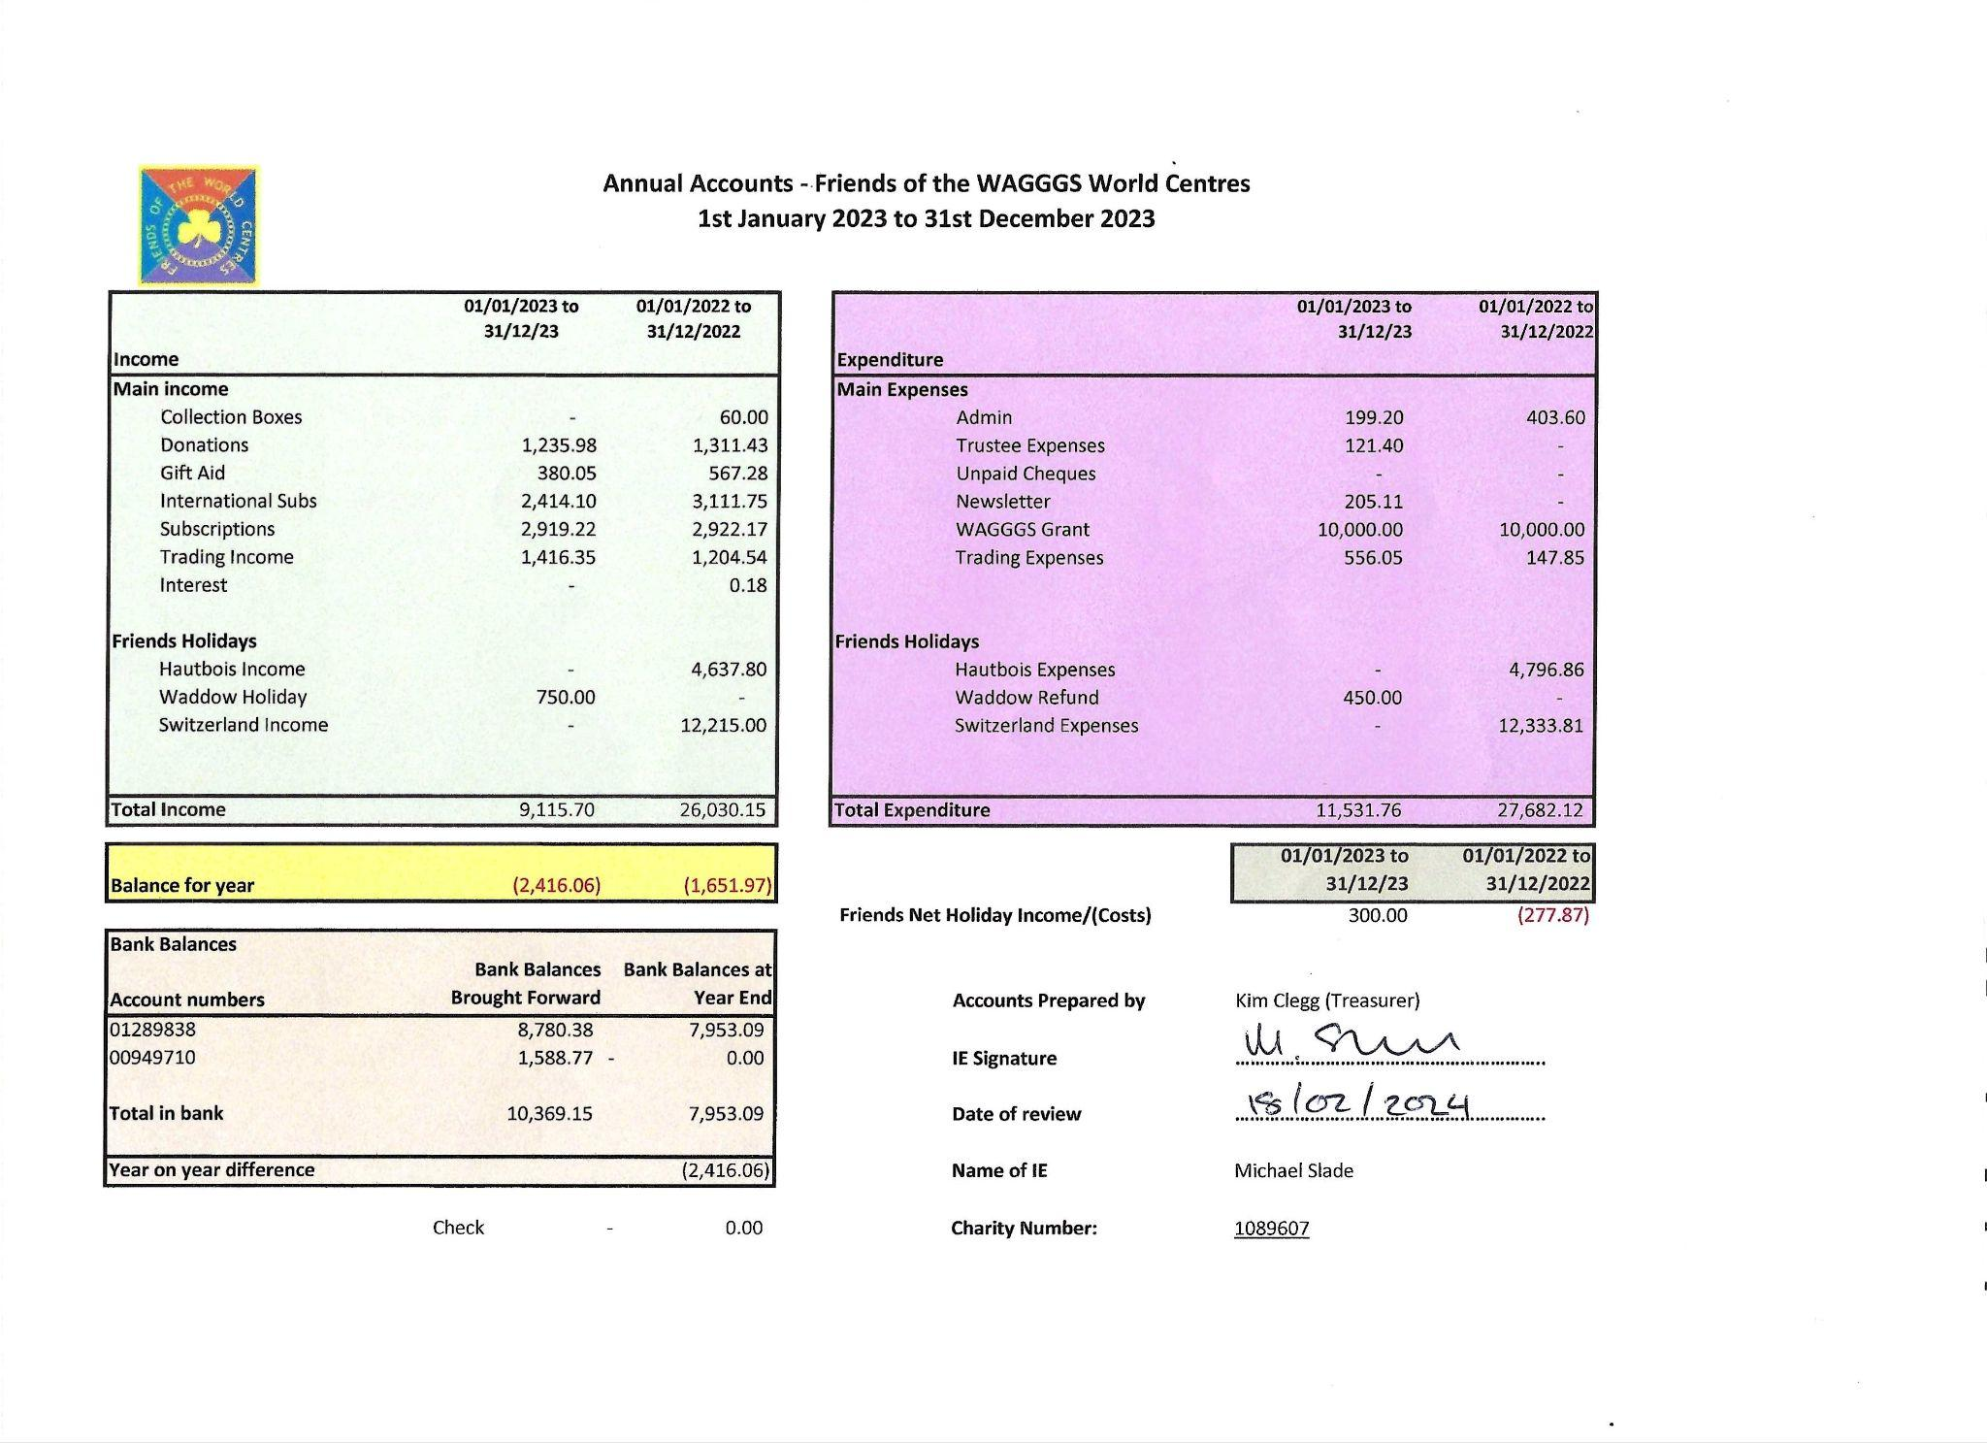

**8) MEMBERSHIP**

Canadian Guilds = 16

UK Guilds and Guiding units (including the Channel Islands) = 52

Individual members:

England = 196, Scotland = 14, Wales = 1, Northern Ireland = 1

Canada = 59, USA = 25, Netherlands = 8, Mexico = 1

**9) UPDATE ON FORTHCOMING TRIPS**

JY explained that since the closing of 5 more of the Guiding UK centres, finding places to visit was getting harder.

She is currently looking at availability in various locations and information will be sent out to everyone when we have more details.

**10) ANY OTHER BUSINESS –**

The Trustees have recently had the discussion of membership fee costs, prompted by many members asking how much.

The decision was taken to keep fees as they are for 2025 but this will be reviewed again next year before the 2026 AGM.

Any donations in addition to membership (which covers expenses) would 100% be put towards the World Centre funds given from the Friends.

SPEAKERS

At Pax Lodge we were joined by two of the volunteers who told us about Guiding in their Country and why they volunteer at Pax Lodge.

Anna from Australia – Anna taught us a song and actions from Australia.

The you tube link is here if anyone wants to hear the song. https://www.youtube.com/watch?v=MLWzPQmd5sc

Lisa from Nigeria – Lisa taught us a game they play in Nigeria with the girls.

The speakers for the evening were Hailey and Abbie who had both been volunteers in the community ‘Tares’ at Sangam. They told us about their individual community work – Hailey on the school bus for the children and Abbie out in the community with the adults.

12) **VOTE OF THANKS**

Heather O’Halloran gave the vote of thanks for the talk and presentation at Pax Lodge.

Jane Muncey gave the vote of thanks to the evening speakers

13) **DATE OF NEXT AGM** - The Trustees will be discussing the 2025 at their next meeting.

Everyone was thanked for attending and those present were served tea, coffee and cake kindly made by Heather.