Operational Amplifiers

- Introduction

Operational amplifier is a type of a differential amplifier that amplifies the difference between two inputs.

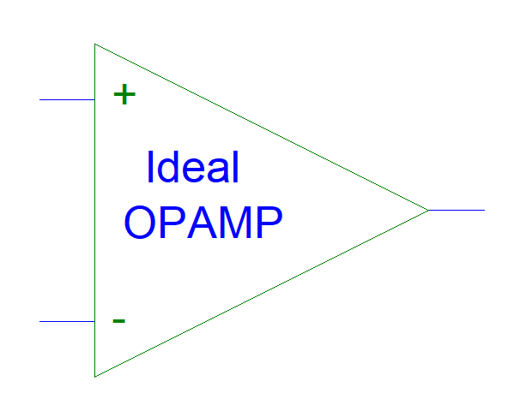
Figure 1: Operational Amplifier Symbol

Operational amplifiers were invented in the 1970s. For many years there were used for the following applications:

Applications | 1970s | Today’s
Analogue Filtering | Operational Amplifiers | Digital Filtering with Microprocessors and Microcontrollers
Low Frequency Oscillators | Operational Amplifiers, Timer ICs (LM555, LM556) | Microprocessors and Microcontrollers
Instrumentation Amplification (medical, voltmeters) | Operational Amplifiers | Instrumentation Amplifier ICs
Educational Purposes | Transistors, Operational Amplifiers | Transistors, Operational Amplifiers
Voltage Reference | Operational Amplifiers, Voltage Regulators | Voltage Regulators
Integrators/Differentiators | Operational Amplifiers | Microprocessors and Microcontrollers
Schmitt Triggers | Operational Amplifiers | Microprocessors and Microcontrollers
Comparators | Operational Amplifiers, Comparator ICs | Microprocessors and Microcontrollers
Load Drivers (Motors, LEDs, Speakers) | Audio Power Amplifiers | Power Amplifiers and Power Operational Amplifiers, LED drivers, Motor Drivers
Table 1: Operational Amplifier Applications

2. Ideal Operational Amplifier

2.1 Characteristics

Ideal operational amplifier characteristics:

- Infinite:
  - Gain (Ad), Vo = Ad * (V1 - V2),
  - Bandwidth (fb),
  - Gain bandwidth product (Ad*fb),
  - Current output supply,
  - Common Mode Rejection Ratio (CMRR) (CMRR = Ad/Ac),
  - Input impedance (Zin).

- Zero:
  - Output impedance (Zo),
  - Common mode gain (Ac), (Vo = Ac * (V1 + V2)/2)
  - Offset voltage (Vo), offset current (Vb), offset current (Io), bias current (Ib), output when the input is zero.

2.2 Ideal Operational Amplifier Circuit

PSpice drawing:

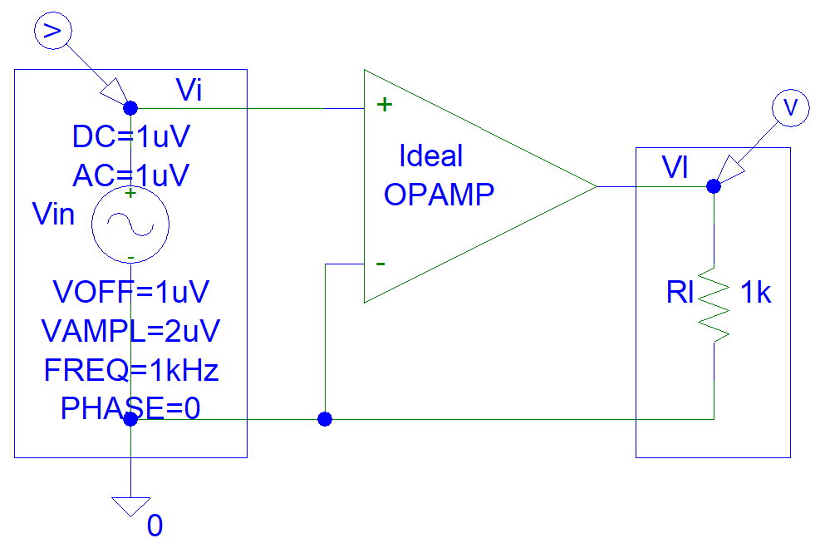
Figure 2: Ideal Operational Amplifier Circuit

PSpice simulations:

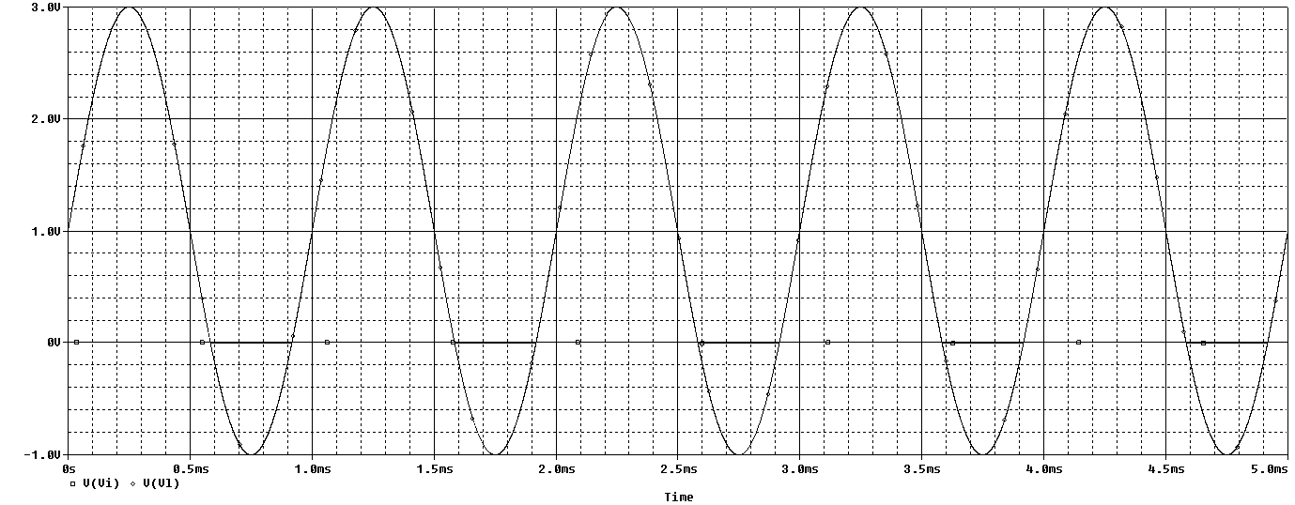
Figure 3: Operational Amplifier Time Domain Simulations

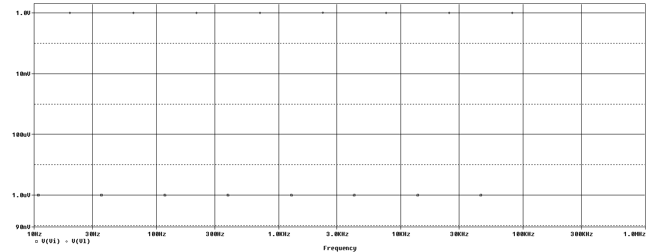
Figure 4: Operational Amplifier Frequency Simulations

3. Practical Operational Amplifier

3.1 Characteristics

Typical operational amplifier characteristics:

- Limited:
  - Gain (Ad) = 1*10^6 (at 1 Hz frequency),
  - Bandwidth (fb) = 1*10^6 (at gain of “1”),
  - Gain bandwidth product (Ad*fb) = 1*10^6,
  - Current output supply (maximum 10 mA),
  - Common Mode Rejection Ratio (CMRR) (Ad/Ac) = 90 dB,
  - Input impedance (Zin) = 1 Megohm.

- Non-zero:
  - Output impedance (Zo) = 50 ohms,
  - Common mode gain (Ac), (Vo = Ac * (V1 + V2)/2)
  - Offset voltage (Vo), offset current (Vb), offset current (Io), bias current (Ib), output when the input is zero.

3.2 Offset Voltage Model

Op-amp offset voltage circuit:
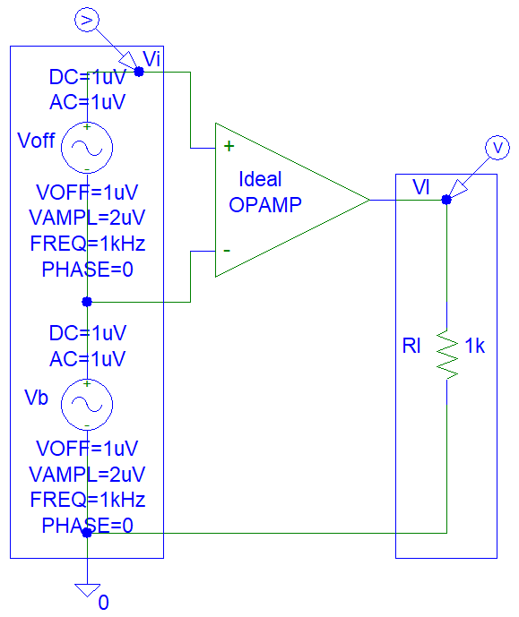
Figure 5: Practical Operational Amplifier Offset Voltage Model

PSpice simulations:

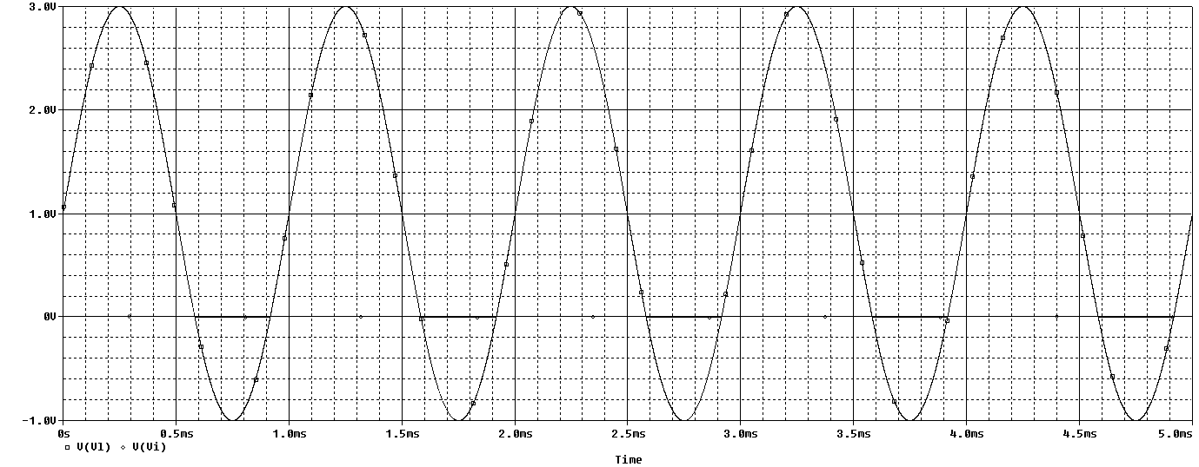
Figure 6: Practical Operational Amplifier Time Domain Simulations

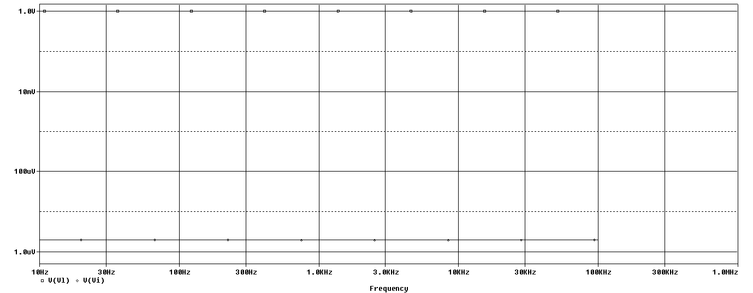
Figure 7: Practical Operational Amplifier Frequency Simulations

3.3. Offset Current Model

Op-amp offset current circuit:
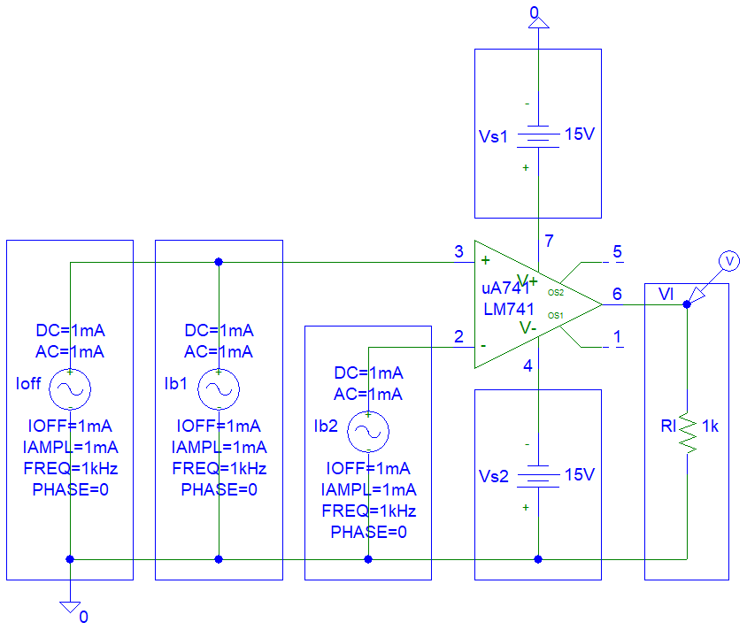
Figure 8: Practical Operational Amplifier Offset Current Model

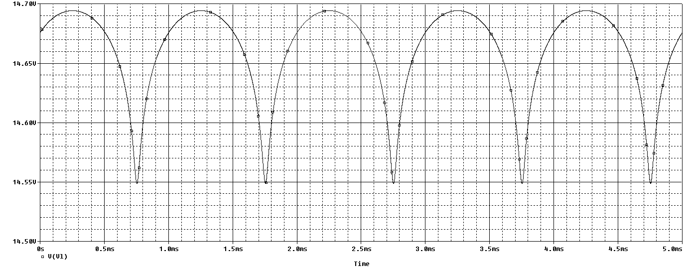
Figure 9: Practical Operational Amplifier Time Domain Simulations

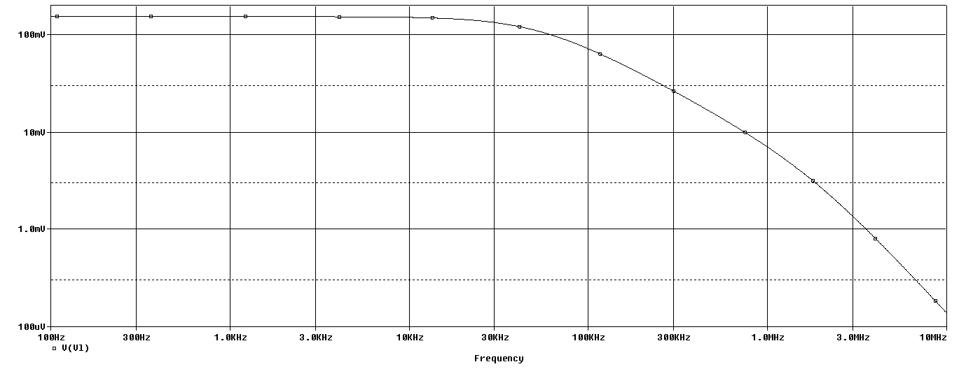
Figure 10: Practical Operational Amplifier Frequency Simulations
4. Applications

4.1 Amplifiers

4.1.1 Non-Inverting Amplifier

This is a non-inverting amplifier circuit for ideal op-amps:
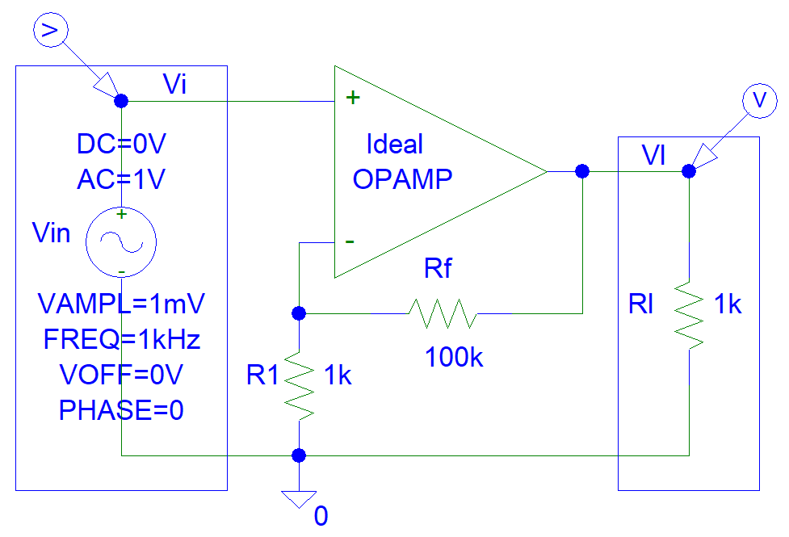
Figure 11: Non-Inverting Ideal Operational Amplifier Circuit

Gain derivations:
Vin = Vo * R1 / (Rf + R1)
Vo = Vin * (Rf + R1) / R1
Vo = Vin * Ad
Ad = Rf / R1 + 1

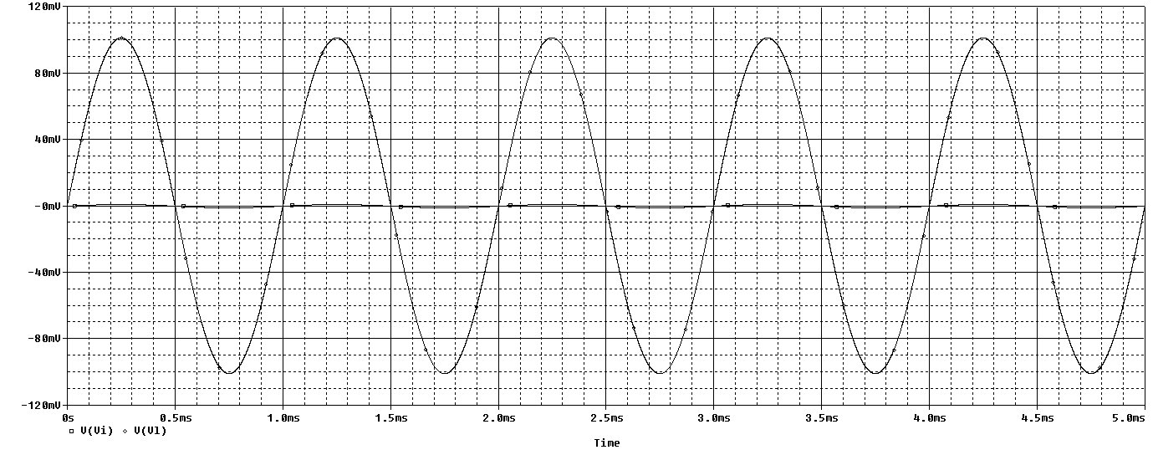
Figure 12: Non-Inverting Ideal Operational Amplifier Time Domain Simulations

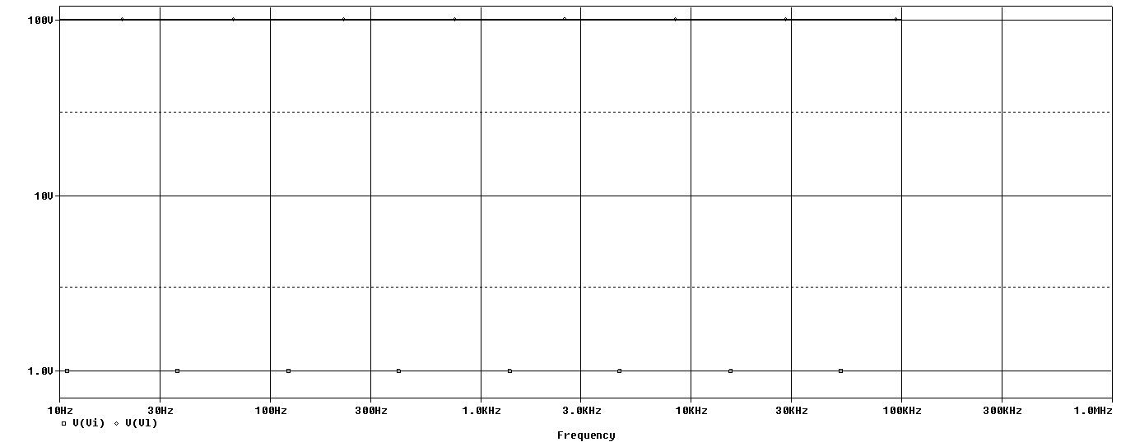
Figure 13: Non-Inverting Ideal Operational Amplifier Frequency Domain Simulations

This is a biased non-inverting amplifier with a single supply.

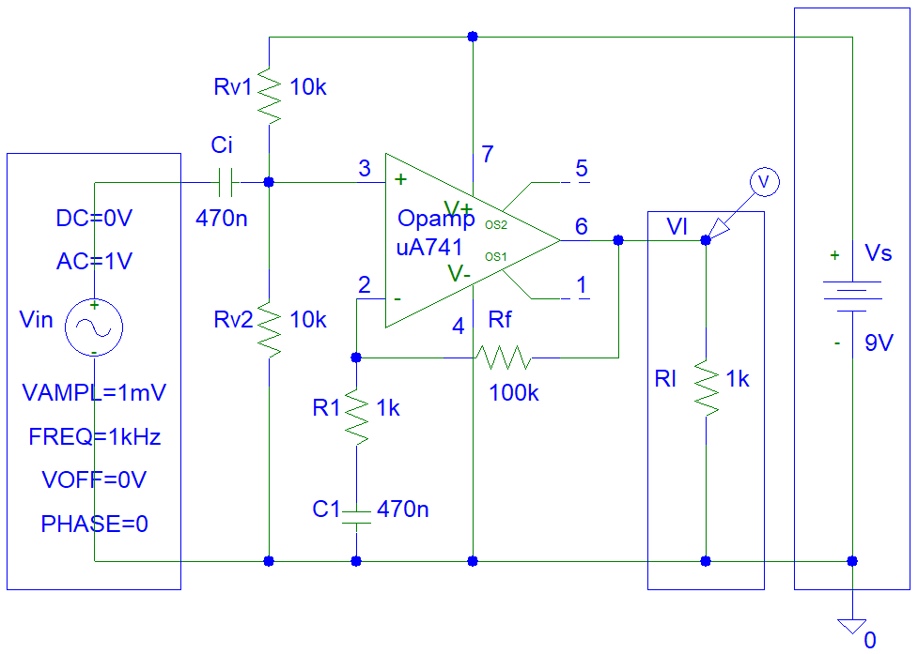
Figure 14: Non-inverting amplifier

PSpice simulations:

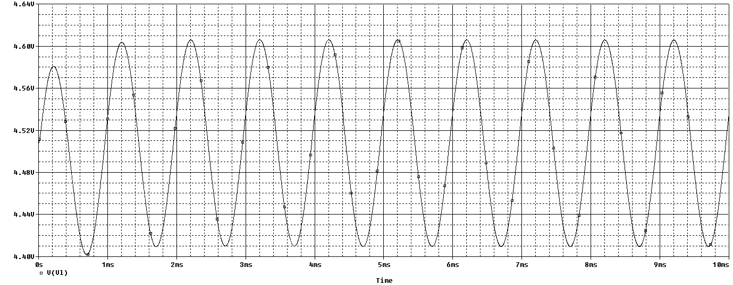
Figure 15: Non-inverting Amplifier Time Domain Simulations

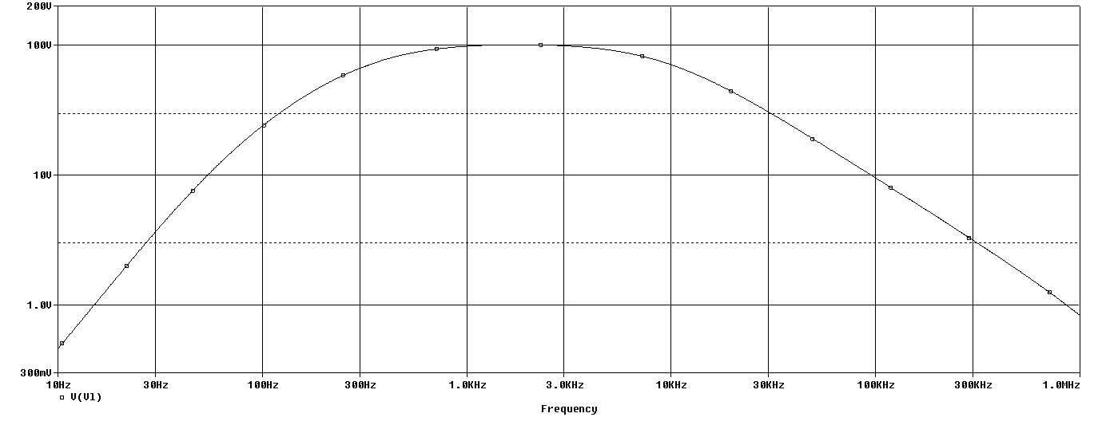
Figure 16: Non-inverting Amplifier Frequency Simulations

4.1.2 Inverting Amplifier

This is a inverting amplifier circuit for ideal op-amps:
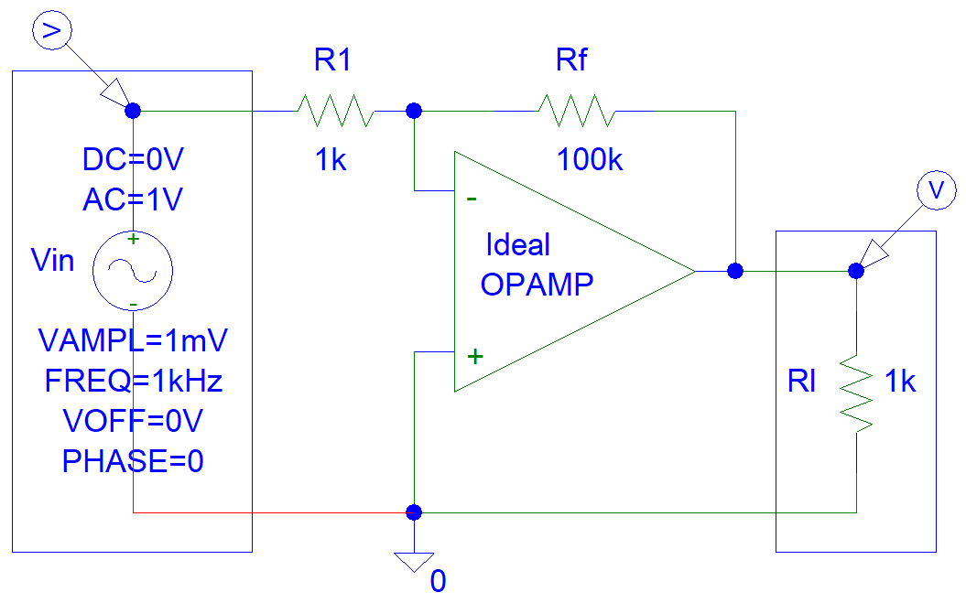
Figure 17: Inverting Ideal Operational Amplifier Circuit

Gain derivations:
Vin / R1 = -Vo / Rf
Vo = Vin * (-Rf / R1)
Vo = Vin * Ad
Ad = -Rf / R1

PSpice simulations:

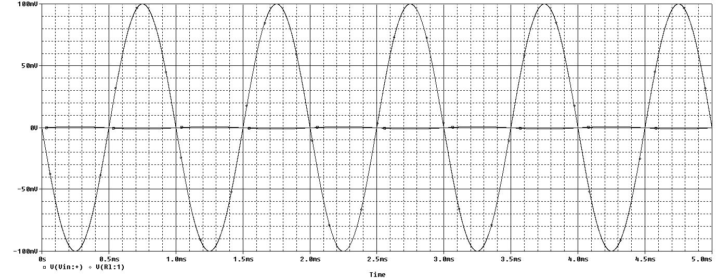
Figure 18: Inverting Ideal Operational Amplifier Time Domain Simulations

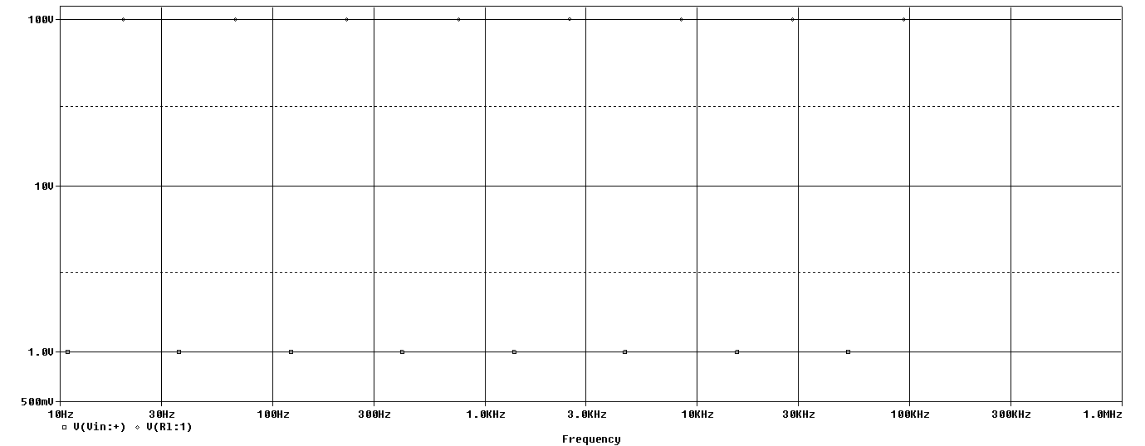
Figure 19: Inverting Ideal Operational Amplifier Frequency Domain Simulations

This is a biased inverting amplifier with a single supply:
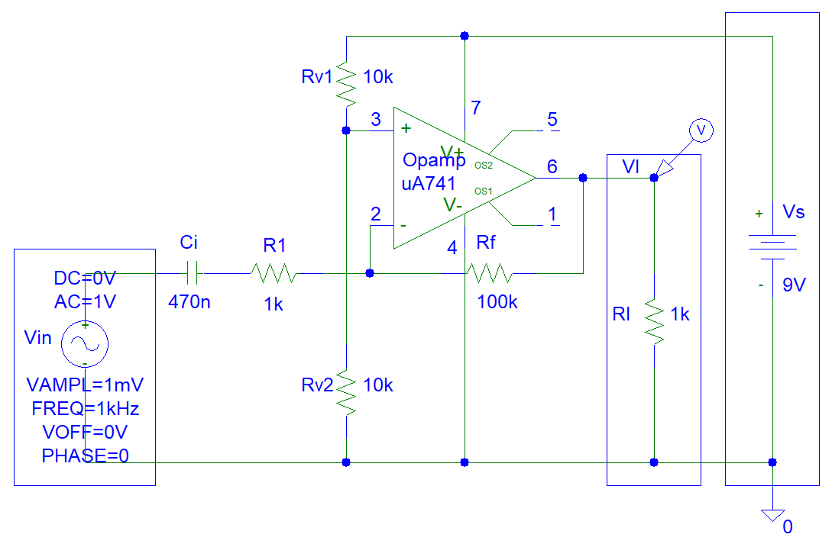
Figure 20: Inverting amplifier

PSpice simulations:

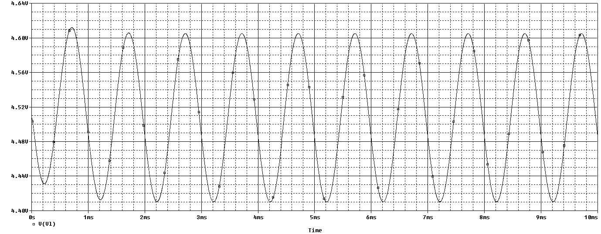
Figure 21: Non-inverting Amplifier Time Domain Simulations

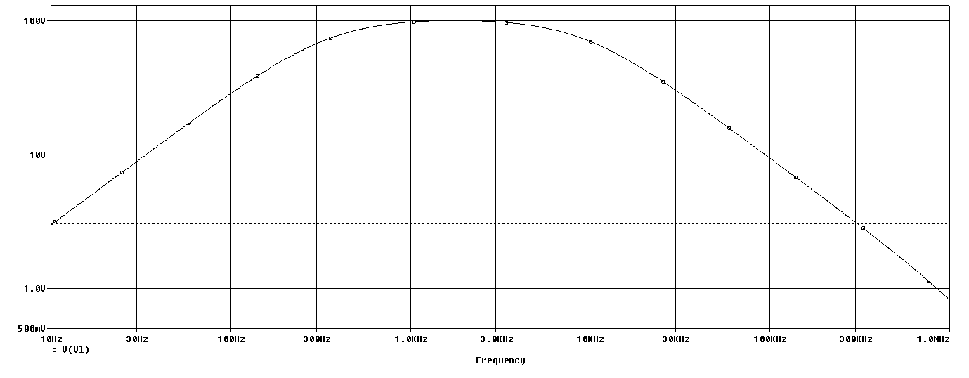
Figure 22: Non-inverting Amplifier Frequency Simulations

4.2 Schmitt Triggers

This ia a biased op-amp Schmitt Trigger design:
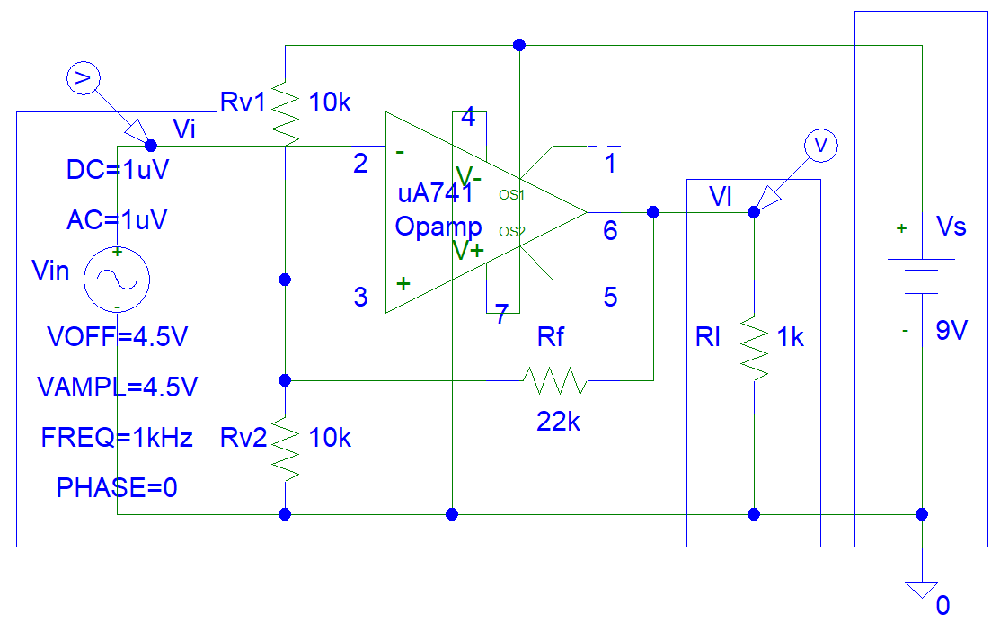
Figure 23: Schmitt Trigger Circuit

PSpice Simulations:
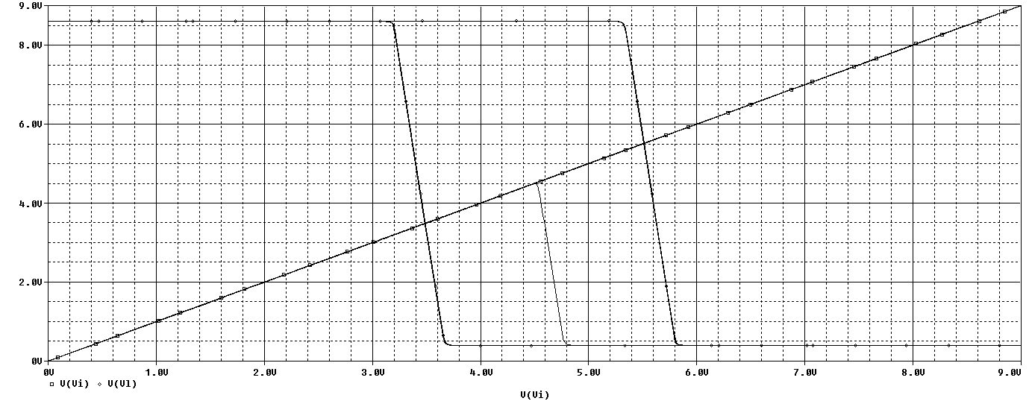
Figure 24: Schmitt Trigger Time Domain Simulations

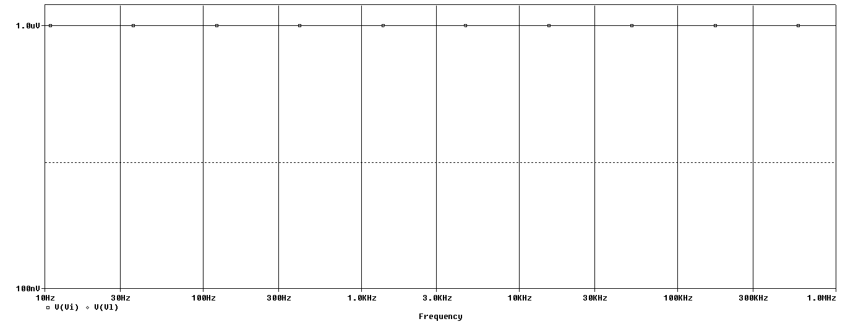
Figure 25: Schmitt Trigger Frequency Simulations

4.3 Op-amp Schmitt Trigger Oscillators

This is biased Schmitt Trigger op-amp oscillator circuit:

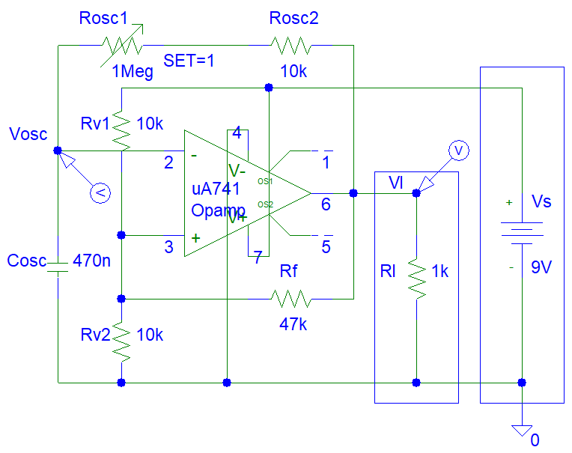
Figure 26: Op-amp Oscillator Circuit

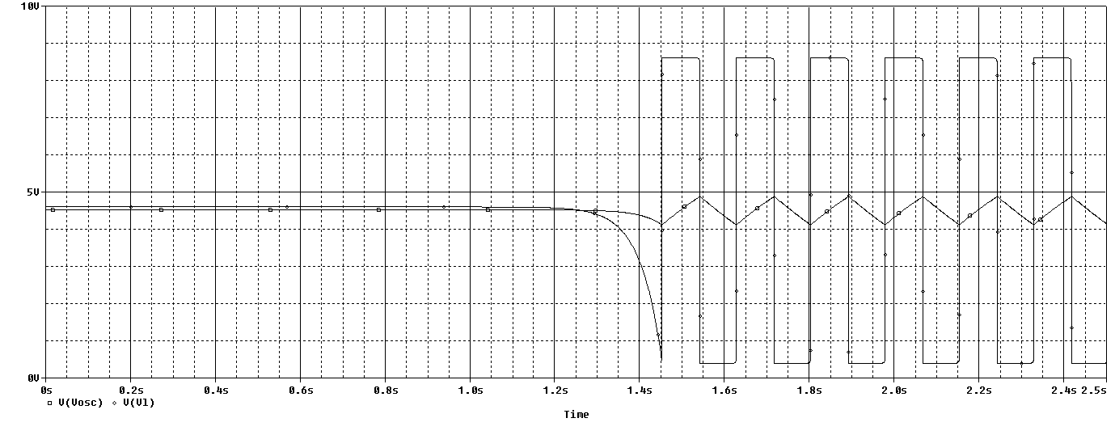
Figure 27: Op-amp Oscillator Circuit Simulations

5. Conclusion

You can click on the references link and read the article about operational amplifier mixer circuits.

6. References
- https://www.electronics-notes.com/articles/analogue_circuits/operational-amplifier-op-amp/virtual-earth-mixer-summing-amplifier.php
- https://www.electronicshub.org/light-sensors/
- https://www.electronics-tutorials.ws/opamp/opamp_2.html
- https://en.wikipedia.org/wiki/Schmitt_trigger
- https://www.homemade-circuits.com/how-oscillators-work/

