Temporary Latch LED Lights

Introduction

This circuit turns the LED ON when you press the button. The LED remains on for at least 5 minutes.

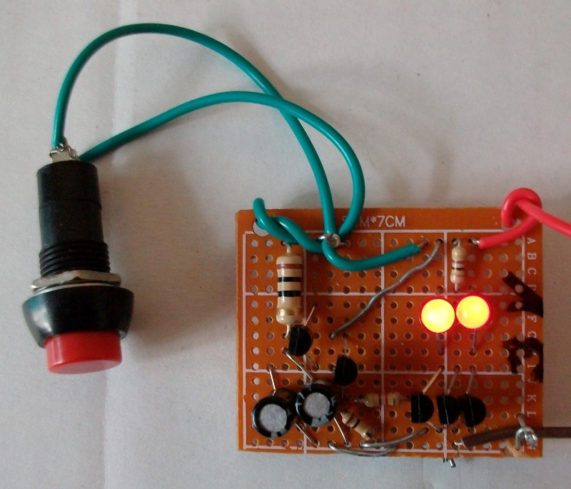
Figure 1: Transistor Temporary Latch Device

Step 1: Design The Circuit

I drawn the circuit in PSpice software:

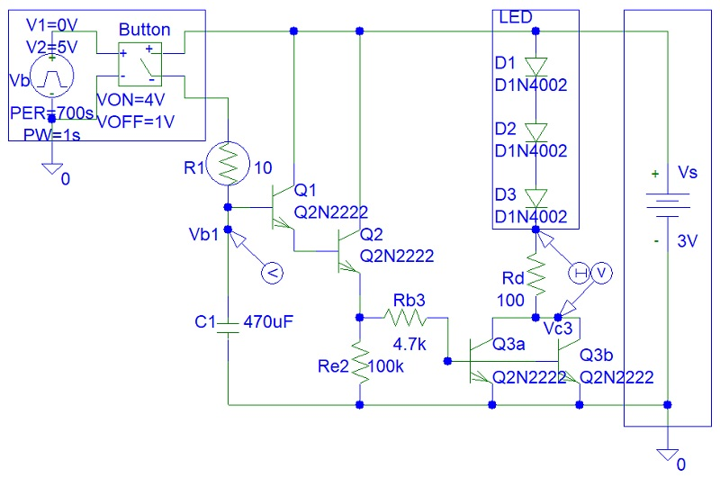
Figure 2: Circuit Design

The voltage across the LED is about 2 V. Thus the current across the LED when Q3 transistors are saturated will equal to:

(Vs - Vled) / Rd = (3 V - 2 V) / 100 = 10 mA.

The equivalent total resistance of the LED and the Rd resistor during transistor saturation is: 3 V / 10 mA = 300 ohms.

The transistor current gain is:

Beta = ((Vs - Vb3) / Rb3) / (Vs / Rd)

Assuming Vb3 is zero because it is only 0.7 V, the current gain will equal to:

Beta = Rb3 / Rd

The minimum Q3 transistor current gain is 20. Thus Rb must be chosen as 6 kohms. There is a 5.6 kohm resistor in the resistor series. However, because we ignored 0.7 V Vb3 voltage we must reduce Rb3 as 4.7 kohms.

Step 2: Simulations

Simulations show a very slow decay in charged capacitor voltage:

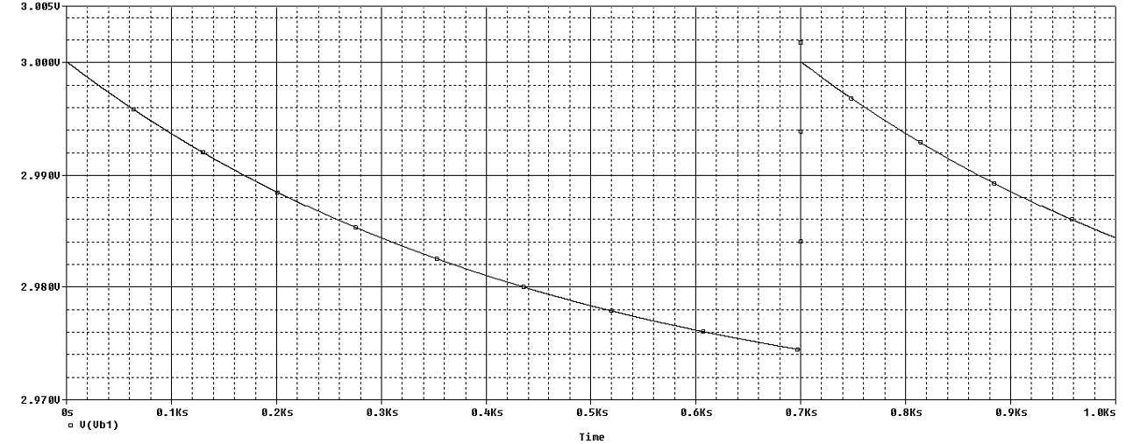
Figure 3: Simulations

Step 3: Build the Circuit

I used pliers to twist the wires together:

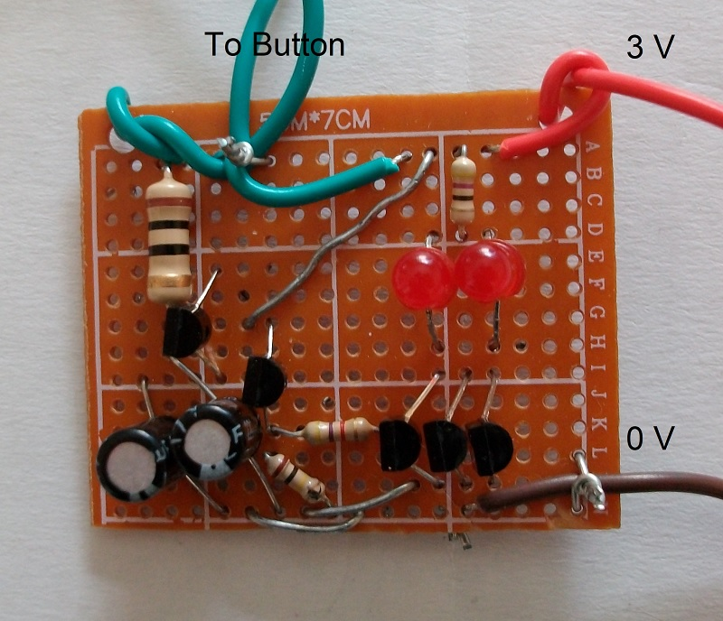
Figure 4: Build the Circuit Photo 1

I used a wire stripper to remove the insulation from the wires:

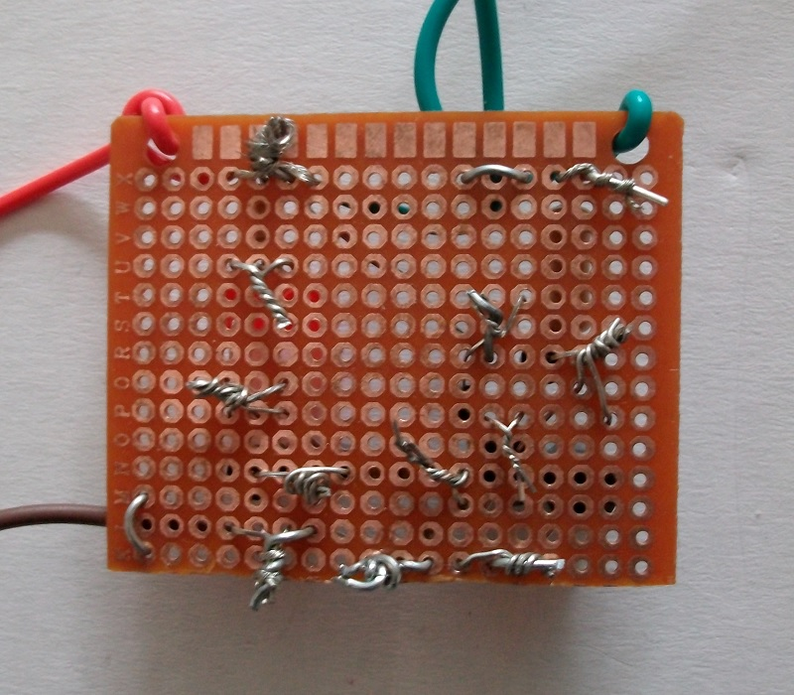
Figure 5: Build the Circuit Photo 2

Conclusion

You do not need a soldering iron as you can see in the build circuit photos.

This circuit is not a permanent latch. No matter how big the capacitor Farad value is and how high the input resistance is of the transistor circuit, eventually the capacitor will discharge and LEDs will turn OFF.

