Christmas Lights

# 

# Introduction

This article is about a simple capacitor charging Christmas Lights circuit. The capacitors are charging with time until the LEDs are ON with full brightness.

Similar circuits can be applied for light bulbs. However, you will need higher value capacitors and in this circuit the capacitors Farad value are high and expensive.

# Step 1: Design the Circuit

This is my PSpice software drawing:

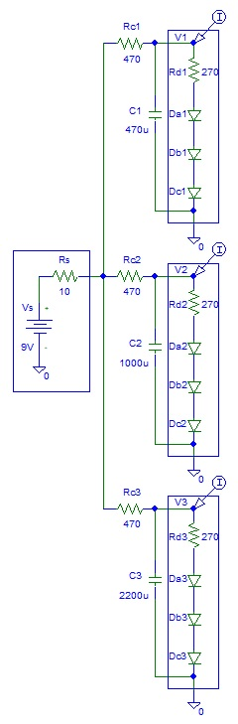

**Figure 1:** Circuit Design

# Step 2: Simulations

Simulations LED current versus time:

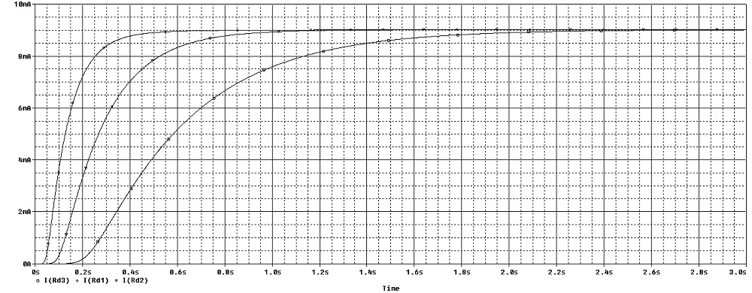

**Figure 2:** Circuit Design

You can see that the LEDs are fully charged after about 3 seconds.

The maximum current is about 9 mA.

# 

# Conclusion

There is also an option of connecting the circuit to a square or sine wave oscillator that you can purchase on the internet.