HUMA 311: Team
Proposal
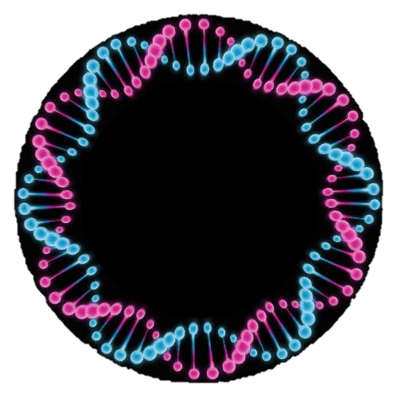
Data
Navigating
Association

Team: Data Navigating Association
Team Members: Hanin Abu Alrub 100043084
Khalid Al Hammadi 100042526
Meera Al Suwaidi 100042747
Rashid Hassan 100042998
Submission Date: June 26, 2019
HUMA 311
Summer 2019

Executive Summary (Rashid & Hanin)
- Introduction
- Contains the purpose of our project, which is improving the efficiency and effectiveness of Marhaba clinic and increase patient satisfaction as the client requested.
- Project Description
- A background about particular areas of interest related to the client’s problem in health informatics, which are issues and challenges in the field, consumers’ interest in health, and latest applications.
- Provided an overview of our objectives, goals and expected outcomes.
- The scope is to incorporate informatics and technology in the health system of Marhaba Clinic, produce a plan for solutions, and satisfy patients. We will exclude medicine and drug discovery.
- Project Plan
- Our deliverables are:
- Identify stakeholders
- Identify main areas of concern
- List of main concerns/issues
- Available options for improving relevant issues
- Evaluation matrix for 10 most suitable solutions
- Evaluation metric to evaluate future success
- Recommendation
    - Demonstrate the efficiency of system.
    - Statistical analysis, numerical data, graphs, tables and visualizations.
- Strategic plan of action
- Gantt chart that gives a timetable for task completion of deliverables, the project will start at 26/06/2019 and end at 11/07/2019.
- Evaluation Methods
- Pairwise analysis of our objectives was done, our objectives ordered from highest to lowest priority were as follows: secure, effective, efficient, and accessible.
- We will measure our success using surveys and focus groups conducted for faculty and patients. We will create and use an evaluation matrix for efficiency evaluation.

Contents
1. Introduction (Meera) 1
2. Project description 1
2.1 Background (Rashid) 1
2.2 Objectives (Team) 2
2.3 Goals & Outcomes (Hanin) 3
2.4 Scope (Khalid) 3
3. Project Plan 3
3.1 List of deliverables (Hanin) 3
3.2 Gantt chart (Khalid) 4
4. Evaluation Methods 5
4.1 Meeting objectives (Meera & Hanin) 5
4.2 Long term success (Khalid) 5
5. Concluding remarks (Hanin) 6
6. References: 6

Tables and Figures
Figure 1: Objectives Tree 2
Figure 2: Gantt chart 4

Table 1: Pairwise Comparision of Objectives 5

1. Introduction (Meera)
We have received a request from Marhaba clinic to overcome the challenges they encounter. The clinic appealed to us to fix the general inefficiency and patient unhappiness. Our aim is to design an efficient, effective and successful system that uses 21st century solution developing the requirements of clinic using our strategies and tactics. This proposal will provide essential aspects relating to your request and necessary information. We will start with a project description containing a brief background research, an explanation and demonstration of our objectives, and our team’s scope. Then, a detailed project plan will be provided that contain our deliverables and Gantt chart. Lastly, we will depict evaluation methods using pairwise comparison of objectives and means of measuring success on the long term.

2. Project description

2.1 Background (Rashid)
Issues in Health informatics, patient interest, and applications of the field are all active area of research. The most prominent challenges targeted were ethical issues and efficiency limitations. Regarding ethical issues, health data is very sensitive due to its effects on patients’ societal image. Patients fear the process of data storage in the web because they doubt the control of accessibility in comparison to a paper-based system [1]. Professionals are very likely to doubt a new system’s efficiency, which poses an issue because the new system may be ignored due to health managers not adapting and rushing back to the old system [1]. A major challenge is to design a system that serves both health professionals and patients [2]. Moreover, [3] discusses that difficulties faced by employees resulted from a new system which are complexity and time consumption. Another important area of study in health informatics is consumers’ interest. It is mentioned by [5] that giving people specific information about their health, will improve their behavior. For instance, [5] created a new compact report with improved features so patients can interpret them. Moreover, he include a personalized recommendation of useful procedures for each patient. According to a study by [2], consumers want a system that can undo their mistakes. The system should be convenient for all types of consumers who may use it. Also, [3] believes that consumers that care about their health may ask for the medical report. They can access all their data by allowing them to read it electronically via OpenNotes and the blue button programs. [4] Claims that by data mining, we can find ways to identify and prevent diseases. Developments focus on enhancing health care using portable devices, by gathering data using smartphones specially using social media [4].

2.2 Objectives (Team)
Figure 1 is a visualization of our team’s objectives. In which we aim that our health informatics system will be secure, where no ethical violations will occur, and the patients’ information will be confidential. Our second objective is a system that is accessible, where it is user friendly and no training or skills are required to use it, and it is practical for use and can be utilized easily. Also, we aim to have an effective system, in which we can measure its performance, and also to be cost-effective, where there is a balance between cost and productivity. Lastly, the system will be efficient, in which it improves patient satisfaction; moreover, it is well structured, in which it is connected and successfully integrated, it is also reliable, where no data loss would occur or sudden crashes.
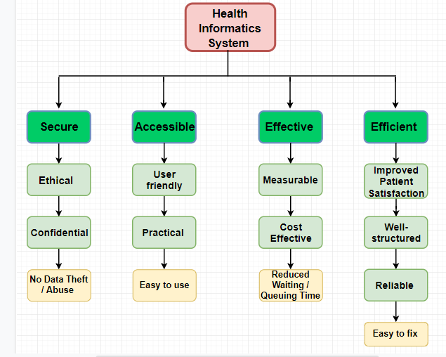
Figure 1: Objectives Tree

2.3 Goals & Outcomes (Hanin)
Our primary goals are to increase the general performance, patient satisfaction, and the efficiency and effectiveness of Marhaba Clinic. Our expected outcomes include a 60% increase in patient satisfaction rate, a reduced average waiting time per day by 50%, and a 75% increase in satisfaction ratings of doctors, nurses and other employees.

2.4 Scope (Khalid)
The project requires including health informatics technology in order to enhance the clinic’s performance. Due to the shortage of time, an actual (physical) system will not be created. Instead, a plan will be produced to raise patient satisfaction rate and to raise performance level. In order to raise performance, different departments will be connected using a system that uses health informatics, this will result in a fast and accurate entry and access to the information. To make patients feel satisfied and confident, their privacy will be ensured using methods such as encryption in order to keep them safe. Also, they would be able to view the results themselves and comprehend them to build their trust. The system will be easy to use and accessible by the employees to guarantee a smooth workflow. We will exclude sectors concerning drug discovery and treatments, as we will be dealing with management and technical aspects only.

3. Project Plan

3.1 List of deliverables (Hanin)
Our deliverables to the client will contain all the necessary information required to meet Marhaba Clinic’s request. Those deliverables are:
- Identify stakeholders
- Identify main areas of concern
- List of main concerns/issues
- Available options for improving relevant issues
- Evaluation matrix for 10 most suitable solutions
- Evaluation metric to evaluate future success
- Recommendation
    - Demonstrate the efficiency of system.
    - Statistical analysis, numerical data, graphs, tables and visualizations.

- Strategic plan of action

3.2 Gantt chart (Khalid)
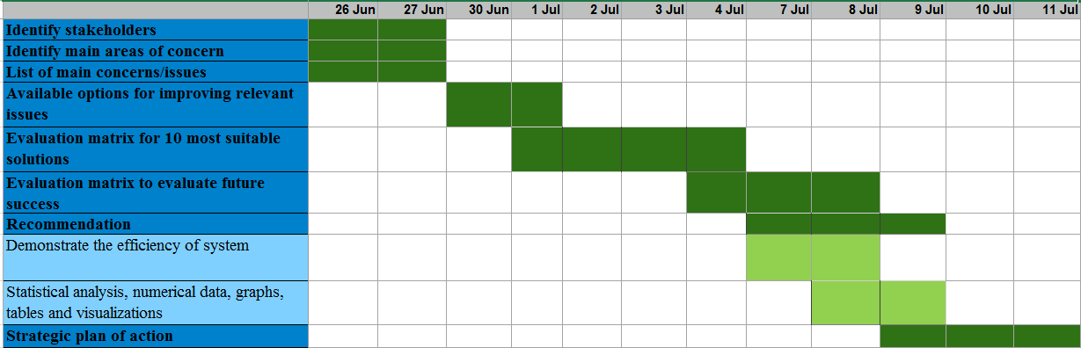
Figure 2 shows a timetable of completion for our deliverables. Some tasks will be done in a parallel manner with other tasks and some will be done after each other. The dates correspond to this year (2019).
Figure 2: Gantt chart

4. Evaluation Methods

4.1 Meeting objectives (Meera & Hanin)
Table 1 contains a pairwise comparison analysis of our objectives that enables us to prioritize each component depending on the total score. As the objective secure has the highest score of 3, it will be the one with highest importance. Preceding it would be effectiveness and efficiency, as they have total scores of 1.5 and 1 respectively. The least important objective is having an accessible system, as it has a total of 0.5.

Table 1: Pairwise Comparision of Objectives
 | Secure | Accessible | Effective | Efficient | Total
Secure | - | 1 | 1 | 1 | 3
Accessible | 0 | - | 0 | 0.5 | 0.5
Effective | 0 | 1 | - | 0.5 | 1.5
Efficient | 0 | 0.5 | 0.5 | - | 1

4.2 Long term success (Khalid)
Our success can be measured by several ways such as:
- Measuring patient satisfaction and taking their feedback through surveys and focus groups.
- Measuring the average queuing/waiting time per day and applying appropriate data analysis on this data.
- Taking feedback from employees regarding the accessibility, efficiency, and effectiveness of the system.
- Create an evaluation matrix that gives a score based on the quality of certain components of the system like technology, frequency and cost of maintenance, and how many patients the system can handle efficiently.
- Comments from the client.

5. Concluding remarks (Hanin)
We would like to inform the client that we have appointed an excellent team to be committed to working on the project, and all the means required to complete the project are provided. System solutions will be evaluated and improved upon your needs and requirements. All tasks will be successfully completed and delivered on time.

6. References:

[1] P. Bath, "Health informatics: current issues and challenges," Journal of Information Science, vol. 34, no. 4, pp. 501-518, 2008. Available: http://eprints.whiterose.ac.uk/78563/8/WRRO_78563.pdf.
[2] G. Larry et al, "Usability and accessibility in consumer health informatics current trends and future challenges," American Journal of Preventive Medicine, vol. 40, no. 5, pp. 187-197, May 2011. Available:
https://www.sciencedirect.com.libconnect.ku.ac.ae/science/article/pii/S0749379711000869
[3] C. M. Kathrin and S. Aziz, “Health information technology in hospitals: current issues and future trends,” Future Healthcare Journal, vol. 2, no. 1 pp.50-56, February, 2015.Availabe: http://futurehospital.rcpjournal.org/content/2/1/50.full.
[4] A.A Roa and A.Sriastava, "Big data in health informatics," ASCI Journal of Management, vol. 47, no. 2, pp. 36-46, 2018. Available: http://search.ebscohost.com/login.aspx?direct=true&db=bsh&AN=135729143&site=eds-live&scope=site
[5] T. Goetz. "It’s time to redesign medical data," YouTube, Jan. 27, 2011. [Video file]. Available: https://www.youtube.com/watch?v=bCGlWQnzDVE. [Accessed: June 15, 2019].

