Module 2: Integrated Mathematics Lesson Plan: Geometric Shapes
Faye Gillespie
American College of Education

Abstract
Within educational institutions, the ways we teach mathematics is changing. Thanks to the Common Core and states trying to obtain increased financial support standards have changed, but the movement to develop and provide more rigorous forms of mathematical instruction runs even deeper than the standards themselves. Blooms taxonomy clearly drives educators to offer increased opportunities for students to analyze, synthesize, and evaluate. The quest to encourage higher levels of learning and Gardner’s work which emphasizes that individuals operate with multiple intelligences provide educators with reasons to rethink forms of traditional instruction. As we create methods of mathematical instruction that emphasize inquiry-based learning, the creation of lessons plans that support 21st century concepts are in order. To accomplish this a series of five integrated math lesson plans for fourth grade Mathematics Florida Standards of Measurement & Data 1.2, 1.3, 2.4 and Geometry 1.1 are created within the context of the assignment expectations of MATH 5213. In this second lesson plan, the focus will be on measurement, data collection, and geometry for the 4th grade architect.

Module 2 Module 2: Integrated Mathematics Lesson Plan: Geometric Shapes
Within this second module, an integrated lesson plan for geometric shapes will be provided. Emphasis will be placed on developing a lesson plan that promotes inquiry-based learning. In this lesson standards MAFS.4.MD.1.3 and MAFS.4.G.1.1 will be utilized. The standard MAFS.4.MD.1.3 states that the learner needs to be able to “Apply the area and perimeter formulas for rectangles in real world and mathematical problems. For example, find the width of a rectangular room given the area of the flooring and the length, by viewing the area formula as a multiplication equation with an unknown factor “and standard MAFS.4.G.1.1 states “draw points, lines, line segments, rays, angles (right, acute, obtuse), and perpendicular and parallel lines. Identify these in two-dimensional figures “(FLDOE, 2018). Chapko & Buchko confirmed that students of the 21st century must have advanced skills that demand changes in how students are taught (2004). Today, we must prepare learners to be problem solves and creators of solutions. Simply put they must be inquirers that can devise answers to a multitude of advanced questions. Inquiry is a process of learning that is driven by questioning, thoughtful investigating, making sense of information and developing new understandings (Diggs, 2009). Math must promote inquiry in many ways including the investigation of geometric shapes, as in this lesson.
Standards and Integration
The focus of five integrated lessons and activities will be that of the Classroom Plaza. The Classroom Plaza will function as a game and incentive station where students find games that are standards driven and incentives for achievement. Daily tickets are provided by the teacher when the student demonstrates that they are ready to learn and follow the simple class created rules for classroom success and engagement. In these five integrated lessons the students will be helping to set up the class incentive store and practice games that will be available this term in the Plaza. The plaza structure will be designed using a variety of shelves and displays built from card board boxes. We will be using this real-world application as we consider area, perimeter, rectangles, points, lines, line segments, rays, angles, perpendicular lines, and parallel lines. The standards, Figure 1, to be addressed in this lesson will be those for fourth grade Mathematics Florida Standards of Measurement & Data 1.3 and Geometry Standard 1.1.
Figure 1
Florida Standards
Standard | Assessment Limits
MAFS.4.MD.1.3 Apply the area and perimeter formulas for rectangles in real world and mathematical problems. For example, find the width of a rectangular room given the area of the flooring and the length, by viewing the area formula as a multiplication equation with an unknown factor. | Figures are limited to rectangles or composite figures composed of rectangles. Fractions are limited to like denominators. Limit multiplication and division to 2-digit by 1-digit or a multiple of 10 by 1-digit. Quotients may only be whole numbers. Limit addition and subtraction to solutions within 1,000. When constructing rectangles, one grid must be labeled with the appropriate dimension.
MAFS.4.G.1.1 Draw points, lines, line segments, rays, angles (right, acute, obtuse), and perpendicular and parallel lines. Identify these in two-dimensional figures. | Items may not require students to name a given figure. Items may not require knowledge or use of ordered pairs or a defined coordinate grid system. Items may require students to draw a figure based on multiple attributes.

This lesson takes the intended path of providing rigorous content that is inquiry based. As learners investigate geometric attributes and definitions for related vocabulary, they are utilizing their knowledge of shapes in combination with their growing special awareness how we need to collect data about the shapes we will be building a Shape Up display for showcasing the Classroom Plaza. Through a series of guided questions, students are encouraged to use their personal understandings and multiple intelligences. Learners will use and share their personal strategies for examining and analyzing geometric shapes in relationship to special surroundings and other objects. This allows for exposures to various thought processes, increased knowledge, and the reshaping of existing ideas related to geometry.
Students will then draw and write about math, as if they were a contractor. Writing about math takes time, but it is well worth the investment. Research links the highest levels of mathematical understanding to the ability to write about math concepts (Meel, 1999) and to the development of multiple math abilities (Bagley & Gallenberger, 1992). When a student can express their thoughts and processes in writing, the student moves beyond simply re-iterating what was heard to deepening the processes involved. Of course, it has been argued that some students do not write well. By integrating writing into math, we are offering a reason to write clearly and to explain based of real processes that are content specific. It is key to recall that communication needs to become the transfer of information in multiple forms, including speech, writing, and visual ques. Communication allows for ideas to become objects of reflection, refinement, discussion and amendment (McCarthy, 2008). When students write about math, the schematic knowledge is enhanced, and students start to understand “why” things happen. In addition, writing about math secures a firm literacy connection to learning.
The goal in these inquiry-based lessons is to create students that are much more than an acquirer of memorized facts. I want students to link what is learned and previously learned to possible solutions for deeper levels of real understanding that is meaningful to the students. Yes, we are going far beyond teaching for testing. “It is fair to say that students can be successful in the short-term, as far as testing is concerned but, without a deeper understanding and problem-solving skills required in mathematics, they will never be successful in the long run” (Borasi &
Rose, 1989). To prepare students we must think about the enduring concepts and information that will serve as knowledge for the future. This means the incorporation of deeper understandings, rigorous content, and technology. Educational content and standards must become integrated into 21st century perspective. The world is no longer perceived as flat and the way we educate students, especially in regard to measurement, data collection, and geometry must be multidimensional.

Lesson Plan and Activity Selection
In this section, Part 2, of this application I shall offer a lesson plan and activity section for geometric shapes, known and labeled as Figure 2.
Figure 2
Lesson Plan and Activities for Measurement, Data Collection, and Geometry
Standard | Assessment Limits
MAFS.4.MD.1.3 Apply the area and perimeter formulas for rectangles in real world and mathematical problems. For example, find the width of a rectangular room given the area of the flooring and the length, by viewing the area formula as a multiplication equation with an unknown factor. | Figures are limited to rectangles or composite figures composed of rectangles. Fractions are limited to like denominators. Limit multiplication and division to 2-digit by 1-digit or a multiple of 10 by 1-digit. Quotients may only be whole numbers. Limit addition and subtraction to solutions within 1,000. When constructing rectangles, one grid must be labeled with the appropriate dimension.
MAFS.4.G.1.1 Draw points, lines, line segments, rays, angles (right, acute, obtuse), and perpendicular and parallel lines. Identify these in two-dimensional figures. | Items may not require students to name a given figure. Items may not require knowledge or use of ordered pairs or a defined coordinate grid system. Items may require students to draw a figure based on multiple attributes.
Learning Goals/Objectives
Define / Discuss Standards and Objectives with students, then Post to Board
Learners will:
- Apply area and perimeter formulas
- Find width or length of a room given area.
- Draw points, lines, segments, angles, perpendicular and parallel lines.
- Collect and analyze data in situations as needed to meet standards expectations.

Instructional Strategies/Lesson Activity

Vocabulary: (As a class, define and draw each term in student notebook.)
Side
Perimeter
Area
Display
Acute Angle
Obtuse Angle
Right Angle
Perpendicular
Parallel
Ray
Lines
Line Segment
Point

Notes:
Post Words to Word Wall and Vocabulary Notebook.
Pictures with words supports ELL students.

Whole Group Lesson: Shape Up with the 4th Grade Architect (use PowerPoint)
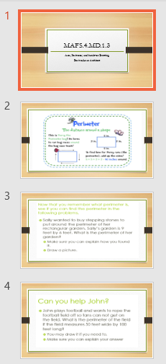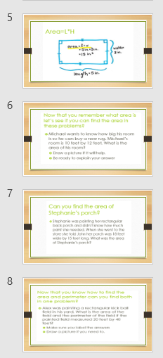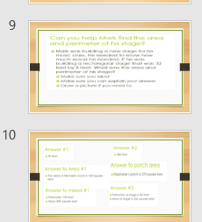
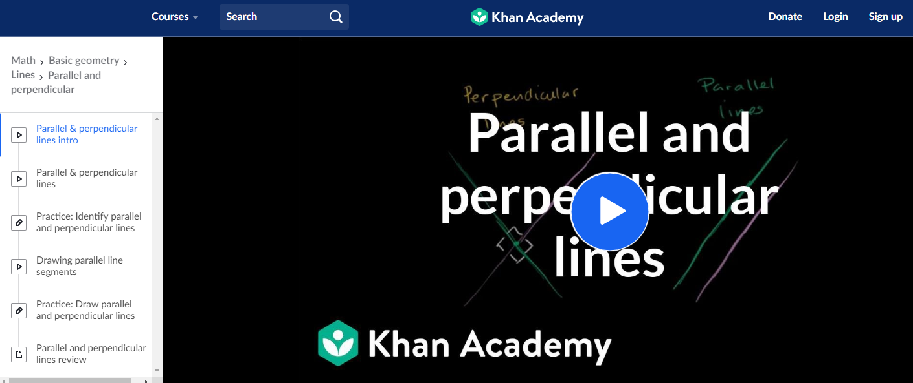
Writing Connection:
Conduct a class discussion on perpendicular and parallel lines using the boxes that are being used to build the Class Plaza display.
Following discussion students will respond in writing to the following prompt: How are perpendicular line different from parallel lines? Draw images to support your writing.

Technology Connection:
iReady and Education Galaxy Assignments for standards-based practice.


Reading Connection:



Formative Assessment

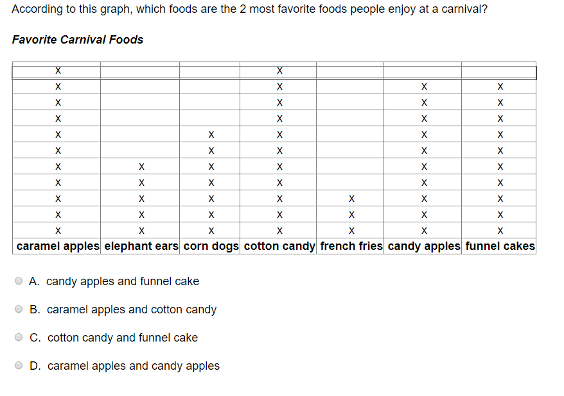

Reminder:
We are not concerned with volume, but simply the flat side (marked with an X) .

Hands on Formative

Each student will be provided with a numbered box and measuring tape or stick. They are to label each side of the box in centimeters.
Calculate the area of the largest face of the box.
Calculate the perimeter of largest face of the box.
What type of angles are the corners of the box?
Explain in writing the size of an acute angle relevant to the angle of the angle at the corner of the box.
Explain in writing the size of an obtuse angle relevant to the angle of the angle at the corner of the box.

Accommodations or Modifications for Unique Student Needs (EL, ESE, 504)
Assist in drawing flat shapes to be measured on paper, if needed.
Resources and Materials
Student Notebooks
Standards and Scales
Computers
Boxes to Build Display
Handouts
Grid Paper
Formative Assessment
Visual Displays
Paper
Rulers or Measuring Tapes
Exit Ticket

Lesson Closure
Homework Assignment – use architect skills to draw and measure the perimeter and area of your bedroom on grid paper.

Exit Ticket
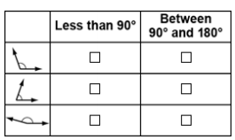

Additional Practice in drawing angles to follow based on exit ticket.

Conclusion
This lesson on geographic shapes, entitled Shape Up, is one that my students love because they want to be part of setting up the Classroom Plaza. Additionally, students enjoy the role of becoming a 4th grade architect and building the plaza. Of course, we need to take a lot of measurements and create lots of real drawings as we construct. The process of setting up the plaza takes several weeks. Of course, it would be easier to do it myself but that would diminish the value of the plaza in the eyes of my students and it would remove the various opportunities to promote meaningful instruction. The anticipation of the opening of our Classroom Plaza is huge. Students start talking about the amount of tickets that they have earned and the worth of the tickets. The have ideas and plans for how the plaza should be constructed and this allows for hands-on practice with geometry. In addition to learning standards, students are engaged in the building of multidimensional concepts that deepen understandings relation to space. While mathematical concepts in this unit are centered on geometric shapes, the opportunities for learning are left open ended and are not confined. I want my students to create their own questions and methods for evaluating what works to solve all types of questions. The multidimensional approach to learning and geometry are preferred as the content is explored and conceptualized from various perspectives. Math should be considered a subject area that has various aspects and concepts that support and deepen one another. Simply put, I want to build inquirers!

References
Bagley, T., & Gallenberger, C. (1992). Assessing students' dispositions: Using journals to
improve students' performance. Mathematics Teacher, 85, 660-663.
Borasi, R., & Rose, B. (1989). Journal writing and mathematics instruction. Educational Studies
in Mathematics, 20, 347-365.
Chapko, M. A., & Buchko, M. (2004). Math Instruction for Inquiring Minds. Principal (Reston,
Va.), 84, 30-33.
Diggs, V. (2009). Ask--Think--Create: The Process of Inquiry. Knowledge Quest, 37, 30-33.
Florida Department of Education (2018). Retrieved from https://fsassessments.org/assets/
documents /G4M_Item-Specifications_Sept2018_Final.pdf
McCarthy, D. (2008). Communication in mathematics: Preparing preservice teachers to include
writing in mathematics teaching and learning. School Science and Mathematics, 108,
334-340.
Meel, D. (1999). Email dialogue journals in a college calculus classroom: A look at the
implementation and benefits. Journal of Computers in Mathematics and Science
Teaching, 18, 387-413.

