Geometry Outdoors
Faye Gillespie
American College of Education

Abstract
Within educational institutions, the ways we teach mathematics is changing. Thanks to the Common Core and states trying to obtain increased financial support standards have changed, but the movement to develop and provide more rigorous forms of mathematical instruction runs even deeper than the standards themselves. Blooms taxonomy clearly drives educators to offer increased opportunities for students to analyze, synthesize, and evaluate. The quest to encourage higher levels of learning and Gardner’s work which emphasizes that individuals operate with multiple intelligences provide educators with reasons to rethink forms of traditional instruction. As we create methods of mathematical instruction that emphasize inquiry-based learning, the creation of lessons plans that support 21st century concepts are in order. To accomplish this a series of five integrated math lesson plans for fourth grade Mathematics Florida Standards of Measurement & Data 1.2, 1.3, 2.4 and Geometry 1.1 are created within the context of the assignment expectations of MATH 5213. In this fourth lesson plan, the focus will be on geometry in nature.

Module 4Geometry Outdoors
Within this fourth module, an integrated lesson plan for geometric outdoors is provided. Emphasis will be placed on developing a lesson plan that promotes inquiry-based learning in nature. In this lesson standard MAFS.4.G.1.1 and MAFS.4.MD.1.3 will be utilized. The standard MAFS.4.G.1.1 states “draw points, lines, line segments, rays, angles (right, acute, obtuse), and perpendicular and parallel lines. The standard MAFS.4.MD.1.3 states “apply the area and perimeter formulas for rectangles in real world and mathematical problems” (FLDOE, 2018). Chapko & Buchko confirmed that students of the 21st century must have advanced skills that demand changes in how students are taught (2004). Today, we must prepare learners to be problem solves and creators of solutions. Simply put they must be inquirers that can devise answers to a multitude of advanced questions. Inquiry is a process of learning that is driven by questioning, thoughtful investigating, making sense of information and developing new understandings (Diggs, 2009). Math must promote inquiry in many ways including the investigations of geometry and measurement within nature.
Standards and Integration
The focus of five integrated lessons and activities will be that of the Classroom Plaza. The Classroom Plaza will function as an activity and incentive station where students find activities that are standards driven and incentives for academic achievement. Daily tickets are provided by the teacher when the student demonstrates that they are ready to learn and follow the simple class created rules for classroom success and engagement. In these five integrated lessons, the students will be helping to set up the class incentive store and practice a variety of activities that will be available this term in the Plaza. The plaza structure will be designed using a variety of shelves and displays built from card board boxes by students. We will be using this real-world application as we consider area, perimeter, rectangles, points, lines, line segments, rays, angles, perpendicular lines, parallel lines, area and perimeter. The standards, Figure 1, to be addressed in this lesson will be those for fourth grade Mathematics Florida Standards of Measurement & Data 1.3 and Geometry Standard 1.1.
Figure 1
Florida Standards
Standard | Assessment Limits
MAFS.4.MD.1.3 Apply the area and perimeter formulas for rectangles in real world and mathematical problems. For example, find the width of a rectangular room given the area of the flooring and the length, by viewing the area formula as a multiplication equation with an unknown factor. | Figures are limited to rectangles or composite figures composed of rectangles. Fractions are limited to like denominators. Limit multiplication and division to 2-digit by 1-digit or a multiple of 10 by 1-digit. Quotients may only be whole numbers. Limit addition and subtraction to solutions within 1,000. When constructing rectangles, one grid must be labeled with the appropriate dimension.
MAFS.4.G.1.1 Draw points, lines, line segments, rays, angles (right, acute, obtuse), and perpendicular and parallel lines. Identify these in two-dimensional figures. | Items may not require students to name a given figure. Items may not require knowledge or use of ordered pairs or a defined coordinate grid system. Items may require students to draw a figure based on multiple attributes.

This lesson takes the intended path of providing rigorous content that is inquiry based. As learners investigate geometry and measurement (perimeter and area) of large spaces within nature, they will consider related vocabulary that builds communication and knowledge. The Geometry & Measurement in Nature display will be featured in the Classroom Plaza. Through a series of guided questions and activities, students are encouraged to use their personal understandings and multiple intelligences. Learners will use and share their personal strategies for examining and analyzing tasks related to the world of nature. By sharing of thoughts and strategies in small groups, students are exposured to various thought processes, increased knowledge, and the reshaping of existing ideas related to geometry and measurement.
Students will draw and write about math, as explorers of nature. Writing about math takes time, but it is well worth the investment. Research links the highest levels of mathematical understanding to the ability to write about math concepts (Meel, 1999) and to the development of multiple math abilities (Bagley & Gallenberger, 1992). When a student can express their thoughts and processes in writing, the student moves beyond simply re-iterating what was heard to deepening the processes involved. Of course, it has been argued that some students do not write well. By integrating writing into math, we are offering a reason to write clearly and to explain based of real processes that are content specific. It is key to recall that communication needs to become the transfer of information in multiple forms, including speech, writing, and visual ques. Communication allows for ideas to become objects of reflection, refinement, discussion and amendment (McCarthy, 2008). When students write about math, the schematic knowledge is enhanced, and students start to understand “why” things happen. In addition, writing about math secures a firm literacy connection to learning.
The goal in these inquiry-based lessons is to create students that are much more than an acquirer of memorized facts. I want students to link what is learned and previously learned to possible solutions for deeper levels of real understanding that is meaningful to the students. Yes, we are going far beyond teaching for testing. “It is fair to say that students can be successful in the short-term, as far as testing is concerned but, without a deeper understanding and problem-solving skills required in mathematics, they will never be successful in the long run” (Borasi &
Rose, 1989). To prepare students, we must think about the enduring concepts and information that will serve as knowledge for the future. This means the incorporation of deeper understandings, rigorous content, and technology. Educational content and standards must become integrated into 21st century perspective. The world is no longer perceived as flat and the way we educate students, especially in regard to measurement and geometry must be multidimensional.

Lesson Plan and Activity Selection
In this section of this application, I shall offer a lesson plan and activity section for Geometry in Nature, Figure 2.
Figure 2
Lesson Plan: Geometry in Nature

Standard | Assessment Limits
MAFS.4.MD.1.3 Apply the area and perimeter formulas for rectangles in real world and mathematical problems. For example, find the width of a rectangular room given the area of the flooring and the length, by viewing the area formula as a multiplication equation with an unknown factor. | Figures are limited to rectangles or composite figures composed of rectangles. Fractions are limited to like denominators. Limit multiplication and division to 2-digit by 1-digit or a multiple of 10 by 1-digit. Quotients may only be whole numbers. Limit addition and subtraction to solutions within 1,000. When constructing rectangles, one grid must be labeled with the appropriate dimension.
MAFS.4.G.1.1 Draw points, lines, line segments, rays, angles (right, acute, obtuse), and perpendicular and parallel lines. Identify these in two-dimensional figures. | Items may not require students to name a given figure. Items may not require knowledge or use of ordered pairs or a defined coordinate grid system. Items may require students to draw a figure based on multiple attributes.
Learning Goals/Objectives
Define / Discuss Standards and Objectives with students, then Post to Board
Learners will:
- Apply area and perimeter formulas
- Find width or length a given area.
- Draw points, lines, segments, angles, perpendicular and parallel lines.
- Collect and analyze data in nature that deepens the understanding of the standards.

Instructional Strategies/Lesson Activity

Vocabulary: (As a class, define and draw each term in student notebook.)
Side
Size
Comparison
Perimeter
Area
Space
Dimensions
Acute Angle
Obtuse Angle
Right Angle
Perpendicular
Parallel
Ray
Lines
Line Segment
Point

Notes:
Post Words to Word Wall and Vocabulary Notebook.
Pictures with words supports ELL students.

Review MAFS.4.MD.1.3

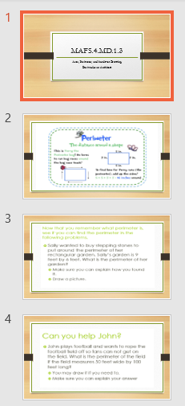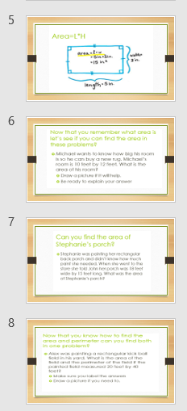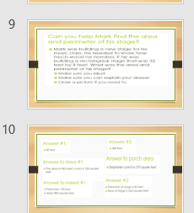

Review MAFS.4.G.1.1
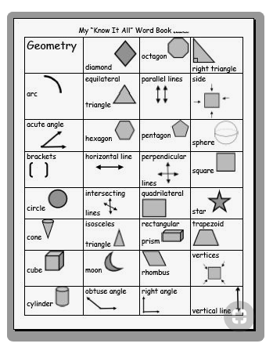
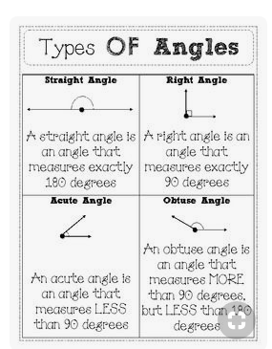
Area and Perimeter in Nature

In this outside activity students will work in groups of four or five. Within the groups, studetns area assignd roles.

Group Work:
2 Measurers, 1 Tech, and 2 Recorders are needed.
The Tech will use camera or mobile phone with an integral camera for taking photographs of he shapes which will be used in the Classroom Plaza.

Outdoor Tasks: Groups measur the Perimeter and Area of the playground, flowerbed, and sandbox.
Students are asked to use their own forms of measuement (sticks, feet, steps, etc.).

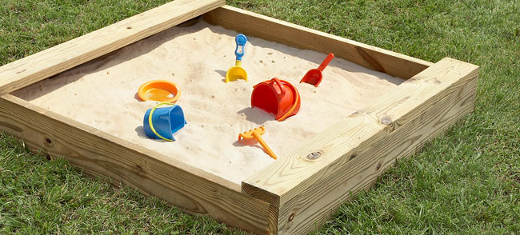

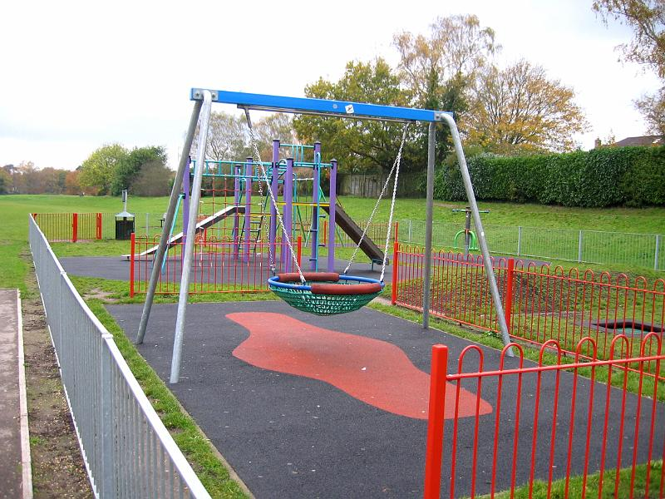

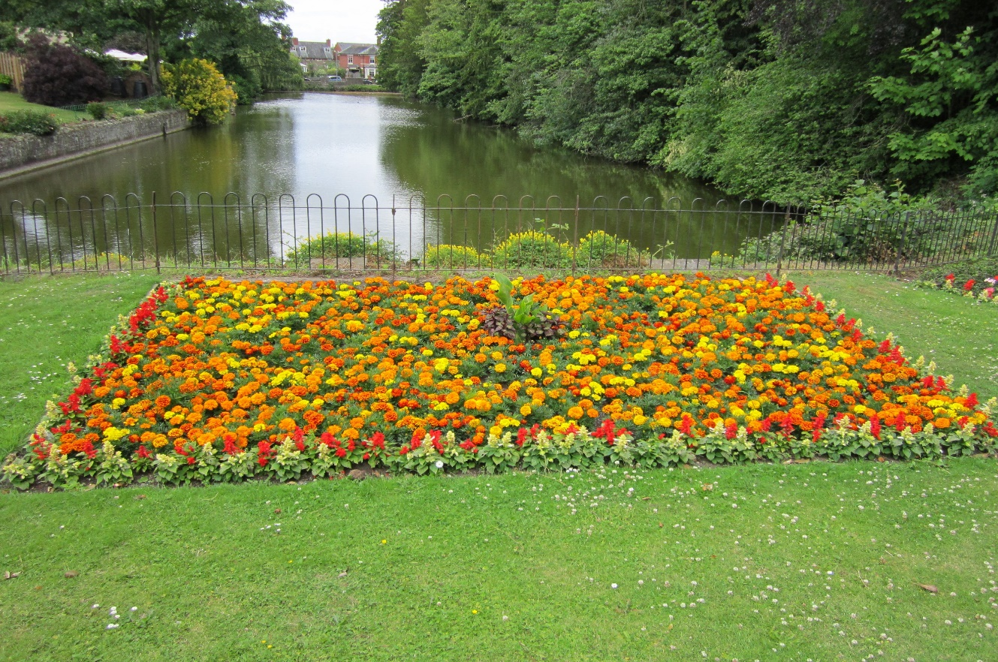

Back in the Classroom: Compare Findings
Student write out their findings. Compare using the overhead projector or smartboard.
Questions:
What is the same and what is different in findings?
What difficulties were encountered in measuring?
What would make the comparison process more accurate and effective? Why?

Geometry (Angles) in Nature

Ask students for examples of when they use Math in real life. They will probably talk about adding and subtracting. Explain that angles and geometry can also be found in nature and today we are going to do an activity to find them.
Note: Students should already be familiar with measuring angles with a protractor.

Outside of Classroom: Teacher finds a plant and model how you can measure the angles between the branches.

Pass out the investigation worksheet and explain that they will work with a partner to look for angles in nature. Tell them to be very careful when measuring the angles of plants, because some plants are fragile and very important to our health and to the environment. Go outside with the students and give them time to measure the angles between branches in trees or flowers, between the ground and the trunk of a tree, etc.

Students to complete columns 1 and 2 outside with the protractor and object, but tell them to wait for the 3rd column, supplementary angles.

Back in classroom: Review supplementary angles and the example on the worksheet. Independent Practice: Students can complete the column about supplementary angles. (Formative Assessment)

Writing about activity: Students to explain some obstacles that they had.

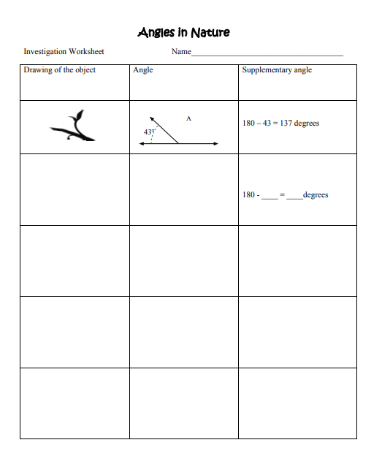

Additional Support Activity for Students

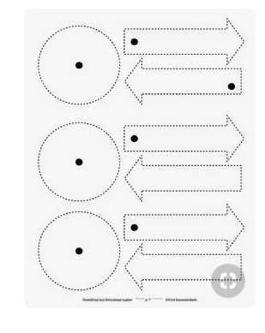
More Writing Connection:
Conduct a class discussion on perpendicular and parallel lines using the boxes that are being used to build the Class Plaza display.
Following discussion students will respond in writing to the following prompt: How are perpendicular line different from parallel lines? Draw images to support your writing.

Technology Connection:
iReady and Education Galaxy Assignments for standards-based practice.


Geometry in Nature Video

https://www.youtube.com/watch?v=4_q1z4k0o8A

Reading Connection:

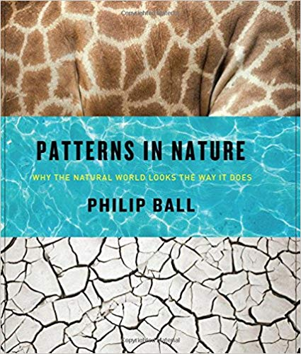

Formative Assessment

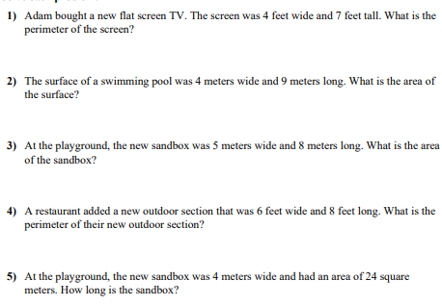

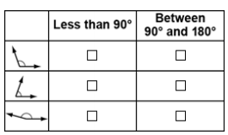

Accommodations or Modifications for Unique Student Needs (EL, ESE, 504)
Assist in making protractors activity, drawing angles, and repeat activities as needed. Reinforce standards and skills using technology.
Resources and Materials
Student Notebooks
Standards and Scales
Computers
Handouts
Cameras
Formative Assessment
Visual Displays
Assorted Measuring Tools
Paper
Book
Software
Construction Paper
Protractors
Exit Ticket

Lesson Closure

Homework Assignment – measure the perimeter and area of a rug in your home. What is the shape of the rug? What kind of angles are represented?

Enrichment: Write a paragraph explaining how nature and math are connected.

Conclusion
This lesson on geography and measurement in nature is one that my students love because they want to be part of setting up the Classroom Plaza and embrace outdoor discovery. Additionally, students enjoy the role of becoming a 4th grade surveyor and naturalist. Of course, we need to take a lot of measurements and pictures in order to set up an outdoor station in our Classroom Plaza. The process of setting up the plaza takes several weeks. Of course, it would be easier to do it myself but that would diminish the value of the plaza in the eyes of my students and it would remove the various opportunities to promote meaningful learning. The anticipation of the opening of our Classroom Plaza is huge. Students start talking about the amount of tickets that they have earned and the which stations the will visit. They have ideas and plans for how the plaza should be constructed and this allows for hands-on practice with geometry inside the classroom. By bringing part of nature inside the classroom, students are increasingly engaged in the building of multidimensional concepts that deepen understandings of geometry and measurement in the world. While mathematical concepts in this unit are centered on geometry and measurement, the opportunities for additional learning are left open ended and are not confined. I want my students to create their own questions and methods for evaluating what works to solve all types of questions. The multidimensional approach to learning mathematics is preferred as the content encourages exploration and conceptualized of various perspectives. Math should be considered a subject area that has various aspects and concepts that supports the overall learning and knowledge of the learner. Simply put, I want to build inquirers!

References
Bagley, T., & Gallenberger, C. (1992). Assessing students' dispositions: Using journals to
improve students' performance. Mathematics Teacher, 85, 660-663.
Borasi, R., & Rose, B. (1989). Journal writing and mathematics instruction. Educational Studies
in Mathematics, 20, 347-365.
Chapko, M. A., & Buchko, M. (2004). Math Instruction for Inquiring Minds. Principal (Reston,
Va.), 84, 30-33.
Diggs, V. (2009). Ask--Think--Create: The Process of Inquiry. Knowledge Quest, 37, 30-33.
Florida Department of Education (2018). Retrieved from https://fsassessments.org/assets/
documents /G4M_Item-Specifications_Sept2018_Final.pdf
McCarthy, D. (2008). Communication in mathematics: Preparing preservice teachers to include
writing in mathematics teaching and learning. School Science and Mathematics, 108,
334-340.
Meel, D. (1999). Email dialogue journals in a college calculus classroom: A look at the
implementation and benefits. Journal of Computers in Mathematics and Science
Teaching, 18, 387-413.

