Module 3: Analysis-Application for Operations with Fractions
Faye Gilbert Gillespie
American College of Education

Abstract
Today, mathematics is a subject that is best taught in concert with other subjects and the world around us. The advancements of technology have both supported and challenged the field of math. Within educational institutions, the ways we teach mathematics is changing. Thanks to the Common Core, and states trying to obtain increased financial support, standards have changed; however, the movement to develop more rigorous forms of instruction runs even deeper than the standards themselves. Blooms taxonomy clearly drives educators to offer increased opportunities for students to analyze, synthesize, and evaluate. The quest to encourage higher levels of learning and Gardner’s work which emphasizes that individuals operate with multiple intelligences provide educators with reasons to rethink forms of traditional instruction. As we strive to create methods of mathematical instruction that emphasize inquiry-based learning, we are called upon to create lessons plans and form units that support 21st century concepts. To accomplish this a series of integrated math lesson plans will be provided to teach fractions, decimals, percent, and ratios. In this third lesson, the focus will be on operations with fractions.

Module 3: Analysis-Application for Operations with Fractions
For the purposes of these lessons, the sixth grade Mathematics Florida Standards (MAFS) will be utilized. The unit of study will encompass MAFS.6.NS.1.1 directed at “extending previous understandings of multiplication and division to divide fractions by fractions”, MAFS.6.NS.2.3 promoting the “fluent adding, subtracting, multiplying, and division of multi-digit decimals using the standard algorithm for each operation”, MAFS.6.RP.1.3c promoting the “finding of a percent of a quantity as a rate per 100 (e.g., 30% of a quantity means 30/100 times the quantity) with solving problems involving finding the whole, given a part and the percent”, and MAFS.6.RP.1.3d “requiring the use of ratio reasoning to convert measurement units along with the ability to manipulate and transform units appropriately when multiplying or dividing quantities” (Florida Department of Education, 2018). While these standards will frame the unit of study, this third lesson will encompass standards, portions of MAFS.6.RP.1.3c and MAFS.6.NS.1.1, that require students to preform operations involving fractions.

Investigate
Fractions are a major mathematical element that are needed to achieve success in algebra and beyond, but students continue to struggle with the concepts of fractions. “NAEP test results have consistently shown that students have a weak understanding of fraction concepts” (Sowder & Wearne, 2006; Wearne & Kouba, 2000). The lack of deep understanding seems to center around the computation of fractions, decimals, and percent (Brown & Quinn, 2007; National Mathematics Advisory Panel, 2008). In fact, “many who research fraction understanding believe students would understand fractions better with more emphasis across other meanings of fractions” (Clarke, Roche, & Mitchell, 2008; Lamon, 2012). This research demonstrates that we must empower learners by offering high interest in-depth learning opportunities that are diverse and use multiple approaches to deepen the overall fractional thinking of learners. This was completed with the first two lessons. In this lesson, the operational process related to conceptualized portions of a whole, multiplication, and division of fractions will be the emphasis.
Analyze
The research from my investigation suggests that teaching fractions with a varied real-world approach that deepens understanding and modeling are appropriate. It seems that the need to captivate the learner’s thoughts and attentions is, also, relevant. When it comes to misconceptions surrounding fractions, there are many that struggle with basic concepts. First, some consider “the numerator and denominator are separate values and have difficulty seeing them as a single value” of an individual fraction (Cramer & Whitney, 2010). To remedy this measuring items and presenting fractions on a number line may help in this instance. Secondly, students may “think that a fraction such as 1/5 is smaller than a fraction such as 1/10 because 5 is less than 10” (Cramer & Whitney, 2010). To help re solve this issue, the use of visuals and contexts should be used to show parts of the whole. Thirdly, models themselves may be the problem if they have been used incorrectly or fashioned without promoting critical thinking. Pure identification is not a strong use of models and can prohibit the understanding of models that seek to deepen visual realization of computational models involving fractions. Models need to provide visualizations that appeal to the learner and are related to real world problems that capture student interest. Finally, when to performing operations involving fractions the needs to apply what they know about operations and conceptualize why fractions have rules that make operations of multiplication and division possible. The process of conceptualizing fractions involved in operations takes time and should be repeatedly spiraled within multiple grades.

Choose
Based on the fact that I want learners to take unique views of fractions, I will offer a literacy connection by using the book The Man Who Counted by Malba Tahan. This book is available online by Amazon and other retail bookstores. For those living in Florida, it is available at the Palm Beach Public Library. Tahan is a Brazilian mathematician and offers a series of mathematical puzzles woven into the narrative of adventures of Beremiz Samir and Honok These. The setting is that of 13th-century Persia. As the two characters run into problems, of course involving fractions, Beremiz solves them by calling on his fantastic mathematical powers. With his accomplishments, Beremiz earns fame and good fortune. The thriller is the final test with of seven challenges to Beremiz's power. The final decision comes down to a truth-teller-vs.-liar puzzle. The adventurous challenges in this book are designed to create a higher level of thinking which requires the reader investigate the situations and call on higher level critical analysis skills. The reader is compelled to follow the thought processes for solving difficult mathematical situations. The book was published in 1993 and holds endless possibilities for opening and inspiring the mind to concepts involving advanced fractional logic. This book binds the lessons presented throughout this unit.
Write
In order to facilitate learning of higher order thinking skill as we read The Man That Counted, I shall offer questions that may be posed to foster evaluative thinking. These are questions based on the material offered in Chapters 8 of the book. (Tahan, 1993).
- In chapter eight, entitled Seventh Heaven, “there are 21 identical casks of wine, of which 7 full, 7 half full, and 7 empty, are to be divided among three men. Consider how each item can be represented numerical and visually. Evaluate your representation compared to that of your partner. What representations seem most logical for the situation?
- Now, “each should receive the same amount of wine and the same number of casts, without opening them. Evaluate how this can be accomplished.
- Beremiz claimed, “the first receives 3 full casks, 1 half full, and 3 empty. The second and third each receive 2 full casks, 3 half casks, and 2 empty. Do you agree or disagree? Evaluated if there is another way to solve? How?
- In chapter 8, “a bill of 30 dinars is paid by the three men, each putting up 10 dinars. It turns out that there was an error; the bill was only 25 dinars. They get back 5 dinars; each takes 1 dinar, and the remaining 2 dinars are given to the slave who served them. However, someone finds this strange, because now each has paid 9 dinars making a total of 27 dinars. Adding in the 2 dinars given to the slave only makes 29 dinars. How did 1 dinar disappear? Evaluate and explain.
Design & Develop Lesson Plan
Content Standard(s)  Mathematics  Grade 6 |  | Prior Knowledge Existing: | Learning Goals/Objectives  Define / Discuss  Post to Board
MAFS.6.NS.1.1  Interpret and compute quotients of fractions and solve word problems involving division of fractions by fractions, e.g., by using visual fraction models and equations to represent the problem. For example, create a story context for 2/3 ÷ 3/4 and use a visual fraction model to show the quotient; use the relationship between multiplication and division to explain that 2/3 ÷ 3/4 = 8/9 because 3/4 of 8/9 is 2/3 . (In general, 𝑎/𝑏 ÷𝑐/𝑑 = 𝑎𝑑 x 𝑏𝑐 .) How much chocolate will each person get if 3 people share 1/2 lb of chocolate equally? How many 3/ 4 -cup servings are in 2 3 of a cup of yogurt? How wide is a rectangular strip of land with length 3/4 mi. and area 1/2 square mi.?  MAFS.6.RP.1.3c promoting the “finding of a percent of a quantity as a rate per 100 (e.g., 30% of a quantity means 30/100 times the quantity) with solving problems involving finding the whole, given a part and the percent |  | - Multiplication  - Division  - Fraction Operations  - Relationships between Multiplication and Division  - Multiplication and Division of a fraction and whole number  - Models | Learners will:  - Deepened skills related to multiplication and division with fractions.  - Develop skills for solving problems.  - Create and develop modeling skills related to fractions in order to deepen the knowledge needed to complete operations involving factions.  - Use skill to create story context, included those of comparison and magnitude.  - Explain, compute, and evaluate fractions involved in dividing fractions.
 | Instructional Strategies/Lesson Activity
Vocabulary Review (Post Words to Wall and Vocabulary to Notebook)
Include the term “of” as meaning times or multiplication.
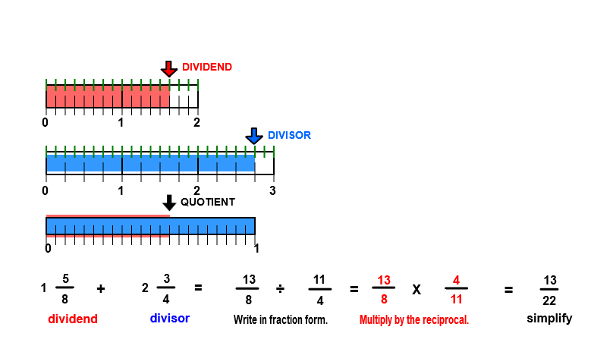
Technology Note: When posing questions to students, utilize LanSchool to receive answer from all learners. This promotes asking questions of all students and can serve as a form ongoing formative assessment.

Spiral Review Models related to Multiplication and Division of Fractions

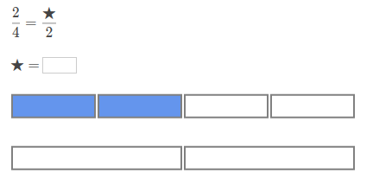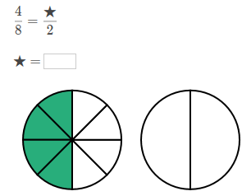

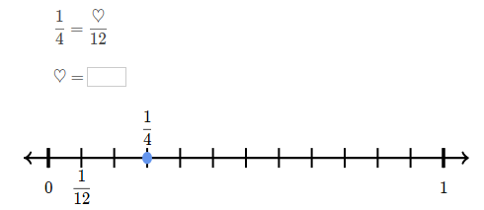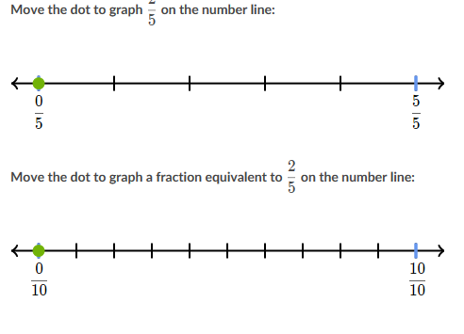
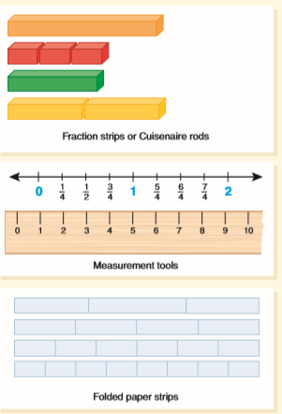

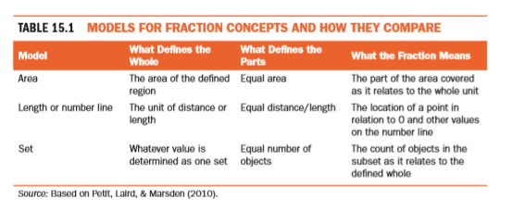

Pre- Instructional Formative

Write an inequality for each of the two modeled comparisons.
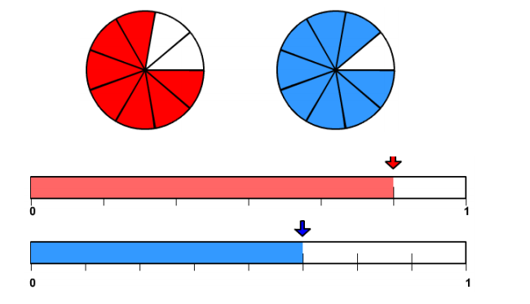

If there are 100 cookies in a bag and 20 are broken, what fractions represent the broken portion? What fraction represents the whole and the unbroken portion of cookies?

Multiply 2/3 x 4/5

Explain how to divide ½ by ¼.

Opening Review and Modeling Activity

In the reading of The Man Who Counted by Malba Tahan, we experience just how smart Beremitz was with numbers and fractions. Now, it is your turn.

Whole Group Instruction
Review of Area Models & Number Lines for Multiplication with Fractions
(from 5th grade standards / deepening knowledge)
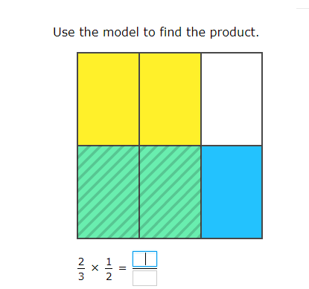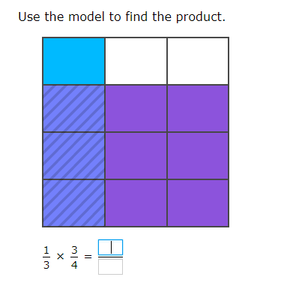
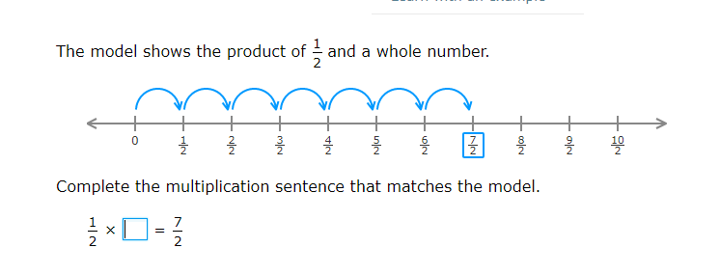
Division (deepening knowledge)
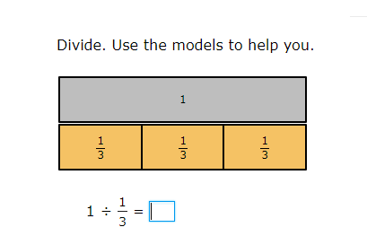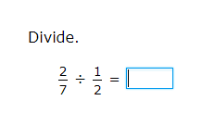

Division of fractions

Video / Technology Application

PowerPoint

https://www.visualfractions.com/Investigate/dividei.pdf

Keep it, Change it, Flip it!

https://www.pbslearningmedia.org/resource/mgbh.math.ns.keepchange/keep-change-flip/#.XPb9f6JKiUk

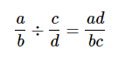
Review Fraction Rules From Lesson 2

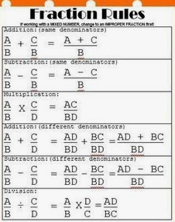

Real World Application

CHOCOLATE IN THE REAL WORLD
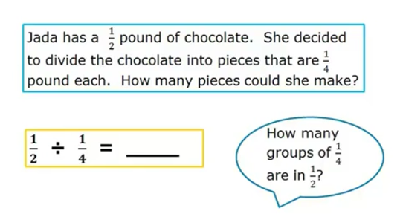

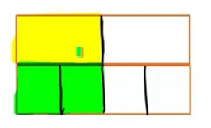

Create a Story Problem Formative

Given the problem 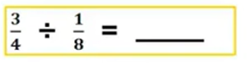Create a story problem.

Example: 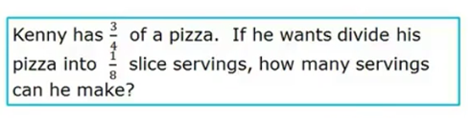

Visualize the problem using a model.

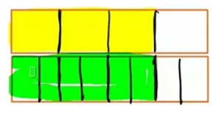

Note Taking & Guided Practice (Literacy Extension)

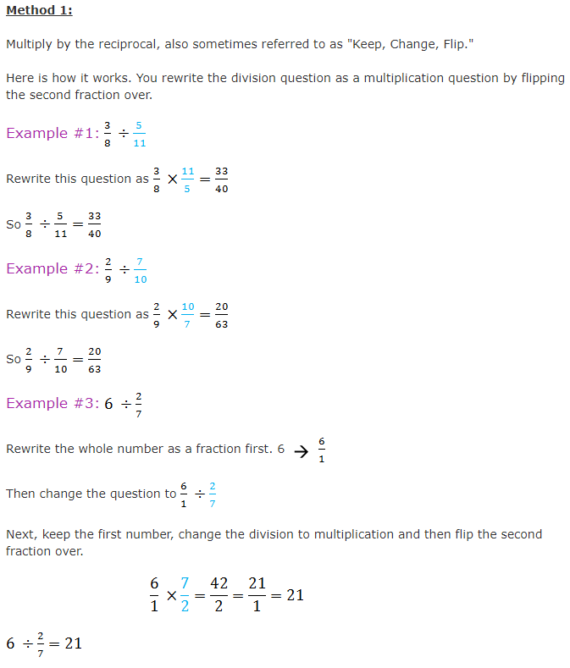

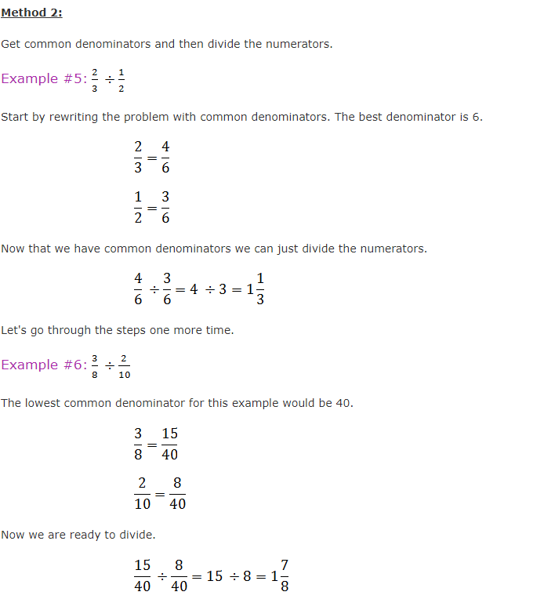

Mixed Numbers as Fractions Greater than 1….More fun
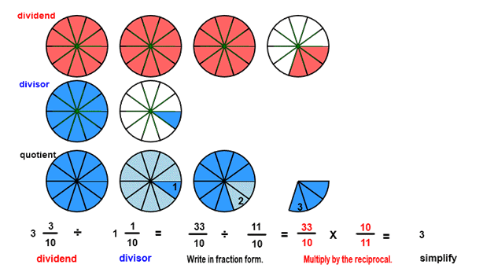

Formative (allow students to use their notes)

Solve and model.
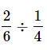

Evaluate various methods to solve the problem.

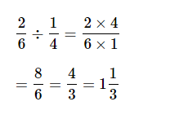
Technology Activity

https://www.khanacademy.org/math/arithmetic/fraction-arithmetic/arith-review-dividing-fractions/v/dividing-fractions-example

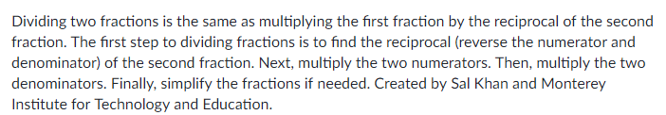

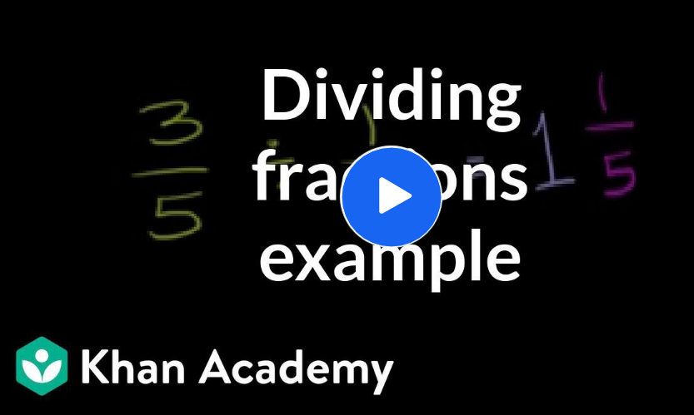

Modeling Activity Recess / Real-World Reality Check

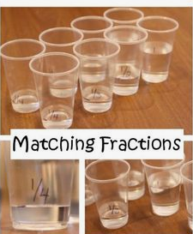
We have ¾ of a gallon of ice cold water to take outside to recess. If each person receives ¼ cup of water, how many students get to drink water?
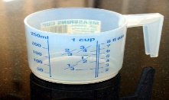

Formative Assessment
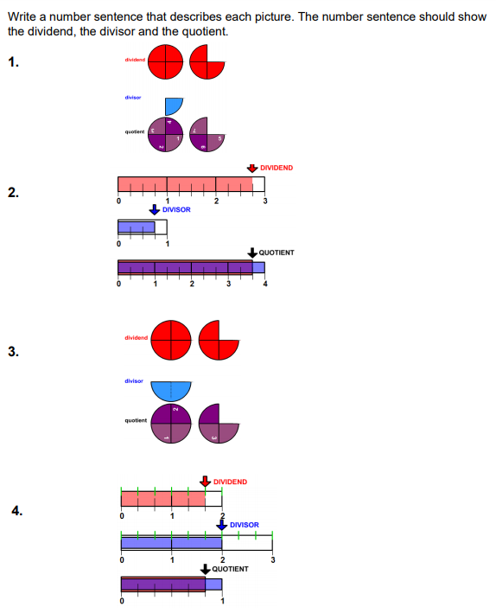

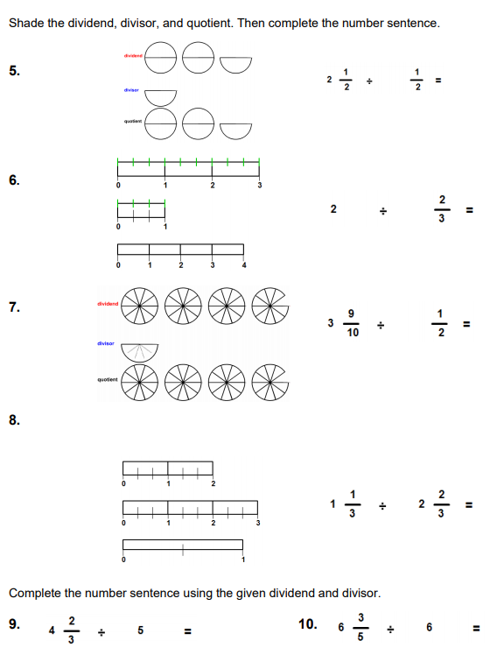

Connection to Literacy

Book: The Man Who Counted by Malba Tahan.
Beremiz Samir (the man who counted) was born in Khoi (Persia). As a young boy shepherd, he counted his master’s sheep. If ½ of 12 sheep were given equally to three men, how many sheep would each man receive?

Contextual Real-World Story Telling & Review Formative

Create a real-world story context for a situation that would result in the calculation of
1 ½ ÷ 2/6. Record your story. Then, model and solve.

Technology Enhanced Learning & Technology Formative

iReady to reinforce, practice, and build fluency with MAFS.6.NS.1.1

 | Resources and Materials
Student Notebooks
Video
Standards and Scales
Formative Assessment
Visual Displays
Measuring Cups
Fraction Tops
Water
Book
Grid Paper (scaffold modeling)
Colored Pencils
Homework Direction sheet
Computers

 | Lesson Closure

Reflection & Conclusion
As I come to the close of this application exercise on operations with fractions, including, I reflectively anticipate that this lesson will deliver a higher level of understanding related to fractions. The lesson starts with a review or spiral from known models that students have been exposed to and transitions into modeling related to the standard. Lessons one and two built understanding allowing to this lesson to offer more complex aspects of dividing fractions by fractions. The activities provide the learner with a real-world visual and extensive opportunities to apply higher level thinking skills. This lesson is not expected to be understood entirely by all learners at the first exposure. I suggest chunking information and small groups based on individual learner need for additional support. The learning should however to progressive and challenging to the student. Overall, a deep sense of understanding of operations related to fractions should be obtained by all. This is a lesson the should be extended over several days and spiraled each day. The learner is frequently called on to evaluate situations which helps build real world critical thinkers and the advancement of knowledge. By using extension questions, the intent is to develop and inspire the highest of inquiry-based learning. This was intentional and sought as a means of approaching research that suggested that a “lack of deep understanding seems to center around the computation of fractions, decimals, and percent” (2012; Brown & Quinn, 2007; National Mathematics Advisory Panel, 2008). The formative assessments are arranged to provide smooth transitions that are not disruptive to the flow. Of course, the formative results may alter the lesson on the spot or daily progression. The instructor must be ready and flexible to meet the needs of the learners is a key component of teaching in the 21st century. My expectation from this lesson is to understand the thinking of my students and evaluate the readiness to advance learning related to advanced grade level operations involving fractions and beyond. I infused concepts of mixed numbers that must be converted into fractions prior to the actual calculations. This should add rigor and maximize the learning related to the division of fractions. Overall, I will be approaching teaching and learning with the desire to prepare all students for a world that is full of mathematics. Mathematics is no longer just a single subject, but rather a component of daily existence woven into the fabric of life.

References

Brown, G., & Quinn, R. J. (2007). Investigating the relationship between fraction proficiency
and success in algebra. Australian Mathematics Teacher, 63(4), 8–15.
Clarke, D. M., Roche, A., & Mitchell, A. (2008). Ten practical tips for making fractions come
alive and make sense. Mathematics Teaching in the Middle School, 13(7), 373–380.
Cramer, K., & Whitney, S. (2010). Learning rational number concepts and skills in elementary
school classrooms. In D. V. Lambdin & F. K. Lester, Jr. (Eds.), Teaching and learning
mathematics: Translating research for elementary school teachers, 4(2), 15–22
Lamon, S. (2012). Teaching fractions and ratios for understanding: Essential content knowledge
and instructional strategies. New York, NY: Taylor & Francis Group.
National Mathematics Advisory Panel. (2008). Foundations for success. Jessup, MD: U.S.
Department of Education.
Link, T., Nuerk, H.-C., & Moeller, K. (2014). On the relation between the mental number line
and arithmetic competencies. Quarterly Journal of Experimental Psychology, 67(8).
Sowder, J. T., & Wearne, D. (2006). What do we know about eighth-grade student achievement?
Mathematics Teaching in the Middle School, 11(6), 285–293
Tahan, M. (1993). The boy that counted. Edinburgh: Canogate.
Wearne, D., & Kouba, V. L. (2000). Rational numbers. In E. A. Silver & P. A. Kenney (Eds.),
Results from the seventh mathematics assessment of the National Assessment of
Educational Progress, 163–191. Reston, VA: NCTM.

