Celtic Harvest at Rescorla
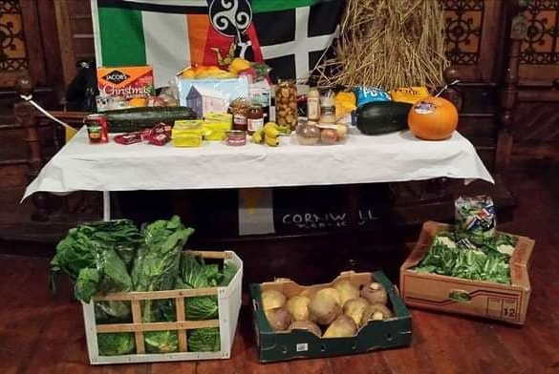
Saturday 22nd October 2022

- Harvest Lunch at noon. If you would like to book please contact Garry (07714210966) or Enid. Price is £7.50 (vegetarian option)

- We will then start at 2pm with our traditional harvest auction with David Michael.

- This will be followed by a Celtic programme of story, music and song including Crying the Neck with Clarinda and Keith Truscott, Celtic hymns, and entertainment by Ilow Rescorla. We will also be joined by the Fable duo, our guest performers for the afternoon.

Check out our website https://rescorlacentre.site123.me/, join our facebook group ‘Rescorla Centre’, email cornishstudies@exeter.ac.uk or telephone 07714210966

