**FORMULA PENAL**

DENIS BERNARDO SANCHEZ DNI 24450782 and domiciled in street ZABALA 2443 APARTMENT 4 apartment No. 10 CABA

I come to file criminal charges for his participation as AUTHORS RESPONSIBLE FOR CRIMINAL OFFENSE OF PERJURY IN HIDING INFORMATION STATEMENT TESTIMONY (ART. 275 CP) No. 27009/2016 IN JUDICIAL RECORD, SANCHEZ, DENIS BERNARDO c / MONTE VERDE SA AND OTHER s / dISMISSAL iN NATIONAL LABOR COURT Nº77 quote in street Perón 990 floor 12. CABA

BERMEJO criminal complaint against LEONOR SILVINA, ID 28096716, ARGENTINA, EMPLEADA. Resident at Bartolome Miter 1465, MORON, BUENOS AIRES PROVINCE.,

criminal charges against Luis Alberto Ghio, ID 14769947, Argentine, accountant employed, resident AV. pueyrredon 1993 1 A, CABA

ZWARYCZ criminal complaint against ALEJANDRO SERGIO, ID 14997482, Argentine, chemical used, a resident of Barabino 479, San Antonio de Padua, Province of Buenos Aires.

criminal charges against DUARTE CARLOS HORACIO, ID 12628393, ARGENTINE, employee, residing in Salta 3948, San Justo Buenos Aires Province.

CICCIOLI criminal complaint against ENRIQUE MIGUEL, ID 7691251, Argentine, married, retired, residing in Tucuman 1861, Banfield, Buenos Aires Province.

DAY 10/11/2017 Silvina BERMEJO LEONOR DECLARES UNDER OATH AND PREJUDICE IN MY Attached copy of testimony (Doc. 22)

*"Which the actor knows because they were co-workers at Monte Verde SA Laboratories located in Villa Martelli Agustin Alvarez, who worked with the actor since late 2012 to mid-2014,"*

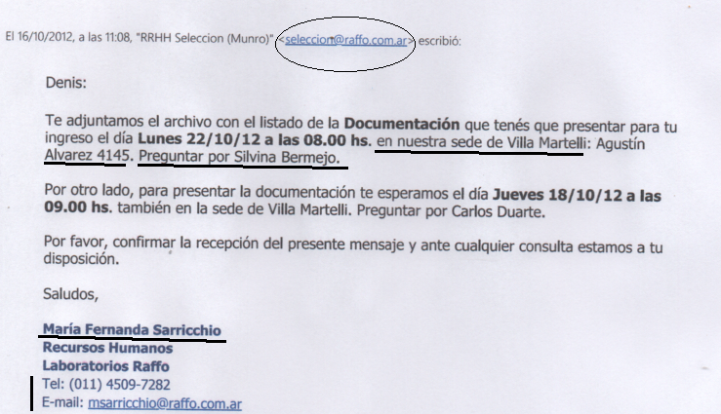**Which it is false as she greeted me from the first day after the selection process Raffo SA.**

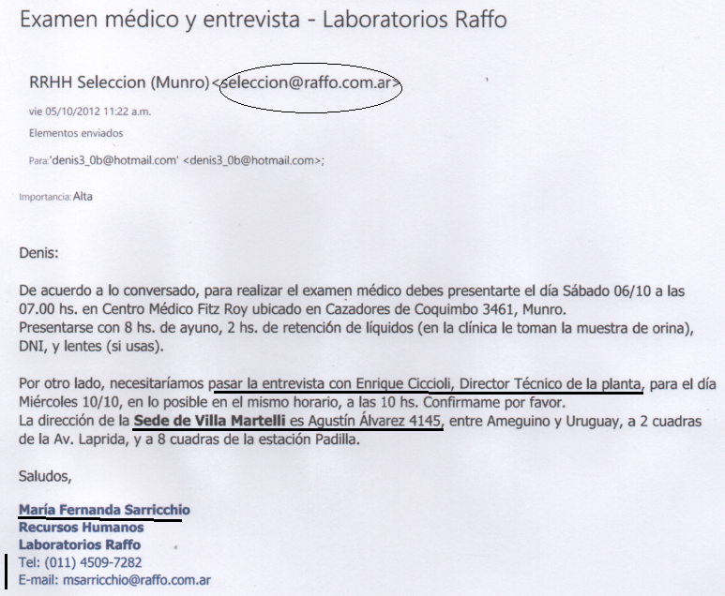**(Doc.19 a) and (Doc. 19 b) in which I requested interview with the Technical Director of Plant Villa Martelli, E. Ciccioli.**

In INAME (Doc. 6) minutes record the presence of inspectors INAME a complaint leaves. The inspectors are received by staff RAFFO Laboratories SA, D. Technical and Chief Quality Assurance, BERMEJO SILVINA. The latter witness claims that:

"Which were never notified of any sanction, which were routine inspections."

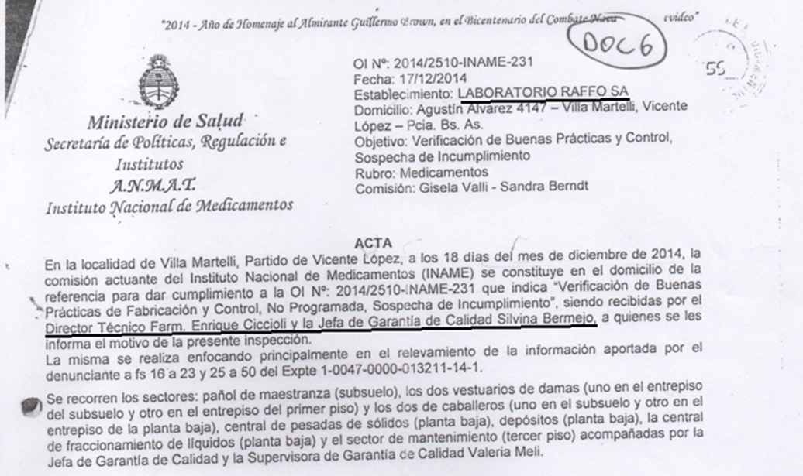

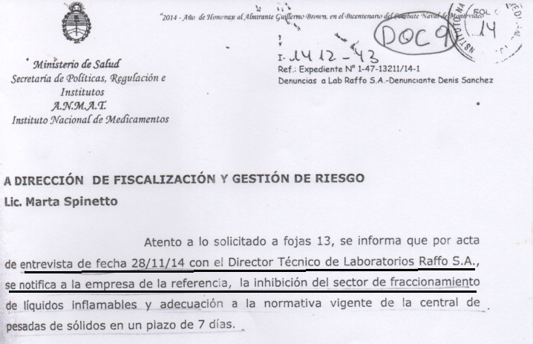

**What is FALSE and that the minutes of the day 11.28.14 evidence of the challenge inspection and routine is not allowed, and the (Doc.9) proof of notification of the penalty imposed was left plant VILLA MARTELLI of RAFFO LABORATORIES SA, (Doc. 16) Plant refer all witnesses.**

**Also in the laboratory evidence of AFIP RAFFO SA shown below, by CUIT: 30-50209419-6 Laboratory management RAFFO SA is observed**

<https://seti.afip.gob.ar/padron-puc-constancia-internet/ConsultaConstanciaAction.do>

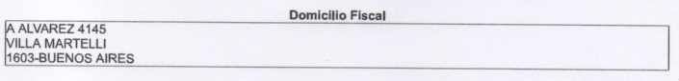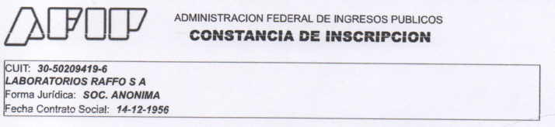

- "That the deponent does not remember that there were problems with the product ASOTREX"

What is false because ASOTREX RAFFO LABORATORIES SA leads the number of complaints, in addition 2819/04 and 2372/08 by provisions, can not ignore the claims information, and she must inform them and some contained in foja 109 exp. ANMAT No. 1-0047-0000-013211-14-1. (Doc.11)

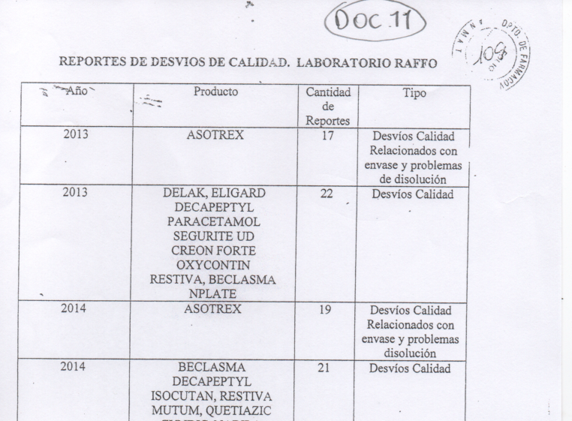

**Enrique Ciccioli in his testimony says:**

***"Which the actor knows because they were co-workers at LABORATORIES RAFFO, which is located on Calle Agustin Alvarez in Villa Martelli, who were co-workers in the period 2012 to 2014*". Bermejo belying SILVINA.**

**Bermejo claims**:

*- "that the deponent knows, the actor did not participate in internal audits, the training that made the actor was involved in various tasks such as inspections or auto inspections and verifications,"*

Which is false and reads the email that she sent him to Alfredo Mammani (manager maestranza, UNAUDITED) with a copy to me, referring to self-inspection 2013 and looks like Bermejo does not distinguish between audit and self-inspection also becomes clear my active participation as they relate to my job so I'm back in the email. (Doc. 4) submitted as evidence to exp. 27009/16,

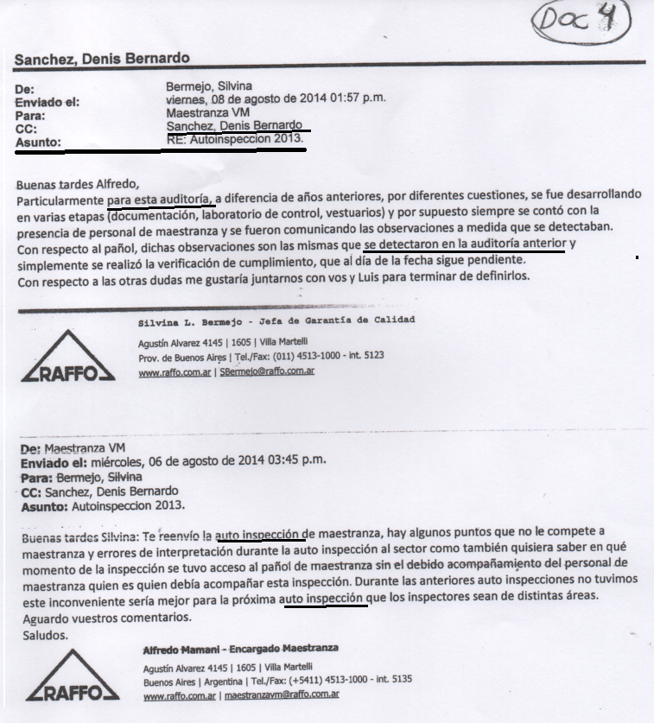**The difference between audit and self-inspection is only the inspection site. It's called self-inspection to internal audit. It is called generally AUDITORIA to the external, for example service providers and materials.**

**It is also the case in the self-inspection report referred to the act as the "audit" (copy attached (Doc. 3)). which it forms part of the record 25945/15 Court of Instruction No. 40 CABA.**

**So the statement that I BERMEJO, Denis Sanchez, did not conduct audits**, It is false, since she herself via email showed me places external audit to lead me to effect it (Doc. 1), also answered my companion ANALIA OROZCO an email informing my participation in an audit on behalf of laboratories Raffo SA (Deputy email, Doc. 2).

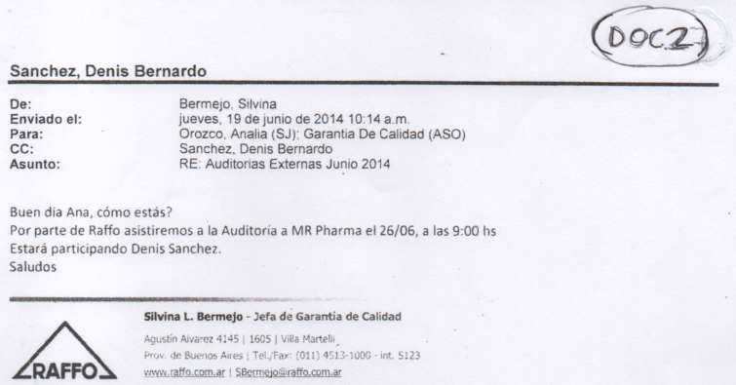

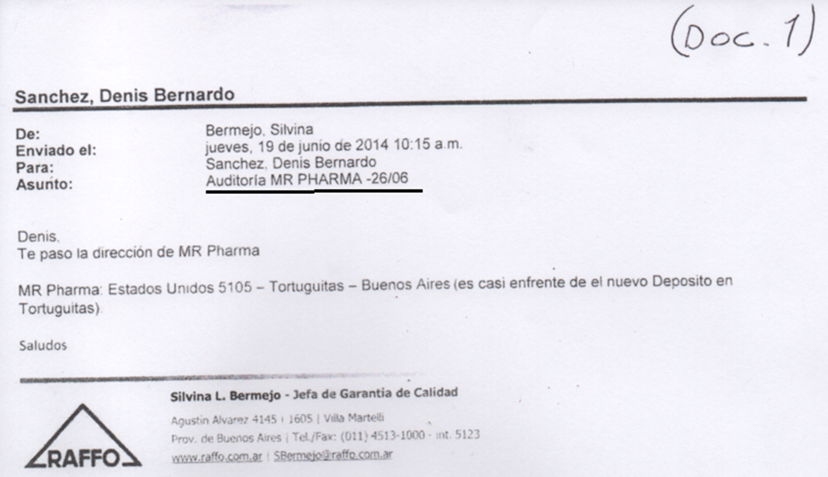The Ms. Silvina Bermejo said that the audits are performed by herself and I was carrying out self-inspections. Which is false by what is seen in the post above.

"That the deponent knows that the quality assurance personnel was in charge of internal audits in 2014 and the leading deponent, the checker is part of quality assurance personnel but has other functions, not the audit. "